Yo

Youth Leadership Program
AY 2022-23
Project Title: The Impacts of Technology on Family time
Sustainable Development Theme: SDG 3 Good health and well-being.

Class | Year 1C
Teacher Name | Ms. Azra Azmeel
Co – Teacher Name | Ms. Khadija

Table of Content
Table of Content

Summary of Report 2
Link of video 2
Youth Leadership Journey for Class 1C 3
I. Preparation Phase 7
a. Training 8
b. Meeting with Deputy Headmistress 9
c. Brain storming session with class 10
II. Execution Phase 11
a. Development of Big Questions 11
b. Student Appreciation 15
c. Inclusion Qatar Identity 12
d. Community Engagement 13
e. Classroom Displays…………………………………...……………………………….…….….14.
f. Work of gifted and Talented students…………………………………. ……….………15
III. Analysis Phase 16

- Learning Results Analysis 17
- Sample of student YLP report 17

V. Reflection Phase 18
- Parent Feedback and Appreciation 19
- Student Reflection 20
- Teachers Reflection 21
Way Forward…………………………………………………………………….……………

Summary of the Program

Impacts of technology on family time.

Is technology a curse or a blessing? - Feel

Students of year 1C Ain Khalid class conducted research on how technology impacts family time.
Technology can have both positive and negative impacts on family time, depending on how it is used. Here are some ways technology can impact family time:
Positive impacts:
  - Improved communication: Technology such as smartphones, social media, and video conferencing can help families stay connected and communicate more frequently, regardless of their physical location.
  - Convenient entertainment: Streaming services, video games, and other forms of digital entertainment can provide families with convenient and affordable options for spending time together.
  - Learning opportunities: educational apps, online courses, and digital libraries can provide families with new opportunities for learning and growing together.
Negative impacts:
- Distractions: Technology can be a major distraction, pulling family members away from each other and reducing the amount of quality time they spend together.
- Social isolation: Excessive use of technology can lead to social isolation and a lack of face-to-face interaction, which can have negative effects on family relationships.
- Unrealistic expectations: social media and other forms of technology can create unrealistic expectations and pressures on families to constantly be connected and engaged, leading to feelings of stress and burnout.
Overall, it's important for families to use technology in a balanced and intentional way, making sure to prioritize face-to-face interaction and quality time together.

Our students were able to conduct field research, surveys and interviews from adults, students, and some external volunteers to collect data of how much time they are indulged using technology such as smart phones, television, video game etc. Based on the data collected, students were able to analyze and determine that there are numerous amounts of response aligning to the fact that technology has an immense effect on family time and relationships.

Research - Imagine
Sample of the survey conducted.
On adults.
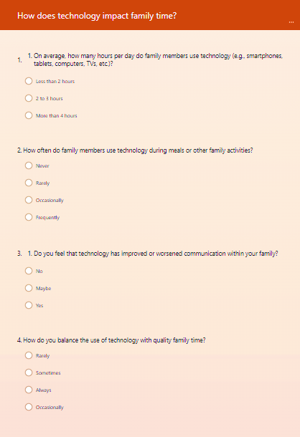

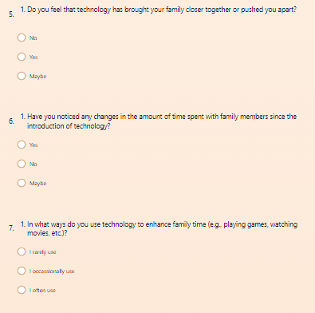
Students made a data analysis based on the responses. They were able to understand the data and the results found on how and when technology impacts family time.
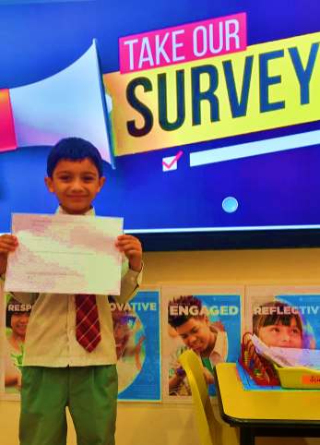

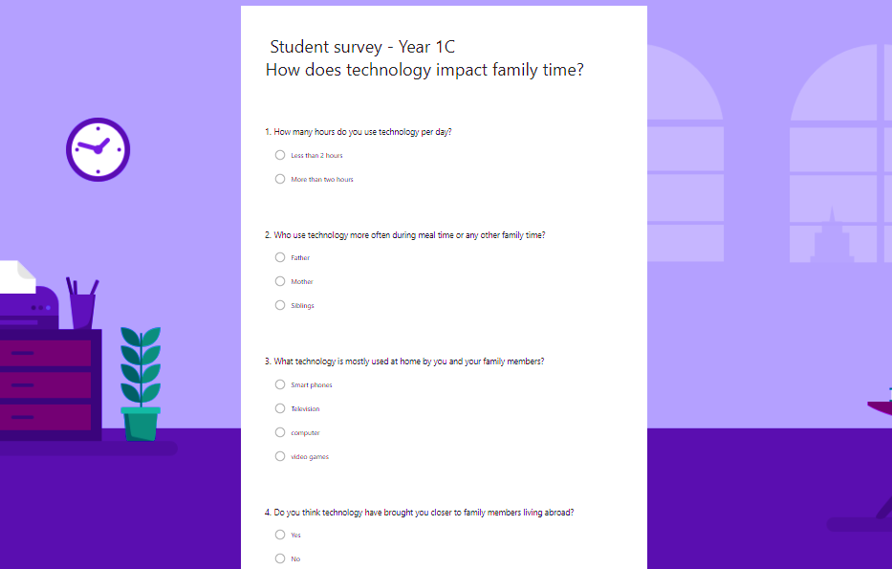

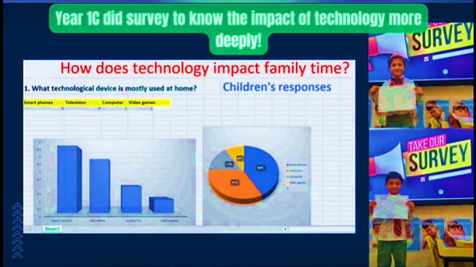

Some key pictures

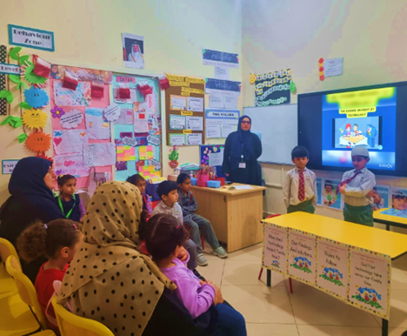

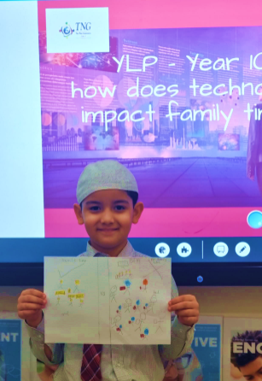
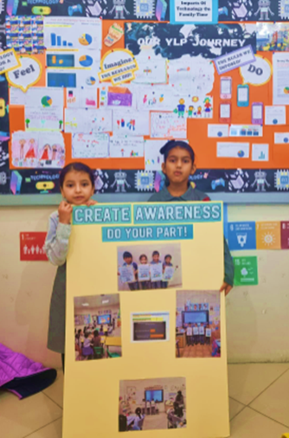

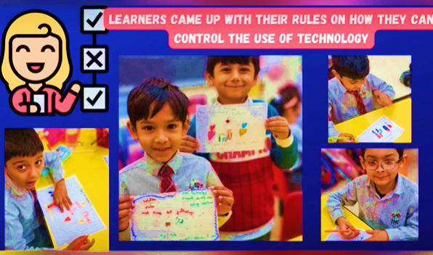

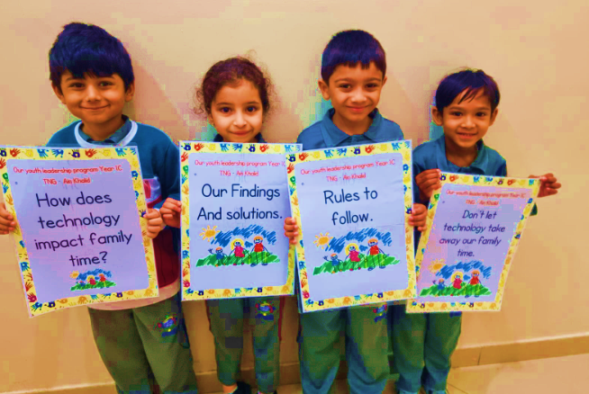

3. Youth Leadership Journey for Class 1C

I. Planning Phase

- Training
Based on SDG 3, I certainly believe that a healthy family relationship plays a vital role in one’s mental health. We, the teachers of year 1C investigated how the technology had negatively impacted the families around the world and how it is now becoming a global issue.
Some quotes from famous personalities.
Frank Kaufmann, a scholar, educator, innovator and activist based in North America, commented, “Technology improves the lives of people who can avoid being dominated by it and forced into debilitating addictions to it. Technology allows me to grow and benefit from loving relationships among friends and family who can now be close despite geographical distance. Tragically it prevents the addicted from growing and benefiting from the most exquisite types of encounters, namely being in the physical and personal presence of another.”

Richard Padilla, a retired system administrator, said, “Tech has changed the development of the lives of everyone. A need to refine its processes for better growth is now the requirement.”

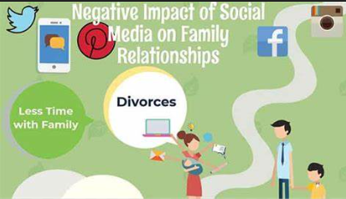

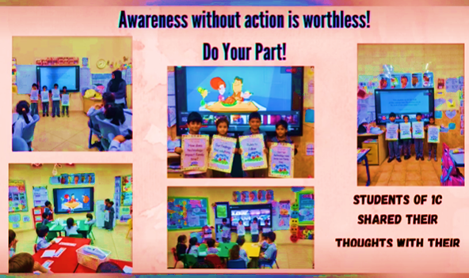
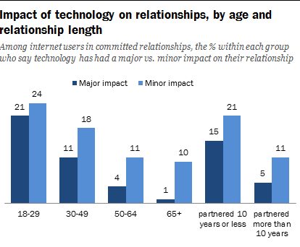
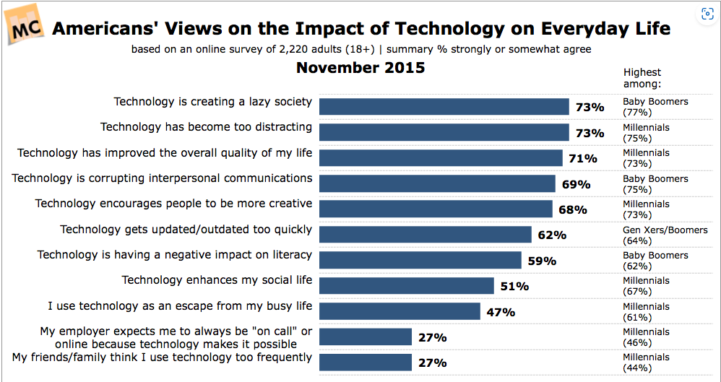

To enhance the knowledge on global issues, we attended The Earthna summit 2023. Across the two days Earthna Summit 2023 will explore a wide range of topics through presentations, interactive panel discussions, workshops, and roundtables. The program was based on a holistic view of being sustainable in all ways.



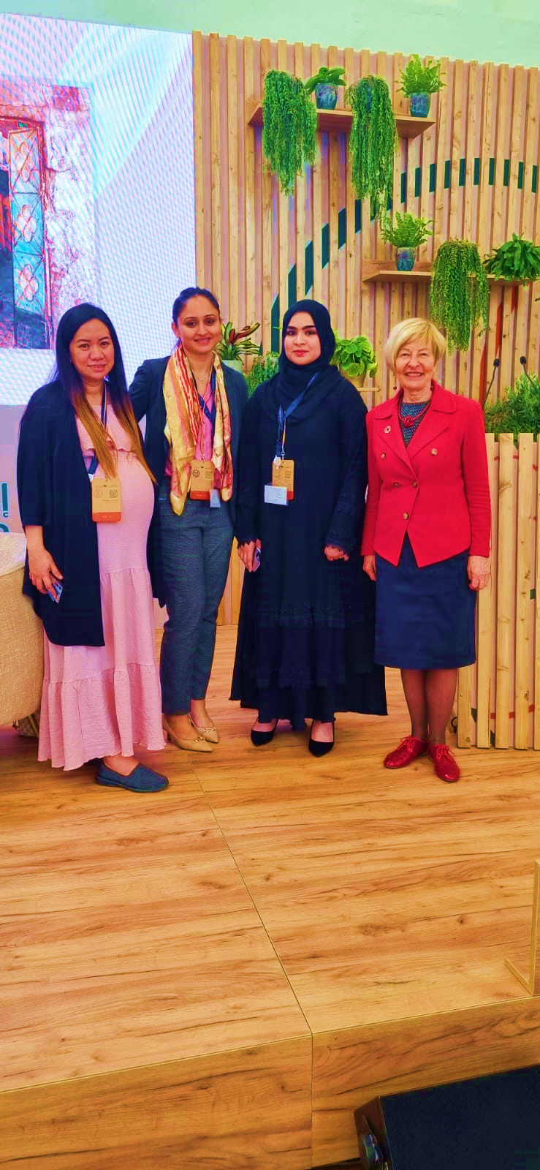

We actively engaged themselves in class discussions about technology. Students shared ideas. They were able to discuss both negative and positive effects of technology to the world. We discussed about the evolution of technology and provided evidence that are clear to them and are relevant to their age.

Some training activities on students.

They did a group project on technology evolution. They also involved in other interactive activities like making their favourite technological device(craft), inventing their own technology, doing a research-based writing (IEP made drawings to share their thoughts and ideas). They came up with various ideas, thoughts, opinions, and suggestions. Their engaging skills developed drastically at this stage. They were excited and curious to investigate more about technology.

- Meeting with Deputy Headmistress:
A meeting was organized with our deputy head Ms. Lally and Principal Madam Javeria, here we got an opportunity to discuss about our research, plan, and strategies to make it successful. Immense support and guidance were given to us to take this research forward. They guided us with various suggestions to enlighten and awaken students learning skills. Continuous support and close monitoring were given by them throughout the research.

C) Brain storming session with class
At this point students were engaged in discussions and activities of how technology impacts family life? They came up with various answers. They were able to think critically about the quality of the time they spend with family and how technology influences their time together. At this point, students were asked to make observations at home on their family members using any kind of technology during family time. They recorded their observations with the help of the parent. They were able to understand how does technology impacts family time.

Students researched about the impacts of technology on family time, both positive and negative.
Our students began to understand the concepts clearly with proper evidence, research, and discussions. The big question for our project was developed.

How does technology Impacts Family Time?

The students were challenged to not use any kind of technology at home for a whole day and spend quality time with their family. They actively engaged in the challenge. Our parents supported us which was the helping hand to our research. Photographs were taken by them when the students actively engaged themselves in the challenge.

II. Execution Phase

- Development of Big Questions
Students researched about the impacts of technology on family time, both positive and negative.
Our students began to understand the concepts clearly with proper evidence, research, and discussions. The big question for our project was developed.

How does technology Impacts Family Time?
The students were challenged to not use any kind of technology at home for a whole day and spend quality time with their family. They actively engaged in the challenge. Our parents supported us which was the helping hand to our research. Photographs were taken by them when the students actively engaged themselves in the challenge.

- Student Appreciation

Students were honoured with merit certificates for their active participation. Sample of the certificate.
“When we give cheerfully and accept gratefully, everyone is blessed.” Maya Angelou.

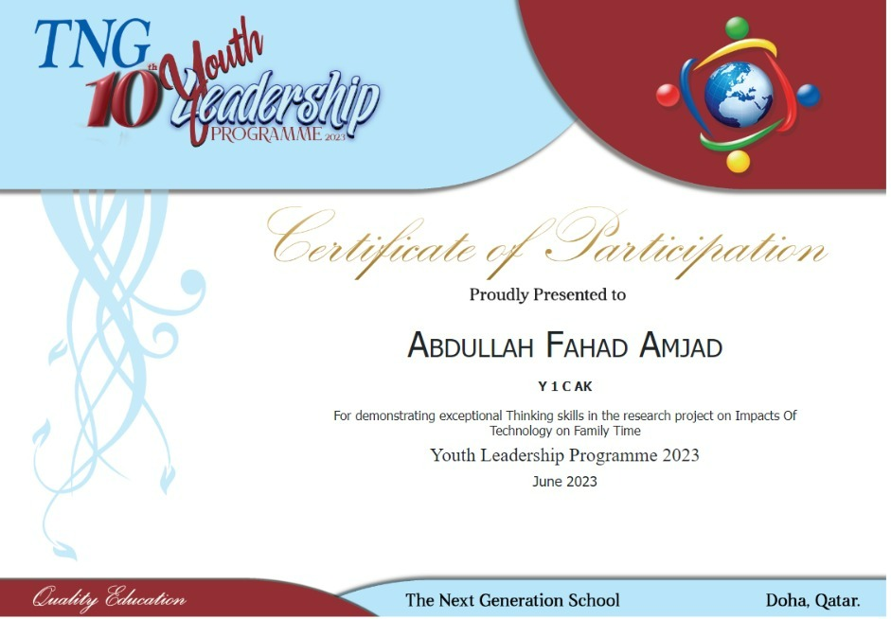

Inclusion Qatar Identity
The impact of technology on family values and traditions in Qatar is significant.
Technology has brought about both positive and negative changes in how families in Qatar uphold their values and traditions. On one hand, technology has facilitated communication and connectivity, allowing families to stay in touch with their extended relatives and maintain cultural ties. Video calls, social media platforms, and messaging apps enable families to bridge geographical distances and share experiences, thus reinforcing family values and traditions.
However, technology also poses challenges to family values and traditions. The increased use of smartphones, tablets, and social media platforms can lead to decreased face-to-face interaction within families. This can impact the transmission of cultural values and traditions, as important rituals and practices may become less prioritized or diluted in the digital age.
Furthermore, technology has influenced the consumption habits and leisure activities of families in Qatar. Traditional forms of entertainment and cultural practices may be
overshadowed by digital media and online content. This can result in a gradual erosion of certain cultural values and traditions as newer forms of entertainment and media take precedence.
It is important for families in Qatar to strike a balance between embracing technology and preserving their values and traditions. Encouraging active participation in cultural events, promoting face-to-face communication, and utilizing technology as a tool to enhance cultural learning can help mitigate the potential negative effects of technology on family values and traditions.
Overall, while technology has undoubtedly impacted family values and traditions in Qatar, it is essential for families to adapt and find ways to integrate technology into their lives while upholding and preserving their cultural heritage.

Students investigated and researched on Qatar’s values and traditions. They came up with some solutions on how people living in Qatar to adapt and find ways to integrate technology into their lives while upholding and preserving their cultural heritage.

d)Community Engagement

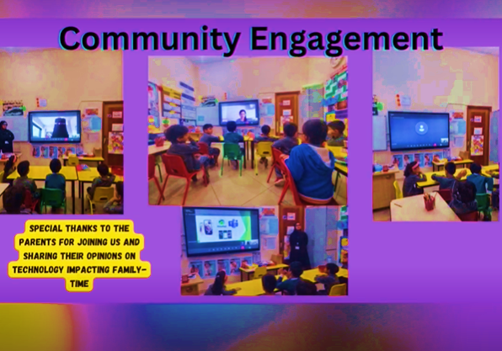

Classroom Displays

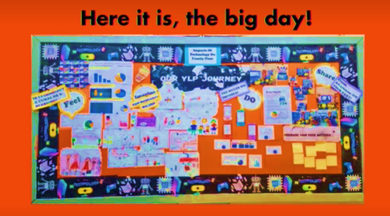

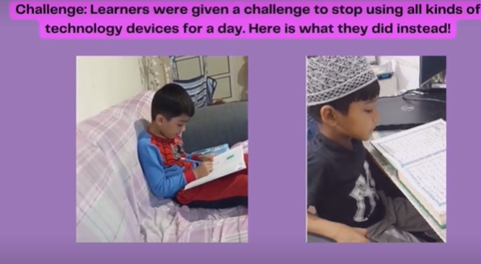
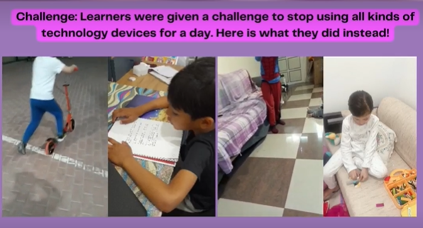

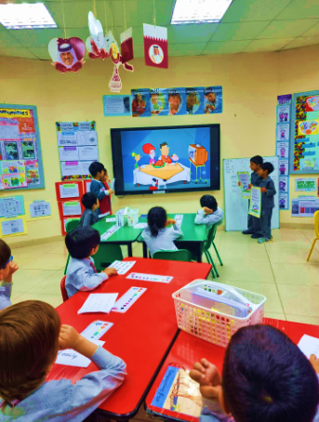

III. Analysis Phase

- Learning Results Analysis

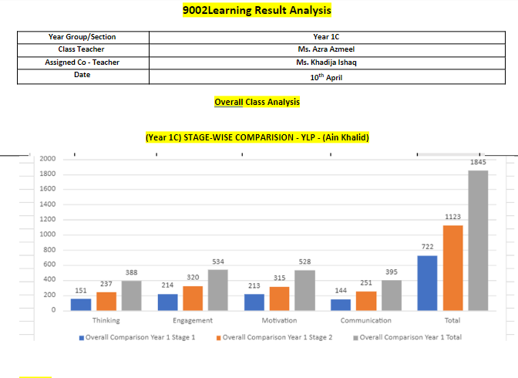

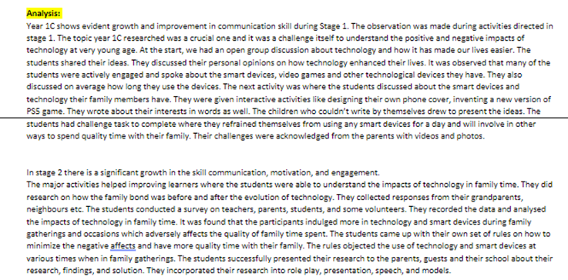

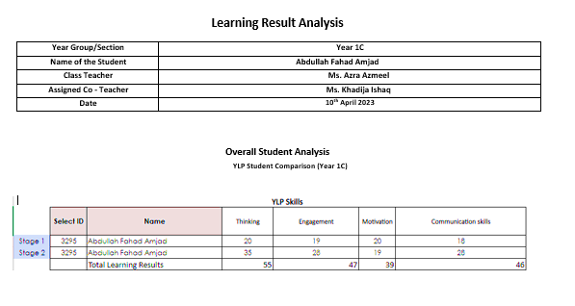
  - Sample of Student YLP Report

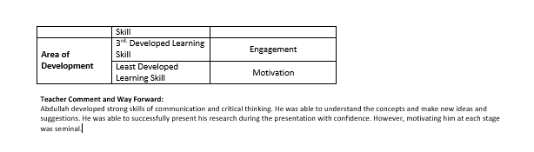
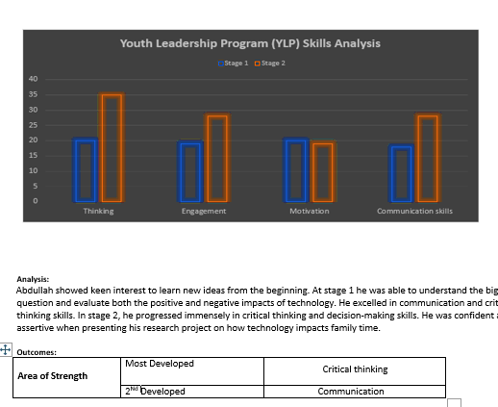

The students came up with some solutions to the problem. They shared their thoughts and the research with other classes at TNG Ain Khalid. They explicated their research with interest and joy.

They brought into practice of detaining the time spent on technology and engaging in various other activities. Students actively engaged themselves in reading, playing, and having outings with their siblings to deviate the urge to use any technology that would steal away their precious time spent with the family.

IV. Analysis and Reflection Phase

- Parent Feedback and Appreciation

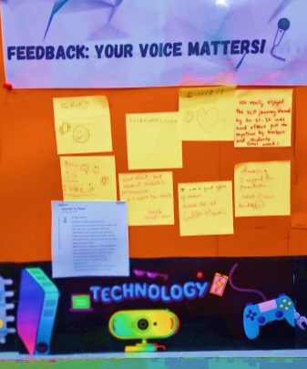

Parent surveys in YLP research program are important because they:
- Provide valuable parental perspective.
- Offer a holistic understanding of a child's life.
- Validate data and enhance credibility.
- Uncover unique factors and nuances.
- Aid in intervention planning and evaluation.
- Increase generalizability of findings.
- Engage stakeholders and promote collaboration.

The respective guests and the parents were impressed with the performance of the little minds filled the classroom with sounds of joy and applauses.

b. Student Reflection

The process of student reflection holds great significance in the youth leadership research program. It provides them with an opportunity to assess their progress, evaluate the effectiveness of their methodologies, and identify areas for improvement. By reflecting on their research journey, students can gain a deeper understanding of their own strengths and weaknesses, enabling them to refine their skills and enhance their future research endeavours. Student’s reflection is crucial in youth leadership research program as it promotes self-awareness, critical thinking, metacognition, and effective communication. It enhances the learning experience and empowers students to become more skilled, adaptable, and thoughtful researchers.

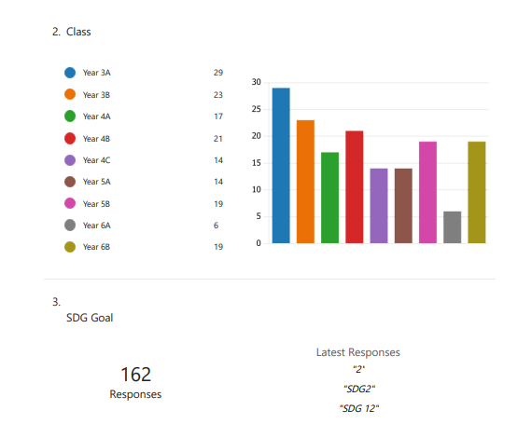
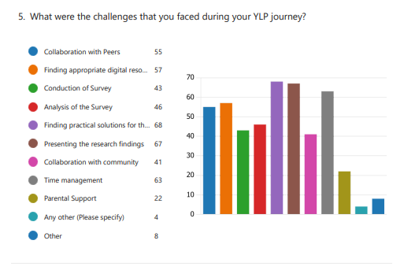

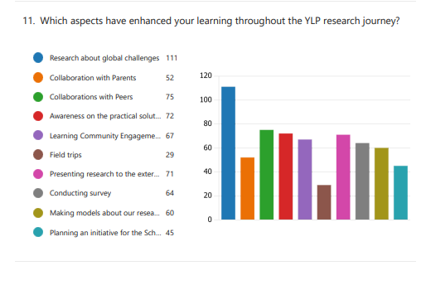

Teacher Reflection
The Youth Leadership Programme presents students with a valuable opportunity to explore global issues from a comprehensive perspective. Alongside recognizing significant challenges and their underlying origins, students engage deeply with these subjects, enhancing their comprehension and examining possible remedies. This initiative fosters critical thinking, research proficiency, and a more extensive recognition of the difficulties our world encounters. By actively participating in problem-solving, students exhibit their commitment to creating a positive influence. Empowered by the Youth Leadership Programme, students are prepared to become knowledgeable and proactive global citizens capable of tackling intricate problems with a holistic mindset.

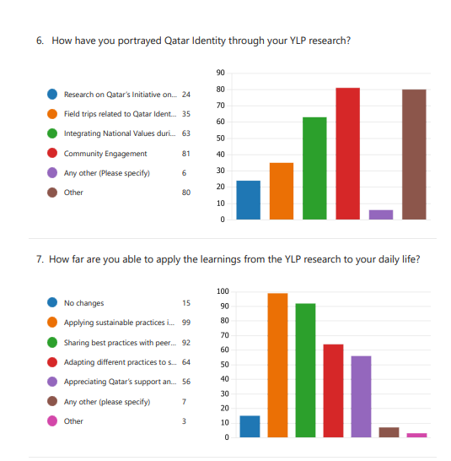

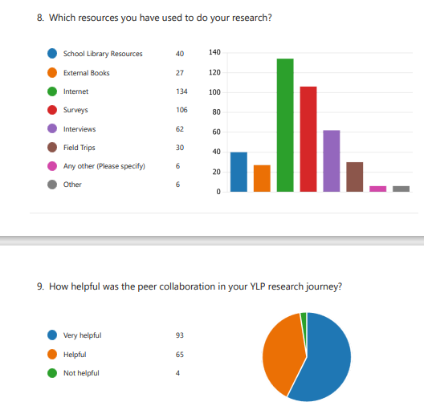

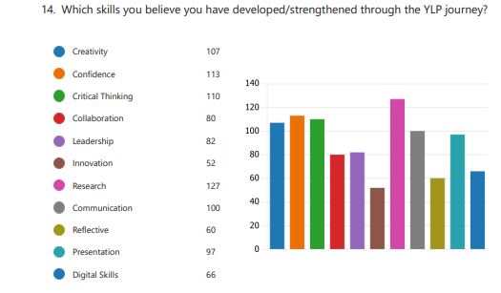

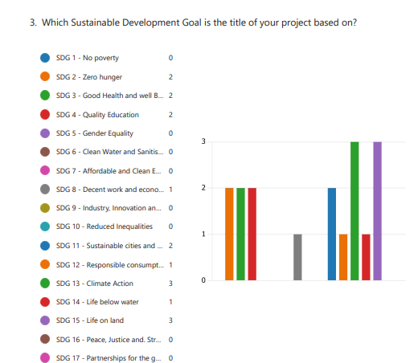

V. Way Forward
- Overcoming the negative impacts of technology on family time requires a conscious effort and a balanced approach. Here are some strategies you can employ:
- Establish technology-free zones and times: Designate specific areas or periods in your home where technology is not allowed, such as the dining table during meals or the bedroom before bedtime. This creates opportunities for uninterrupted family interactions.
- Set boundaries and limits: Encourage open communication and establish clear guidelines for technology use within the family. Determine the appropriate amount of time that can be spent on screens and ensure everyone follows these limits.
- Lead by example: As a parent or guardian, model healthy technology habits yourself. Limit your own screen time and be present and engaged during family activities. Children are more likely to emulate behaviors they see from their role models.
- Plan dedicated family activities: Schedule regular family activities or outings that encourage quality time together. Engage in activities that promote interaction, such as board games, outdoor games, cooking, or shared hobbies.
- Encourage face-to-face communication: Encourage open conversations and face-to-face interactions within the family. Encourage everyone to put away their devices during discussions and allocate time to talk and listen to each other's thoughts and experiences.
- Create technology-free rituals: Establish traditions or rituals that do not involve technology, such as reading books together, going for walks, or having designated family game nights. These activities strengthen family bonds and create lasting memories.
- Utilize parental control features: Use the available parental control features on devices and applications to manage and limit screen time for children. These features can help restrict access during specific hours or block certain apps and websites.
- Foster alternative interests and hobbies: Encourage family members, especially children, to explore a variety of offline activities and hobbies that foster creativity, physical activity, and social interaction. This helps to diversify their interests and reduce dependence on screens.
- Practice mindful technology use: Encourage mindfulness and intentionality in technology use. Encourage family members to be aware of how technology affects their well-being and to use it purposefully rather than mindlessly.
- Maintain open communication: Regularly discuss the impact of technology on family life and the importance of balance. Engage in conversations about the challenges and benefits of technology and involve everyone in finding solutions that work for the entire family.
- By implementing these strategies, you can mitigate the negative effects of technology on family time and create a healthier balance between screen time and meaningful interactions.

