Youth Leadership Programme 2022-23
Journal

Year | 4 A
Teacher | Ms. Munaza Qureshi
Co-teacher | Ms. Khadija Fiaz
Mentor | Urwa Hareem, Hamza Faiz Khan

Project name: | Health is Wealth
Project Idea | Effects of Physical activities on mental and physical health of humans.
Objective of the project: | Our project is based on SDG 3: Good health and wellbeing. The aim is to create awareness about the importance of physical and mental health among us and the people around us.

Description of the project:

Learners will explore the effects of physical activities on human beings through a Big Question: "What happens when we engage in physical activities?" They will conduct their own research by trying out different physical activities for a few days before starting their lessons. They will then reflect on their experiences and observations from these experiments.
Next, they will create a questionnaire and work in groups to gather feedback from their classmates about how they feel on days when they have physical education (P.E.) classes. This feedback will help them understand the impact of P.E. on their peers.
During their Young Learner Program (YLP) journey, they will also interview professionals in the health field, such as doctors, school nurses, and P.E. teachers. These interviews will provide them with valuable insights and different perspectives on the topic.

Implementation:

The students had the opportunity to engage in various physical activities and games, gaining first-hand experience through active participation. Following these experiments, the learners expressed their reflections through video recordings and written accounts.
To showcase their project, we opted to create a poster highlighting their findings in both English and Arabic languages. Additionally, as part of secondary research, the students visited different classes to conduct a survey, compiling valuable data from their peers.
Furthermore, we decided to conduct interviews with the school nurse and parents who are doctors, drawing upon their life experiences to gather additional information. This data collection process allowed us to enrich our project.
Finally, armed with their research findings, the students prepared a compelling presentation to share their discoveries and insights.

What have we achieved from the project?

We studied the problem and found out about many issues that affected people all around the world. This really made us realize how serious the problem is. Our research also helped us spread the word in our school, making more people aware of the issue.

Way forward (How do we want to expand our project?):

We are planning to continue this project or carry it forward in next session.

How did we involve the community in our project?

We collaborated with parents and interviewed with the school Nurse and also a lecture from school psychologist Ms. Human. We also plan to host workshops in the future with the younger students and we will therefore be involving their parents in our project too.

Skills developed during the project:

- Research skills
- Communication skills
- Team management skills
- Critical Thinking Skills
- Self-Evaluation skills

Glimpses from our Youth Leadership Program:
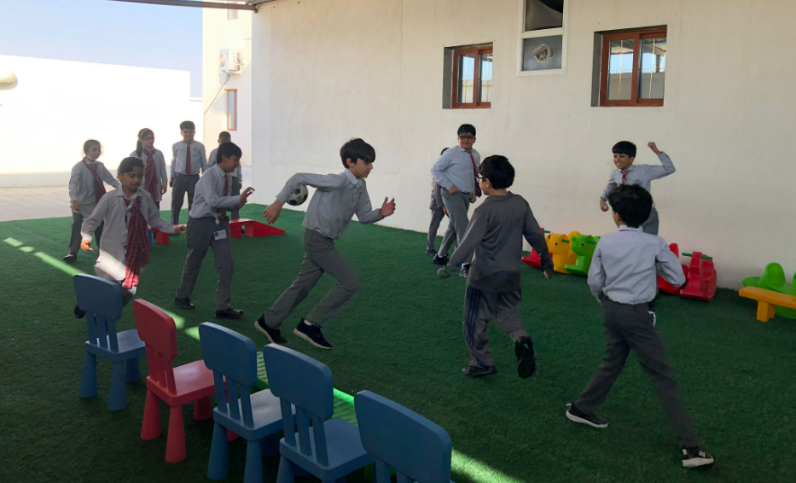

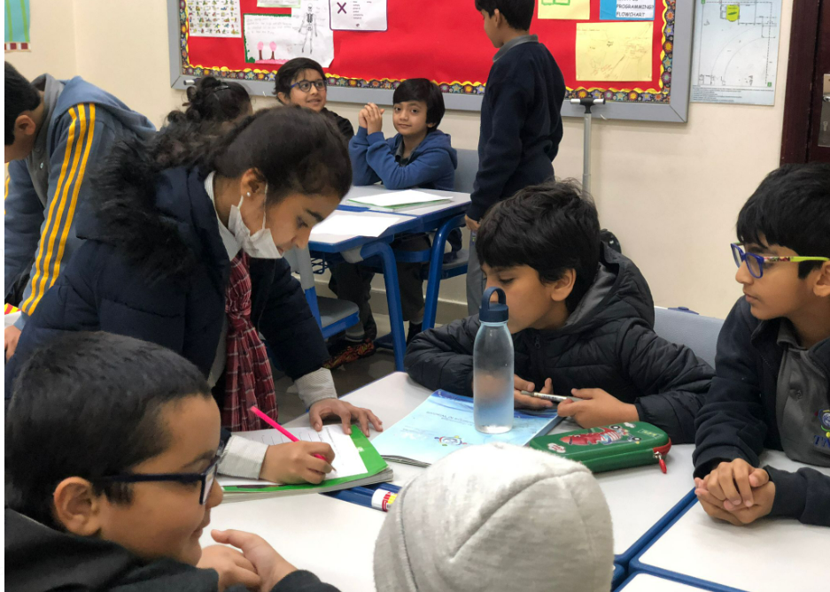

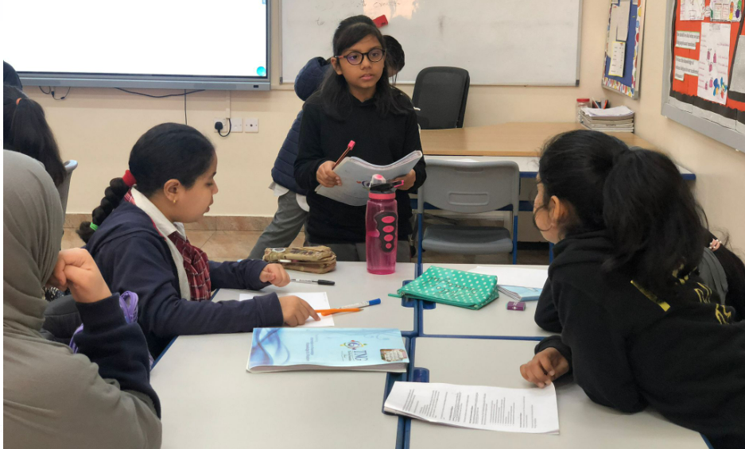

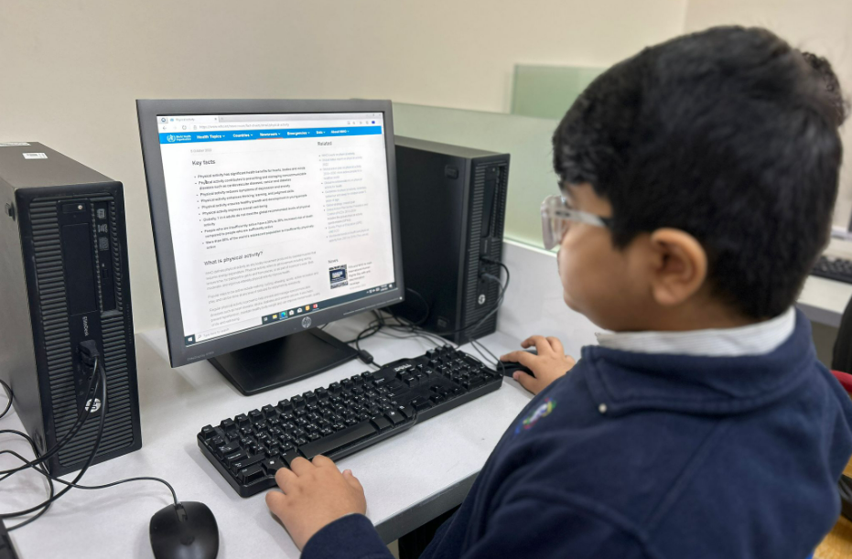

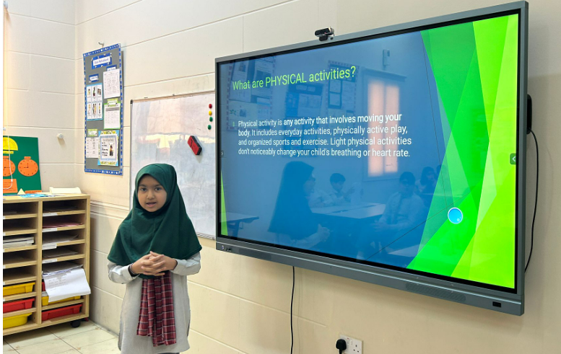

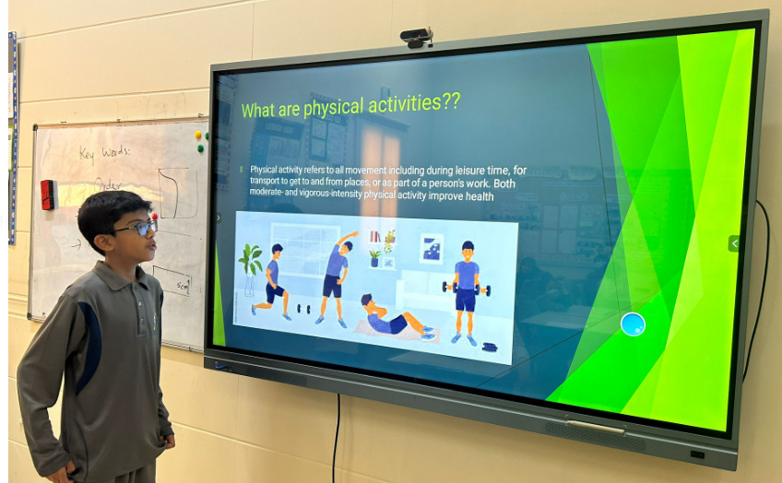

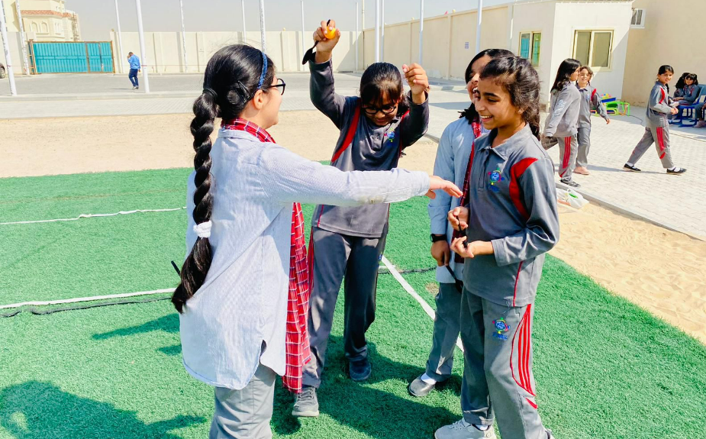

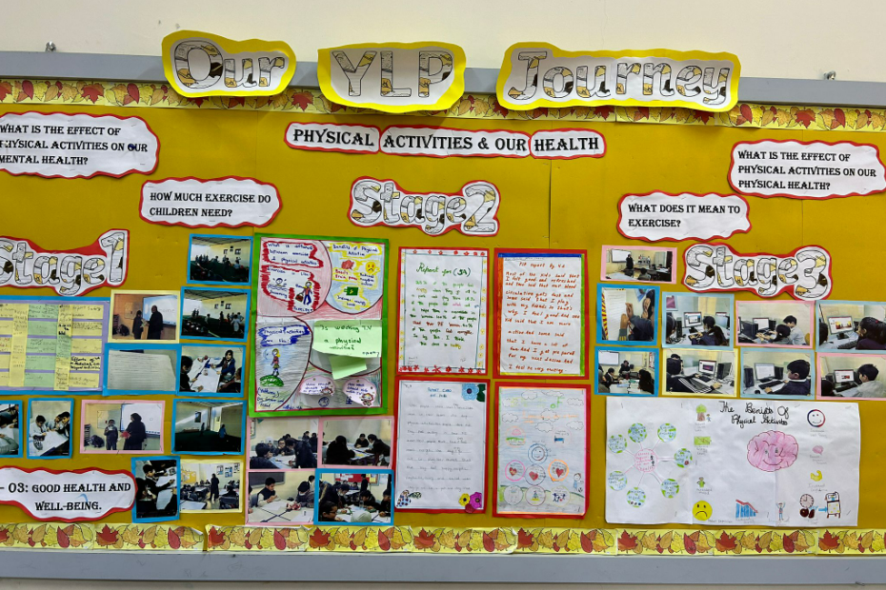
YLP Poster
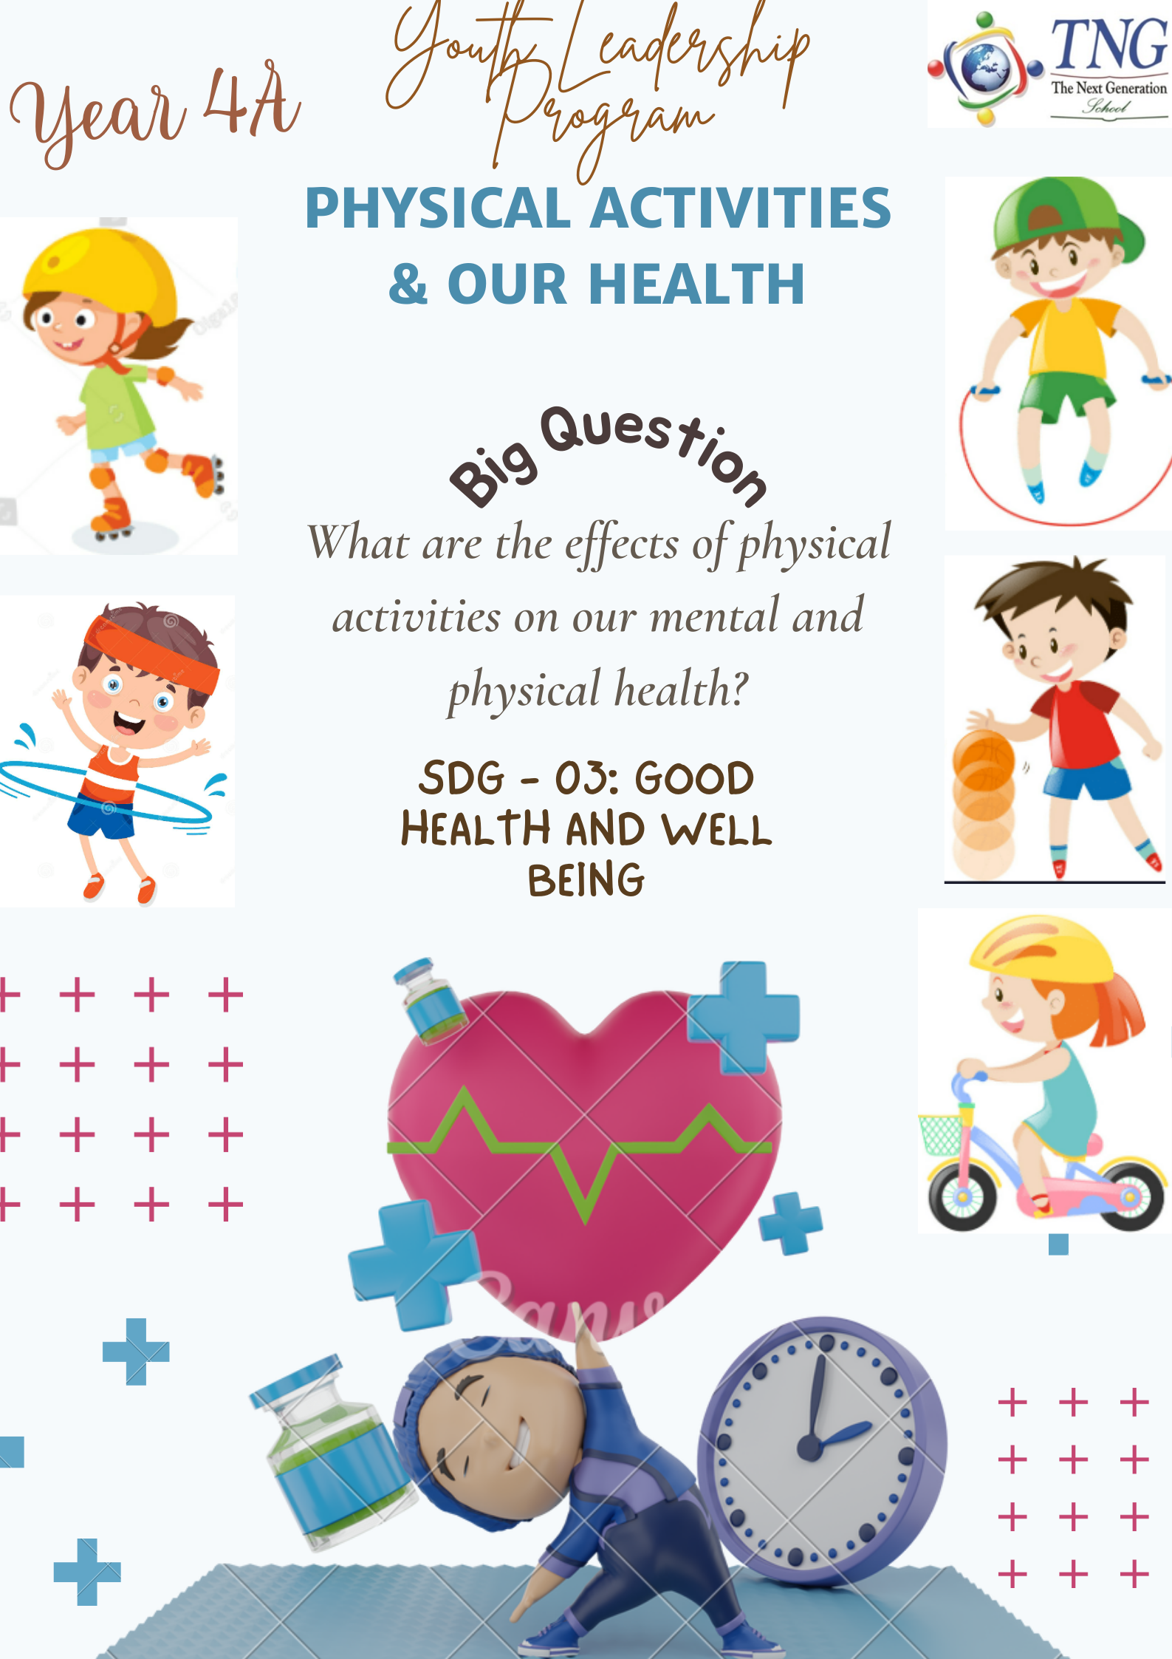
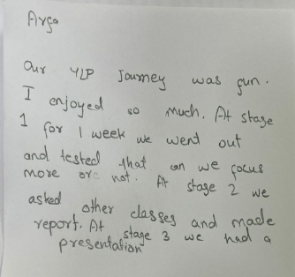
Students’ reflections:
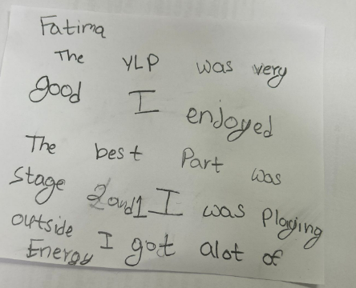

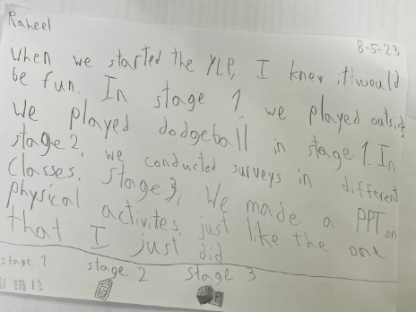
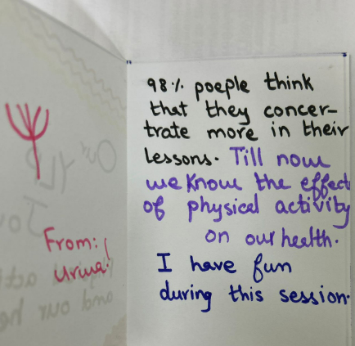

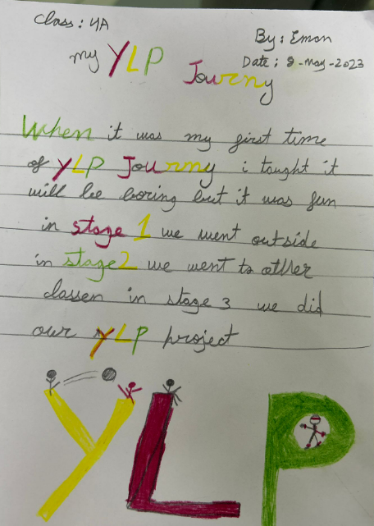

Reflections

Ms. Munaza Qureshi – Teacher
It fills me with great joy to observe students taking charge of the Youth Leadership Programme. Throughout the project's initiation and execution, the students remained fully engaged, demonstrating their ability to think holistically and establish valuable connections between the pre and post lockdown periods.
I had the privilege of witnessing the growth of their problem-solving skills during this endeavour, as it was our duty to raise awareness about the selected issues and devise effective solutions for the challenges that emerged along the way. They honed their critical thinking abilities, learned to evaluate themselves constructively, fostered teamwork, and perhaps most significantly, cultivated a deep sense of empathy.

