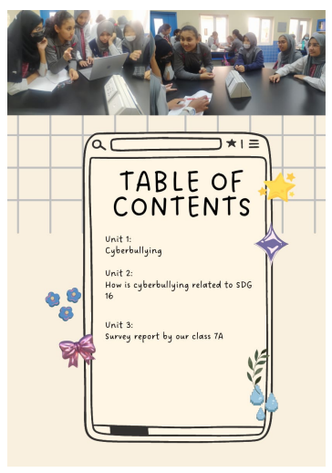

Unit 1

Cyberbullying

It is the same concept of face-to-face bullying but happens on the internet. Cyberbullying is bullying that takes place over digital devices like phones, computers, and laptops. It can occur through SMS, apps, games, or other online social media platforms where people can view, participate, or share content. Cyberbullying includes sending, posting, or sharing negative, harmful, false, or mean content about someone else. It can also include sharing personal or private information about someone causing embarrassment or humiliation. Sometimes, cyberbullying crosses the line into unlawful or criminal behaviour. The person who posts or share mean content about someone is called a Cyberbully. The person about whom mean content is shared or who get cyberbullied is called the victim in cyberbullying.

Cyberbullying can affect the mental and physical health of the targets, causing stress, anxiety, depression, low self-esteem. It happens the most on Instagram and least on Twitter.

Real life example:

Aamir Liaquat, a Pakistani televangelist, whose cause of death was also Cyberbullying, because he was a television anchor, and everyone knew him and could hate him. Some people who were in touch with him, claimed that he was suffering from anxiety after his video got leaked. He was in deep depression and felt very lonely. Extreme trolling on social media was the reason for his depression and then death. His own wife leaked his videos after which he was ashamed by many people on social media. This is what the issue of cyberbullying can do. People who get cyberbullied get into extreme depression and anxiety and this causes them to either commit suicide or die of humiliation and depression.

Solution:

If you get cyberbullied, then you should report your parents, teachers, or a trustworthy adult. If you can ignore, then ignore the bully and block them. Speak and spread awareness against it.

Answer the questions below, after reading this passage.

1. Who are victims of cyberbullying?

____________________________________________________________________________________________________

1. Who is a cyberbully? (Add an example)

____________________________________________________________________________________________________

1. Where does cyberbullying happen the most?

____________________________________________________________________________________________________

Which of these are cyberbullying? Mark a tick on the correct answer.

Yes

A Youtuber who makes gaming videos gets a comment in which people are telling him bad about his game skills and bad names.

Emily posted a photo of her in a WhatsApp group, her friends suggest the photo would be great if she had a good lighting.

No

Lara post a Facebook post on her page saying that Trump is a Good President, everyone gives their opinion and says that he’s not.

No

Three of Johnny’s teammates send texts to him, blaming him for the team’s loss and telling him that he does not know how to play the game.

No

No

Yes

Yes

Yes

How to recognize Signs of Cyberbullying?

* Having trouble sleeping at night.
* Seeming unwilling or uneasy to go to school.
* Appearing nervous or angry when they get an online message, email, or text.
* Unwilling to share any information about their online activity.
* Unusual, disrupted eating patterns and even stomach problems.
* Unexpected weight gain or loss.
* Becoming less social with friends and family.
* Spending more time in their room than before.
* Unexplained depression or being withdrawn after going online.
* Avoiding their phone or other electronic devices.
* Can’t concentrate on their schoolwork.
* Sudden unexplained drop in grades.
* Loss of interest in activities that they once enjoyed.
* Expressing dark thoughts or emotions.

**Unit 2**

How is cyberbullying related to our chosen SDG 16?

This is a big question that how is our subtopic and the main topic related to each other? So here is how our subtopic which is SDG 16 peace justice and strong institutions related to the main topic which is cyberbullying.

First, we need to know that SDG goal 16 is about promoting peace, making our environment as peaceful as possible and eliminating all forms of violence so in this way cyber bullying is also a form of violence which can ruin the peace and justice and according to this, cyberbullying shall be removed to bring peace and justice and to achieve the goal of SDG 16.

Cyberbullying is a type of violence, it sometimes crosses the limits of criminal behavior which can cause the victims to commit suicide and when there are crimes, deaths, fights and suicides, there is no peace. When people judge others by looking at their nationality, color, race, culture, face etc., then cyberbully them and they do not treat everyone equally, there is no justice.

Therefore, we are trying to stop this violent issue of cyberbullying because we do not want victims to commit suicides and we do not want the cyberbullies to judge others. We want to spread peace in the world by taking these small steps first.

**ARE YOU ALL WITH US?**

Here is a fun activity for you, find the words you saw in this unit. Enjoy this fun and easy activity.

K P E A C E H S H Q V J K T I C E N H W J W P S H R

N I N S U I C I D E J S E L C C V I O L E N C E H S K

W N I P D H N I H Y J S J S I W N K J M W J D J R N

H B H D J W J S B U W J S J S J E E I C R I M E S W

G O A L S U F D T R U I M B J R Z Q KI S N K J Z W

N W J S U I B I W B S E Q U A L L Y O N C F T T I J D

Y D A VR L U L J E I H H W I W J J E W J H N Y I L J S

J U S T I C E I S K I K Y W B S J J J W J E J J S J S N U

R I S W J M C Y B E R B U L L Y I N G H I Q N S N Z

Y U B Q L U N W P A M H S G F A G M S Q R I M W

|  |
| --- |
| Peace Justice Crimes Suicide  Cyberbullying Goal Equally Violence |

**Unit 3**

Survey Analysis

These are the survey results that our class made to check other people’s opinions on cyberbullying and to spread awareness about it.

The concept of cyberbullying is receiving online harassment. Online harassment as small as an offensive text message is considered cyberbullying, although it is not recognized by many people.

Our group had a theory on cyberbullying. We believe that not all, but most people, might recognize an offensive text but not consider it cyberbullying. One of the reasons that makes it very hard to stop. This survey has been circulated throughout all 7 TNG campuses in Qatar.

So, we asked two different questions that meant the same thing to test our theory.

**View, analyze** data**, and interpret results.**

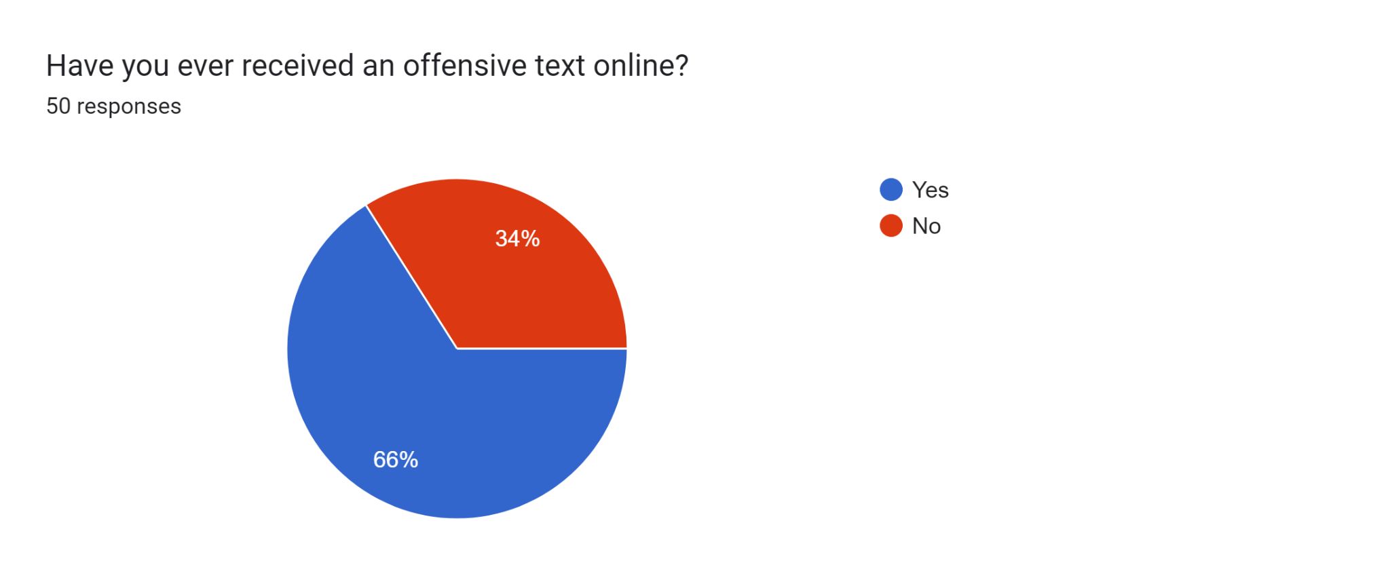

Out of 50 students in TNG, 33 (66%) reported receiving an offensive text message online, demonstrating the rise in cyberbullying in recent years. On the other hand, 17 (34%) say they haven't received any offensive text on social media platforms, which is positive news.

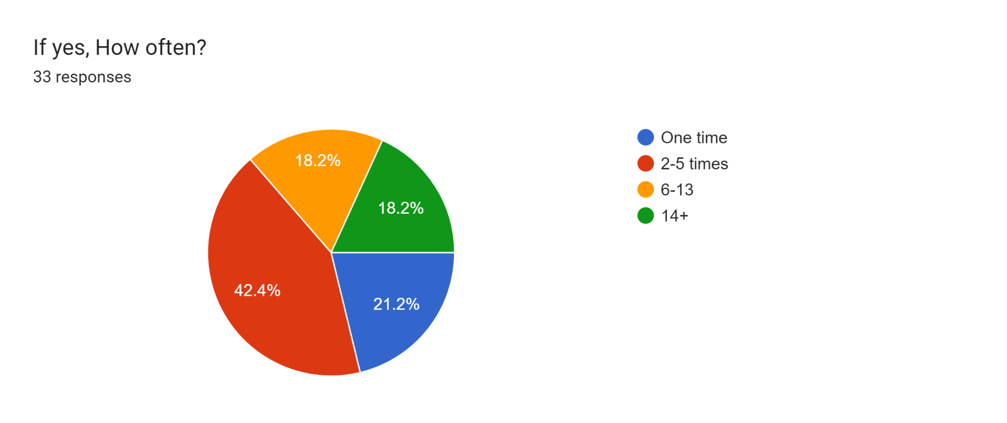

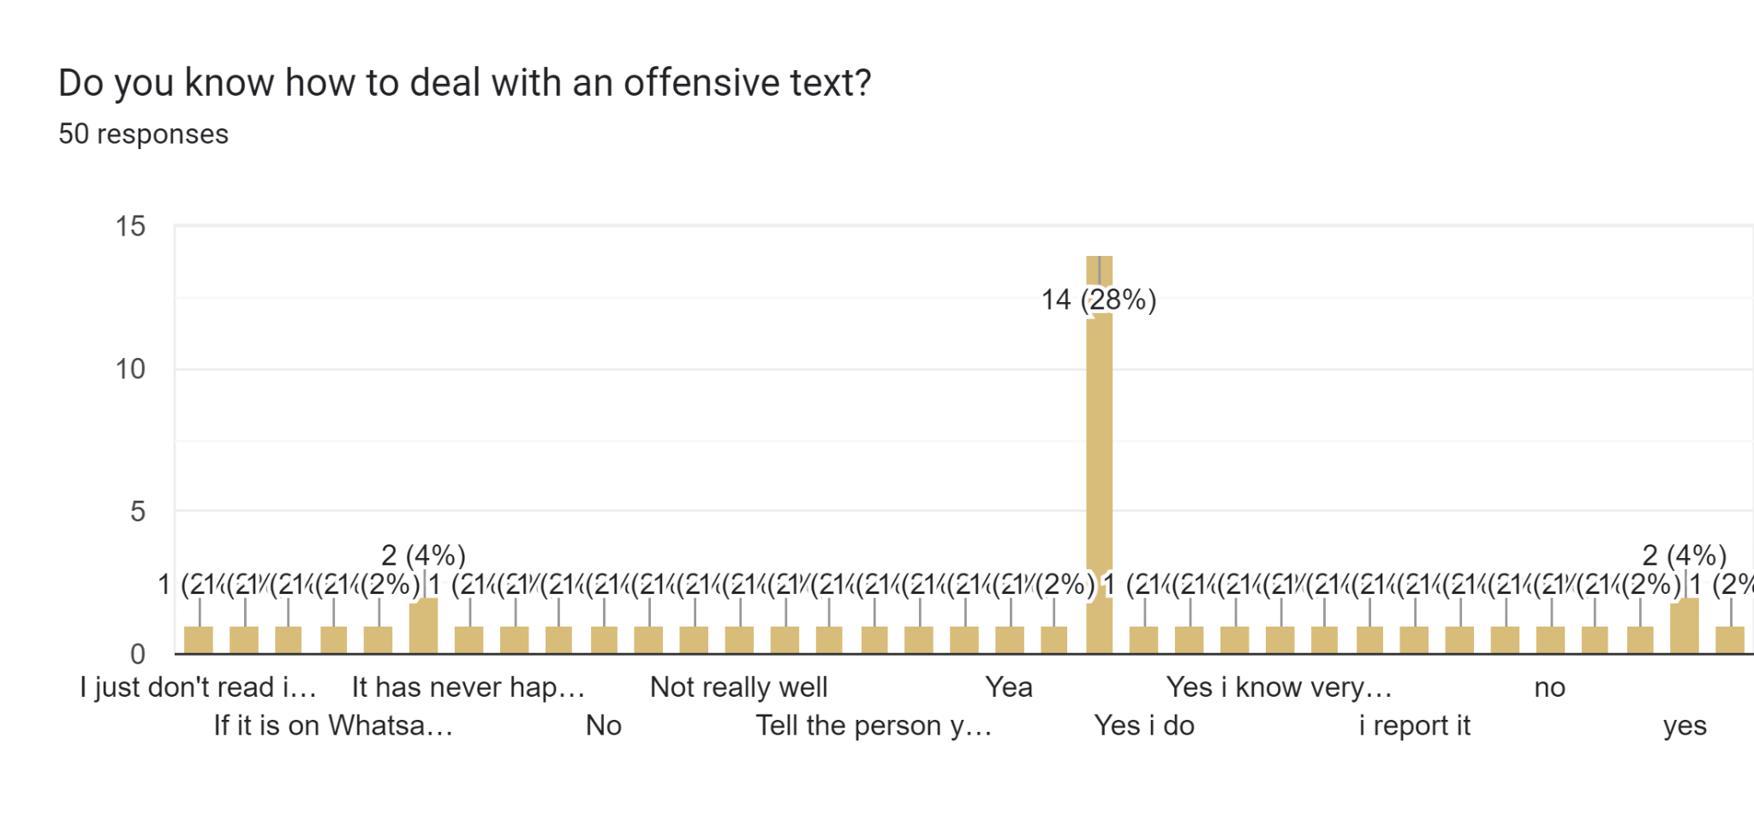

There are different opinions; some are aware, while others aren’t or haven’t experienced being cyberbullied.

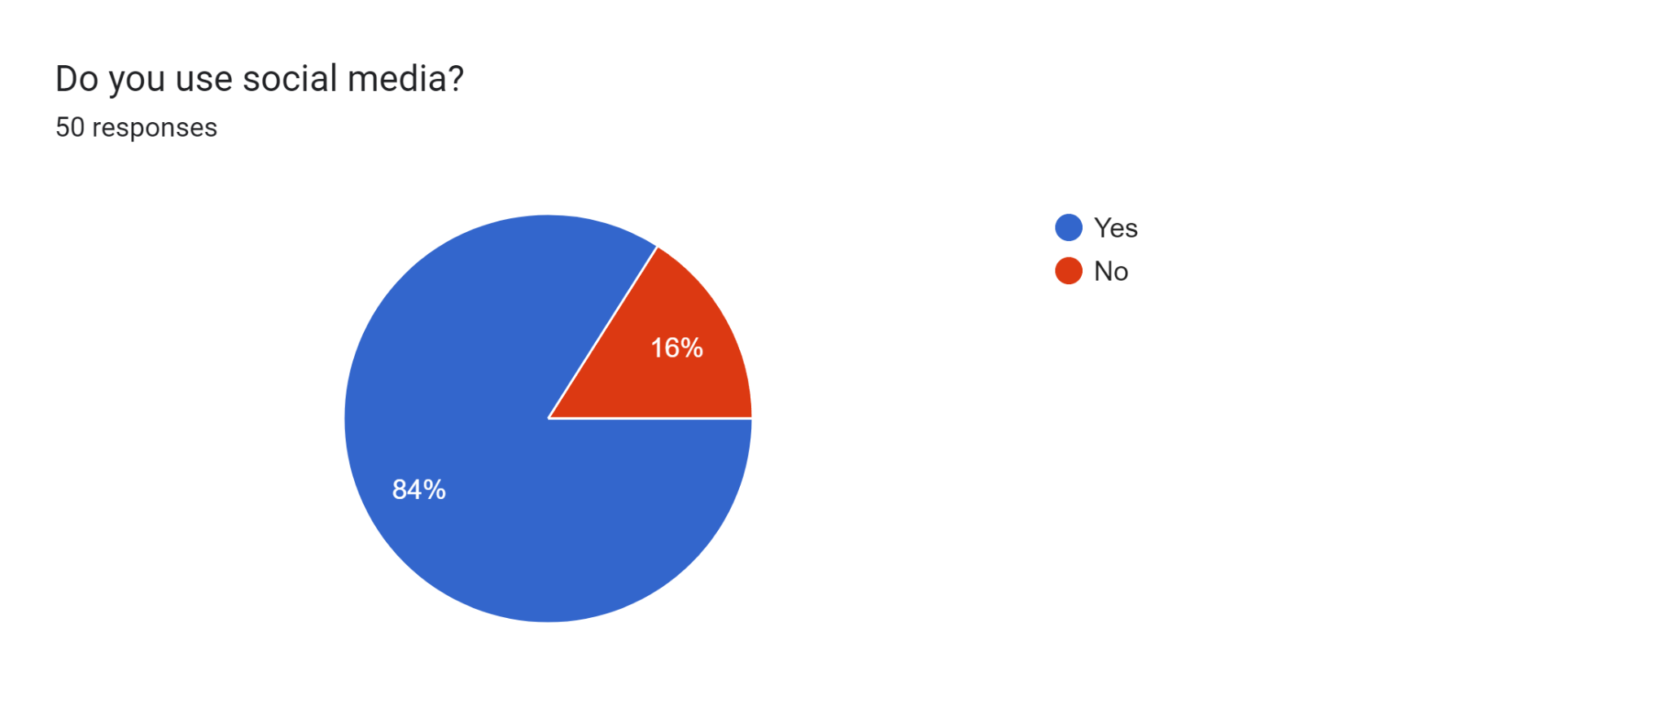

Out of 50 students, 42 (84%) report that they use social media platforms, which increases the chances of that individual being cyberbullied. Although it's surprising given how quickly technology is developing currently that 8 (16%) of students say they don't use social media, it lowers the likelihood that they will be the target of online bullying.

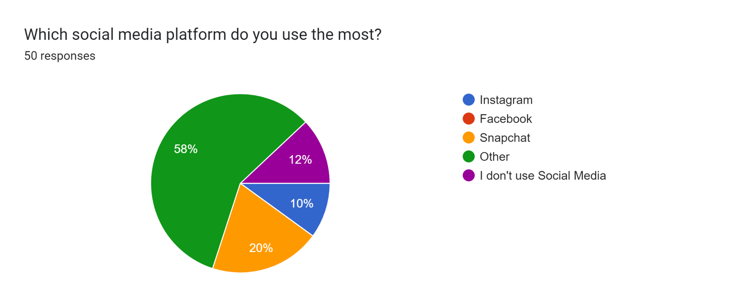

Every platform serves a unique purpose and offers a variety of information and entertainment to users around the world. 29 (58%) state they use platforms other than Instagram, Snapchat, and Facebook, which could possibly be WhatsApp, Discord, YouTube, etc. 10 students (20%) claim that they use Snapchat, which can have unwanted/unknown contacts, eventually which might result in cyberbullying. 6 students say (12%) that they do not use social media, which will keep them safe from online harassment, distractions, misinformation, reduced productivity, negative effects, etc. Lastly, 5 students (10%) report that they use Instagram. Students become addicted to Instagram because it has become an addiction for consumers, and even now, youngsters often use Instagram for enjoyment.

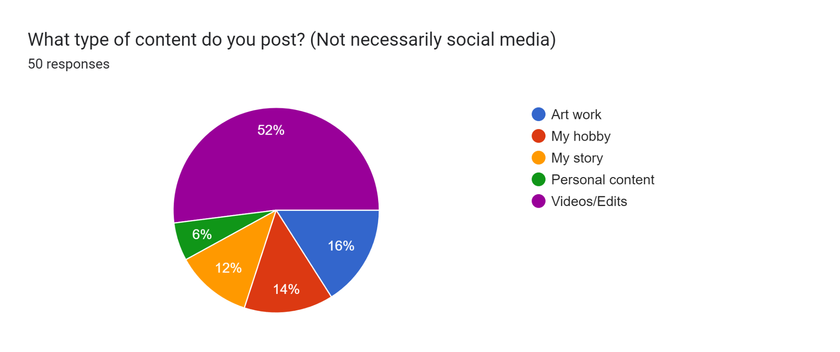

Out of 50 students, 26 youth (52%) claim that they post Videos/Edits, which is okay if it is appropriate. 8 pupils (16%) report that they post their artwork, which will help them improve their talent and should spread a friendly environment/positive impact on youth and kids. 7 students (14%) report that they post their hobbies.

6 students (12%) state that they post their stories on social media platforms, which nowadays might be about their personal routine or their life, which is dangerous as other pieces of information can be extracted from it and could be re-posted with edits, which is cyberbullying. Finally, people (6%) report) that they post personal content, which is again like their story.

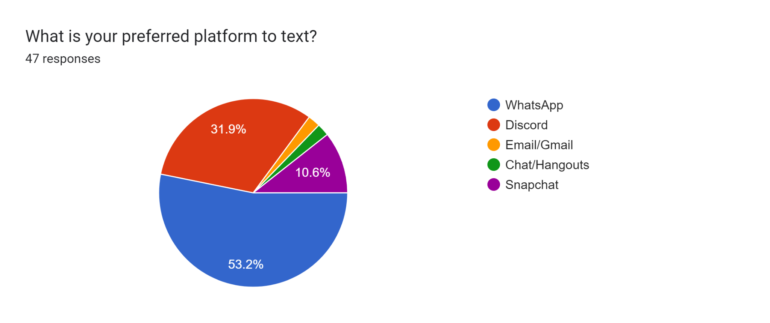

Platforms are

* WhatsApp (25 students, 53.2%)
* Discord (15 students, 31.9%)
* SnapChat (5 students, 10.6%)
* Email/Gmail (1 student, 2.1%)
* Chat/hangouts (1 student, 21 %)

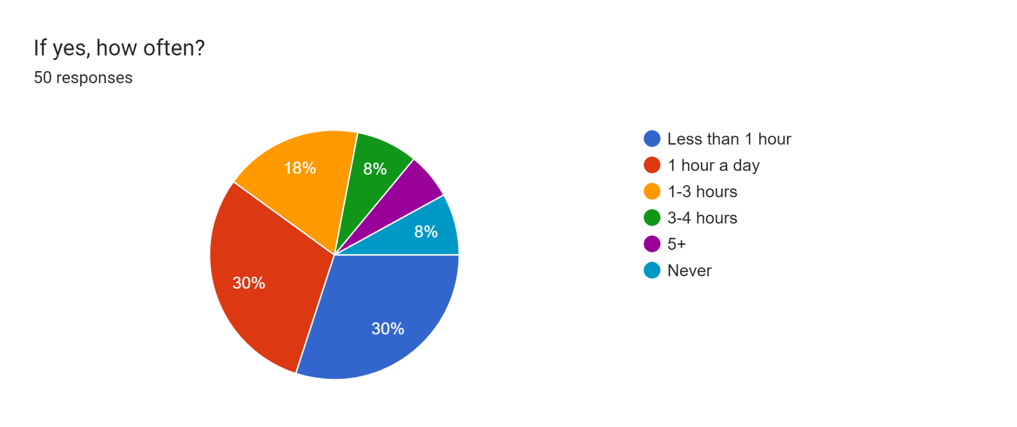

30 students (60%) say that they use social media for around 30-60 minutes. Nine students (18%) report that they spend 1-3 hours. Eight students (16%) report that they either use it for 3-4 hours or never. 3 students (6%) report that they use social media for more than 5 hours a day, which increases their chances of being a victim of cyberbullying.

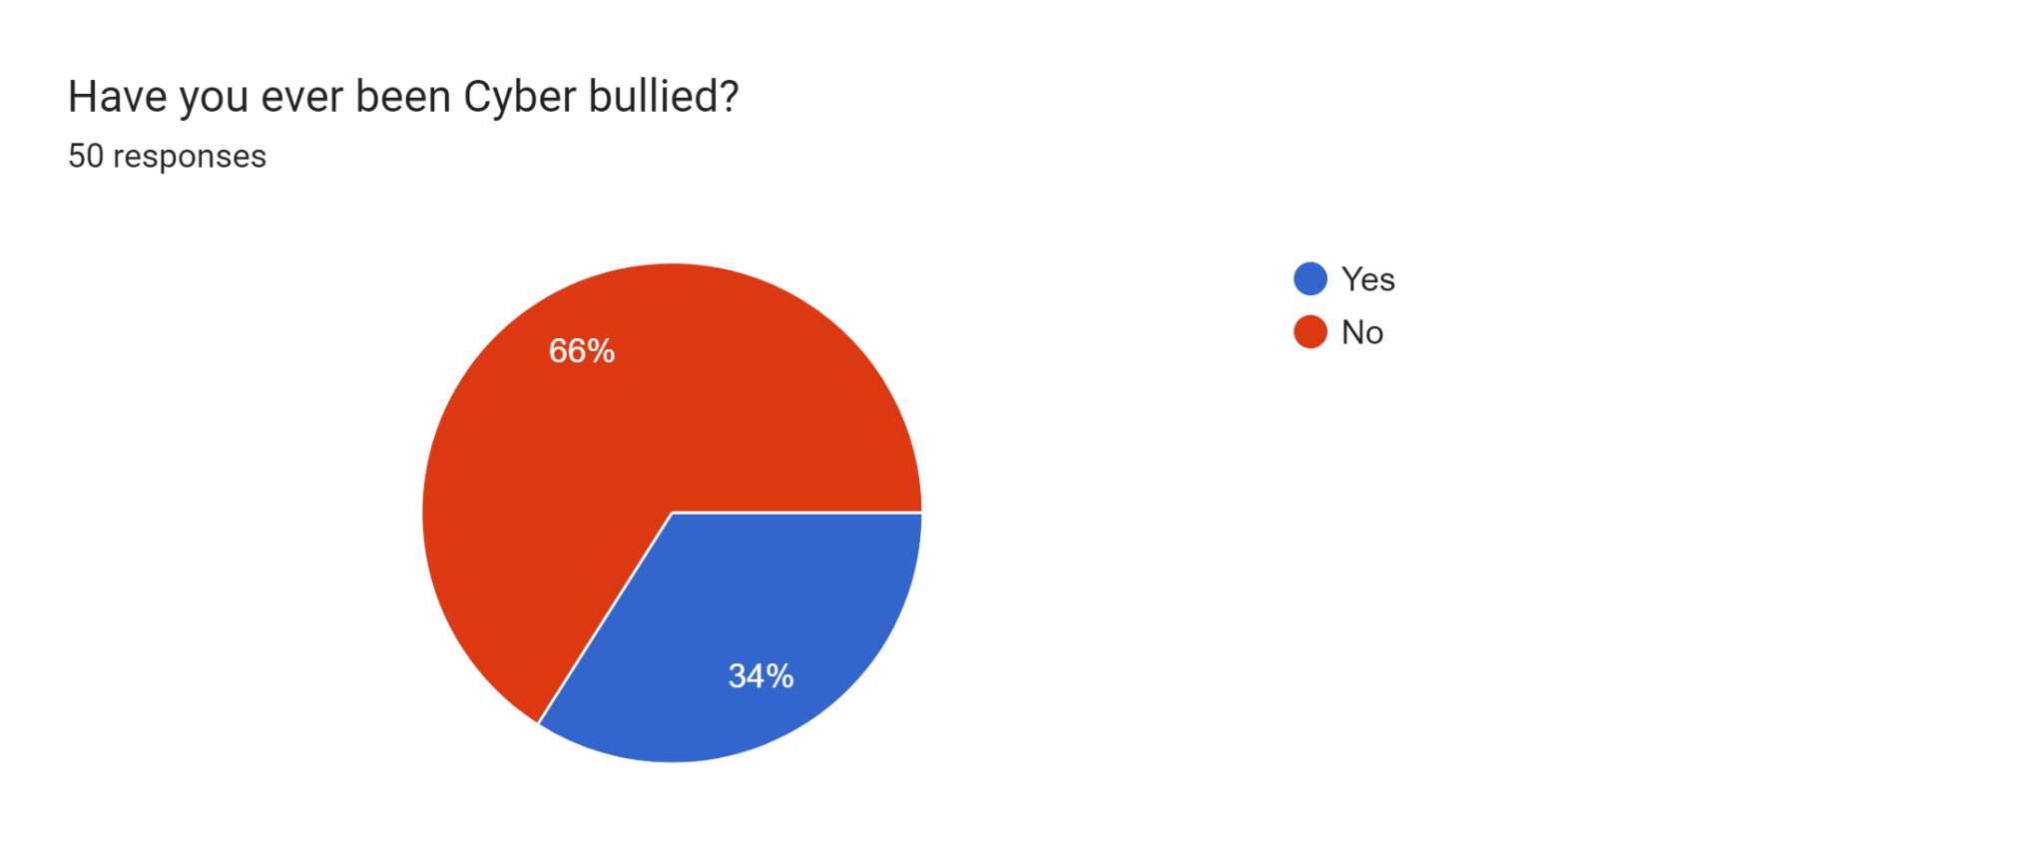

Most students (33, or 66%) say they haven't experienced cyberbullying, which is encouraging. Whilst 17 students report that they have been a victim.

Conclusion

As you can see, teens, kids, and society are still at risk from cyberbullying. You run the risk of being attacked if you use technology. But as it continues to change, several fresh strategies have been put in place to stop bullying on websites and social media. The primary factor, as seen in this analysis, is that most texters aren't even aware of the distinction between bullying and a regular text. Additionally, those who could be accused of bullying lack the skills necessary to safely express their opinions and feedback.