**Youth Leadership Programme 2022-23**

**Journal**

|  |  |
| --- | --- |
| **Year** | 3A |
| **Teacher** | Miss Raheela |
| **Co-teacher** | Miss Ghina |
| **Mentor** | - |

|  |  |
| --- | --- |
| **Project name:** | Save the environment |
| **Objective of the project:** | Exploring about effects of human activities on our environment and what can we do as community to save our environment. |

**Description of the project:**

|  |
| --- |
| Our project is based on SDG 12, 13, 14 and 15: Responsible consumption and Production; climate action; life below water and Life on land. The aim is to create awareness about the importance of keeping the environment clean around us and its relation to the Qatar Vision 2030 |

**Implementation:**

|  |
| --- |
| Our Youth Leadership Program (YLP) commenced with a focus on three fundamental questions. Students engaged in brainstorming sessions to explore their understanding of the term "environment" and shared their diverse ideas. This initial phase paved the way for the next stage of the YLP, which involved an in-depth examination of human activities that have a detrimental impact on our environment. Finally, during the concluding phase, students collaboratively developed solutions and strategies to address these environmental challenges. As part of the program, we organized a field trip to Al Suwaidi Paper Factory, providing students with firsthand knowledge of sustainable manufacturing practices. Additionally, the students showcased their creativity and commitment to environmental sustainability by repurposing old t-shirts into functional tote bags through recycling techniques. |

**What have we achieved from the project?**

|  |
| --- |
| The project has achieved increased environmental awareness, enhanced knowledge, and solution-oriented thinking among students. It provided practical exposure to sustainable practices through field trips, fostered skills in recycling and upcycling, and empowered students to actively contribute to conservation. Collaboration with schools and organizations, advocacy for stronger policies, and integration into the curriculum expanded the project's impact. Technology, international collaborations, research, and continuous adaptation ensured relevance and progress. Overall, the project successfully promoted sustainable practices, engaged communities, and nurtured a generation of environmentally conscious leaders. |

**Way forward (How do we want to expand our project?):**

|  |
| --- |
| Encourage students to conduct research on specific environmental topics and develop innovative solutions. Support their participation in science fairs, competitions, and projects that focus on sustainability, fostering a culture of innovation and scientific inquiry. |

**How did we involve the community in our project?**

|  |
| --- |
| We shared information and resources with the parents through the class dojo. This allowed community members to stay informed about our project's progress. |

**Skills developed during the project:**

|  |
| --- |
| * Research skills * Analysis skills * Communication skills * Team management skills * Team-building skills * Critical Thinking skills * Problem-Solving skills * Exploration skills |

**Glimpses from our Youth Leadership Programme:**

***Planning phase***

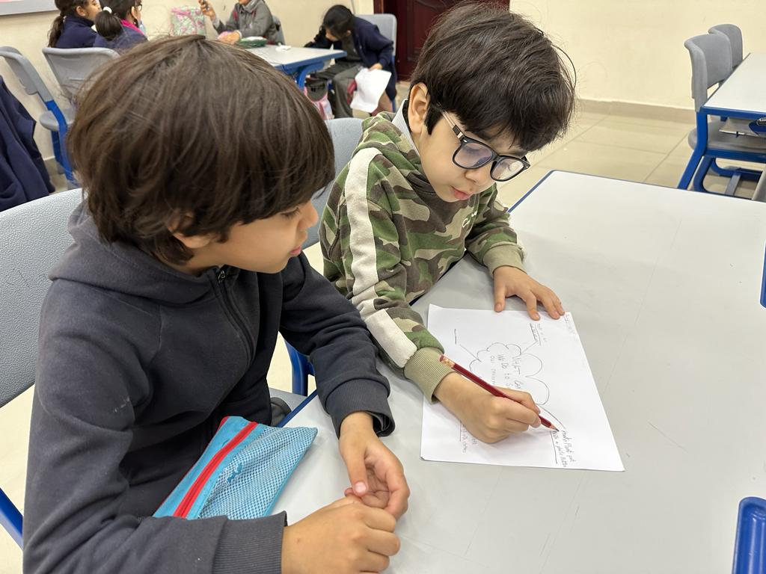

***Preparation phase***

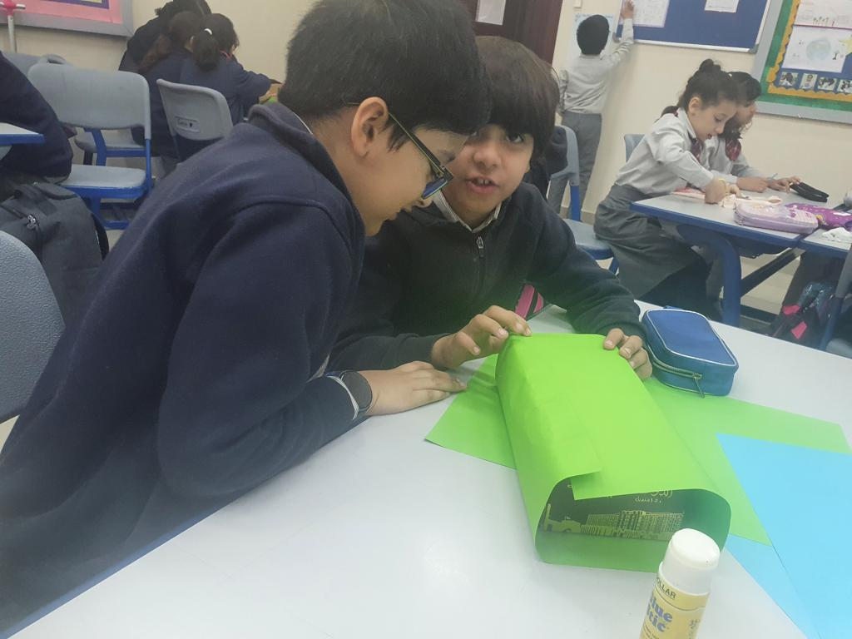

***Researching Phase***

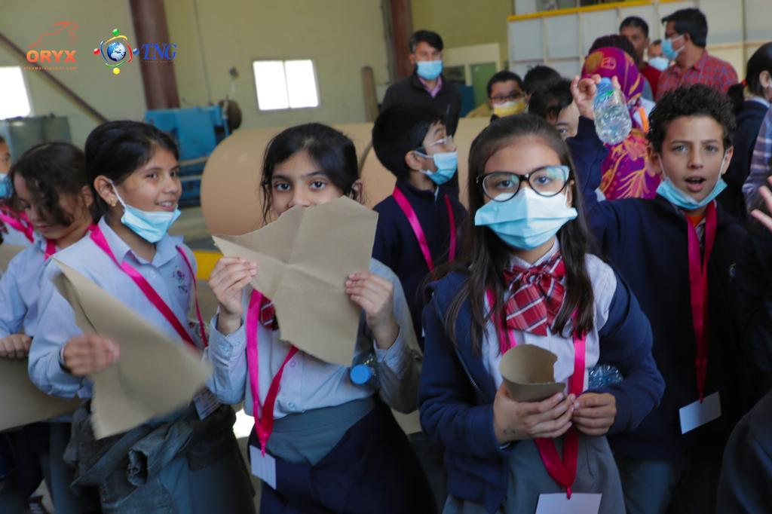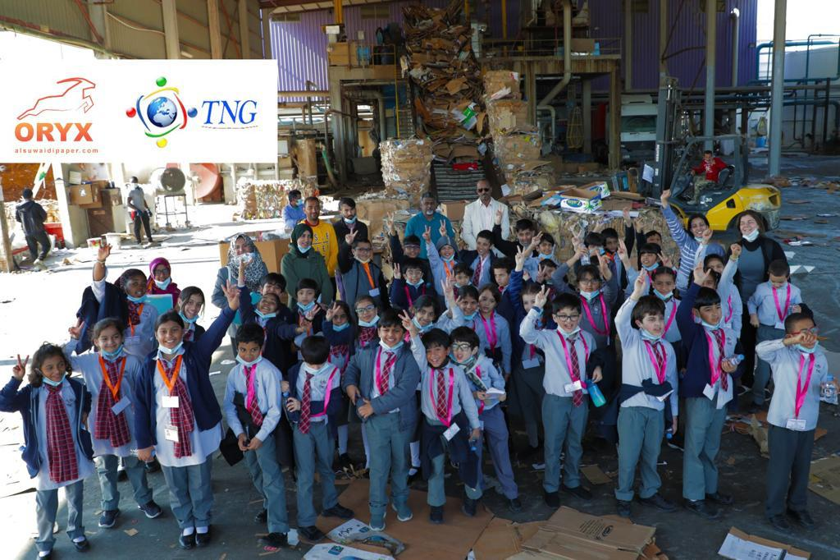

***Implementation phase***

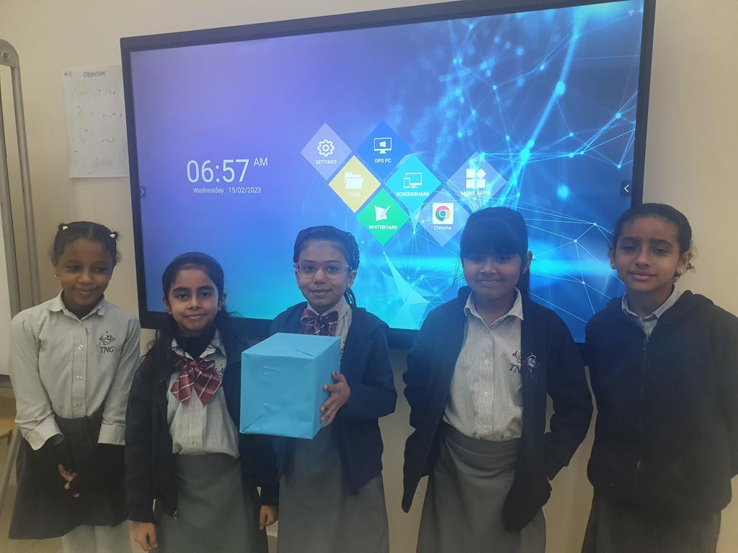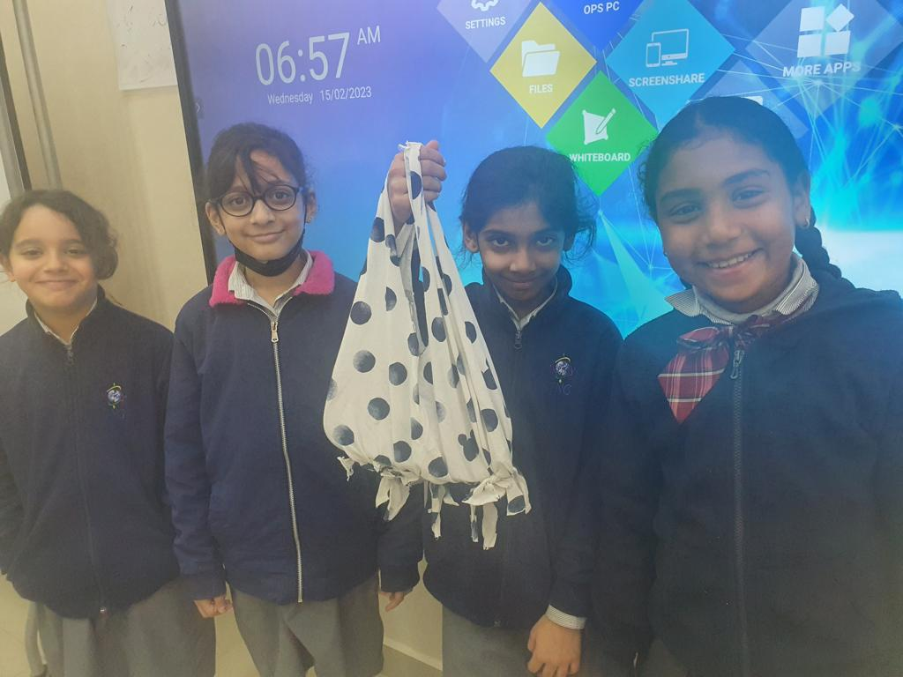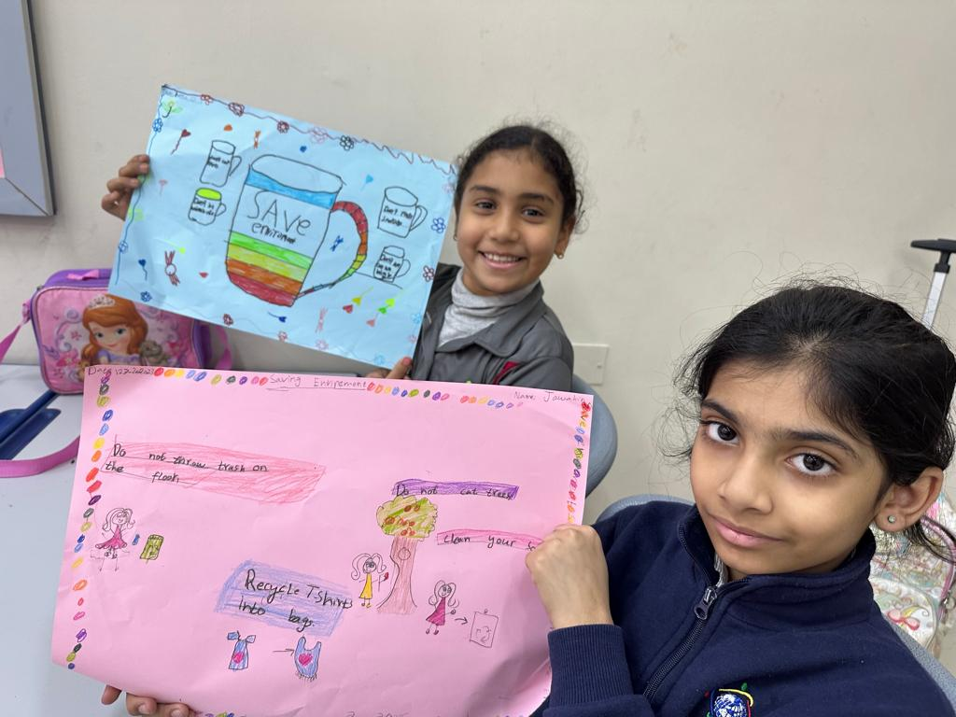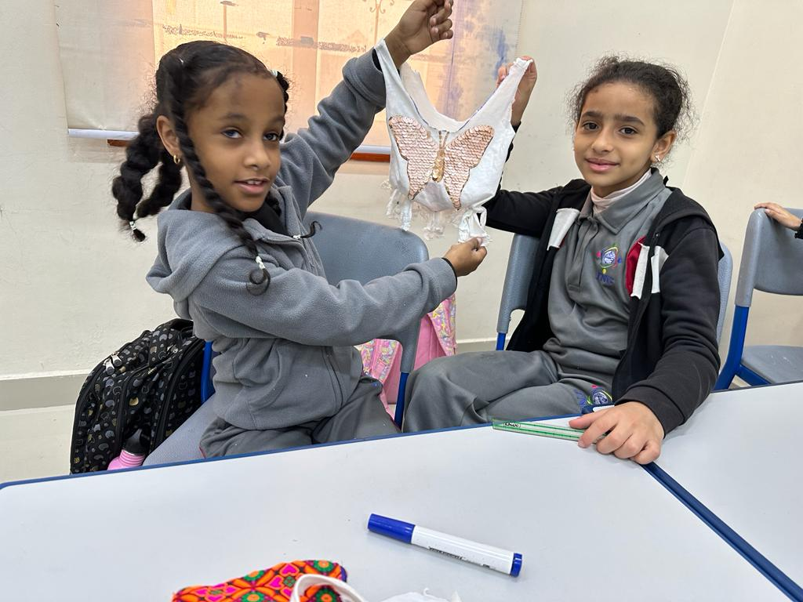

**Reflections**

**Haider Khan** – Class Student

|  |
| --- |
| We went on a field trip to Al Suwaidi Paper Factory to see how paper is made. It was pretty fun. We also made tote bags out of old T-shirts and gift boxes using old boxes. This was my favourite part. |

**Syed Nuh** - Class Student:

|  |
| --- |
| I liked the field trip to Al Suwaidi but not that much because it was too hot. What I really liked about was that we could see paper recycling. |

**Syeda Zahraa**– Class Student:

|  |
| --- |
| In our YLP journey we first learned about the environment, human activities impacting the environment and what we can do to save our environment. I learned that we could save our environment by planting more trees. I also liked the field trip the most. |

**Ms. Raheela** - Teacher

|  |
| --- |
| As a teacher, I am incredibly proud of the Youth Leadership Program (YLP) and its impact on my students. Throughout the project, I witnessed their growth in environmental awareness and critical thinking. From brainstorming sessions to a field trip to Al Suwaidi Paper Factory, they gained firsthand knowledge and practical skills. The students' creativity in repurposing old t-shirts into tote bags showcased their commitment to sustainability. Seeing them actively engaging with the community and inspiring others was truly inspiring. This project has not only deepened their understanding of the environment but also empowered them to become agents of change. |