**Youth Leadership Programme2022-23**

**Journal**

|  |  |
| --- | --- |
| **Year** | 5A |
| **Teacher** | Ms.Alvia |
| **Co-teacher** | Ms.Ruzaika |
| **Mentor** | Dua Muzammil |

|  |  |
| --- | --- |
| **Project name:** | Impact of Emotional Intelligence in the academic performance of learners |
| **Objective of the project:** | Through a project based learning model, they will be able to explore the inner dimensions of Emotional intelligence and its role in the field of education. |

**Description of the project:**

|  |
| --- |
| Our YLP Project focused on researching the impact of emotional wellbeing on the academic progress of children under age 13.Emotional intelligence plays a vital part in students’ academic learning. Students with greater emotional intelligence are more self-confident in managing academic challenges. Therefore, emotional intelligence is considered a significant predictor of students’ academic performance in higher education. |

**Implementation:**

|  |
| --- |
| Brainstorming sessions were conducted in class to identify the topics of learner interests. A voting poll was conducted to finalize the given topic. The big questions and slogans were identified through the process of class discussion.  Data was gathered by interviewing experts from the field of psychology. Secondary data was collected through reviewing credible sources from the Internet. An in-depth analysis was made of the gathered data and the results were displayed through an infographic poster.  Visiting the Education city mosque broadened our scope of knowledge and information, and we were able to get answers to the big questions that we had at the start of the project. Presentations, Posters, Videos& Quizzes will be used to create awareness about the need for a support system to facilitate emotional intelligence amongst the students. |

**What have we achieved from the project?**

|  |
| --- |
| We researched the issue and discovered the importance and the impact of emotional intelligence upon a learner’s academic achievement. We analyzed the causes of negative emotions and the healthy way to deal with it. We were able to record our findings through various concept maps and presentations. |

**Way forward (How do we want to expand our project?):**

|  |
| --- |
| We are planning to take our project further by creating awareness about the need for a support system to facilitate Emotional intelligence amongst learners in the campus. |

**How did we involve the community in our project?**

|  |
| --- |
| We collaborated with parents so that they can help the students to take care of their emotions. We took the parents’ feedback, and they shared their thoughts and ideas with us. The students were given training on how to incorporate emotional intelligence through Islam on the educational trip. |

**Skills developed during the project:**

|  |
| --- |
| * Research skills * Communication skills * Team management skills * Critical Thinking Skills * Self-Evaluation skills |

**Glimpses from our Youth Leadership Programme:**

***Planning phase***

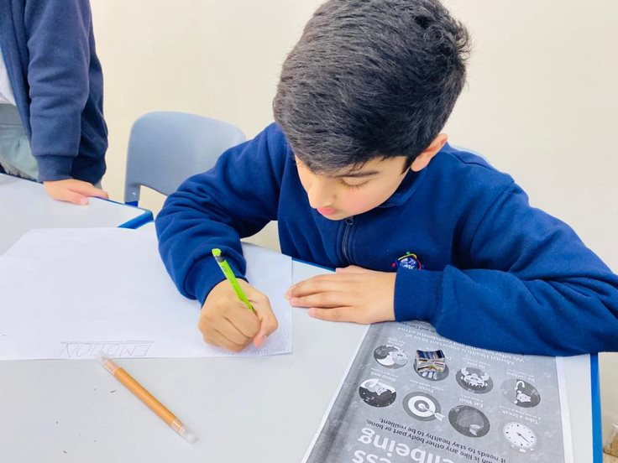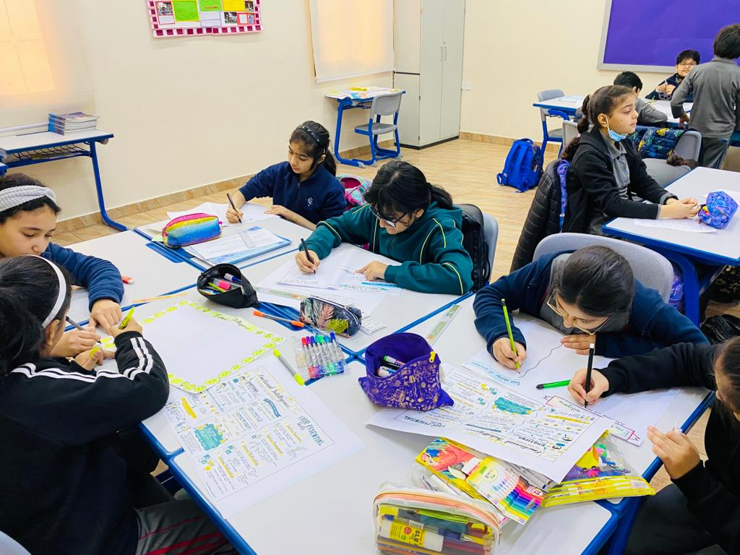

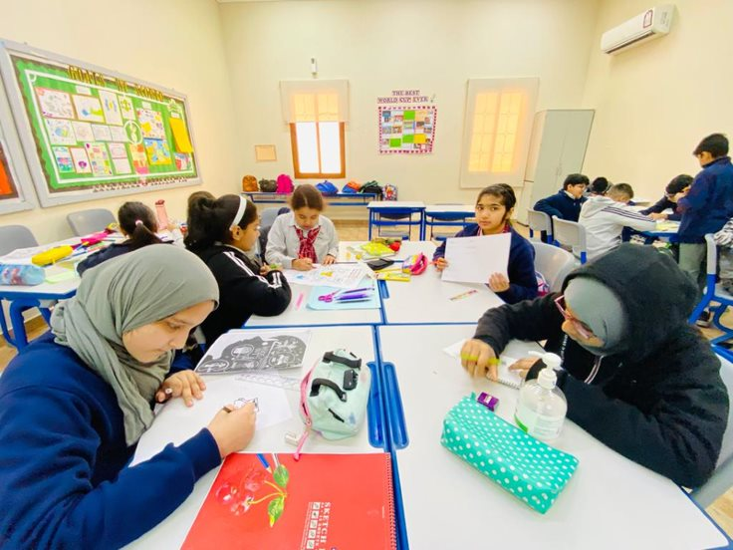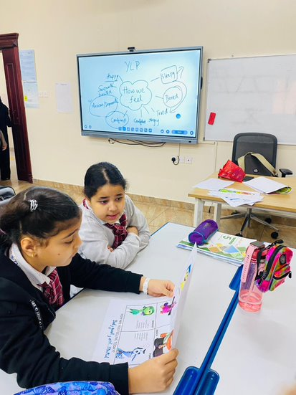

***Preparation phase***

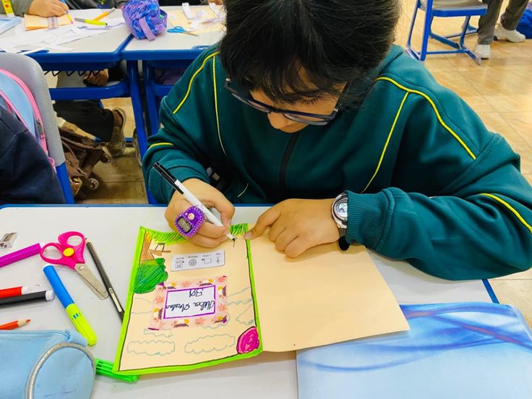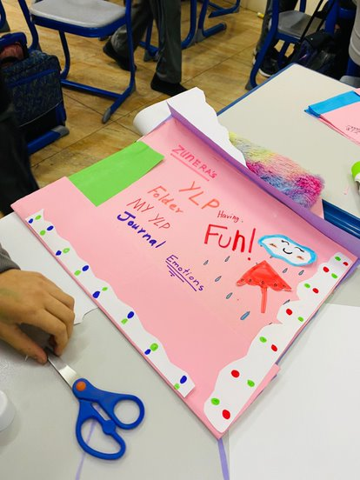

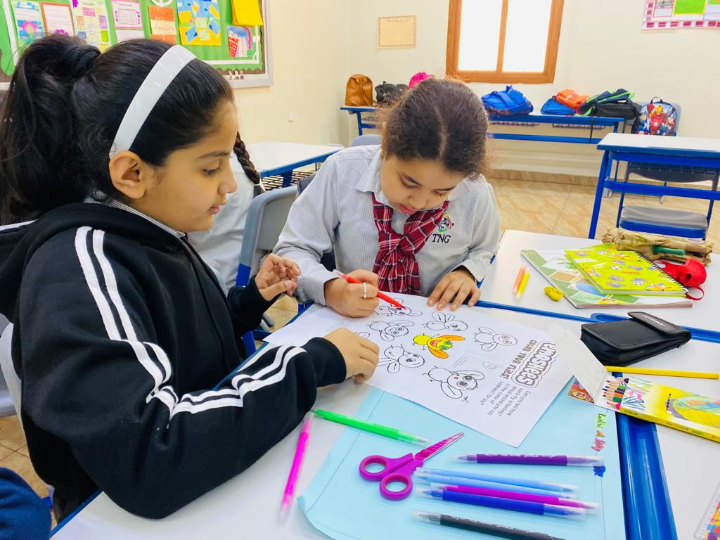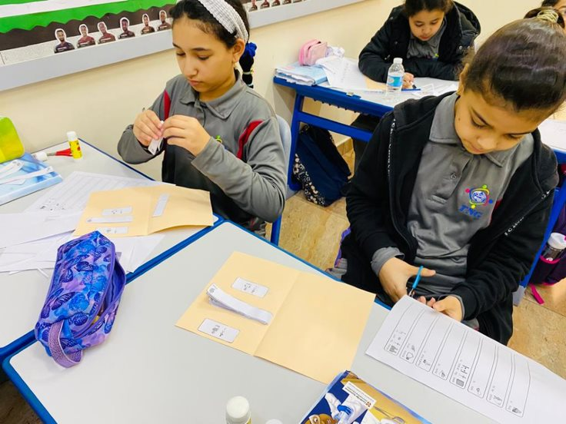

***Implementation phase***

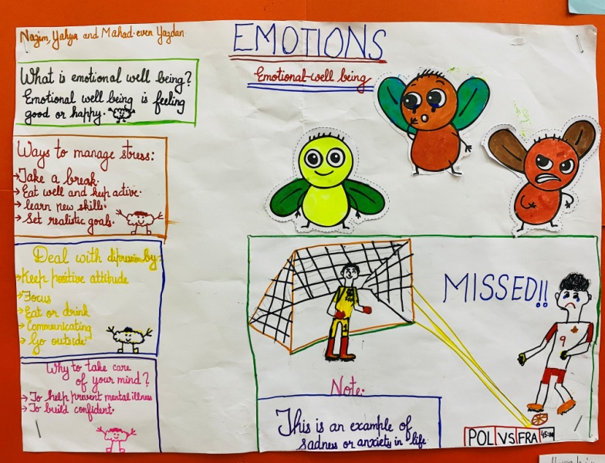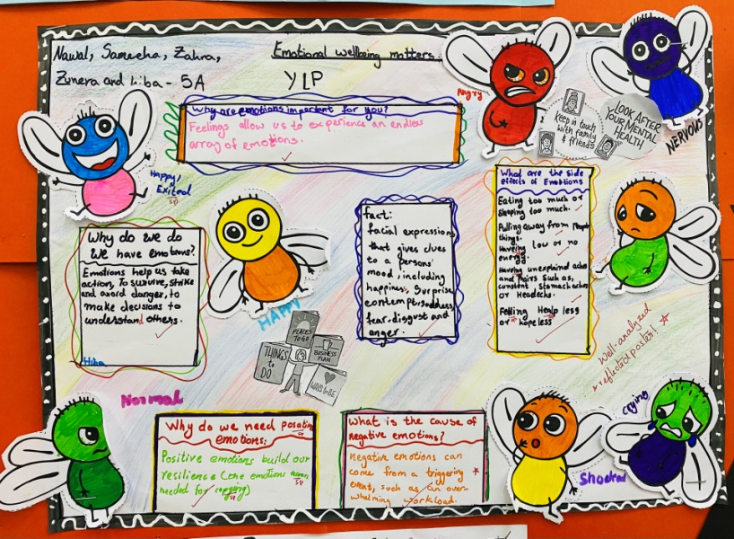

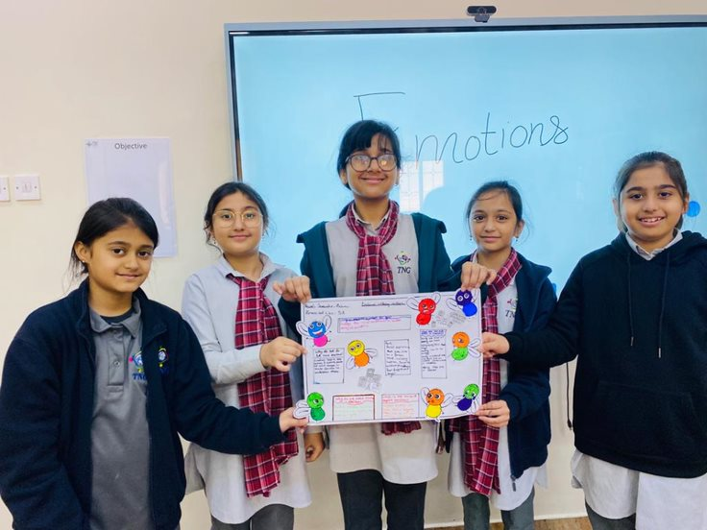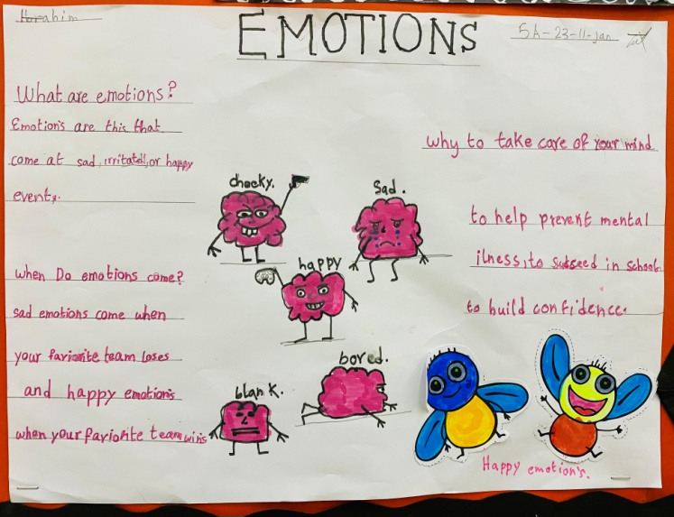

**Reflections**

Nazim **– Mentor:**

|  |
| --- |
| I liked YLP and felt as adventure mind trip. It was so helpful to brain and now I am better in academics .it was a important and mindful topic. The topic emotional intelligence made a great change in life . The journey took us to the knowledge of brain and mental brain strategies . the YLP field trip made me get more knowledge about our topic . it was also related to our religion. |

Halima **– Class student:**

|  |
| --- |
| I liked the YLP topic because It helped me during the academic performance by improving my marks and relaxing my emotions. |

Sameeha **– Class student:**

|  |
| --- |
| I liked the YLP topic because it helped me and our class to deal with unpleasant emotions and because it helped me during the academic by helping us face the unpleasant emotions we had in our academics. |

Zuneira **– Class student:**

|  |
| --- |
| I liked the YLP because it is very important in our life and we should always control our un pleasant emotions that we felt during our YLP journey we went to a field trip and I really liked it and I enjoyed a lot during this years YLP and the topic really helped me in my life. |

Ashir **– Class student:**

|  |
| --- |
| The YLP journey was very exciting and a lot of fun. I think YLP is an important thing in our life especially for us learners. There were many different stages such as going to a field trip and researching.in all the YLP journey helped me a lot. |

Yaara **– Class student:**

|  |
| --- |
| Our ylp journey was so fun it made me feel creative and I became confident about myself. Although the topic was simple and easy and the topic made me think about myself when I feel crying or other emotions. |

Ms. Alvia**– Teacher**

|  |
| --- |
| It gives me immense pleasure to watch students leading the Youth Leadership Programme. While initiating and implementing the project, the students were quite busy with thinking comprehensively, making meaningful connections on their day-to-day emotions and the causes behind it. I witnessed that their research and communication skills developed during this project since they were able to breakdown complex concepts in depth while creating their concept maps about the components of emotional intelligence. They developed critical thinking, self-criticism, teamwork and most importantly, empathy. |