Youth Leadership Programme 2022-23
Journal

Year | 6B
Teacher | Ms. Khadija Abid
Co-teacher | Marah sadek
Mentor | Abdul Hadi

Project name: | SDG7  AFFORDABLE AND CLEAN ENERGY
Objective of the project: | Through this project, we aim to:  • Understand that energy is vital for everyone's quality of life; Know the Global Goals were set by UN countries to alleviate world poverty; Understand the link between energy and poverty reduction.  • Understand the challenges and opportunities we face in cutting greenhouse gas emissions while meeting demand and supporting economic growth.  • Analyse and reduce energy and paper use in our school and compare to others around the world that we are connected to;  • Present and interpret data in tables and charts and in report writing. Raise an awareness campaign. Offer solutions to the problem.

Description of the project:
Our project mainly focused on understanding the various forms of energy, the problems related to the overuse of non-renewable energy sources and how they are impacting our lives and finally exploring solutions to these problems and adopting clean energy in our daily routine. SDG7 is all about ensuring access to clean and affordable energy, which is key to the development of agriculture, business, communications, education, healthcare and transportation. The lack of access to energy hinders economic and human development.

What have we achieved from the project?
Through this project, we were able to understand and learn in depth about the various forms of energy, the problems of energy wastage and the problems with the overuse of unreliable energy sources that have a huge impact on the carbon footprint. During the planning and research stage, we worked in groups, shared ideas and had numerous discussions that improved our cognitive and communication skills. Visiting the Kahrama Awareness park broadened our scope of knowledge and information and we were able to get answers to the big questions that we had at the start of the project. Towards the end of the project, we were able to create awareness among our peers and family members about adopting simple ways through which they can reduce energy wastage. Presenting the entire journey of our YLP in front of our school heads really helped boast our confidence.

Way forward (How do we want to expand our project?):
We plan to encourage the use of sustainable energy in our school by using energy-efficient lighting and equipment such as LED bulbs and Energy Star-rated appliances. These items use less energy and can help reduce the school's energy bills. Moreover, a detailed action plan with cost and benefit analysis to install Solar panels on school roof tops in all TNG campuses will be devised and forwarded to the TNG management in a move to a cleaner and more sustainable energy solution.

How did we involve the community in our project?
We involved the community by informing and encouraging our family members about the importance of conserving energy in our daily lives through simple acts like turning off lights and electronics when not in use, purchasing and using energy-efficient appliances and light bulbs.
In the school, a small awareness campaign was conducted by the year 6 students spreading awareness about the SDG 7. KS2 Students were encouraged to switch off classroom lights when their classrooms are not in use especially at home time and when leaving for PE or Urdu/Arabic lessons (which are usually conducted in another classroom).

Skills developed during the project:

- Research skills
- Communication skills
- Team management skills
- Critical Thinking Skills
- Self-Evaluation skills

Glimpses from our Youth Leadership Programme:

Planning phase

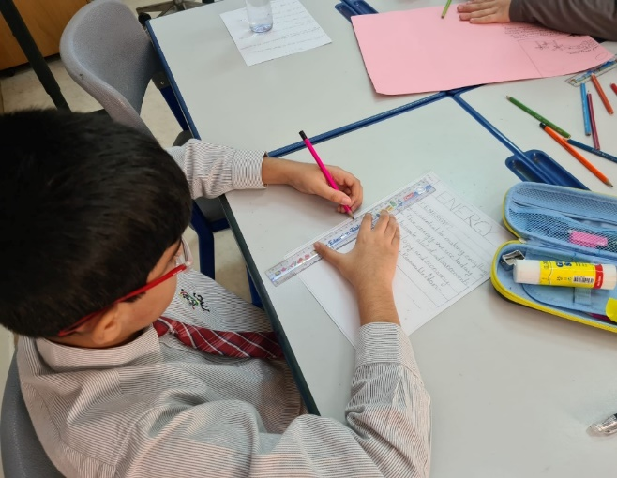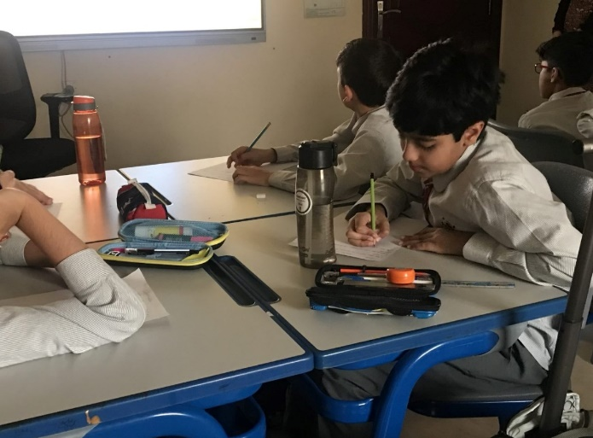

Preparation phase
Visit to Kahrama Awareness park Doda Qatar to understand more about SDG 7.
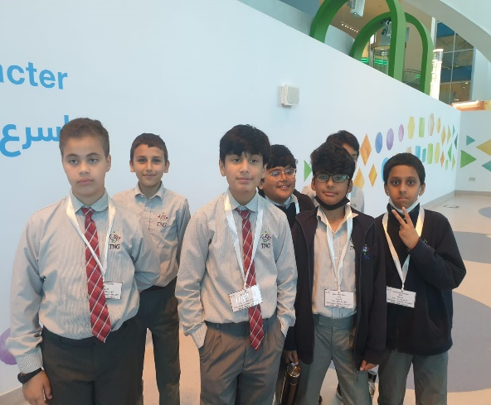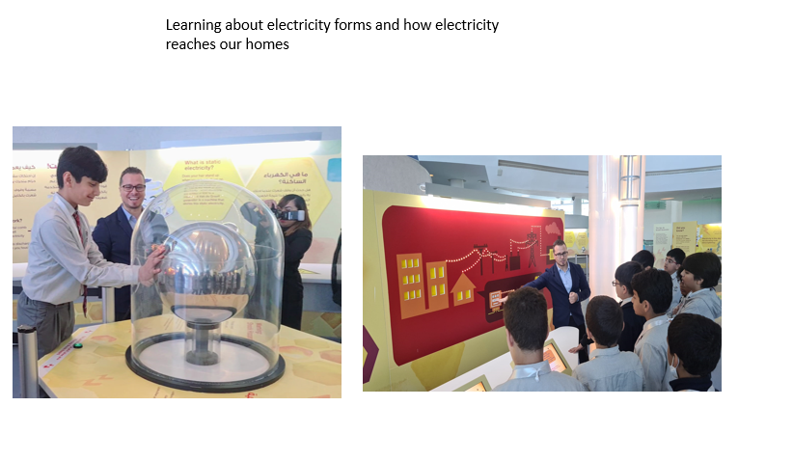

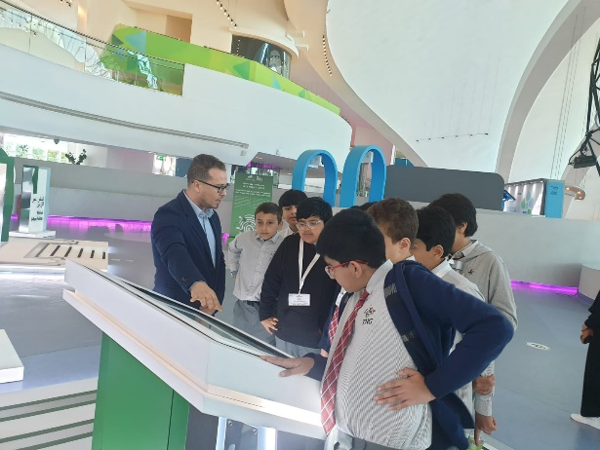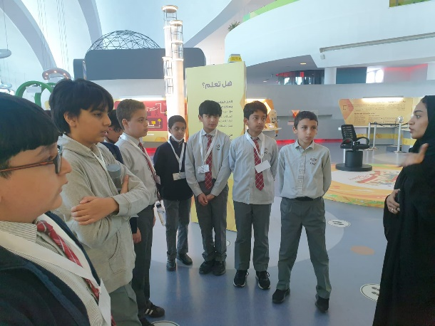

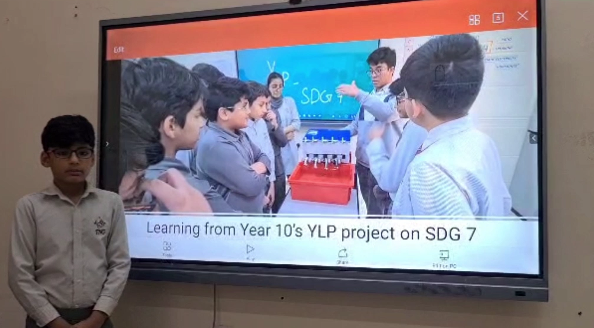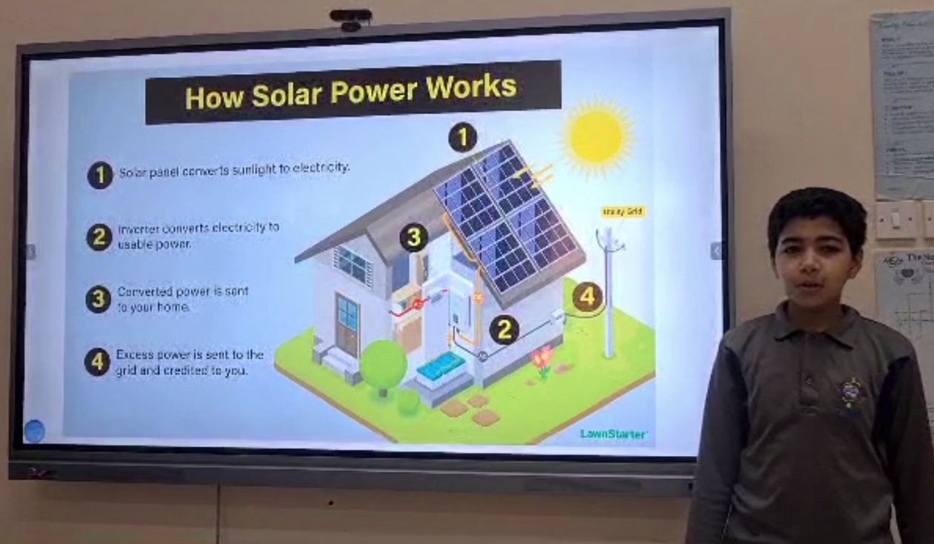

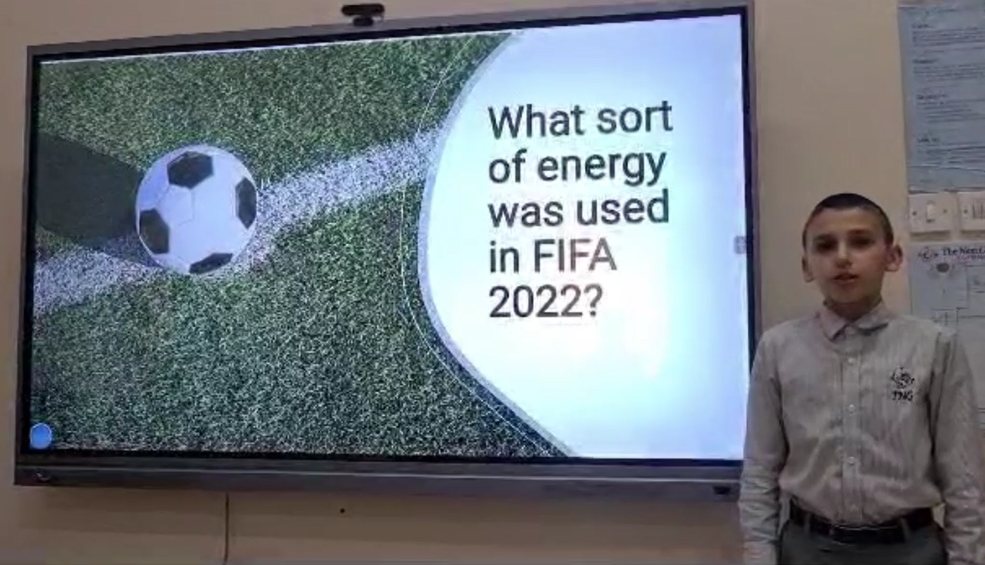

Implementation phase
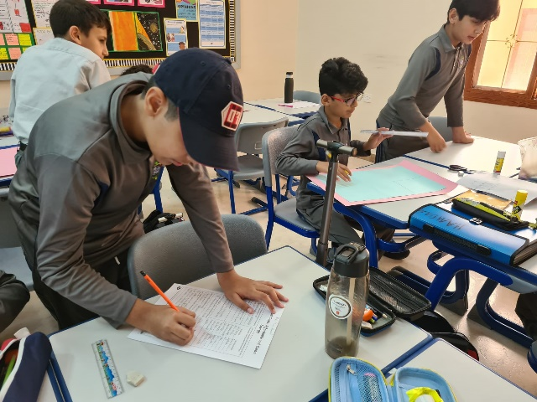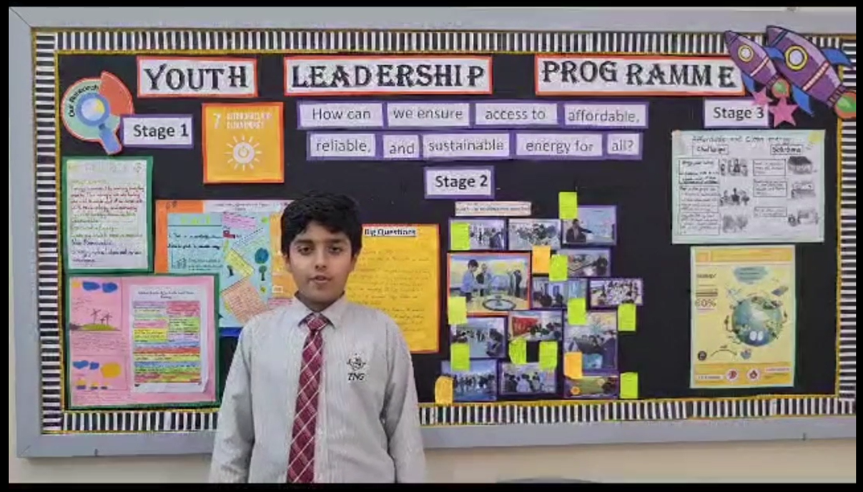
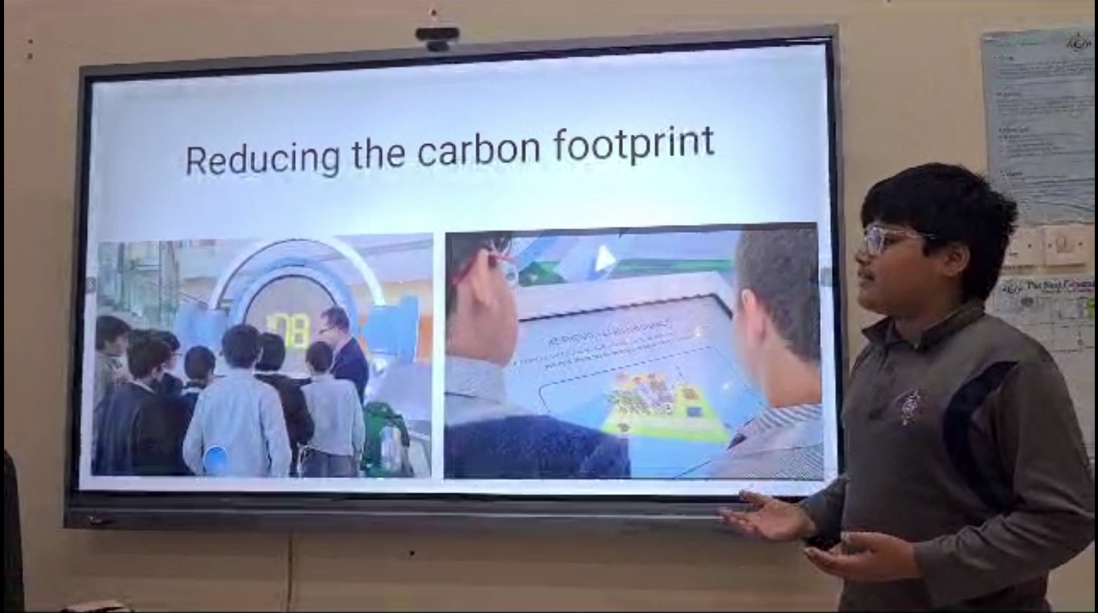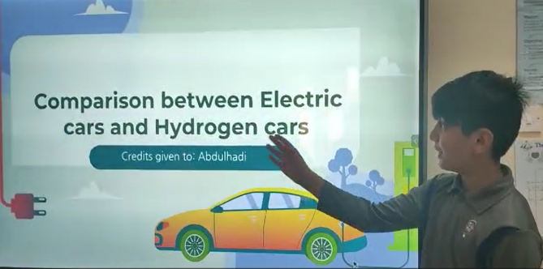

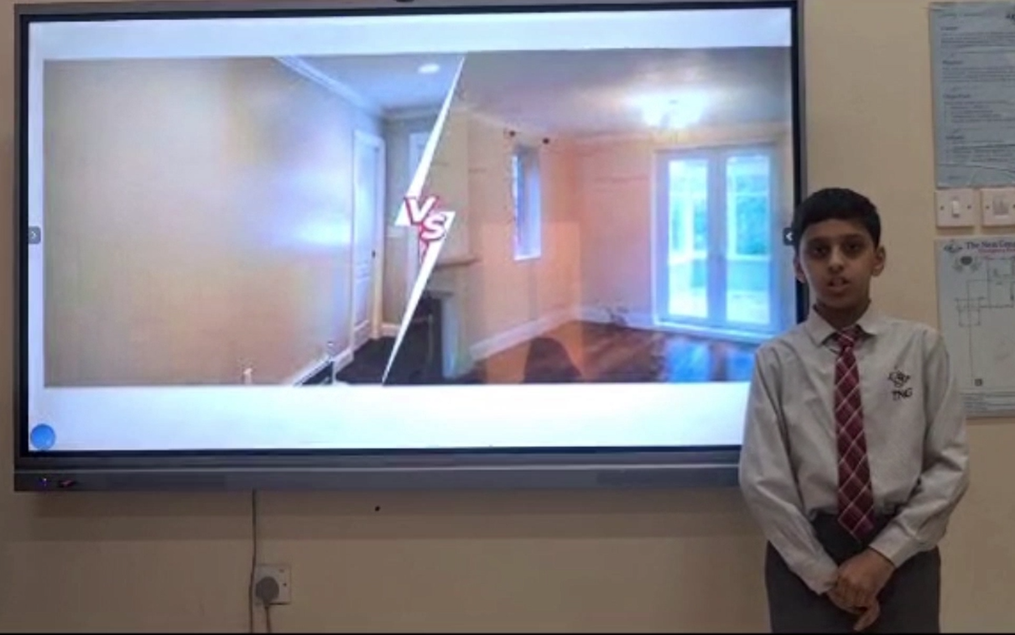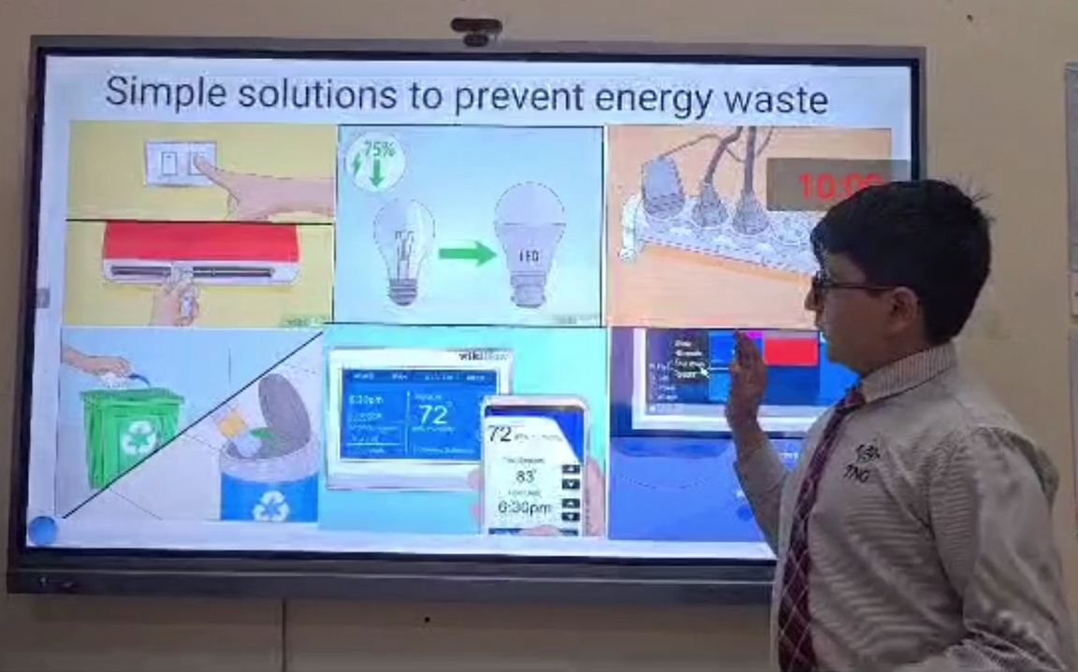

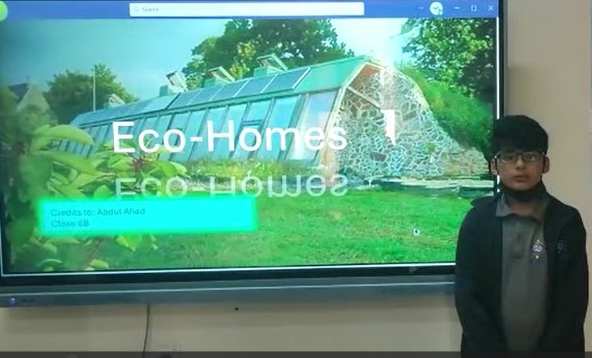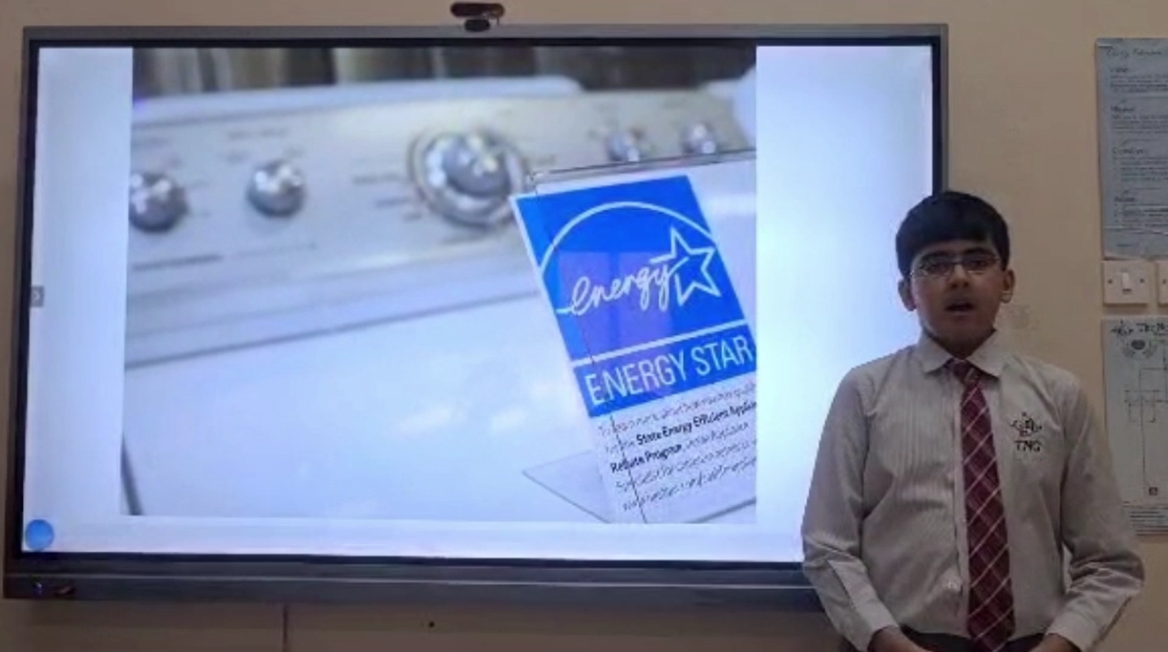
Reflections

Marah sadek –Co teacher:
It has provided an opportunity to not only educate students about the importance of sustainable energy but also It has been inspiring to see students take ownership of the project, and to see them develop a passion for sustainability and energy conservation.

Wali – Class student:
I felt that this project was good enough and through it we can convince other people to use clean resources. On the other hand, through this project it was a bit hard to convince people as many are used to the non-renewable sources and I think they won’t even think about switching so easily. The skills I learned are that I got a little more confidence.

Ayaan – Class student:
There are many advantages that can be achieved through our project including energy saving, helping the earth and many more. This process may help fix the atmosphere quicker! Although efficient, this project may spell doom on countries which rely on selling gases to stay financially stable.
Some skills I have learned are to be careful of what I am doing daily in my home to save energy like turning off the water tap when brushing teeth and turning off the light when it’s not in use, same goes for the computers.
We wanted to make a project on solar panels but didn’t get the time to because of the Check point exam.

Hanan – Class student:
I feel our project was strong and well identified as it was focused on a very crucial topic. We visited Kahrama awareness park to investigate more about our topic SDG7 affordable and clean energy, we explored the challenges and solutions. We also read online about the different energy solutions and the facts about developing countries whether they have access to affordable energy or not.
I think this project helped me in improve my communications and presentation skills. However, I think I need more time to get better with my friends during group work.

Abdulahad – Class student:
I felt like this project was strong because we all worked together and it can help solve many crucial problems such as climate change. Compared to the last YLP, I got more confidence and learned that teamwork makes dream work. I think that the voice in the video was a bit loud, which we can improve.

Ms. Khadija Abid– Teacher
It was great to watch students leading the Youth Leadership Programme. While initiating and implementing the project, the students were quite busy with thinking comprehensively. I witnessed that their problem-solving skills developed during this project since it was our responsibility to create awareness for SDG 7 and create solutions for the problems that arose in the process. Our students developed critical thinking, self-criticism, teamwork and most importantly, empathy. The highlight of our project was the visit to the Kahrama Awareness Park which the students not only enjoyed immensely but also learned about sustainable energy solutions. An interview was also planned with an expert in the field of energy but could not be conducted due to the Checkpoint exams.
Stage 1: Students were shown the option of various SDG goals to choose from. The SDG for YLP 2022 was be finalized. The substages and details of this SDG were discussed.
Students researched about the different types of energy such as, fossil fuels, biomass, nuclear and renewables including the uses of these energy sources.
Stage 2: Students used a questionnaire to conduct survey on how to:
• measure their environmental carbon footprint.
• Understand the link between energy and poverty reduction.
• Conduct interviews with people in the field to understand the implications of this SDG and discuss solutions such as possibility of making affordable Solar panels etc.
• Visit the ‘Karhama Awareness park’

Stage 3: Students made posters, PowerPoints and ran school-wide campaigns to create awareness on how to minimise the negative impacts of energy use, specifically as this relates to climate change around the school community. They presented their solutions to ensure access to affordable, reliable, sustainable and modern energy for all.

