**Youth Leadership Programme2022-23**

**Journal**

|  |  |
| --- | --- |
| **Year** | 1 A |
| **Teacher** | Miss Spougmay |
| **Co-teacher** | Miss Shakira Faisal |
| **Mentor** |  |

|  |  |
| --- | --- |
| **Project name:** | How to save the earth. |
| **The objective of the project:** | How to save the earth and what the young learners can do to make a difference |

**Description of the project:**

|  |
| --- |
| Our YLP Project focused on how to save the earth. Saving the earth is a critical challenge that requires concerted efforts from all individuals, organizations, and governments worldwide. We found that saving the world's natural resources are finite, and the population is increasing at an unprecedented rate, making it more important than ever to implement sustainable practices to preserve our planet. |

**Implementation:**

|  |
| --- |
| We started with growing plants and focused on taking care of the plants to make the environment clean. We also decided to reduce reuse and recycle different items that we are using daily. We did cleaning campaigns and started from the classroom. Different activities were done like poster making, role play, etc. We visited an educational trip to the Education-City micro-farm. During our visit, the learners experienced and participated in gardening activities including soil mixing and plant repotting. Each student adopted a plant, and they looked after it as they are a source of oxygen for our planet Earth and can help in reducing pollution. |

**What have we achieved from the project?**

|  |
| --- |
| We researched the issue and found out the causes of pollution on Earth. We took steps to save the earth by doing small things daily like turning off the lights, cleaning our place, less use of plastic, and recycling waste. Through the cleaning campaign, we raised awareness among young learners. |

**Way forward (How do we want to expand our project?):**

|  |
| --- |
| We are taking care of the plants that we adopted. Once the plant has grown healthy and happy, we will replant it in any park as a contribution to the environment. We will continue with the 3 R's of reduce, reuse, and recycle as these are essential practices that can help us to reduce our environmental impact and protect the earth's natural resources |

**How did we involve the community in our project?**

|  |
| --- |
| We collaborated with parents so that they can help the students to take care of their plants. We took the parents’ feedback, and they shared their thoughts and ideas with us. The students were given training on how to take care of the plants on the educational trip. |

**Skills developed during the project:**

|  |
| --- |
| * Research skills * Communication skills * Team management skills * Critical Thinking Skills * Self-Evaluation skills |

**Glimpses from our Youth Leadership Programme:**

***Planning phase***

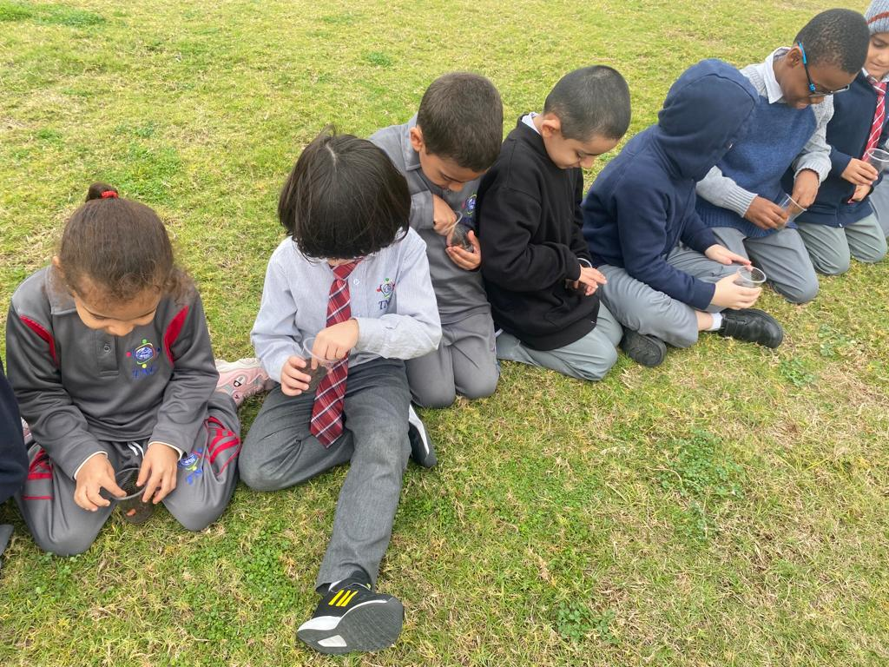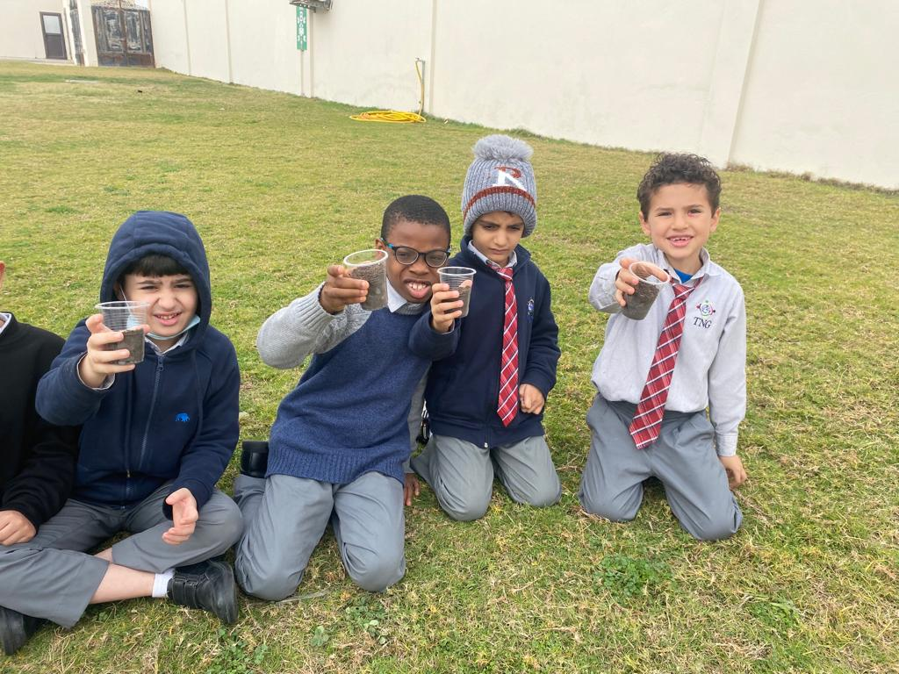

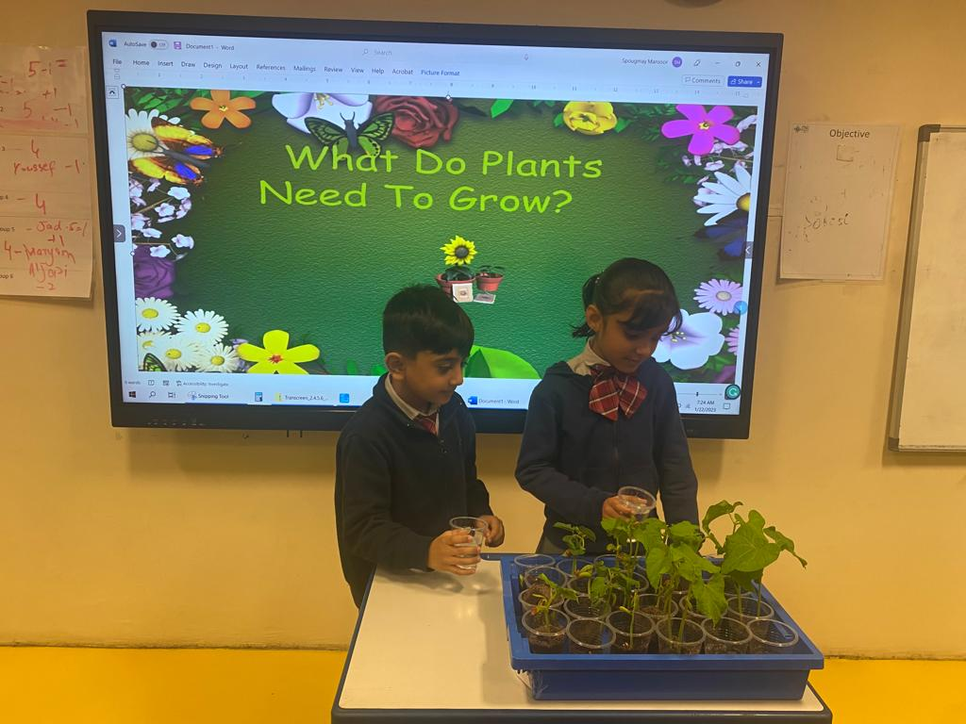

***Preparation phase***

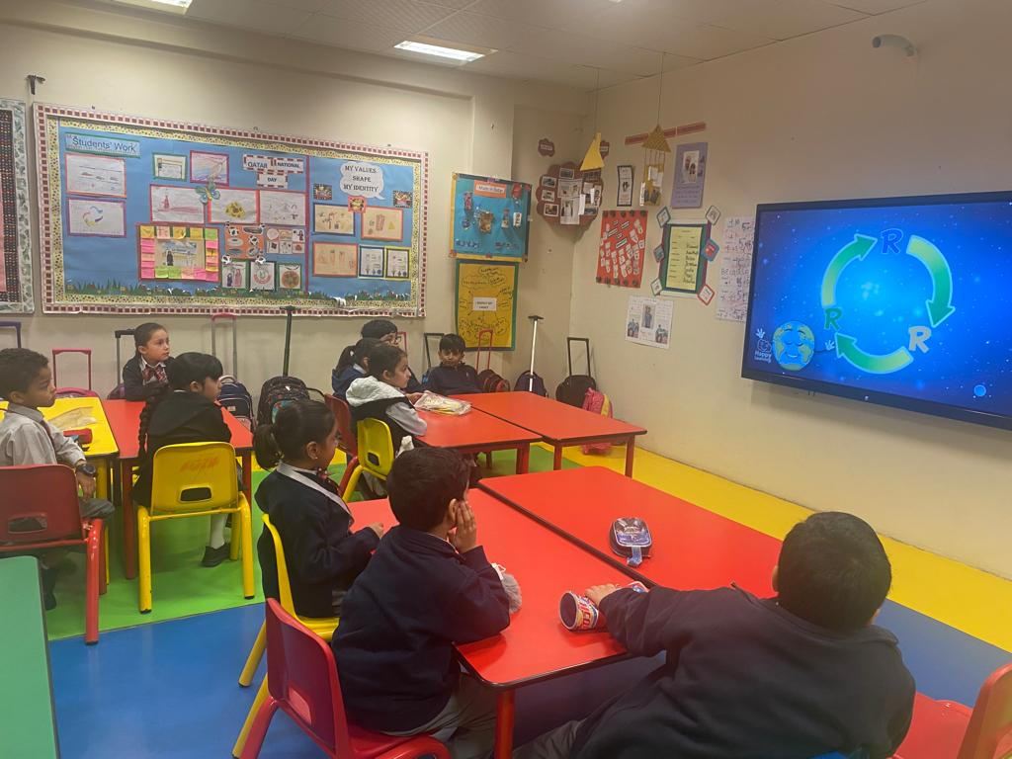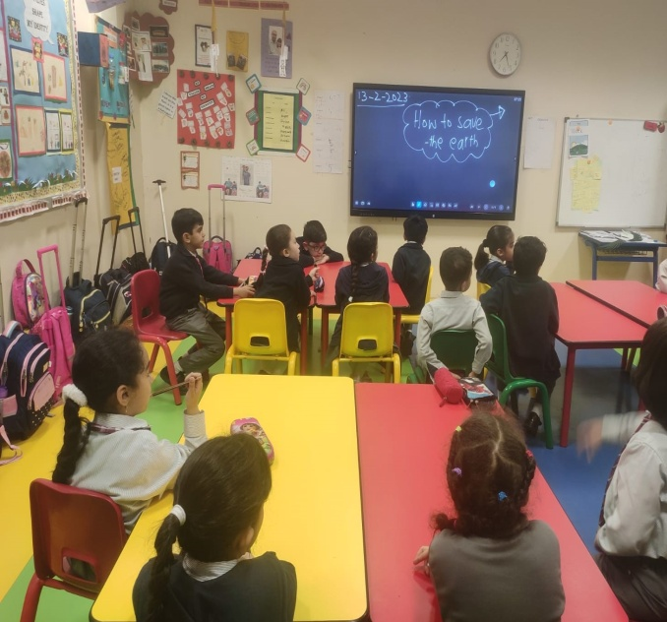

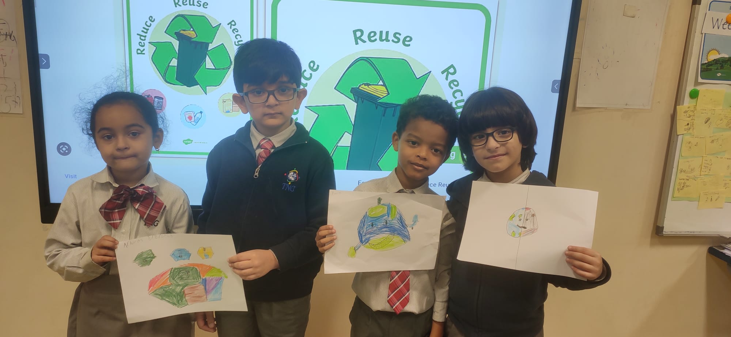

***Implementation phase***

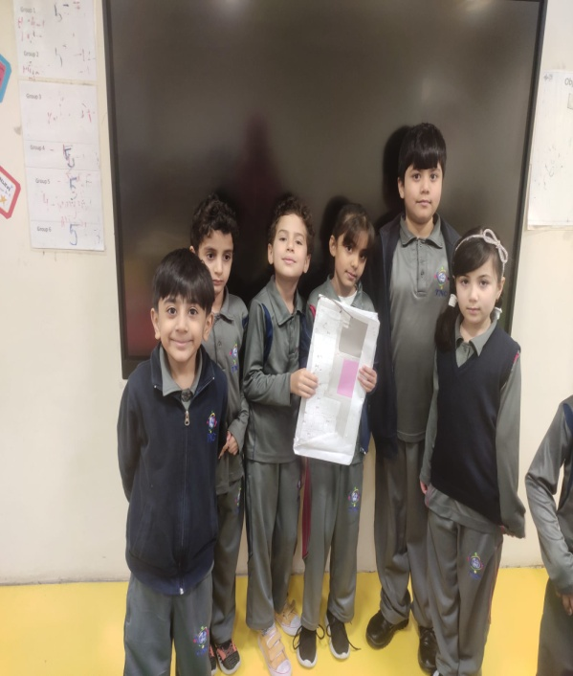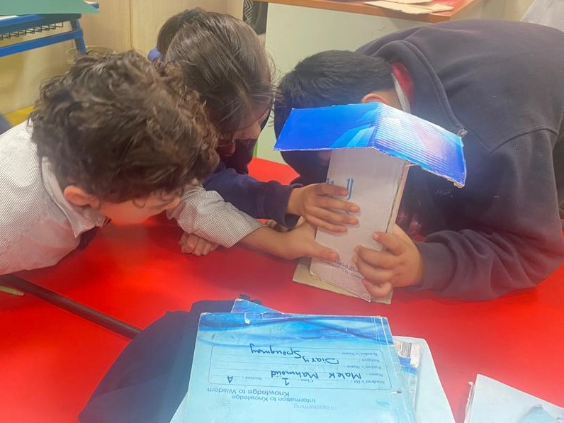

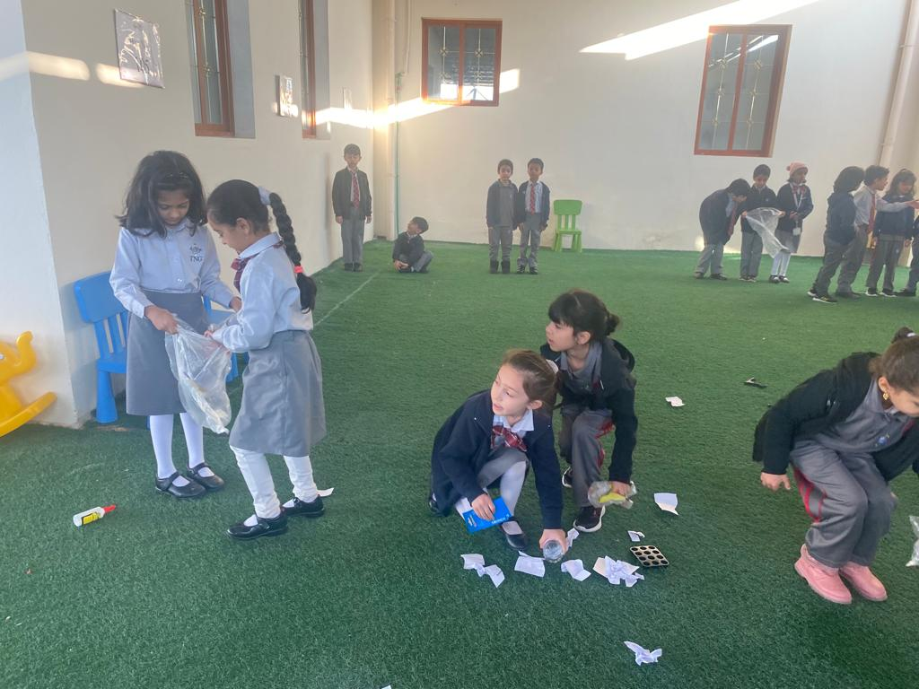

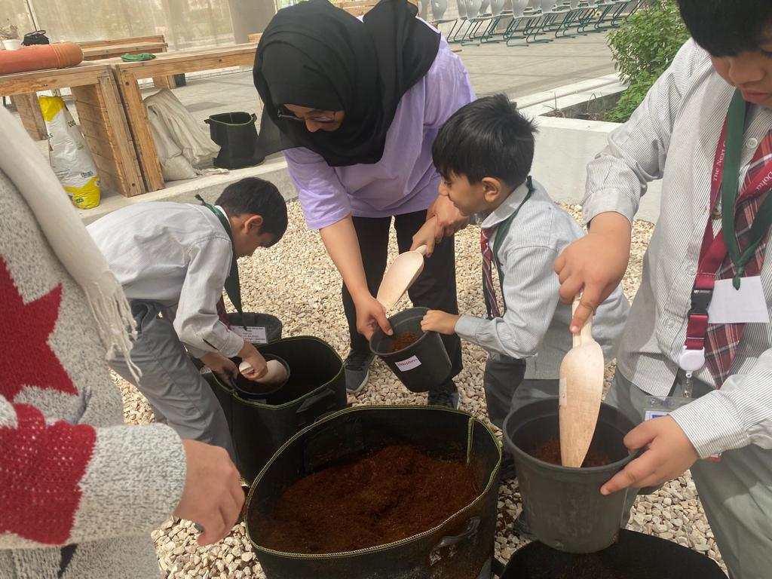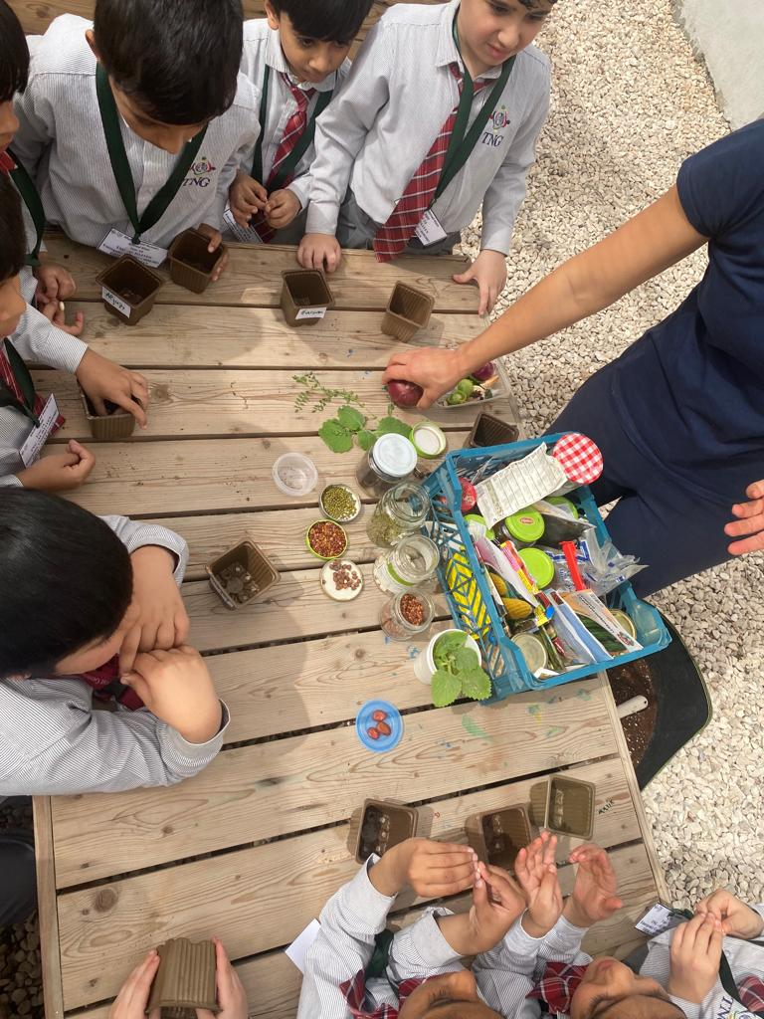

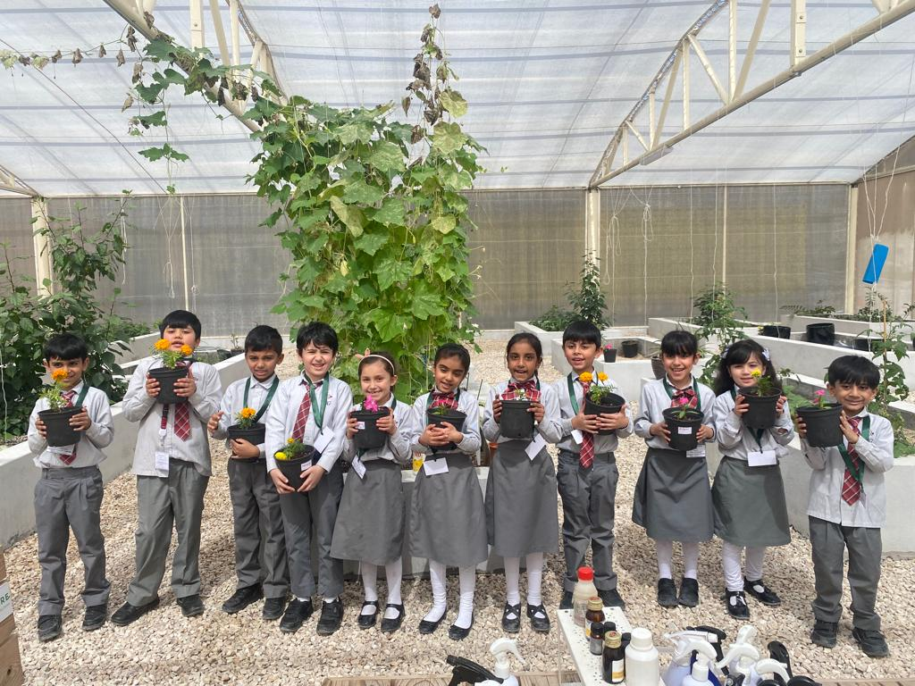

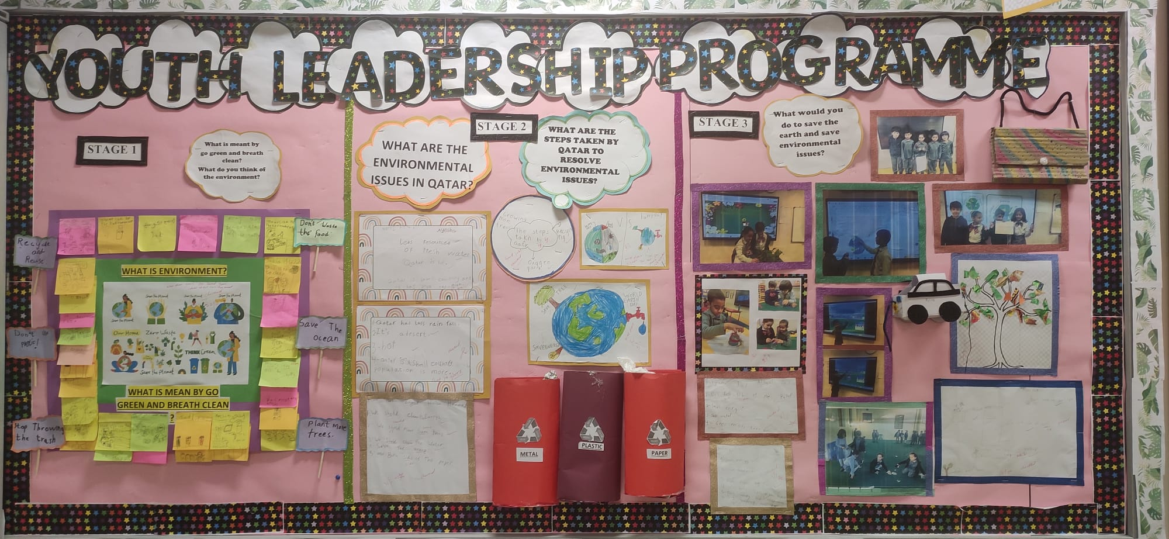

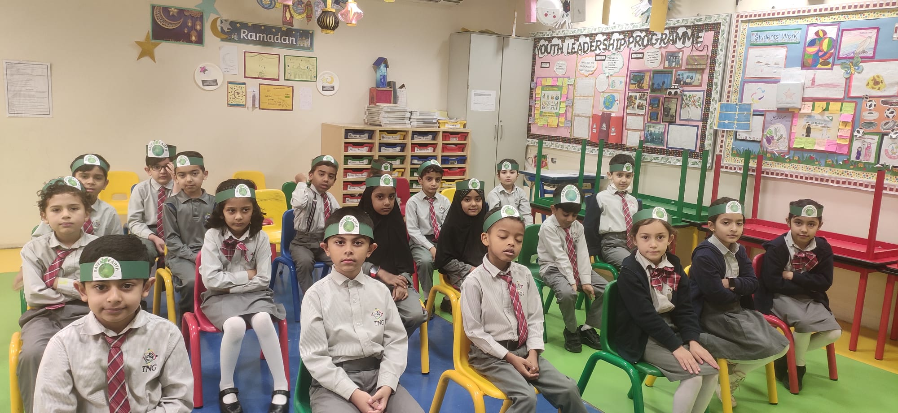

**Reflections**

Hassan Imran**–Class student:**

|  |
| --- |
| I feel that our project was strong this year. What I really liked about our project was we had a lot of group work, poster-making, and discussions. It helped me in enhancing communication and research skills. However, it would have been much better if we made some 3D models. |

Muhammad Meraj Aziz   **–Class student:**

|  |
| --- |
| This year’s YLP journey was exciting. Everyone got a chance to express their ideas and there were a lot of activities. I feel like we must include more field trips next year. |

Sadia Qasim    **–Class student:**

|  |
| --- |
| This YLP journey was quite fun in my opinion as we got to work as a team. Learning about the plants and ways to take care of the environment was interesting. We recycled paper into paper bags and learned how to reuse the plastic bottle. However, I feel we could have done more cleaning campaigns. |

Ms. Spougmay**– Teacher**

|  |
| --- |
| It gives me immense pleasure to watch students leading the Youth Leadership Program. One important aspect of the project was its emphasis on individual actions and responsibilities. Every student played a role to promote sustainability and recycle waste. When we all take small steps towards taking care of the earth, we can collectively make a significant difference. I witnessed their problem-solving skills develop during this project since it was our responsibility to create awareness for the issues chosen and create solutions for the problems that arose in the process. They developed critical thinking, self-criticism, teamwork, and most importantly, empathy |