**The Next Generation School**

**Wukair Primary Campus**

**Student Individual Report – Youth Leadership Programme A.S. 2022 – 2023**

**Name: Mahbano Akbar**

**Class: 3B**

**Topic: No Poverty**

**SDG: 1**

**Reflection**: During stage 1 of YLP, Mahbano has demonstrated tremendous critical thinking skills and asked very interesting questions during our research stage. She even proposed creative solutions to each cause of poverty and demonstrated problem solving skills. In stage 2, however, her individual research and ability to present was evident.

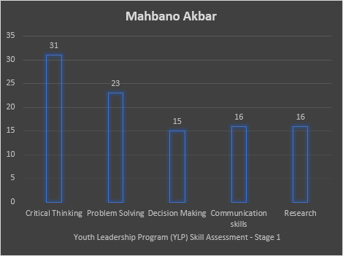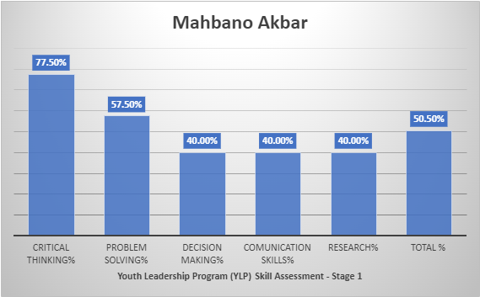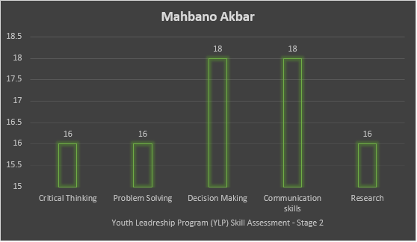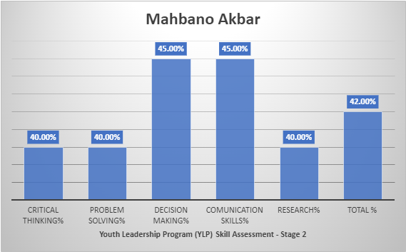

**Name: Muhammad Qaseem**

**Class: 3B**

**Topic: No Poverty**

**SDG: 1**

**Reflection**: Qaseem has demonstrated commendable critical thinking skills and was inquisitive during our research stage. He proposed creative solutions to each cause of poverty and demonstrated problem solving skills. In stage 2, his individual research and ability to present was showcased.

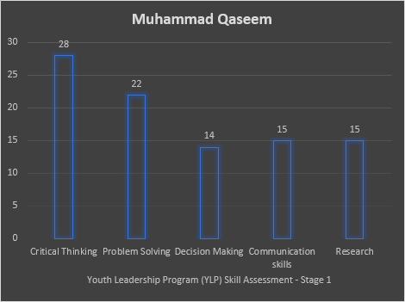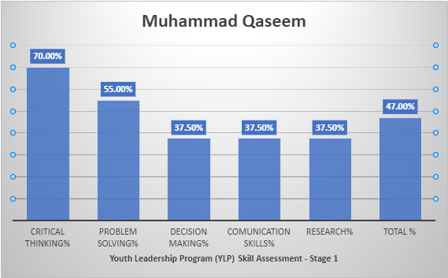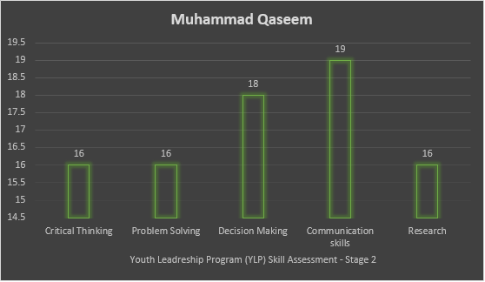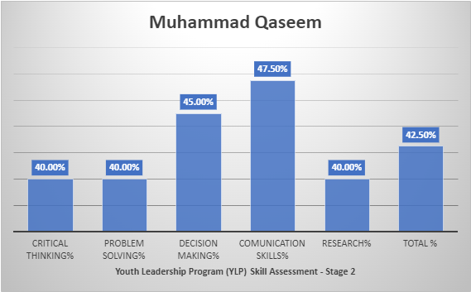

**Name: Haniya Inaya**

**Class: 3B**

**Topic: No Poverty**

**SDG: 1**

**Reflection**: In stage 1 Haniya has demonstrated her critical thinking ability and was inquisitive during our research stage. She proposed creative solutions to each cause of poverty and demonstrated problem solving skills. Her research and presentation skills were prominent in stage 2.

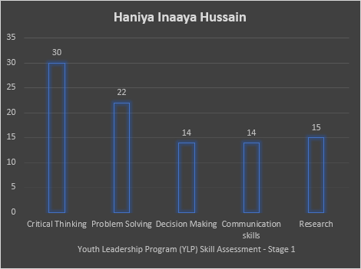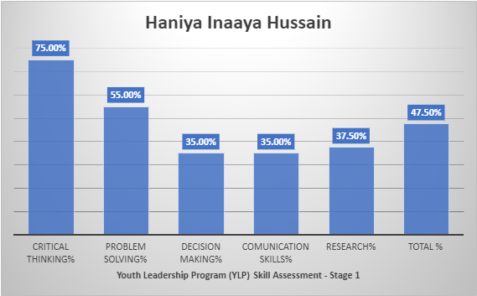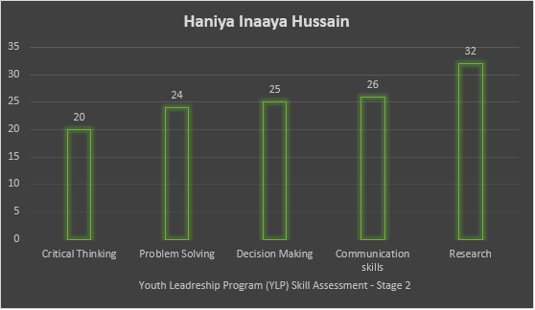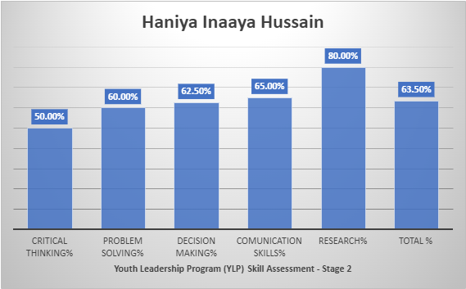

**Name: Haniya Muhammad**

**Class: 3B**

**Topic: No Poverty**

**SDG: 1**

**Reflection**: Stage one was when Haniya’s critical thinking and problem solving skills were prominent. She proposed creative solutions to each cause of poverty and demonstrated problem solving skills. In stage 2 her research and presentation skills were evident.

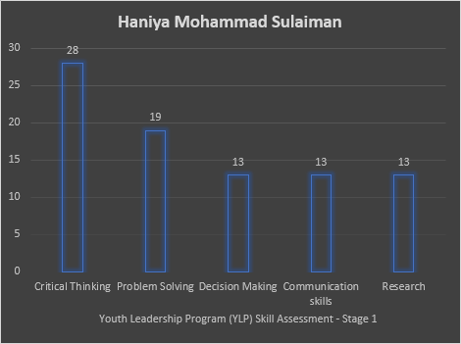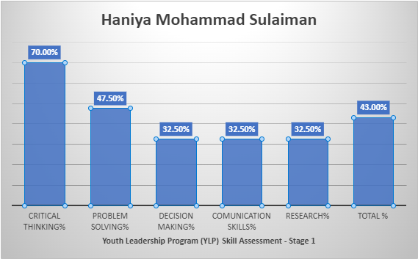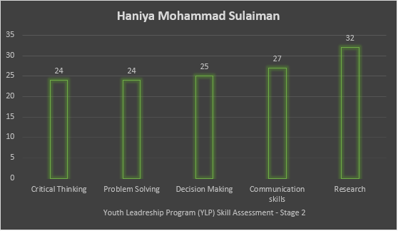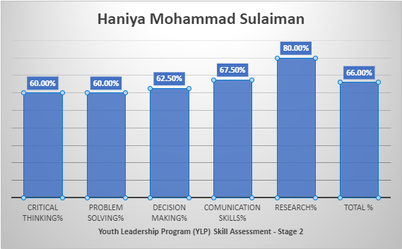

**Name: Muhammad Hashir**

**Class: 3B**

**Topic: No Poverty**

**SDG: 1**

**Reflection**: During stage 1, Hashir showcased critical thinking skills and was inquisitive during our research stage. He proposed creative solutions to each cause of poverty and demonstrated problem solving skills. Stage 2 was our presentation stage where is research and presentation skills were demonstrated. His presentation included lots of critical analysis.

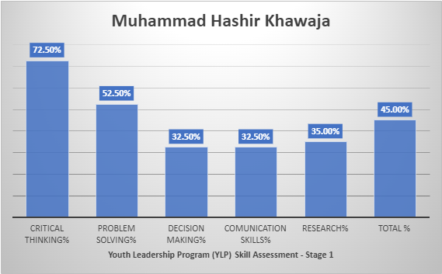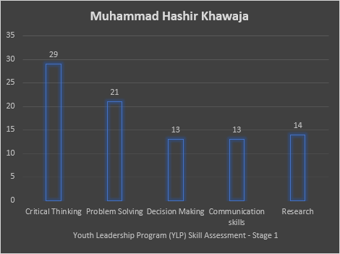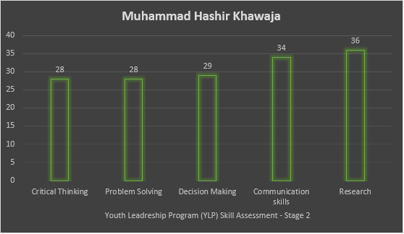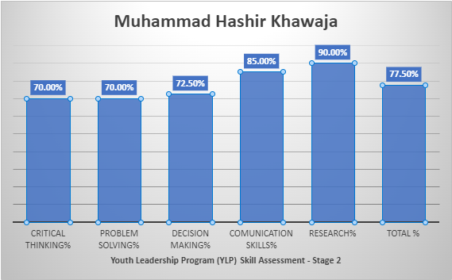

**Name: Manahil Fatima**

**Class: 3B**

**Topic: No Poverty**

**SDG: 1**

**Reflection**: During stage 1 Manahil has demonstrated commendable critical thinking skills and was inquisitive during our research stage. Her problem solving ability as also at par. Her individual research and ability to present was demonstrated during stage 2. She needs to work more on her research skills.

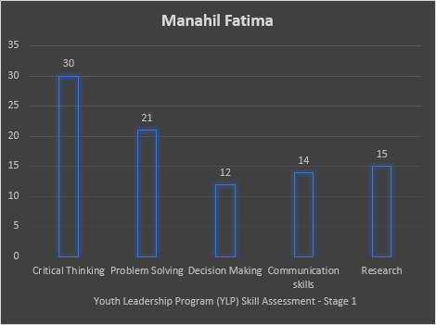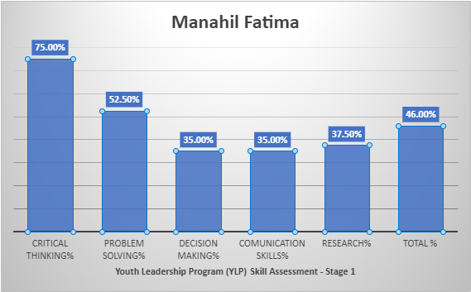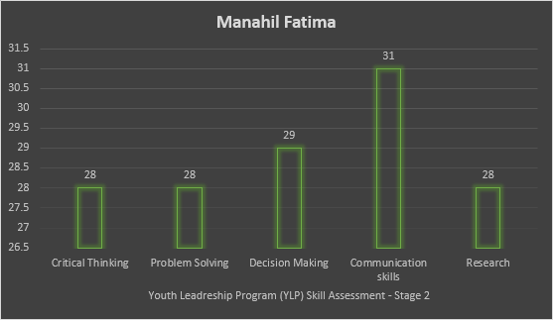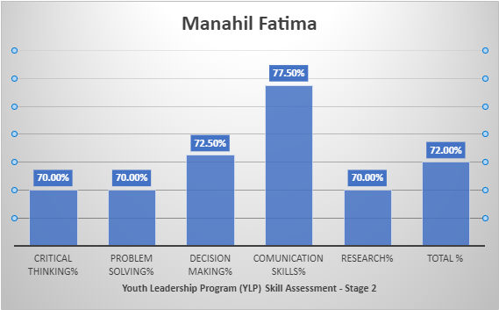

**Name: Mohammad Sohaib**

**Class: 3B**

**Topic: No Poverty**

**SDG: 1**

**Reflection**: During stage 1 Sohaib has demonstrated commendable critical thinking skills and was inquisitive during our research stage. He proposed creative solutions to each cause of poverty and demonstrated problem solving skills. He needs to work on his presentation and research skills as he did not get invol

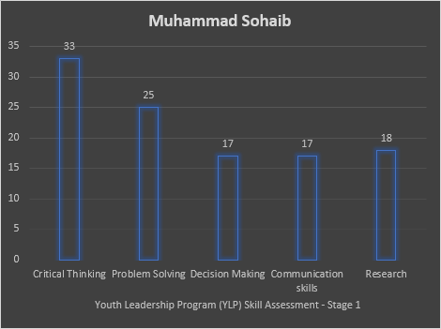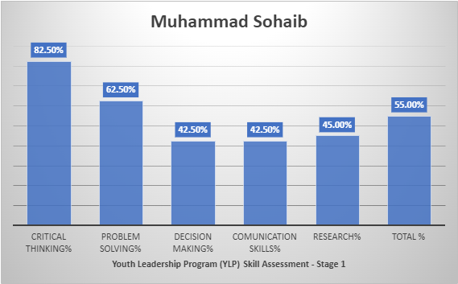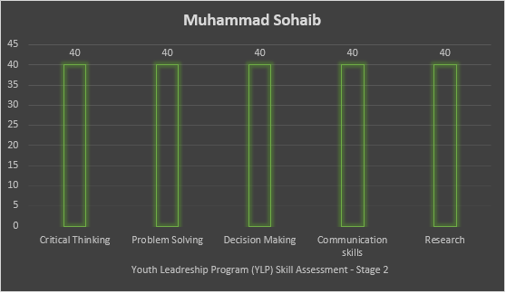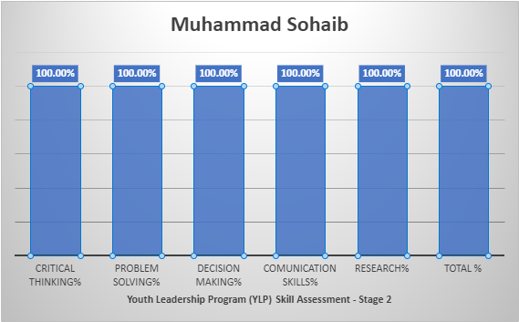

**Name: Muhammad Danyal**

**Class: 3B**

**Topic: No Poverty**

**SDG: 1**

**Reflection**: Danyal’s overall performance was satisfactory during stage 1. He did collaborate with his group members and demonstrated critical thinking and problem solving ability. During stage 2 he was able to showcase his presentation skills. He needs to work on his research and problem solving ability.

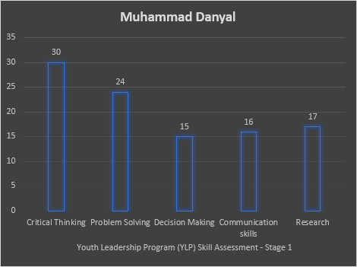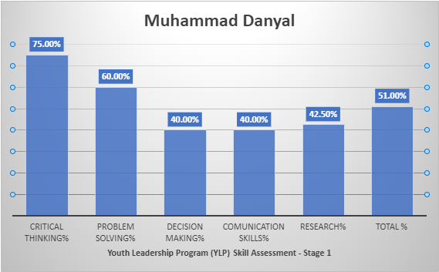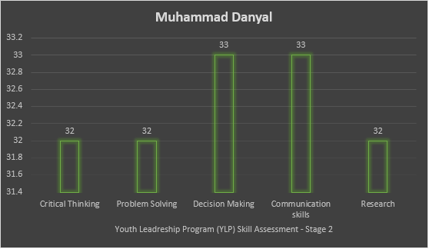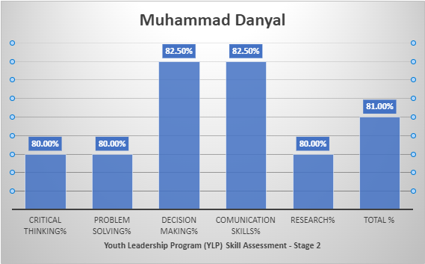

**Name: Inayah Shoaib**

**Class: 3B**

**Topic: No Poverty**

**SDG: 1**

**Reflection**: Stage 1 was where she demonstrated her keenness to bring problem solving solutions to the table by thinking critically. Stage 2 was when she exceeded all expectations and portrayed critical thinking, problem solving, decision making and communication skills. Her overall involvement was par excellence.

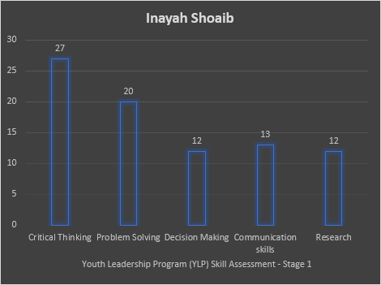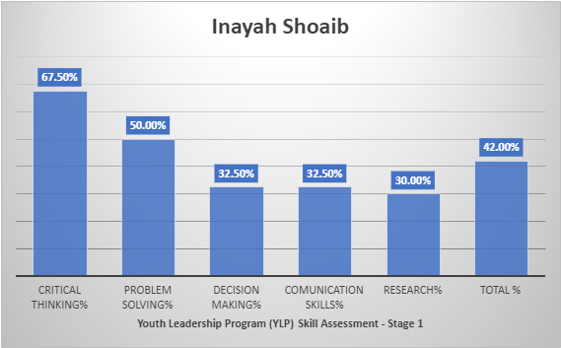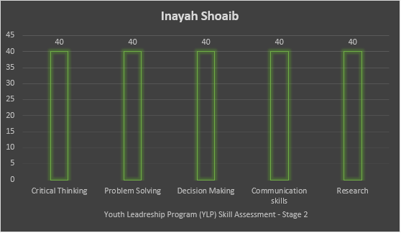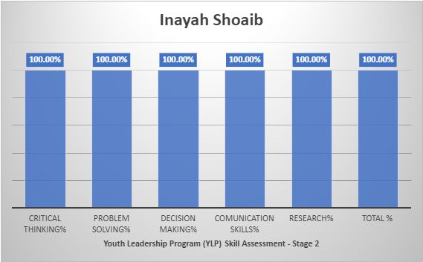

**Name: Iqra Fida**

**Class: 3B**

**Topic: No Poverty**

**SDG: 1**

**Reflection**: Iqra showcased her critical thinking and problem solving ability during stage 1. Whereas her participation in stage 2 demonstrated her research and communication skills. She needs to work more on her research ability.

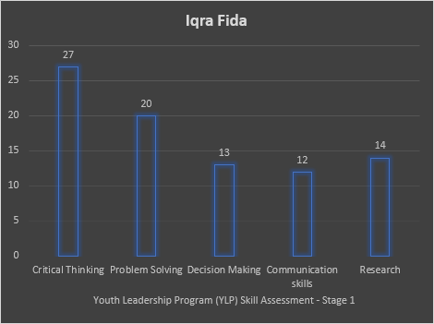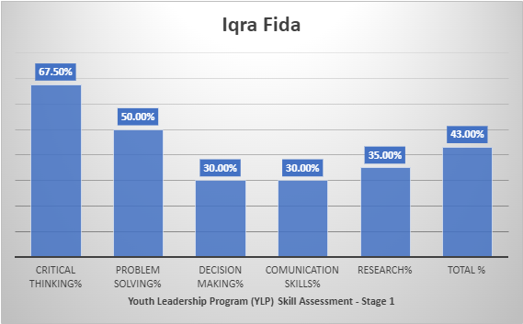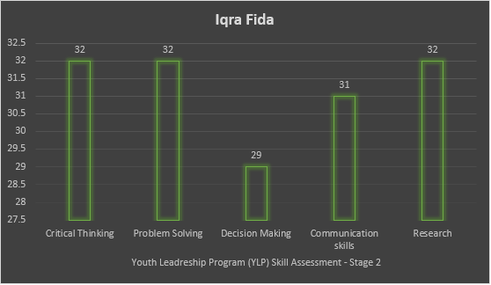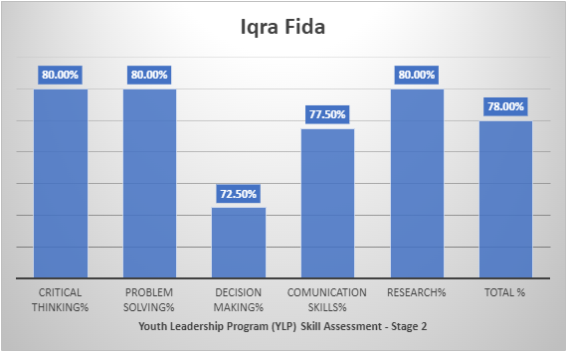

**Name: Hibba Rizwan**

**Class: 3B**

**Topic: No Poverty**

**SDG: 1**

**Reflection**: Hibba stayed very eagerly involved during stage 1, where she took active part in individual research and demonstrated critical thinking and problem solving ability. Stage 2 was where she showcased all skills specially her communication skills.

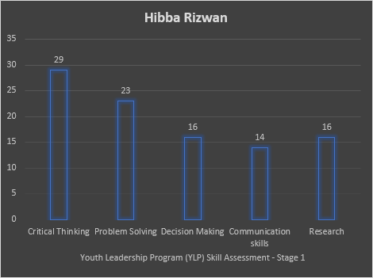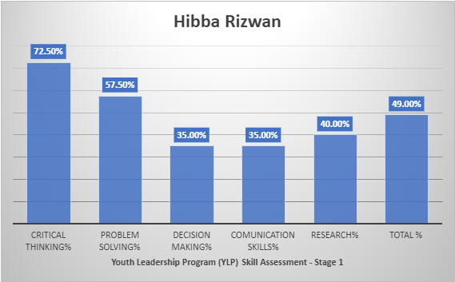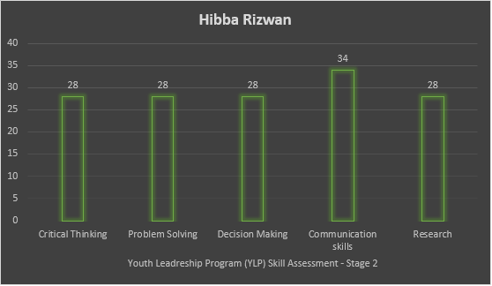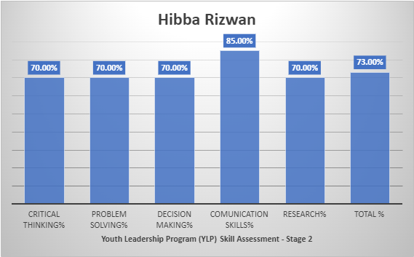

**Name: Manahil Jadoon**

**Class: 3B**

**Topic: No Poverty**

**SDG: 1**

**Reflection**: Manahil has demonstrated problem solving and critical thinking skills in stage 1. Whereas in stage 2 her presentation and communication skills were very prominent. She needs to work on her decision making skills.

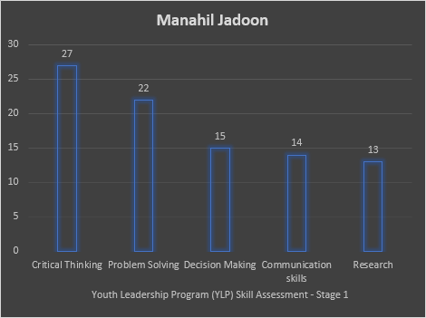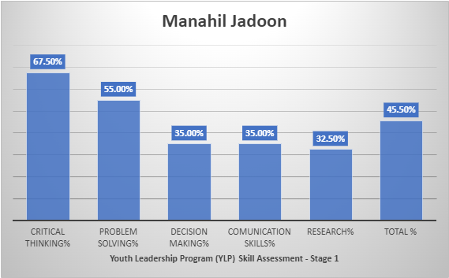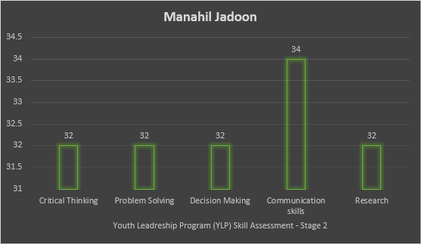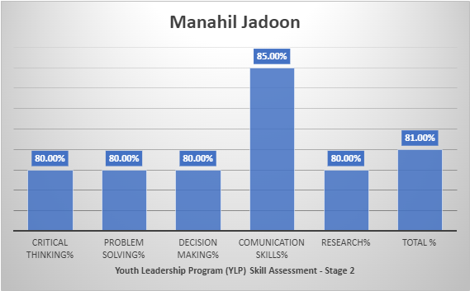

**Name: Ryan Ahmad**

**Class: 3B**

**Topic: No Poverty**

**SDG: 1**

**Reflection**: Ryan is a very smart participant and from the very beginning was keen on proposing solutions to the problem. His critical thinking ability and problem solving skills were very prominent during both stages. Stage 2, she spoke very candidly, showcasing his presentation and communication skills. He needs to work on his research skills.

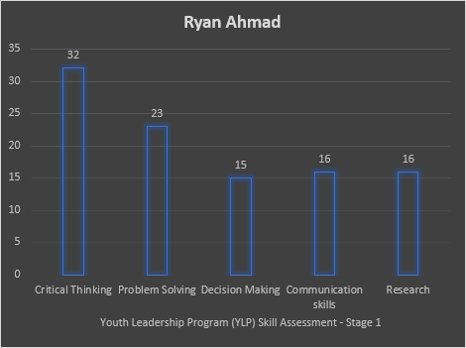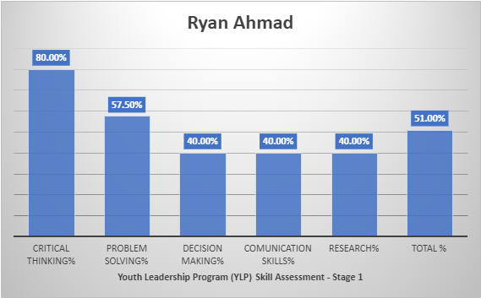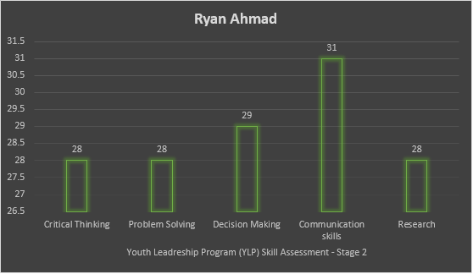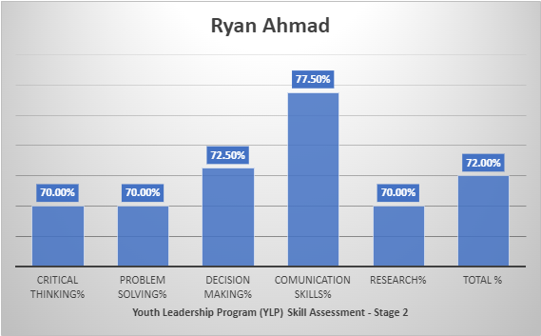

**Name: Shayan Abro**

**Class: 3B**

**Topic: No Poverty**

**SDG: 1**

**Reflection**: Shayan is a very inquisitive learner and was very eager to not only learn but add to the information provided. He has strong critical thinking ability. During stage 2 he, very confidently displayed and presented his elaborate model. Showcasing his communication skills. He can work on his research skills to further enhance it.

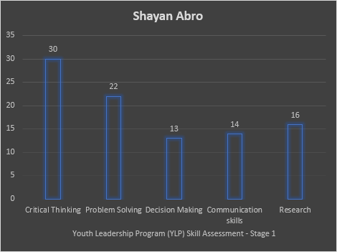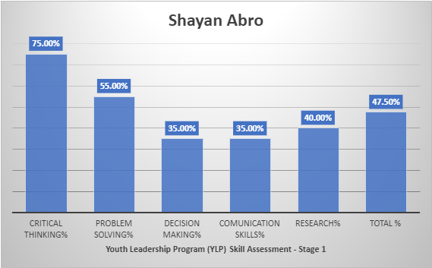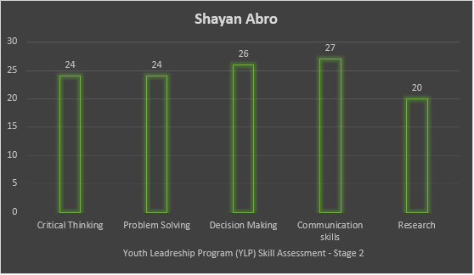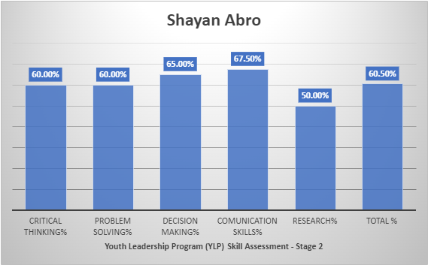

**Name: Muhammad Ayaan**

**Class: 3B**

**Topic: No Poverty**

**SDG: 1**

**Reflection**: Ayaan has demonstrated commendable critical thinking skills and was inquisitive during our research stage. He proposed creative solutions to each cause of poverty and demonstrated problem solving skills. His individual research and ability to present was vivid during stage 2.

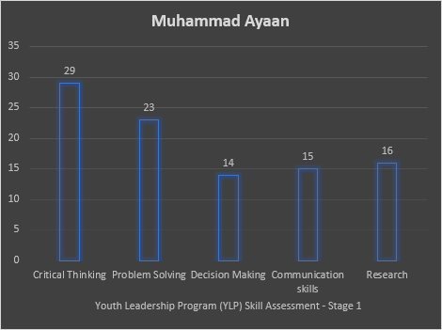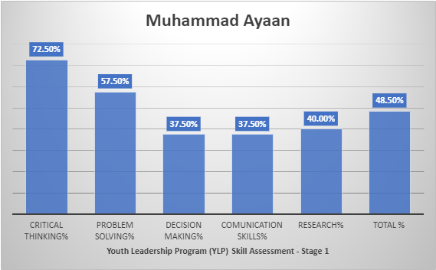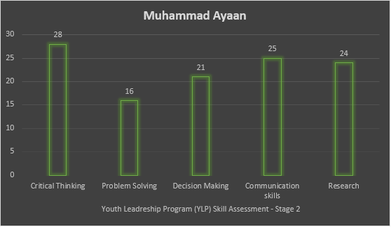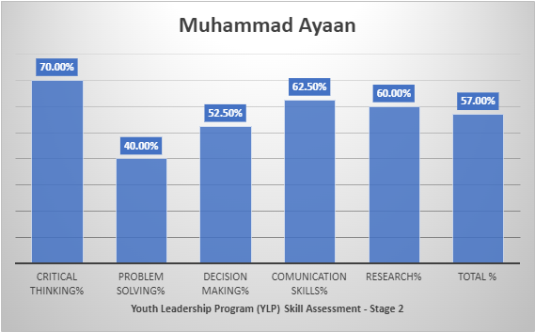

**Name: Sanayah Rafaqat**

**Class: 3B**

**Topic: No Poverty**

**SDG: 1**

**Reflection**: Sanayah took active part in stage 1 research and critical thinking activities. She needs to work on her communication and decision making skills. During stage 2, she showcased mostly

