Youth Leadership Programme 2022-23
Journal

Year | 7D
Teacher | Syed Owais Shah
Co-teacher | Riyaz Muhammad
Mentor | Abdullah Ishfaq

Project name: | The Smart City
Objective of the project: | We aim to address the growing demand of smart cities all around the world and especially Qatar, and such a project should contribute to the overall sustainability of the country.

Description of the project:

The project explored the design, infrastructure and operation systems of a potential smart city in Qatar and how it goes along Qatar Vision 2030. The class was divided into different groups to focus on and research about different aspects of the smart city and then combined the results to make a promising and in-depth model of the whole city, as if it’s ready to be built.
This goal is:
- Specific: It aims to design a smart city and its systems.
- Measurable: It was expected to have a lower carbon footprint than other cities.
- Achievable: It took into account financial means and resources available.
- Realistic: It includes as many details as possible to make implementation feasible.
- Timely: Research work was divided among the class to make complete it faster.

Implementation:

It was a mixed reaction of the students when they first heard about YLP. The ones with good past experience of involvement and the outcome of their YLP project looked enthusiastic. Students were given freedom to opt for the topic of this year YLP. They carried out discussion and discussed all the topic under the domain of Qatar National Vision 2030, Post-Pandemic era and continuation of their last year YLP project. The concept of the smart city is the initial proposal.
After having a thorough discussion on the topic, five groups finalised their area of research.
Group 1 worked on the solar powered energy for the Smart City.
Group 2 worked on water preservation strategies for the Smart City.
Group 3 worked on the greener aspect of the Smart City.
Group 4 worked on the technological aspect of the Smart City.
Group 5 worked on the financial aspect of the Smart City.

What have we achieved from the project?

Students improved their research skills by conducting primary research and generating questionnaire for the survey. Primary research was conducted according to the five groups working on the Smart City Project. Survey questionnaires were shared, and responses were tabulated and graphically anaylsed. PPTs were completed and presented by each group which improved their communication skills. Suleiman and Mahrus compiled a video whereas Mustafa completed a 3D digital project. Arafell presented the final presentation with great enthusiasm and confidence. It developed their team building capabilities and execution of plans according to the assigned task.

Way forward (How do we want to expand our project?):

We plan to go ahead with the Smart City idea to be implemented in the community starting from the school. We can make it more practical and efficient in the next session so that we may present our reflections to the ministry for a broader prospect.

How did we involve the community in our project?
Many activities were conducted such as Primary research was conducted by each group; each individual of each group was allotted with a specific research topic to prepare a comprehensive survey questionnaire. We visited Lusail Smart City management for in-depth understanding of a Smart City on 23rd March 2023. It was a comprehensive visit through which all group heads got a detailed view of how actually Smart City functions. An informative seminar was conducted on water preservation by Mr. Saeed on 26th March 2023 to cover the greener aspect of the Smart City.

Skills developed during the project:

Students have enriched their leadership, communication, and analytical skills by involving in all the group activities, going through research of their individual sub-topics in detail, presenting it in the class and coordination with other groups. They worked really hard in developing questionnaires and collecting data from the online resources about smart cities around the globe. They share the feeling of empathy towards other members and assist each other.

Glimpses from our Youth Leadership Programme:

Planning phase (photos)
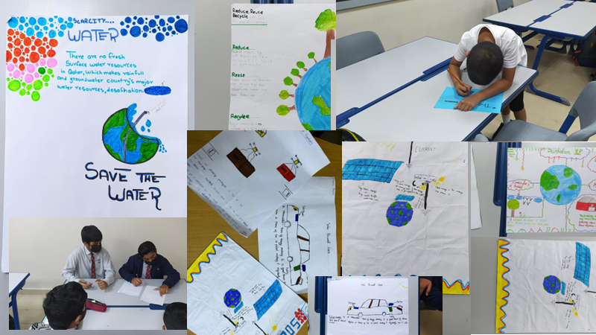

Preparation phase (photos)
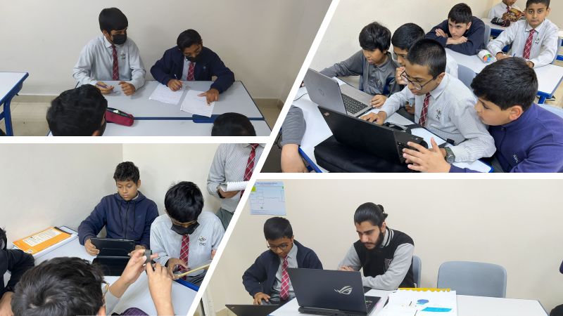

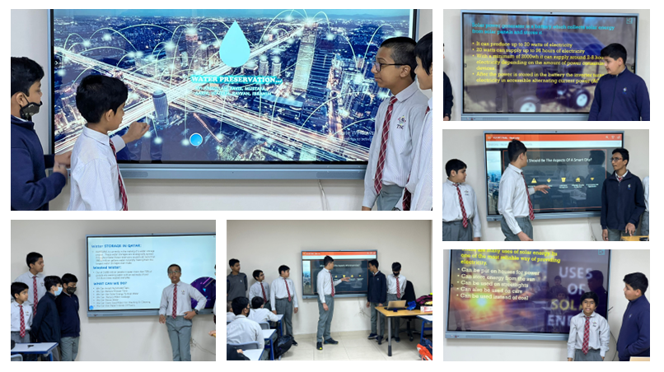
Implementation phase (photos)

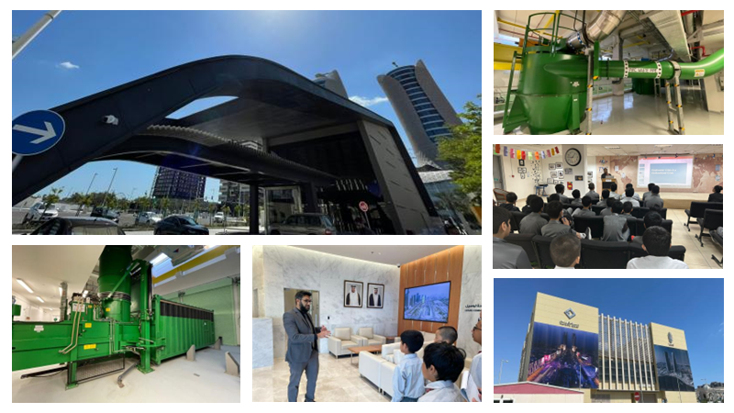

Reflections

Mentor: (Abdullah Ishfaq, 12)

As a mentor of 7D for YLP this year, I was quite happy with the experience I gained throughout. The students were cooperative and completed the tasks assigned to them. I also liked that the idea was unique and it allowed us all to gain an insight on the future of our societies and how smart cities will play an increasingly large role. Even though some corners had to be cut due to time constraints, I think this year’s YLP project was a job well done. The trip to Lusail was a memorable experience too!

Student: (AbdulRahman, 7D)

This year's YLP has been outstanding since it taught me a lot of things, it has taught me socialising skills it has taught me how to manage a classroom, how to be a mentor and it also taught me teamwork skills. The most memorable part about this year's YLP was the presentation, it was outstanding I have never seen such an amazing presentation. I would love to be in more YLP programmes in the future.
This was the best YLP experience overall.

I got a very good message from this YLP and that is:

TEAMWORK IS EVERYTHING

Student: (Khalid, 7D)

This year's YLP was a great experience for me and my group as this year's YLP (Youth Leadership Programme) helped us in developing our learner skills.
We learned many things on how we can prevent and sustain the usage of resources for a sustainable future generation.
It was a great experience throughout due to the commitment and contribution of the teachers of TNG, I would like to thank them for their hard work.
The most memorable part of this journey was of course when we got to go to one of Lusail’s command centre in there we got to explore
Many new things which helped us in our YLP topic Smart City.
In conclusion this had to be one of the most fun yet interesting YLP Journey that we have gone through and I hope to see an improvement in the next YLP to ensure a fun experience.

Student: (Umer Taimoor, 7D)

This year's YLP was a great experience for us and our group because we learned a lot of stuff such as how a smart city works and how much does it cost to completely build a smart city and if it is sustainable or not.
We especially being in the financial group developed a lot of researching skills.
Wildan from our group went to Lusail to experience how a smart city works and he also saw the solid waste management over there.
Overall it was a very successful year and we will be looking forward to it next year too.

Teacher: (Syed Owais Shah)

It was a great YLP journey which was exciting and wonderful learning experience. Mr. Riyaz assist us throughout since day one, he provided us with all his technical and technological experience to make our project to reach to a standardised one. I observed students from low motivation at the initial stage to reach great heights of motivation by involving themselves in group activities. Group heads put in great effort lead by the senior mentor and class mentor. Abdullah Ishfaq, the mentor supported us throughout and assist students to resolve issues and continue working on their projects and improve their skills.

