**Youth Leadership Programme 2021-22**

**Journal**

|  |  |
| --- | --- |
| **Year** | 7a |
| **Teacher** | Muhammed Musthafa |
| **Co-teacher** | Mr Wail |
| **Mentor** | **The Whole Class Year 7-a** |

|  |  |
| --- | --- |
| **Project name:** | Impact of social Media |
| **Objective of the project:** | Reasearching how social media affect all aspects of human life |

**Description of the project:**

|  |
| --- |
| Our YLP Project focused on three core issues that impact of social media on learning, impact of social media on teens , and impact of social media on family life. |

**Implementation:**

|  |
| --- |
| We grouped in to three and started researching on the main three issues. We also created a padlets where we can share our finding. A survey with in the campus also helped well to get realistic results regarding the issues.We also created a website where others can get the results. |

**What have we achieved from the project?**

|  |
| --- |
| We researched on the issues and discovered many problems that occurred to different people across the world which really opened our eyes to the problem. We also gained some reach through our survey which means that we also raised awareness across the school. |

**Way forward (How do we want to expand our project?):**

|  |
| --- |
| We are planning to continue this project or carry it forward to the next level. |

**How did we involve the community in our project?**

|  |
| --- |
| We collaborated with many social media users and the survey made a community involvement |

**Skills developed during the project:**

|  |
| --- |
| * Research skills * Communication skills * Team management skills * Critical Thinking Skills * Self-Evaluation skills |

**Glimpses from our Youth Leadership Programme:**

***Planning phase***

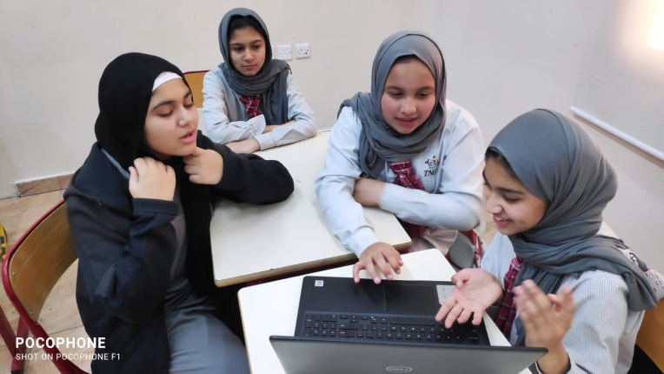

***Preparation phase***

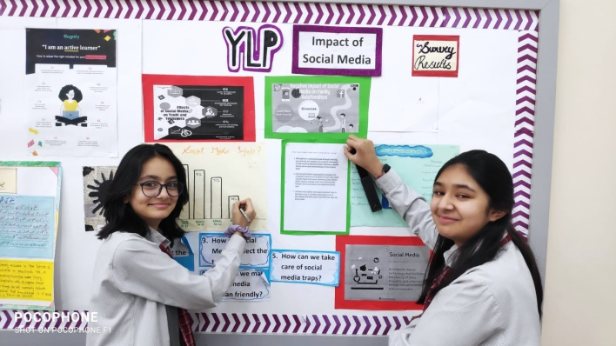

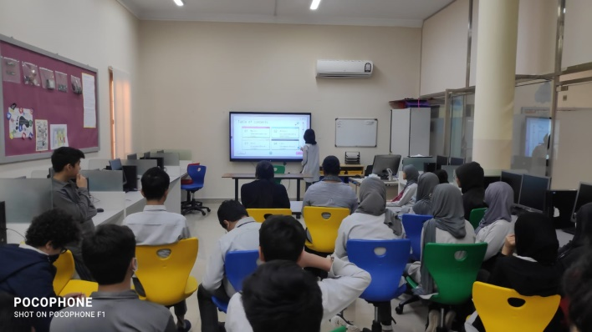

***Implementation phase***

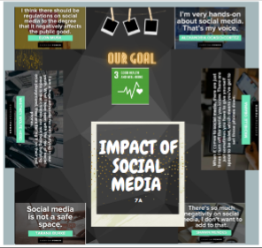 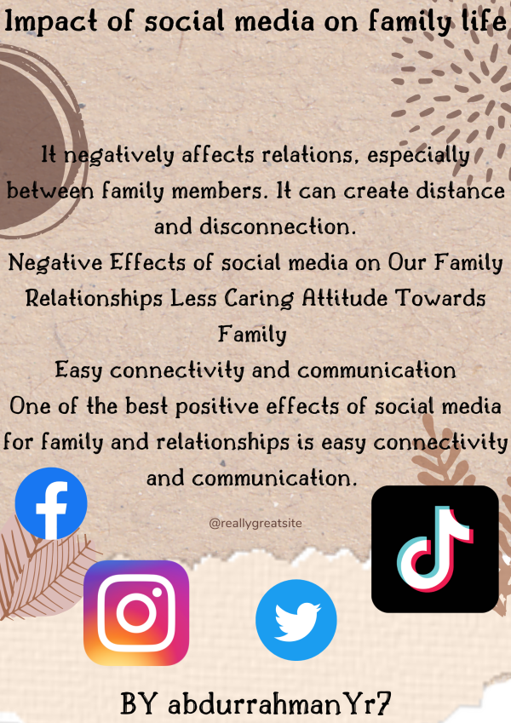

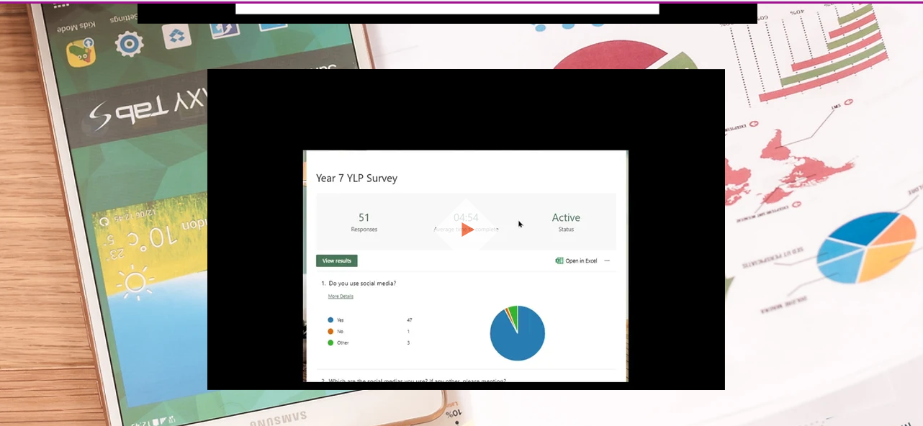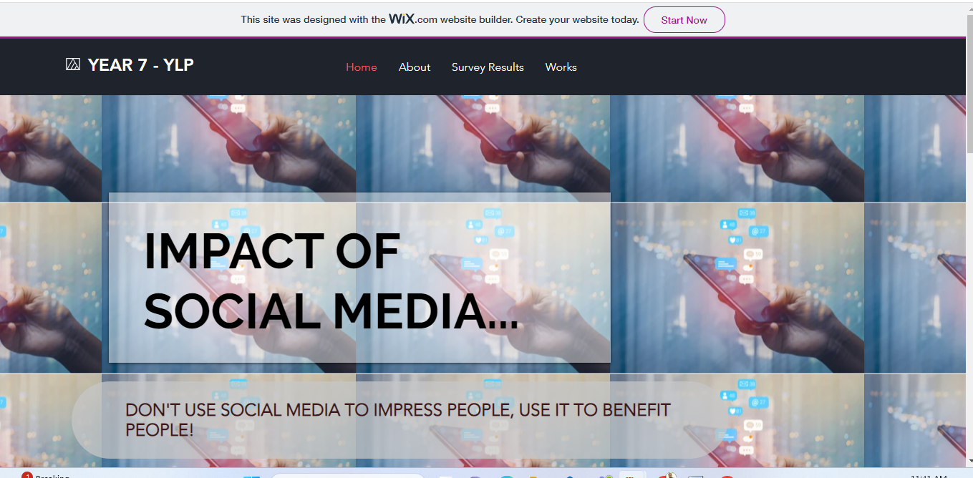

**Reflections**

**Haniya – Mentor:**

|  |
| --- |
| The influence of social media on mental health was the topic of our Ylp project. Considering that 89 percent of people utilize social media, this issue was both interesting and important in daily life. |

Maheen**– Class student:**

|  |
| --- |
| Working on our YlP Project had truly been a hassle but I had enjoyed it because I was able to reconnect even more with my peers and I hope to do the same in next years reflection |

Anum**– Class student:**

|  |
| --- |
| Working on the YLP Project has been an excellent experience. Being able to spread awareness about this problems felt really purposeful, I feel like we managed to make a small difference. |

Rodina Elghandour**– Class student:**

|  |
| --- |
| This YLP journey was quite fun in my opinion as we got to work as a team and have very interesting info shared between all of us. I had fun practicing for the play and presentation, and was happy to collaborate with all my classmates. |

Mr Musthafa **– Teacher**

|  |
| --- |
| It gives me immense pleasure to watch students leading the Youth Leadership Programme. While initiating and implementing the project, the students were quite busy with thinking comprehensively, making meaningful connections between the pre and post lockdown times. I witnessed that their problem solving skills developed during this project since it was our responsibility to create awareness for the issues chosen and create solutions for the problems that arose in the process. They developed critical thinking, self-criticism, team work and most importantly, empathy. |