**Youth Leadership Programme 2022-23**

**Journal**

|  |  |
| --- | --- |
| **Year** | 9A |
| **Teacher** | Ms Tini |
| **Co-teacher** |  |
| **Mentor** | Haleemah Owais |

|  |  |
| --- | --- |
| **Project name:** | METASARC |
| **Objective of the project:** | METASARC is a virtual experience which aims to spread awareness of sustainable communities through the METAVERSE |

**Description of the project:**

|  |
| --- |
| Students of year 9A created a project about building a sustainable community with the help of renewable energy, decreasing the use of fossil fuels and spreading awareness. |

**Implementation:**

|  |
| --- |
| Students had created a Minecraft game about how to use different types of renewable energy. It was show cased in different classes and then students wrote their reflections on what they learnt from the game and how they can implement it in their lives. |

**What have we achieved from the project?**

|  |
| --- |
| We have achieved the different ways of how to build and create a sustainable community through the works of using the METAVERSE for making it more interactive for the younger audience |

**Way forward (How do we want to expand our project?):**

|  |
| --- |
| We want to soon publish our Minecraft world to the public and host mini games in which people guess the amount of carbon emission a certain object gives out. |

**How did we involve the community in our project?**

|  |
| --- |
| We conducted a survey about renewable energy with parents, teachers and students to create a sense of understanding about what the community knew about sustainability and how we can help create a more deeper understanding for others to learn |

**Skills developed during the project:**

|  |
| --- |
| Students learnt critical thinking skills, coding, creativity, public speaking, and how to design games. |

**Glimpses from our Youth Leadership Programme:**

***Planning phase (photos)***

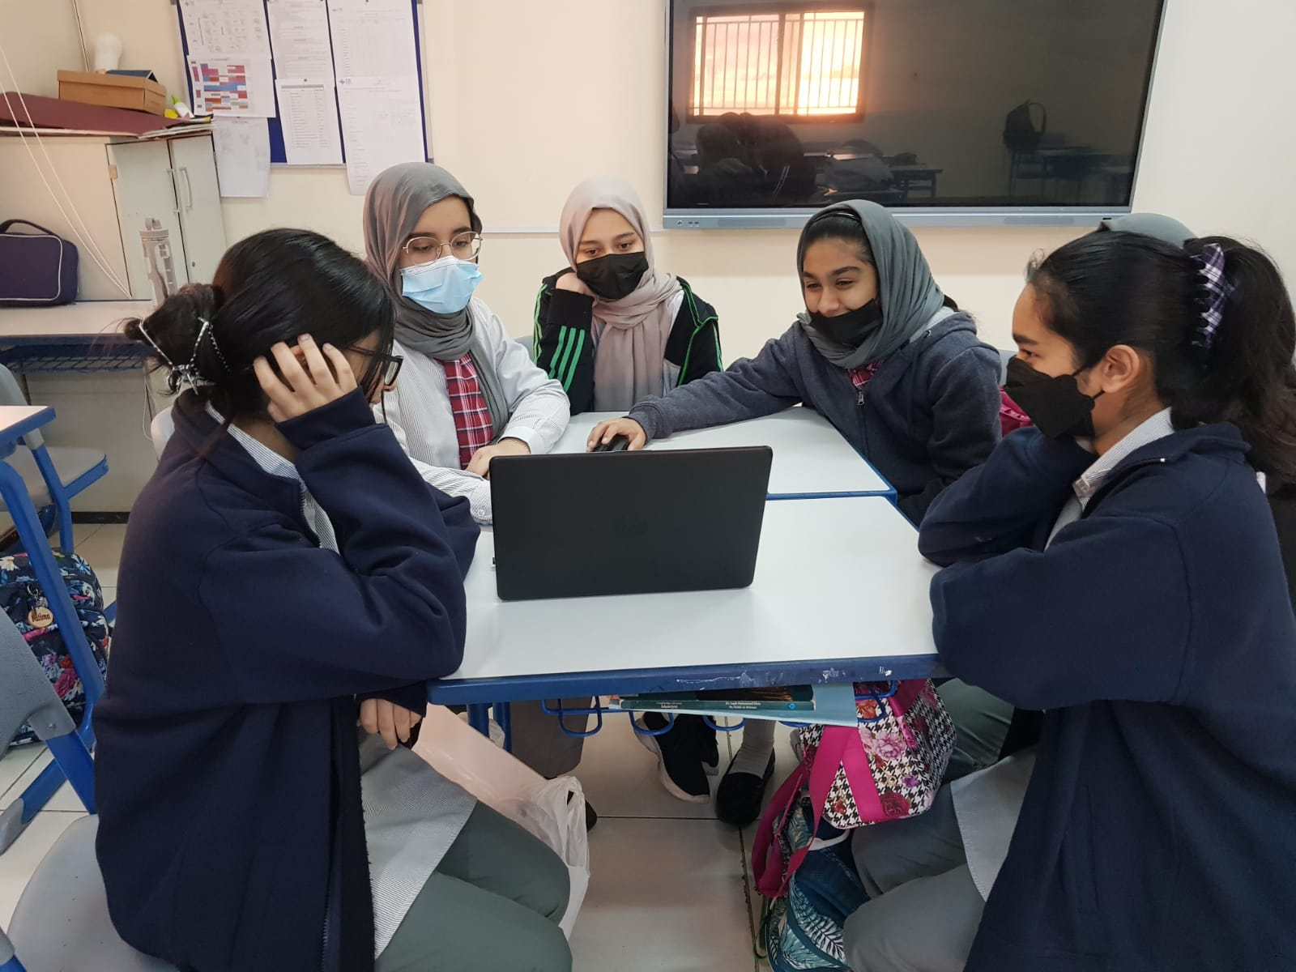

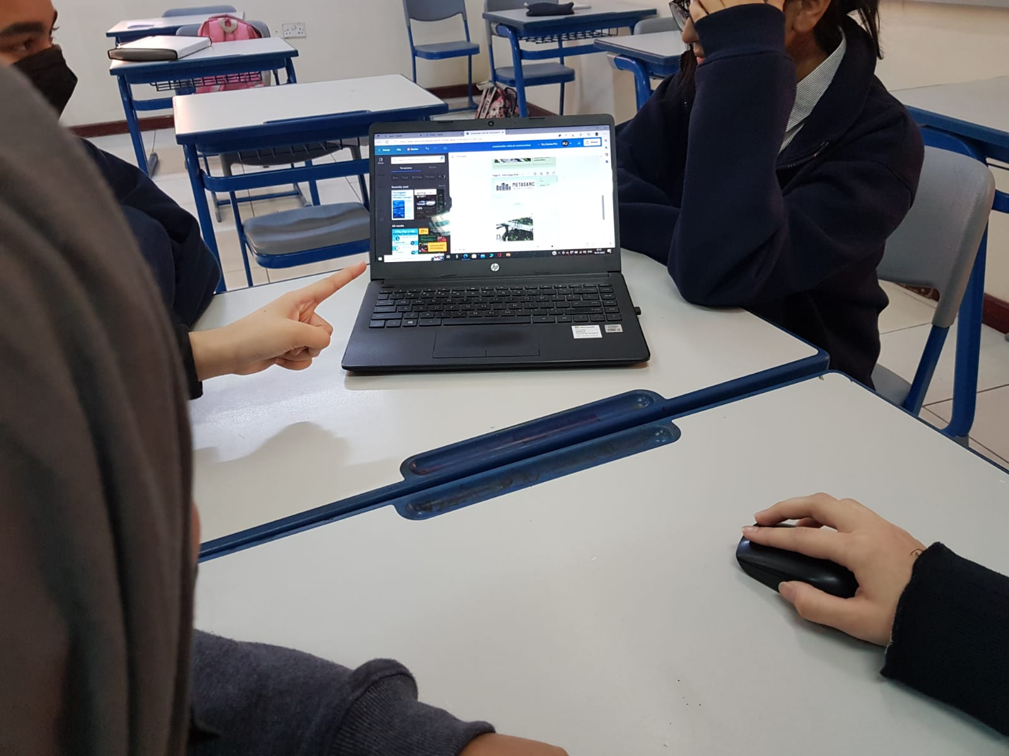

***Preparation phase (photos)***

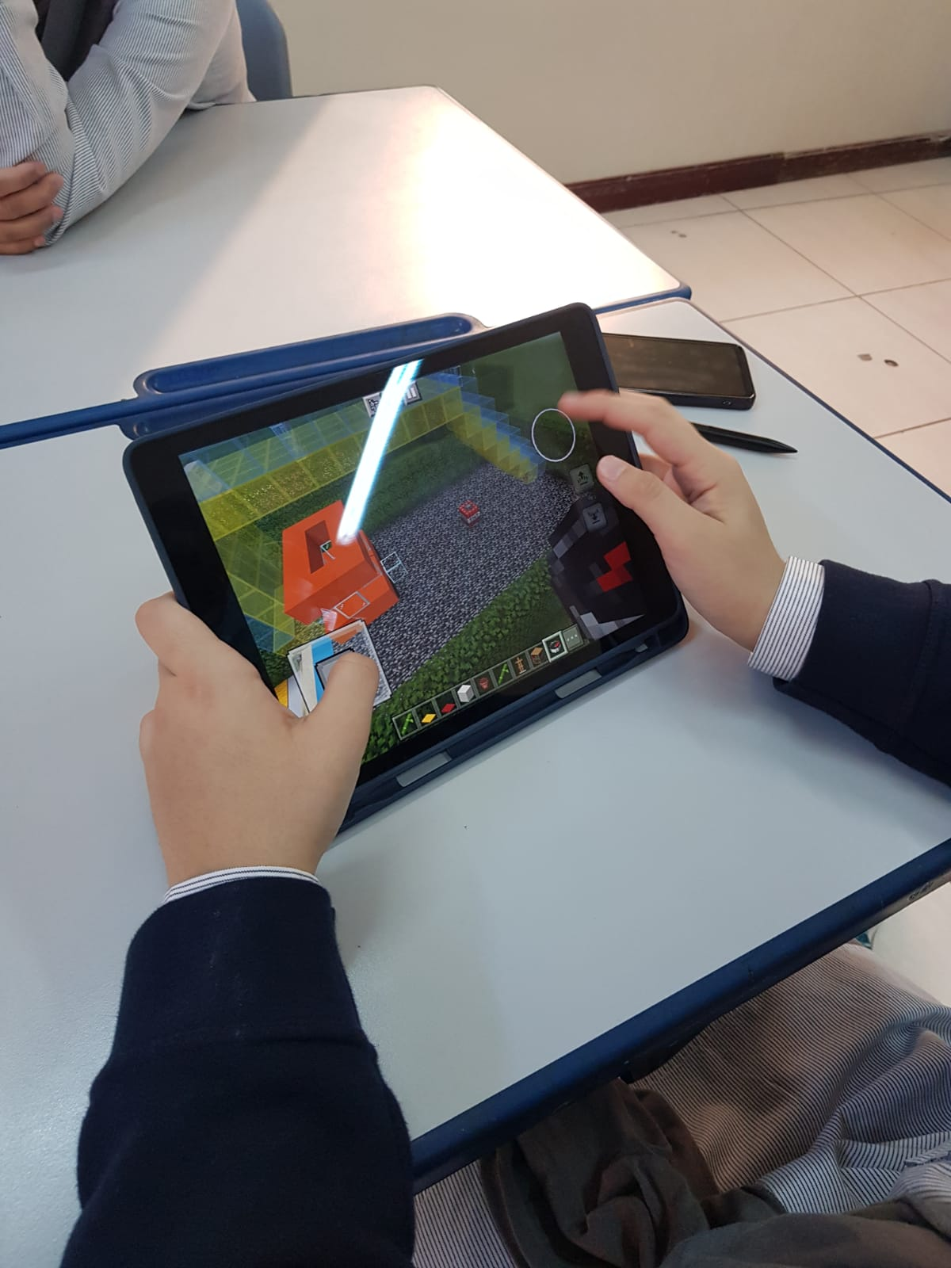

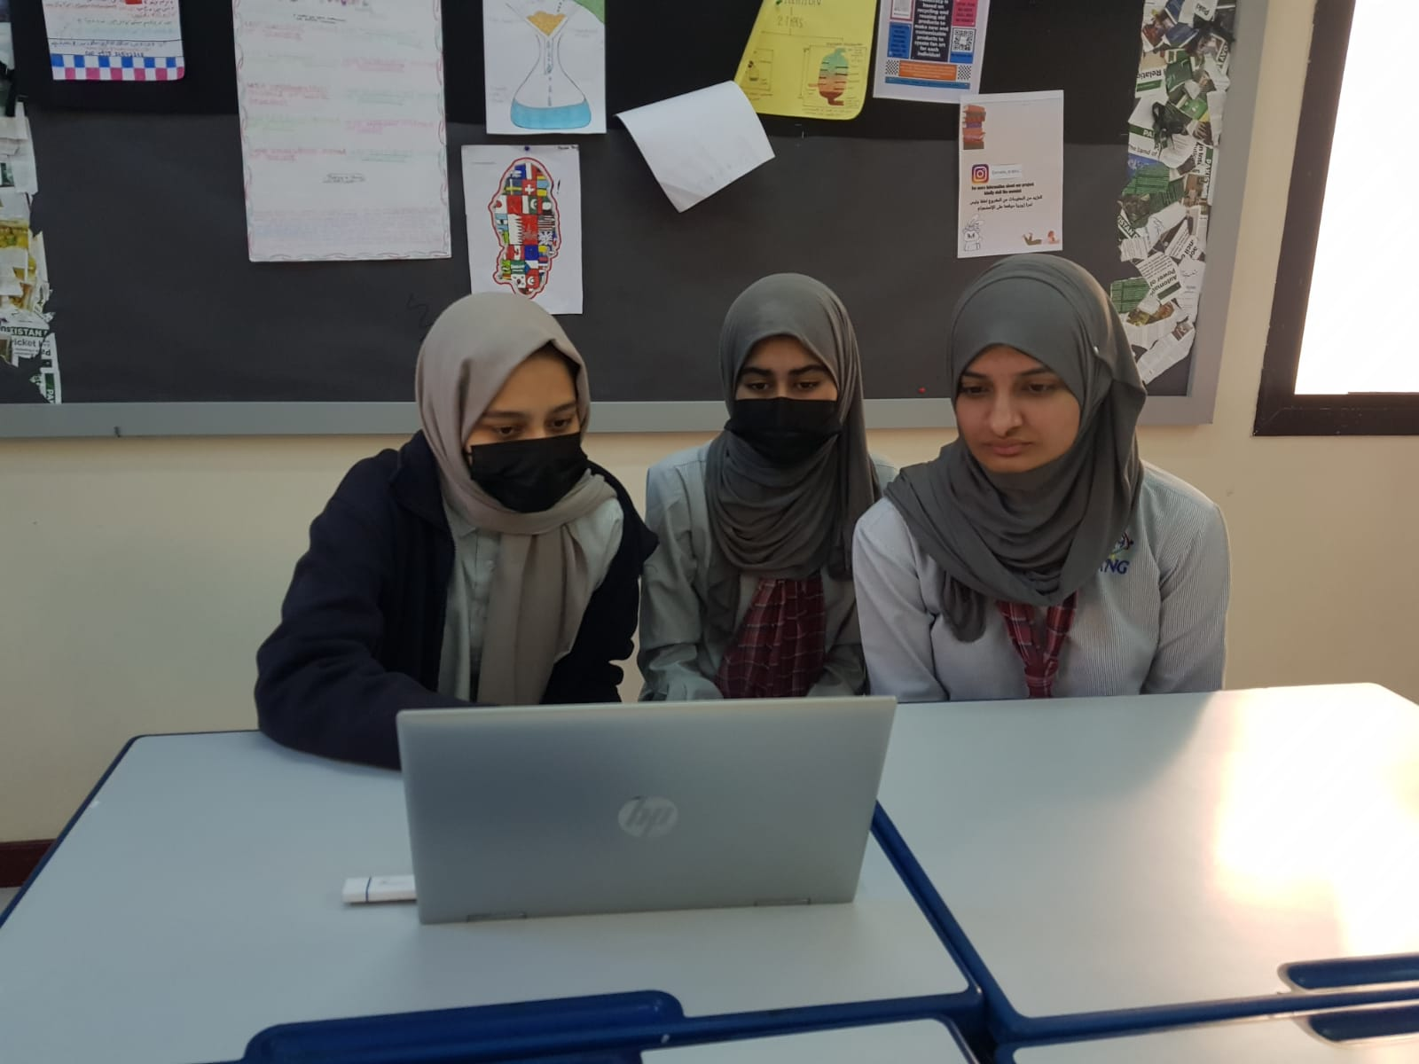

***Implementation phase (photos)***

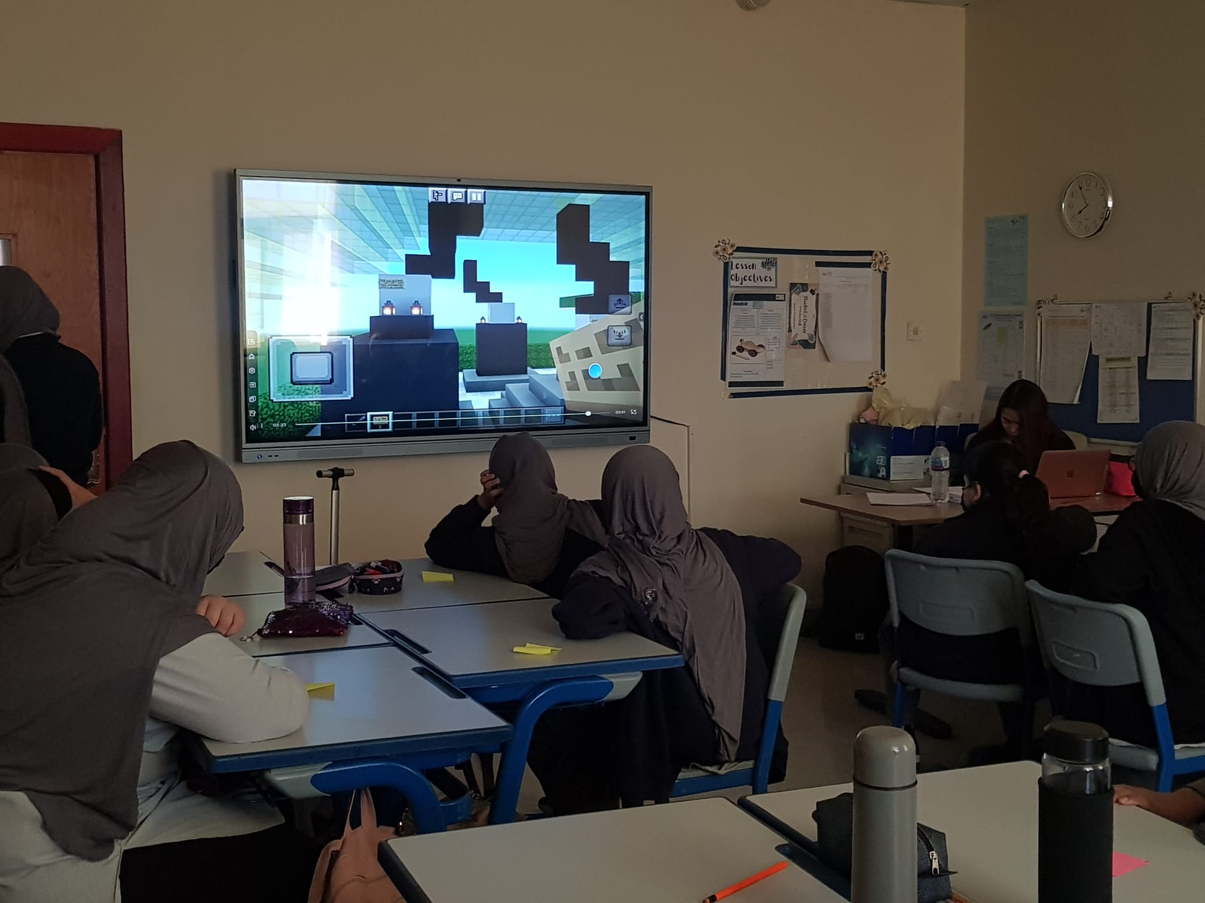

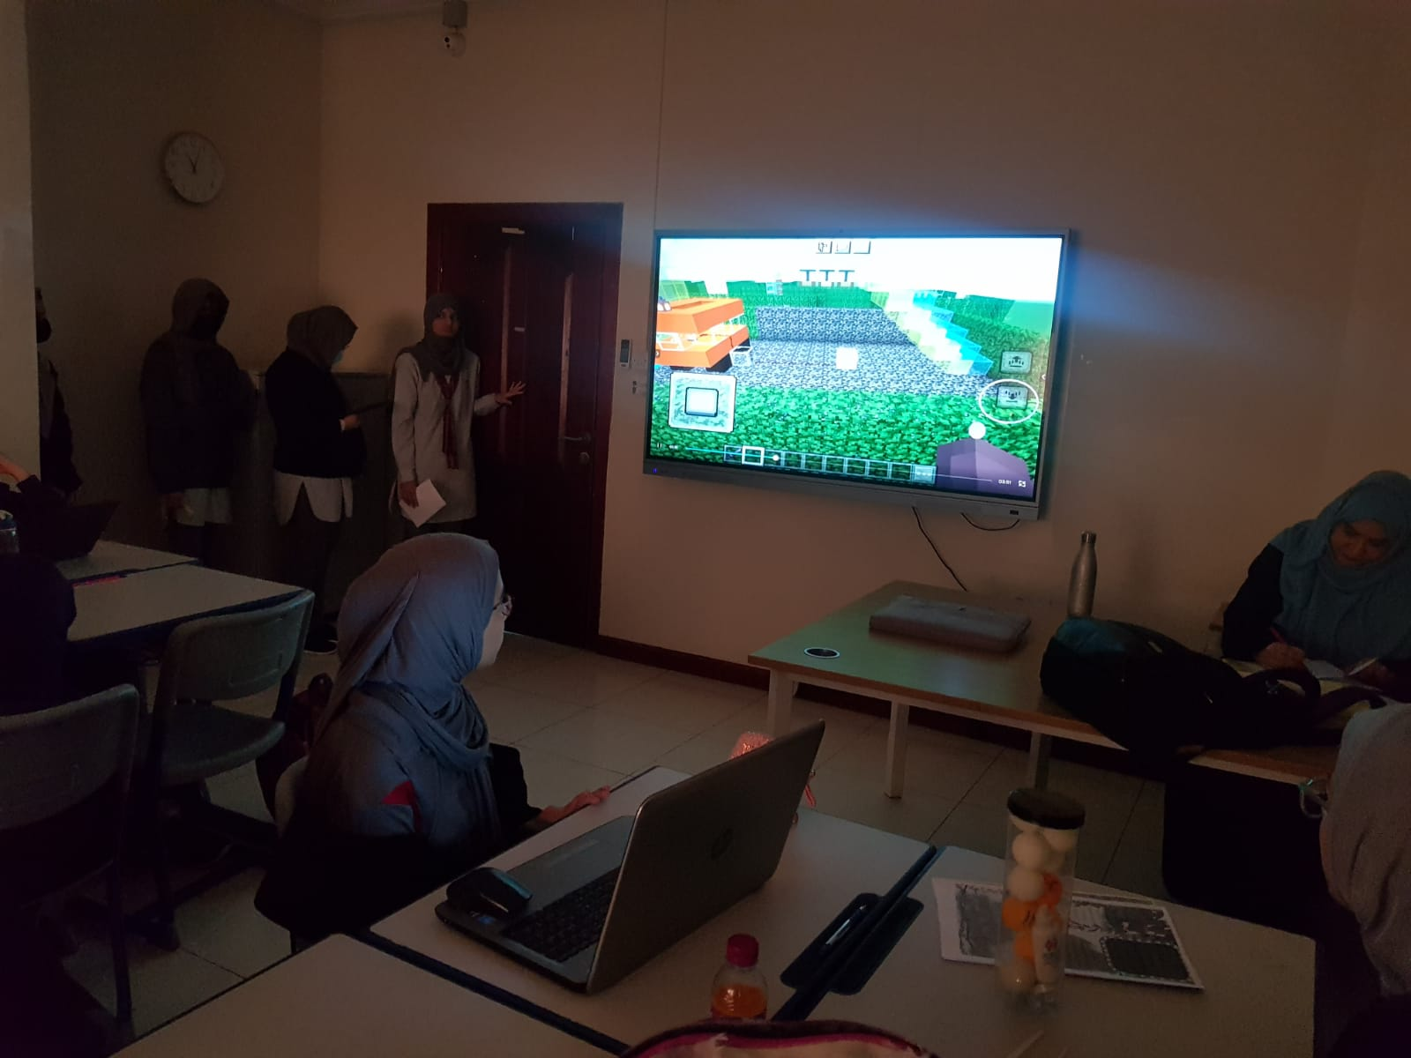

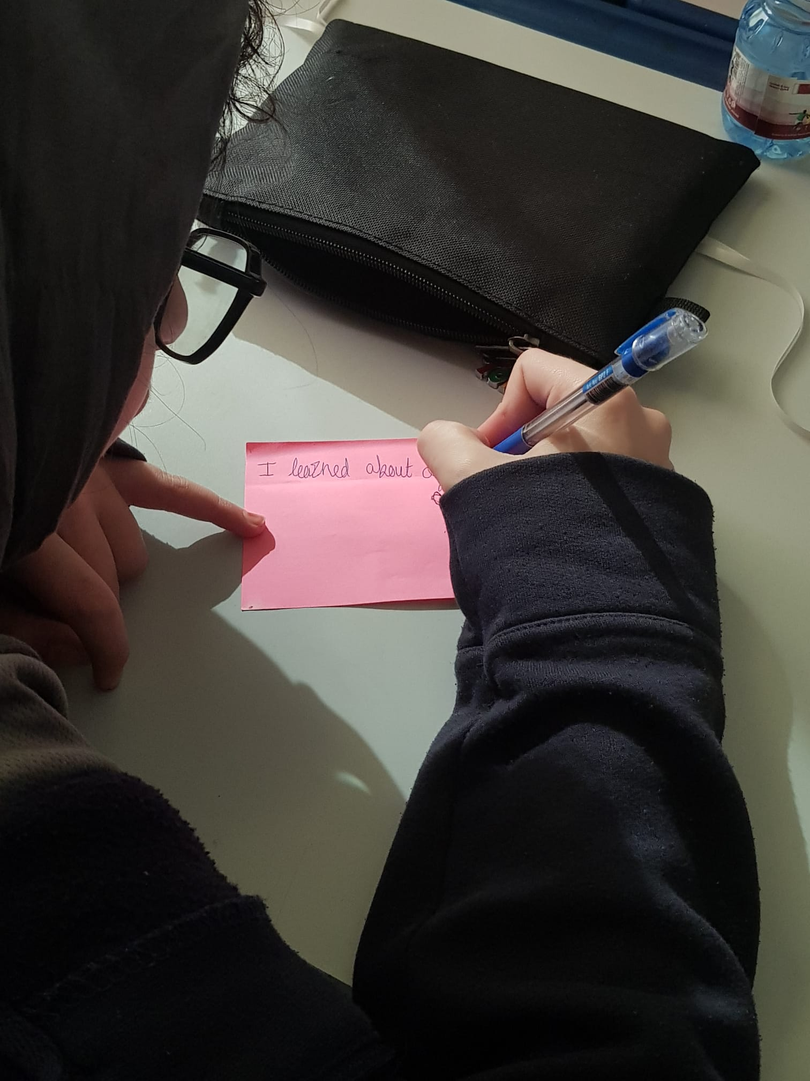

**Reflections**

**Mentor: Haleemah Owais 10A**

|  |
| --- |
| This year, I felt like YLP had given students the opportunity to think outside the box and be more creative with their project and how to implement it. Students were very creative with their project and came up with multiple solutions to only 1 main problem, being sustainability. They gained a sense of understanding on how to tackle difficult worldly problems in a civil manner. |

**Student: Fariha Tariq 9A**

|  |
| --- |
| I was part of this year’s Youth Leadership Program, now yielding you with my intake on our project. I felt like our undertaking emerged well this calendar year. We were able to deduce a clear scheme of our topic and take the equitable sources and initiatives to bring it to operation. Despite the disruptions and diversions, we were still able to keep an enthralled route and managed to produce a commendatory outcome even through a brief period of unused time. Adding on, the content we elected was also quite consequential and spellbinding principally since it had an alliance with the extant maniacs and prospering technology. Although I feel like we hadn’t amplified our full inherent and could have composed an even superior outcome. We should have perpetrated some sort of out-of-campus stir and orchestrated talks with proficient and such. Predominantly with the game, I perceive that there could have been more joint effort and moil on that part, and we could have swelled it to other sandbox groundings or such. The disposition of the terminal presentation also could have been supplemented however I was complacent with the way our PowerPoint Presentation turned out, considering how it had to be concluded rear minute. If we had feasibly paid more inquisitiveness to the project, I feel like we could have done an even finer operation. Overall, the episode was way better than the last few years, and I felt like we had more sway over it and were able to articulate our artistry and diligent endeavors. |

**Student: Mahnoor Aamir 9A**

|  |
| --- |
| I was a part of Year 9A’s Youth Leadership Program. It was a tremendous honor to be a part of this YLP for class 9A. I believe that our project was very strong and interactive. We spread awareness about sustainable cities and communities (METASARC). As a class we worked together as a team. What I really liked about our project was that it was well focused, and we were able to achieve our objective and created a game in which we tried to cover our entire project. We conveyed our message in a very effective way, which I think is very important as we tried our best to examine every critical issue and find solutions for each problem which arose. However, I feel that we could have done better by doing interviews with concerned personalities or people who are involved in this topic as well as making a social media page. I think we could have improved our weaknesses by coming up with another plan to overcome this issue or could have asked students to involve their families/friends in it by making a social media page. Overall, it was a different and far better experience than last year as I feel that we were not only doing the project, but we were using our full capabilities to achieve our goals to eradicate the problem. Last year, all the activities that we conducted were online or within the school so it was good to expand our project this year, not only inside school but outside as well. Personally, I believe we not only kept our focus on our project but also managed to reach our goals. This YLP journey has helped me to polish my communication and my leadership skills. |

**Student: Fatima Kashif 9A**

|  |
| --- |
| I was a part of this year’s youth leadership Programme and presented our project to the students, teachers and the respected principal. Our youth leadership Programme was very unique and very interactive. I loved that we did something different and were able to make it interesting for the students to interact with our project directly. Our research was crystal clear and everyone had a part in the project. Our presentation theme was amazing however we could have presented it in a better way and the audience might have gotten bored in between. We will try to improve next year if we get a chance and add more interactive actions during the final presentation to engage the audience even more. Next time we will try to complete and start our project earlier than we did this year. Overall, it was a very engaging and fun learning experience through which I learned many new things. I developed confidence, research, teamwork and leadership skills which is the main aim of the Youth Leadership Programme. I will try better next time. |

**Teacher: Ms Tini**

|  |
| --- |
| The Topic chosen by my students was “Sustainable communities through the METAVERSE”. Communities has evolved dramatically over the years, my students took up the challenge of bringing forth the potential differences between Renewable and Non-Renewable energies. It was amazing to see such young talented students to work together as a team with so much of zest and zeal when time and resources were limited. It required a great deal of research and development which the students have carried out with so much ease to achieve their goal.  It inspired the students to use their imaginations and come up with alternative solutions for current sustainability issues. It enhanced their critical thinking skills through different perspectives and views which encouraged them to think deeper.  However they could have taken their project a step further by extending their ideologies to all the classes in the school as well as outside school and onsite visit to GCO (Environment and Sustainability) to know how Qatar is maintaining sustainable development.  Overall it was a splendid learning experience with my students during the YLP journey. |