**Youth Leadership Programme 2022-23**

**Journal**

|  |  |
| --- | --- |
| **Year** | 9 C |
| **Teacher** | Ms. Nadiya |
| **Co-teacher** | - |
| **Mentor** | Nabeelah Khan |

|  |  |
| --- | --- |
| **Project name:** | Recurity |
| **Objective of the project:** | Our project aimed to raise awareness about diseases that endanger the environment. With this, we also hoped to present a solution for developing and underdeveloped countries to improve their bio-security protocols. |

**Description of the project:**

|  |
| --- |
| The goal of this project was to raise awareness throughout the school through various activities and awareness campaigns. Furthermore, we wanted to spread the word globally, so we created a social media account. This project sought to uncover the numerous bio-security efforts made by Qatar and other developed, developing, and underdeveloped countries. |

**Implementation:**

|  |
| --- |
| We started by conducting a survey around campus to see if anyone was aware of bio-security. However, the percentage of people who said "No" was higher. As a result, we conducted awareness campaigns and ensured that our school was educated on this topic in order to prevent diseases like Covid.  Following that, interviews were conducted with a veterinarian, a zoologist from Pakistan (whose research expertise is in the biological control of dengue mosquitos), and an Indonesian botanist.  Furthermore, we held inter-school activities for students in grades 7 and 8 to educate them on disease transmission and prevention.  We also created a social media account to spread bio-security information around the world.  Finally, we conducted extensive research on developed, developing, and underdeveloped countries' protocols. And as a result, we provided a solution and a model for developing and underdeveloped countries.. |

**What have we achieved from the project?**

|  |
| --- |
| The main thing we accomplished with this project was collaboration and teamwork. We also succeeded in spreading this information throughout the school. And we hope to prevent diseases by teaching the students about bio-security protocols. |

**Way forward (How do we want to expand our project?):**

|  |
| --- |
| We would like to broaden our project by conducting an interview with the Ministry of Municipality and Environment in order to learn more about Qatar's efforts. We would also like to go on a field trip to Natural Reserves and other locations to learn about the bio-security protocols that are in place. |

**How did we involve the community in our project?**

|  |
| --- |
| We engaged the community by conducting interviews with people from all over the world. We also sent a form to parents so that they could be informed about bio-security. |

**Skills developed during the project:**

|  |
| --- |
| We developed many skills during the project, such as:  1. Collaboration  2. Team-work  3. Creativity  4. Effective Communication skills  5. Problem solving  6. Critical thinking  7. Leadership  8. Organization  9. Conflict resolution  10. Time management |

**Glimpses from our Youth Leadership Programme:**

***Planning phase***

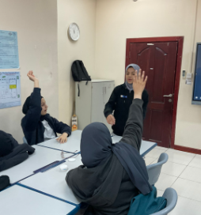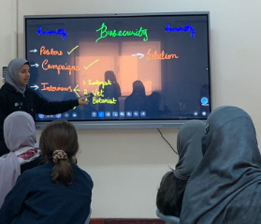

***Preparation phase***

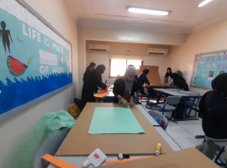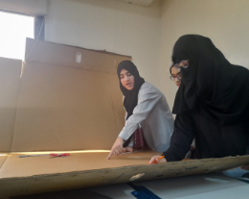

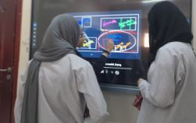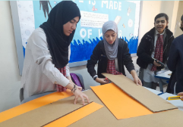

***Implementation phase***

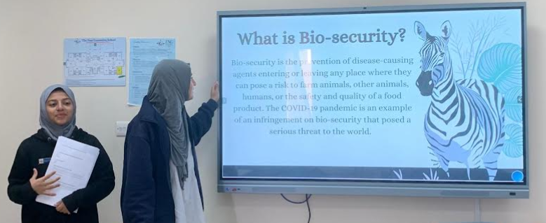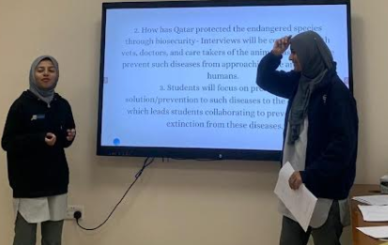

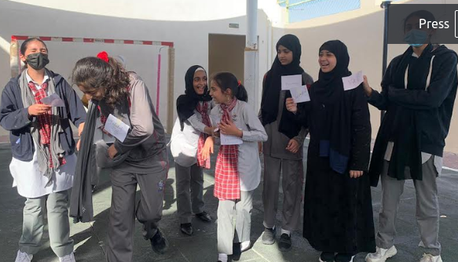

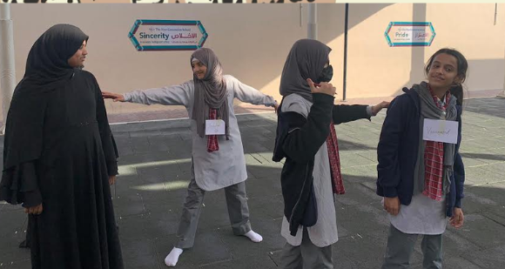

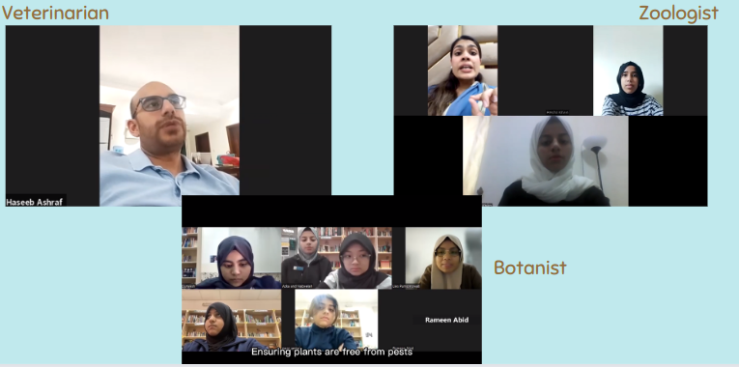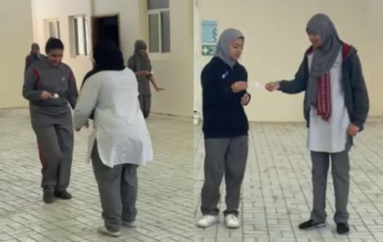

**Reflections**

**Mentor: Nabeelah Khan, 9C**

|  |
| --- |
| In my opinion, this was the most enjoyable YLP I have ever done. As a mentor, I value collaboration and critical thinking. And through this, we were able to sharpen a variety of skills.  What I liked best about this project was that it was unique and that we were able to achieve our objective. We were able to communicate our message, which I believe is especially important in light of the pandemic. We critically examined the issues and attempted to present a solution. However, I believe that the project would have improved if we had interviewed the Ministry.  There was difficulty in selecting a topic. However it was sorted but I think, that if we had worked on our weaknesses then we would have finished our project a bit earlier. Overall, it was a different experience than last year's as we had a suggestive working model. This project helped me polish my time-management and communication skills. The choice of a topic was difficult. However, it was resolved, but I believe that if we had focused on our weaknesses, we would have completed our project significantly earlier. Overall, the experience was different from last year's because we had a suggestive working model. This project helped me improve my time management and communication abilities. |

**Student: Hamdiya Yaser, 9C**

|  |
| --- |
| I, as a student of 9C, think that our project was influencing and powerful this year. What I really liked about this project, was that the main topic, and how our class, as a team implemented it. The model, presentation designs, the plan, everything was amazing, and up to the standard. On the other hand, what might have stained our paper was the video, where there was a slight problem in the audios. Nevertheless, it was an amazing experience, where we got to present and work face to face, rather than online, which also improved our speaking and presenting skills. Overall, it was a boost of fun and collaboration, and I hope we have a better one again, next year. |

**Student: (Fatima Ilyas, 9C)**

|  |
| --- |
| According to my opinion our recent ylp project was a significant improvement compared to the previous year’s project. Our project successfully met its objectives by utilizing various activities in addition to the students’ diligent research. These activities included games for younger students and interviews with specialized veterinarians,botanist and zoologist. Although our ylp journey was great, there were areas that could have been better, such as the video's short duration and the completion of the project's main model. To improve, we could have started working on these aspects earlier in the project. Overall, through this ylp journey, I developed better communication and collaboration skills |

**Student:- (Rameen Abid, 9C)**

The Biosecurity YLP project provided me a comprehensive exploration of the critical topic of biosecurity, including risk assessment, biosafety, biocontainment, and bioterrorism. While the project had several strengths, such as its use of various resources and its broad coverage of the field and interactive elements one of its weaknesses was the lack of hands-on experience. To improve the project, even more, practical activities could be incorporated, along with guidance on applying knowledge to real-world scenarios. Nevertheless, the project helped me develop critical thinking, research, and communication skills. Overall, the Biosecurity YLP project was a valuable experience that provided me with a foundational understanding of an essential topic, and I look forward to further exploring the field in the future and implanting what I learned.

**Teacher: (Miss Nadiya)**

|  |
| --- |
| Youth Leadership Programme 2022-23 has been quite a journey. The students were able to narrow down on a relevant issue, which is centred around the issue of biosecurity of Qatar- how it was affected during the Covid and how Qatar improved upon it. “PROJECT RECURITYY” based on extensive research and analysis instilled creativity in the students, where they thought about out of the box ideas and solutions to the problem in hand. It was overwhelmingly memorable journey as all the students took an active part throughout, and hence has been a learning experience for all. Our students have become more confident and It has inculcated leadership skills in them, fostered mutual understanding, respect, and civic engagement as well. I am sure that the takeaways by our students will serve instrumental in their future endeavours. |