Youth Leadership Programme 2022-23
Journal

Year | 11A
Teacher | AILYN SUNGCAYA
Co-teacher | MADIHA
Mentor | HAADIYA FAYYAZ; ESHAL NAEEM BARG

Project name: | SENSORY ROOM
Objective of the project: | To design a custom sensory room that utilizes a variety of stimuli to aid in the development and engagement of the senses of children and students with special needs.

Description of the project:

Throughout our project, we will conduct a series of activities regarding sustainable development goal# 10: Reduced inequalities in the younger TNG campuses. We want to involve children and people with disabilities in sensory activities that cater to their interests and abilities. Learning to interact with their environment in a supportive environment can enable people with learning disabilities, developmental disabilities, or sensory impairments increase their confidence and skills.

Implementation:

Children with intellectual or physical disabilities who have a hard time expressing themselves inspired our YLP project Stanza Sensorial. Stanza Sensorial stands for sensory room in Italian. We came up with this project to help those children with exploring themselves with the help of the five sensoria’s that are a great way for these special children to understand themselves and others better.
Year 11 A visited AL-Wakra primary and secondary branch and set up a room with multiple activities associating with the five senses that were approved by the psychologist as a good activity for them. The room was filled with bright and colourful items with a soothing background sound for a calm atmosphere. There were nine stations in total each activity relating to a different sense.
Activities included spot the difference that students enjoyed doing with the help of the assigned stationmaster who guided them, another activity related to sight was the reading station where a smart pen was used to read books with the help of the stationmaster inside a children’s tent to make a comfortable reading area. Our class made coloured glasses that were given to the students who wore them and described what they saw in different colours. The stationmasters and students had a wholesome interaction where we kept asking if they were comfortable and enjoying themselves throughout the session.
The sense touch had the most activities, which also seemed to be enjoyed the most by the children too. It included playing with blocks where children built what their imagination led them too as the stationmaster cheered them. The station next to the blocks had kinetic sand with which the children felt its weird texture to give them a giggle. A separate board was made for them to touch and feel different materials and textures of different objects so they can guess if they recognize them. Another activity related to touch were the foam floorboards with the children fit in the puzzles inside the floorboards with the help of the stationmaster.
The next sense was silent disco where students wore headphones and listened to multiple sounds. One stationmaster made them listen to comforting instrumentals and the other stationmaster made them guess different sounds that the children had a fun time guessing and hard time leaving the comfort music. Next was Aroma station where the students smelled various smells like flowers, vanilla so on and tried to guess them. Last but not least, once it was time for the students to leave stanza sensorial they were each given a treat for the last sense taste!
Year 11 A had a fun time organizing and interacting with these students and hopefully helped them realize that they’re no different than others.

What have we achieved from the project?

The sensory room is the space where the individual will receive sensory input so they can control themselves and feel more at ease doing daily activities. The sensory room will assist them in creating a private environment where they may study and develop their social skills. For children with special needs, a sensory room will have numerous impairments, thus having one will give them a secure and encouraging learning environment. The use of sensory activities in the classroom will help pupils decompress and improve their study skills. -Ms. Nubla

Way forward (How do we want to expand our project?):

Sensory rooms are highly recommended to kindergarten schools as it creates a safe space designed to help an individual with sensory issues learn to regulate their brain’s negative reactions to external stimuli by developing coping skills for these experiences.

How did we involve the community in our project?
11A worked with TNG Al Wakra Primary and Secondary where they catered the students with special needs and Year 1 class with their prepared sensory activities.
Two students, Haadiya and Khadija, created biodegradable crayons which is safe for the children and sustainable to the environment. They presented it at Qatar Youth Science Forum and won 4th place. Their project will be presented at the upcoming London International Youth Science Forum this July 2023.

Skills developed during the project:
Leadership skills, time-management, communication skills, kinesthetic, visual skills, collaborative skills, innovative skills

Glimpses from our Youth Leadership Programme:

Planning phase (photos)

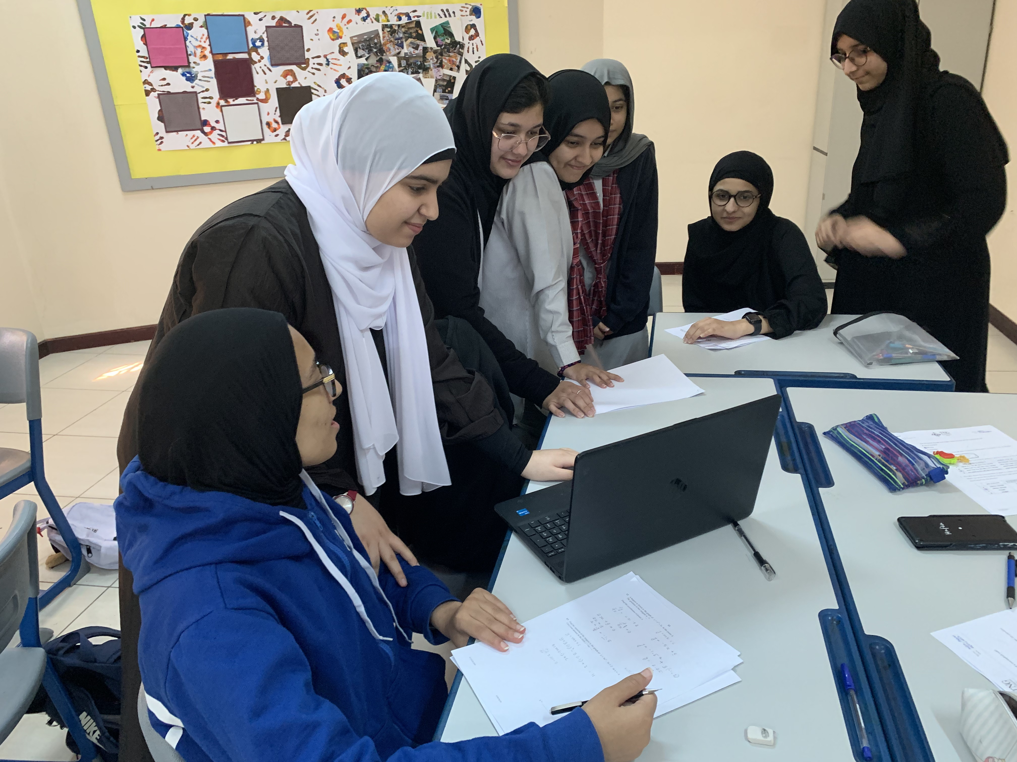

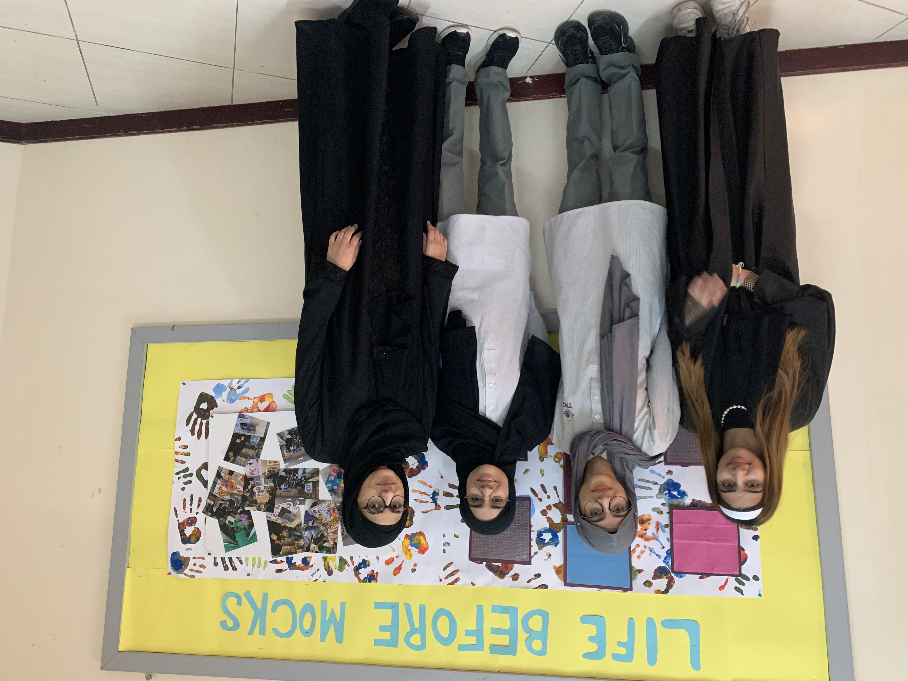

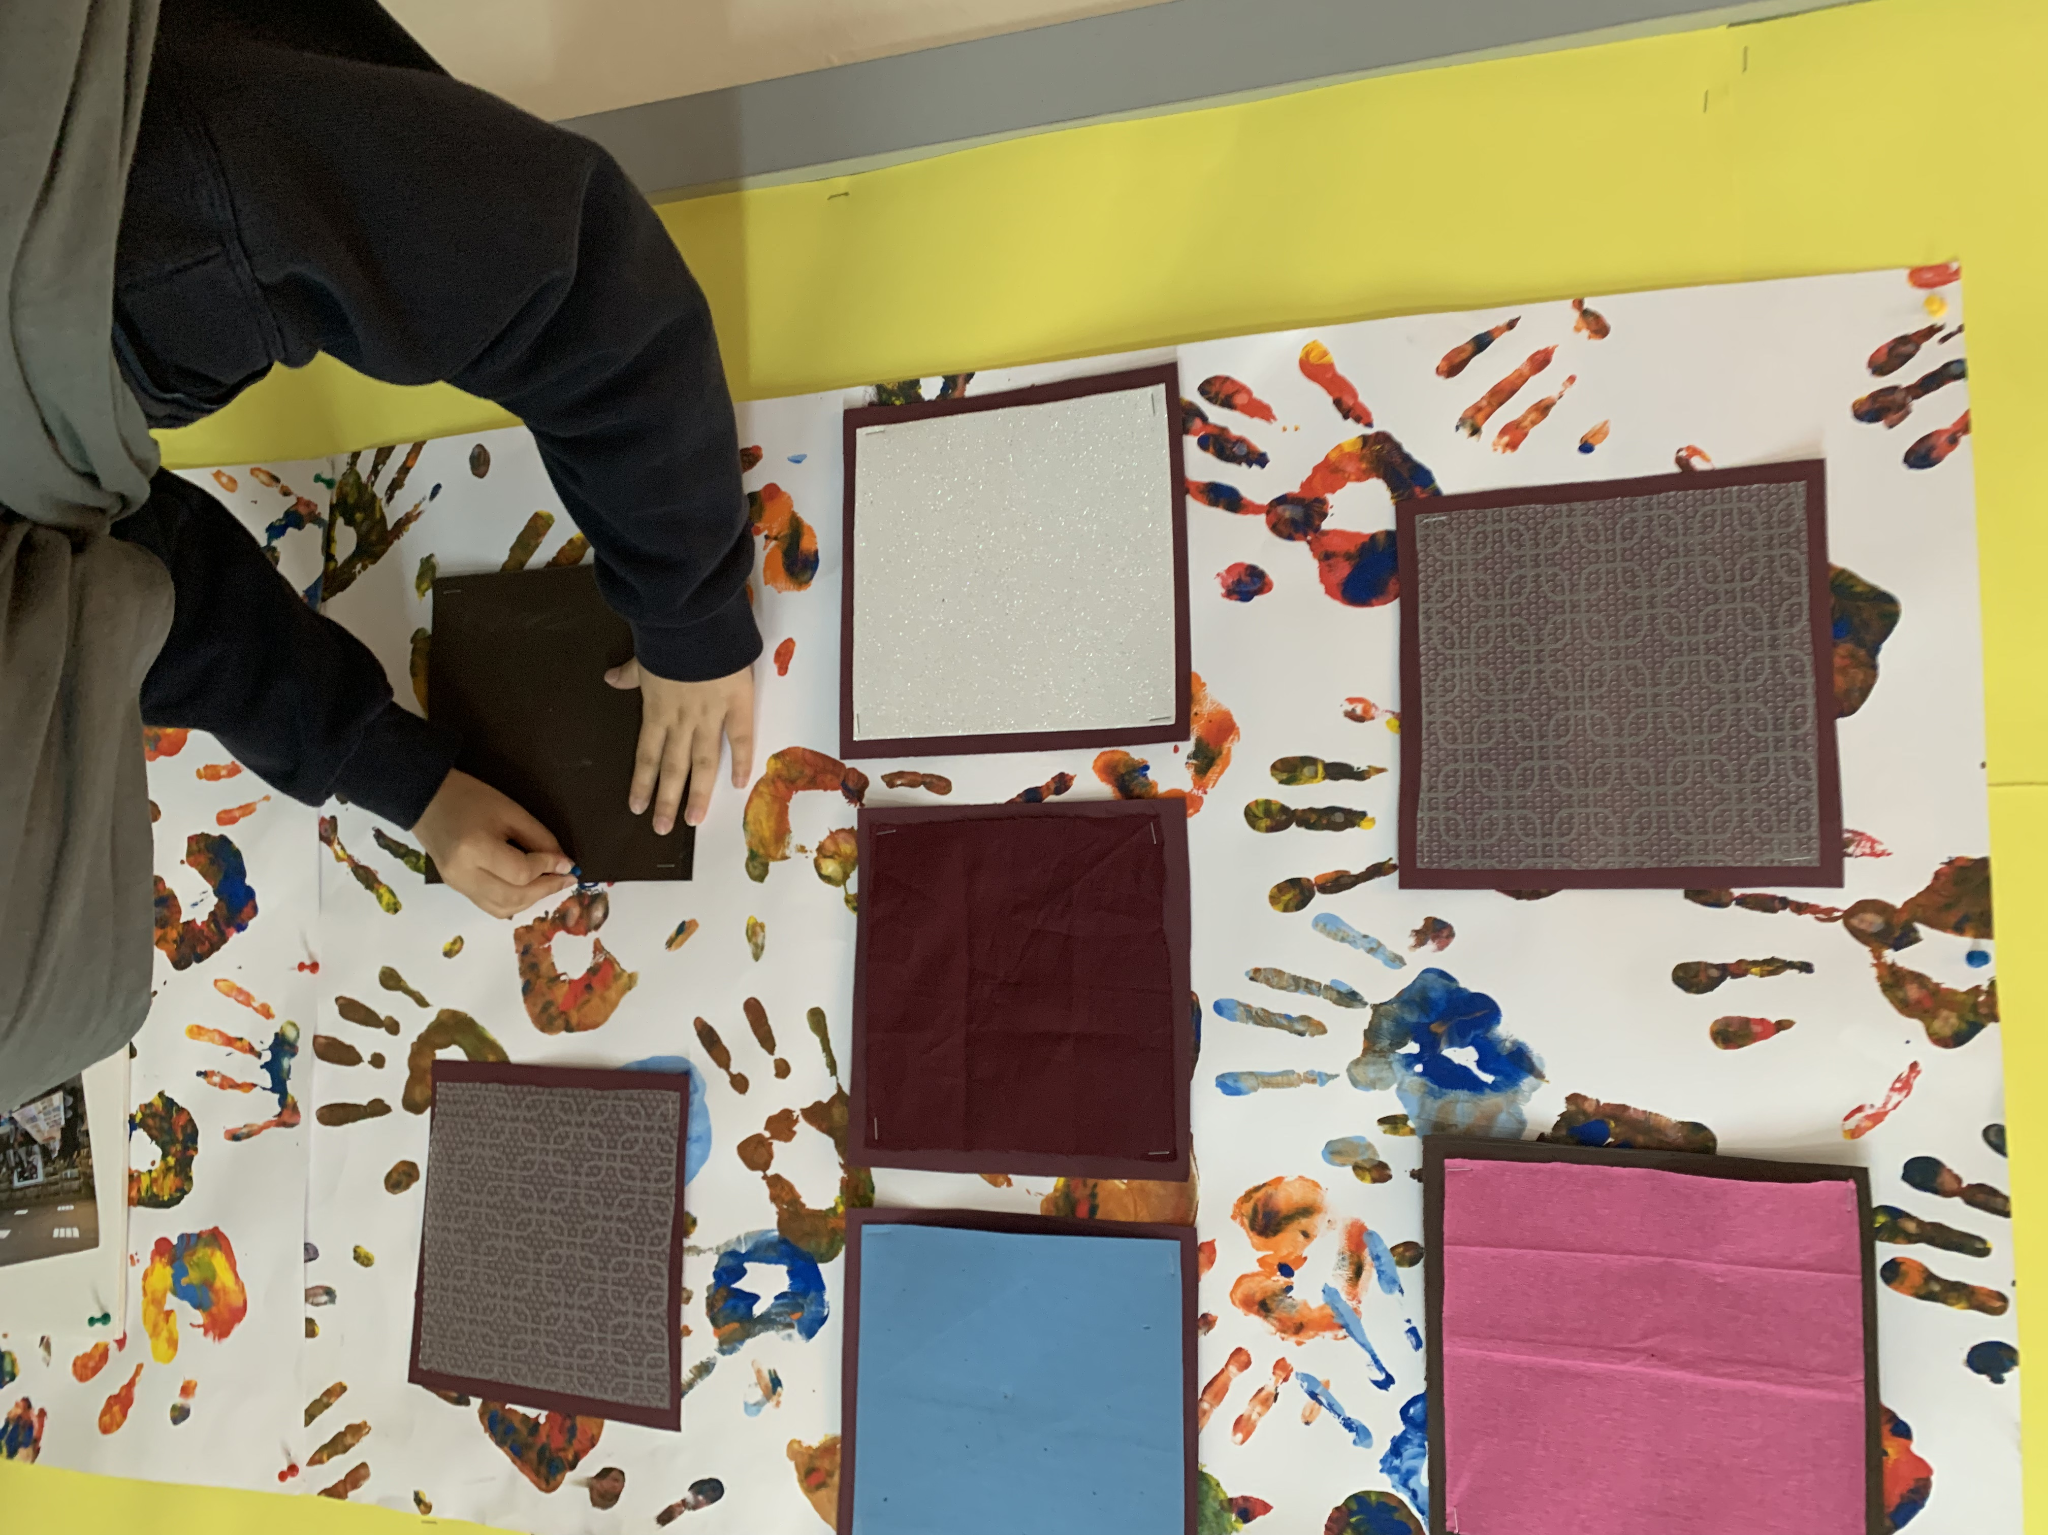

Preparation phase (photos)
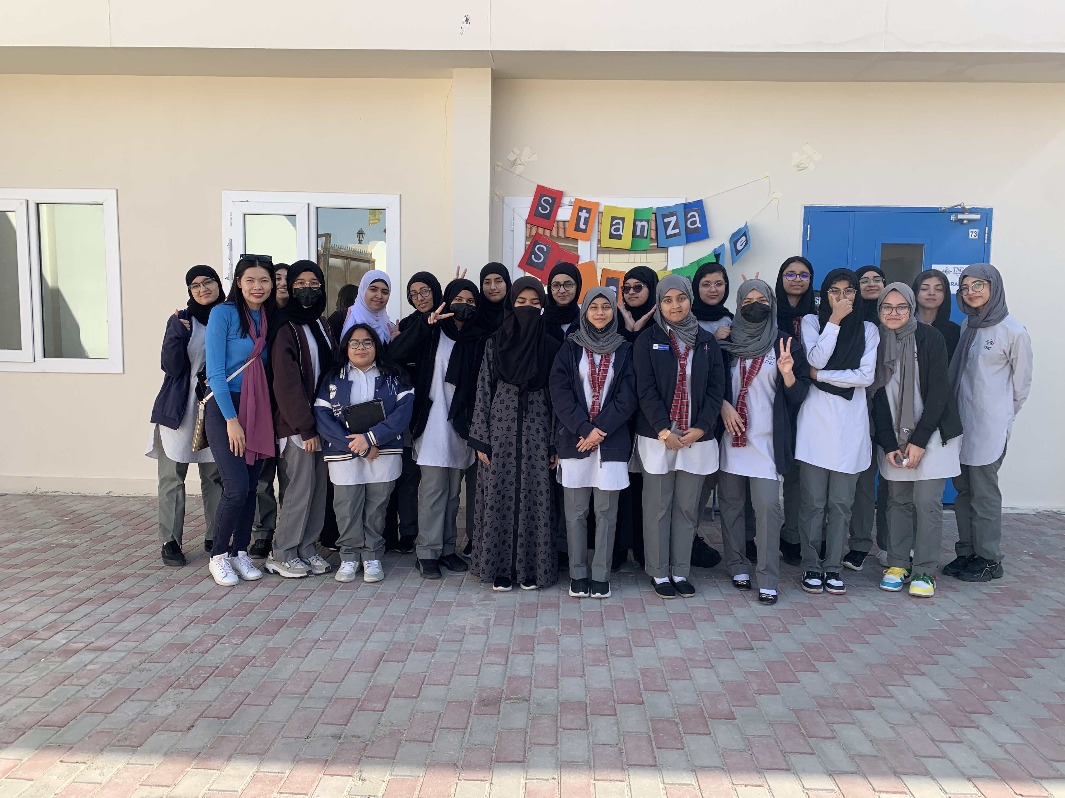

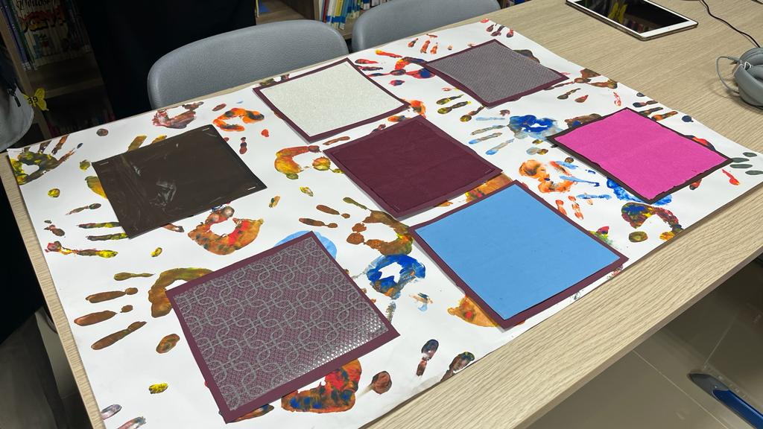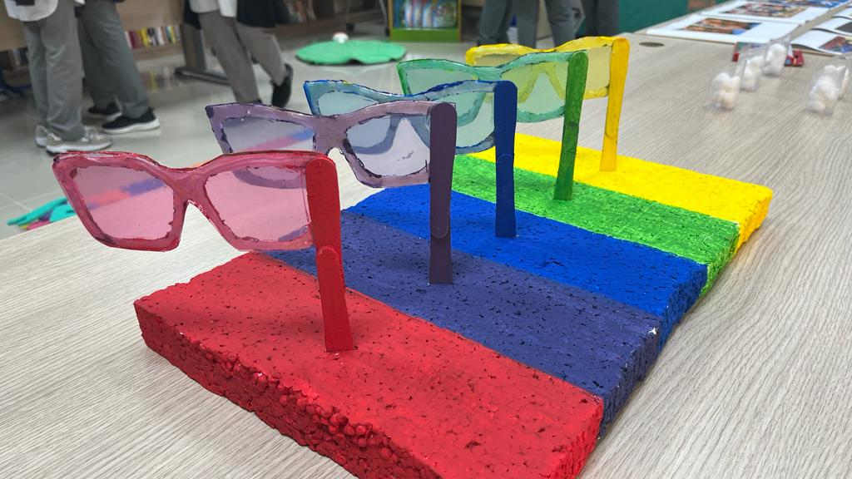

Implementation phase (photos)

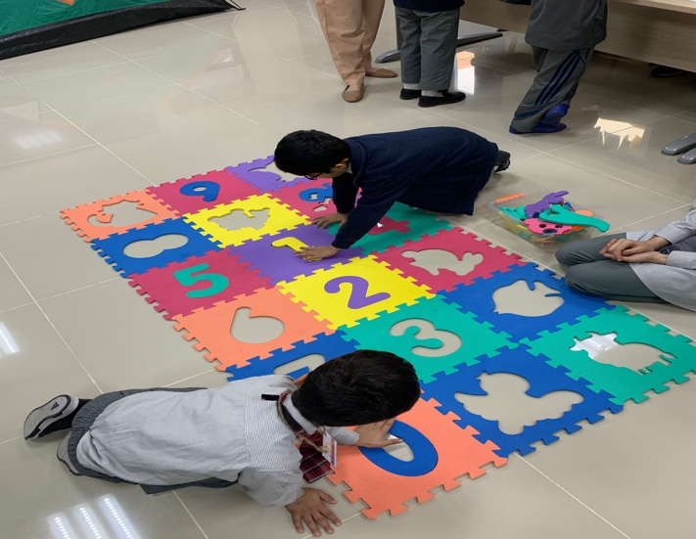

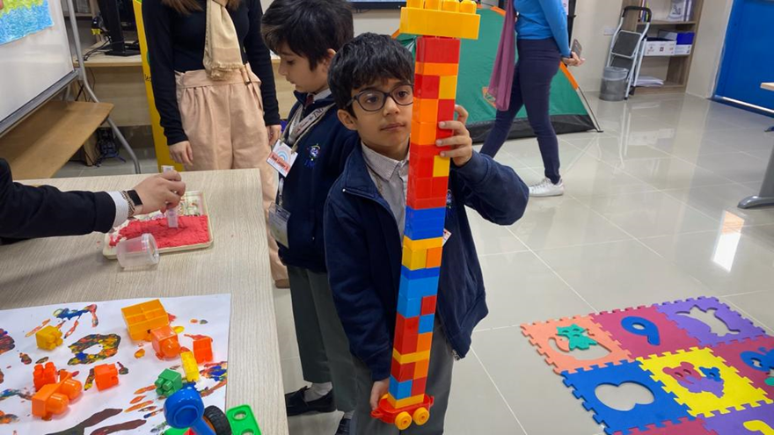

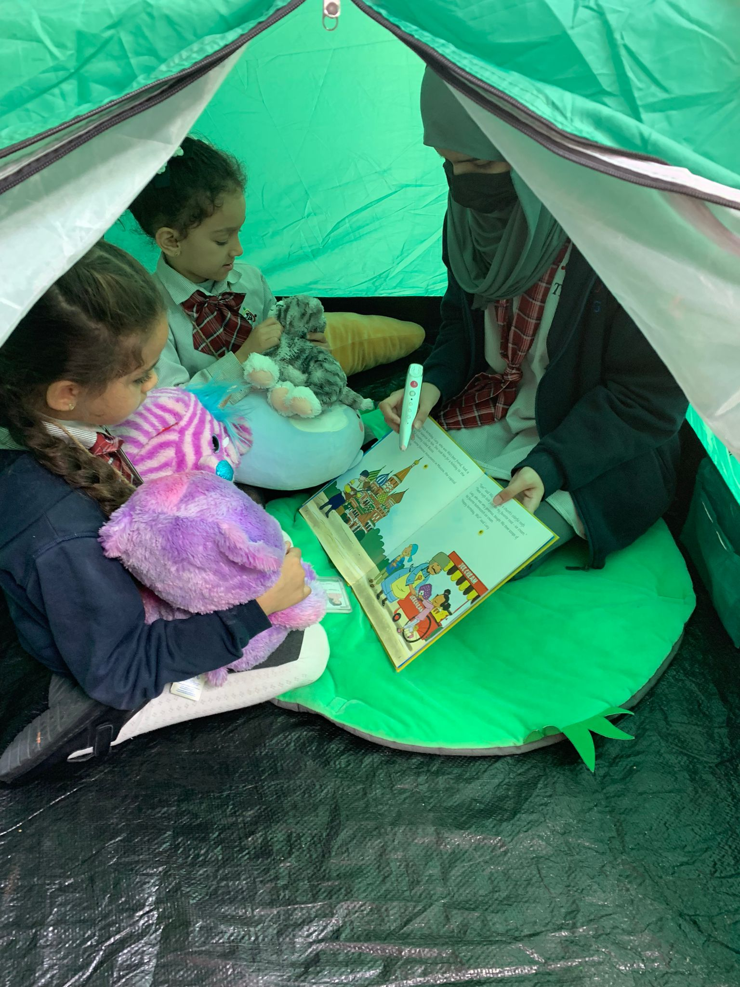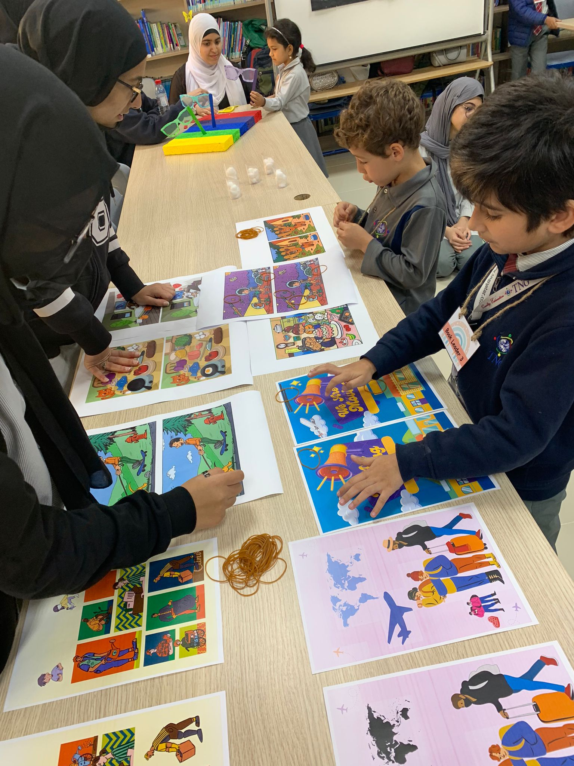

Reflections

Mentor: (Eshal Barg, 11A)

Our project was very productive this year. We had a lot of activities for our sensory room and the special needs kids and children clearly had a lot of fun as they checked out the different varieties of sensory games. We didn’t restrict ourselves and had everyone participated and included. I believe that we definitely did a good job at educating not only people but ourselves since I learnt a lot while researching for our project as well. I do feel that if we didn’t have IGCSE maybe some of our students would’ve been more willing to give more help since it was hard to get some work done at times. We could have been more careful with choosing our room since we took the library and all the books and computers can be very distracting to the special need kids. I’ve learnt so much from this project about sensory impairment and how to be patient with special need kids. I’ve gained communication and leadership skills from our project regarding sensory impairment.

Mentor: (Haadiya Fayyaz, 11A)

Our project this year was very fun and unique to carry out. It allowed us to expand our creativity by thinking outside the norms of formulating a presentation or a video along with actually being able to implement what we learnt for the benefit of others in the community. Keeping in mind that our project was conducted on the set date and was carried out smoothly within the time and space alloted to us, in my opinion, our project was a success. Having said that, I feel that our project could have been better managed if the assigned tasks were completed within the time frame, in order to avoid any clashes with other procedures going on at the same time. Overall our project was prodigious and delightful-an experience to remember for the rest of our lifetime.

Student: (Irha Khan, 11A)

Our project this year, in my opinion, was successful. We were able to accomplish our goal towards the end of our project, which is something I truly appreciated about it. We were successful in getting our point through, which is essential. Executing the project wasn't an issue because we had the tools, we needed to do it. Even, the assistance from the school's resources allowed us to complete the job promptly. However, I believe that since we were unable to locate the required time to finish the project on deadline, time management was the root of our difficulty. By giving everyone a specified assignment to do within a set amount of time, I believe we may have addressed our weak point in time management. Also, it would have been preferable if we had enlisted the aid of experts with familiarity with the senses who might have provided us with suggestions on how to proceed with the project. Overall, it was a fantastic experience, and we had a great time. While working on this project, I was also capable of strengthening my creativity and collaborative skills, as we looked for entertaining sensory activities for youngsters to participate in.

Student: (Fatima Zahra, 11A)

I believe this year's project was successful. The concept behind our project was something I truly enjoyed. Together, we were able to accomplish our major goal, and we had a successful YLP.
Yet I thought that the youngsters' shyness prevented us from engaging them in conversation. They usually interacted with the teachers to ask for assistance. If we could speak with the student personally, I believe our effort would be more successful and have a greater impact.
Overall, it was a different experience than last year, when we were able to engage kids on the primary campus, put our YLP idea into practice, and inspire them. Also, this endeavor aided me and many others in improving our communication abilities. Thus, in the end, I believe the YLP initiative was terrific.

Student: (Jana Ahmed, 11A)

In my view, our project this year was quite victorious as we achieved our goal. The project implementation went smoothly as we had the required tools, gadgets and support from the school recourses. However, time management was quite a challenge, which could have been addressed by assigning specific task within a set time frame and a group of people to work on them. Additionally, expert input on the project’s subject matter would have been helpful too. Despite the challenges that we faced, the project was overall a great experience that helped me develop my creativity skills and gain more team work skills too while coming up with fun activities for the children and implementing them too. Altogether, there was great participation from everyone in class and it was a fantastic experience.

Teacher: (Ailyn Sungcaya)

I find our project very strong this year. We prepared sensory activities to cater the students with special needs in which I’ve seen empathy in action towards my students during the implementation phase. The presence of Ms. Nubla, the school psychologist, strengthen our effort to achieve our ends. We conducted interviews with her which allows us to understand further the importance of a sensory room in a kindergarten school. However, the project would have been better if we were given a room with less wall destruction to maximize the activities prepared for the students. This project is highly recommended for all TNG Primary Campuses as it promotes a positive environment and safe space with the goal of stimulating other senses that are less likely used in class. Overall, it was a collaborative experience for the whole class where they showcased their creativity, communication and management skills in their respective sensory activity.

