 **The Next Generation School**

**Wakra Primary and Secondary Campus**

**AY 2023 -2024**

**Youth Leadership Programme**

**Year / Class 3B**

**A. Project Title:**

Life on Land

**B. Name of the Students:**

|  |  |
| --- | --- |
| 1 | Muhammad Taashfeen Malik |
| 2 | Waniya Afzal |
| 3 | Noor Ul Huda Khan |
| 4 | Hafsa Aleem Akram |
| 5 | Arham Javed Bhatti |
| 6 | Muqaddas Yasir |
| 7 | Madiha Tariq |
| 8 | Muhammad Ahmed Tahir |
| 9 | Rehab Fatima |
| 10 | Hassan Fouad Shafiq |
| 11 | Hareem Shahid |
| 12 | Manha Umair Qureshi |
| 13 | Abresh Mehtab |
| 14 | Muhammad Haider Aslam |
| 15 | Ayaan Aslam Malik |
| 16 | Abdul Haadi Rasool |
| 17 | Rahma Ahmad |
| 18 | Addan Mansoor |
| 19 | Irha Umair |

**C. Name of the Teachers:**

Ms Preethy Anto Fernandez

Ms Soumaya Boulmaache

**D. Poster / Pictures:**

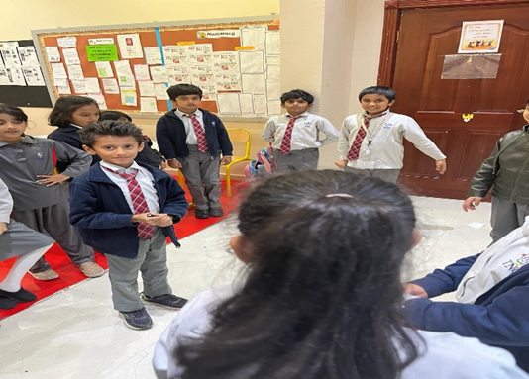

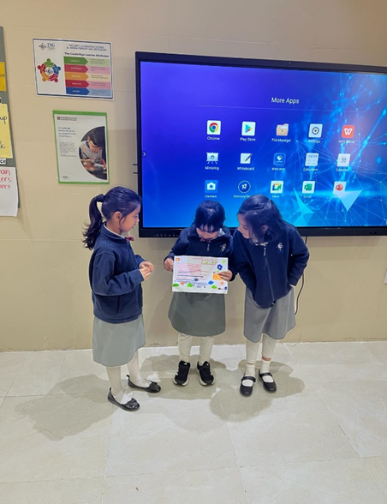

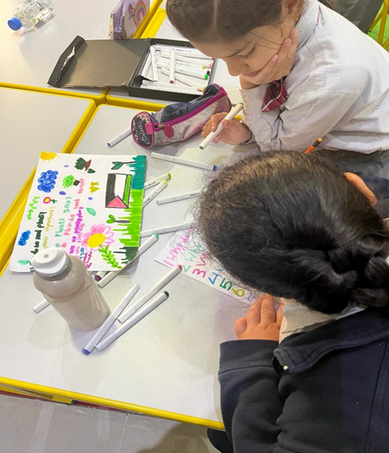

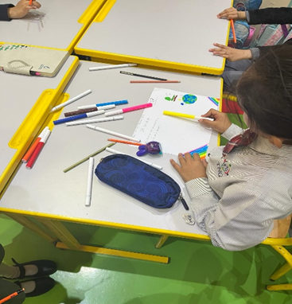





**E. Synopsis of the Project:**

**Understanding the concepts of, Protect, Restore and promote sustainable use of terrestrial ecosystems, sustainably manage forest, combat desertification, and halt and reverse land degradation and halt biodiversity loss.**

**Students watched the resources regarding life on land and discussed the importance of preserving life on land. Students were able to analyze each one’s duty to protect the precious life on land.**

**Students prepared posters and charts related to SDG goal 15- life on land. They also prepared a survey on the topic and presented PowerPoint presentations in the other classes which gave them confidence and more involvement to understand the topic very well.**

**F. What are the key takeaways from this year's Youth Leadership Programme?**

**1. More active participation of students**

**2. Students could enthusiastically and curiously be involved in YLP**

**Journey.**

**3. Better hands of parents support and their personal involvement**

**G. What are the plans for the next Youth Leadership Programme in the upcoming academic year?**

**1. Better look ahead and subject choose.**