YLP

2023-2024

Event Tourism

Events in Qatar

**AFC Asian Cup 2023**

On 17 October 2022, Qatar was announced as the bidding champion to host the AFC Asian Cup 2023. This will be Qatar's third time hosting the tournament after 1988 and 2011. The event will take place from 16 June-16 July 2023.

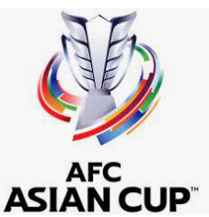

AFC U23 Asian Cup 2024

Qatar is the chosen destination to host the AFC U23 Asian Cup 2024™ by the Asian Football Confederation (AFC) Competitions Committee. Qatar previously hosted the tournament in 2016. The event dates are 10–28 January 2024.

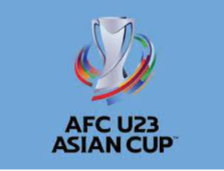

Expo 2023 Doha Qatar

Expo 2023 Doha Qatar will be a first-of-its-kind horticultural exhibition in the Middle East and North Africa. The expo will open on 2 October 2023 and will be 179 days of celebration running until 28 March 2024, with 3 million worldwide visitors expected.



21st FINA World Championships Doha 2024

The 21st FINA World Championships Doha 2024, also known as the World Aquatics Championships, is expected to showcase the best of aquatic sports.  
  
The championship, set to take place from 2-18 February 2024 in Doha, will watch international athletes compete in swimming, diving, high diving, open water swimming, artistic swimming, and water polo.



Formula 1 - Qatar Grand Prix

For those F1 racing lovers in Qatar, 2023 is the year! The Qatar Grand Prix will be back in 2023 after its first edition in 2021. The event will take place at the Lusail International Circuit from 6-8 October 2023.



Geneva International Motor Show Qatar 2023

The Geneva International Motor Show is a car showcasing platform. Coming to Qatar for the first time, the Geneva International Motor Show Qatar will take place at the Doha Exhibition and Convention Center (DECC) from 5-14 October 2023.

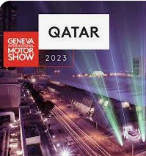

ITT (Institute of Travel Tourism) Conference

The ITT Conference is a prestigious event of the travel industry which hosts ITT Members and senior figures from the UK travel and tourism industry.

The conference will take place from 5-7 June and is open to ITT Members, including tour operators, travel agencies, airlines, hoteliers, cruise lines, tourist offices and more. Other specialists working within the travel and tourism sector can also attend.

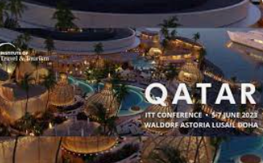

Qatar Auto Museum

The much-anticipated Qatar Auto Museum is expected to welcome car enthusiasts in 2023. Under the umbrella of Qatar Museums, this museum is expected to be a space for Qatar's car community to come together.

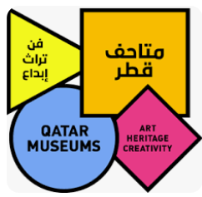

Volleyball Beach Pro Tour Finals 2023

The Volleyball Beach Pro Tour Finals 2023 will be the first of three Beach Pro Tour Finals to be held in Qatar from 26-29 January 2023. It will be the final round of all beach volleyball tournaments, and the best 8 teams in the world rankings will participate.

