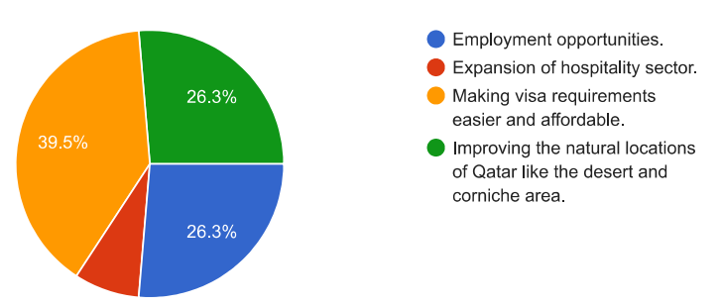

**SURVEY RESULTS – PARENTS.**

Tourism for economic growth and our proposals.

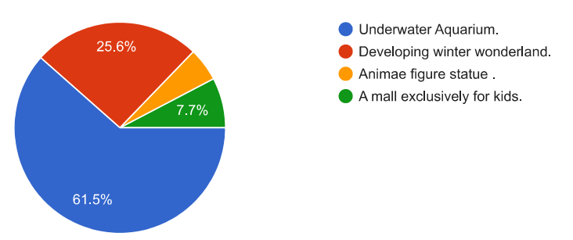

**SURVEY RESULTS – TEACHERS.**

**

Tourism for economic growth and our proposals

**SURVEY RESULTS – STUDENTS.**

 



