



Youth Leadership Program

AY 2022-23

Project Title: How Climate Change Affects Our Health
Sustainable Development Theme 13: Climate Change

Class | Year 2C
Teacher’s Name | Ms. Dipika
Co – Teacher’s Name | Ms. Faiza

Table of Contents

- Summary of the program

Some key pictures
- Youth Leadership Program of 2C

Planning phase
    - Training

Meeting with deputy headmistress
    - Brainstorming session with the class

Execution phase
    - Development of big questions

Student appreciation
    - Inclusion of Qatar identity

Community engagement
    - Classroom displays

Work of gifted and talented
  - Analysis phase

Learning result analysis
    - Sample of student YLP report

Analysis and reflection phase
    - Parent feedback and appreciation

Student’s reflection
    - Teacher’s reflection

Way forward

- Summary of the Program

Changes in weather and climate patterns can put lives at risk. Climate change affects the social and environmental determinants of health-clean air, safe drinking water, sufficient food, and secure shelter. Climate change is the single biggest health threat facing humanity, and health professionals worldwide are already responding to the health harms caused by this unfolding crisis. Between 2030 and 2050, climate change is expected to cause approximately 250000 additional deaths per year, from malnutrition, malaria, diarrhea, and heat stress. Rising global temperatures lead to more frequent and intense heat waves. Heatwaves can cause heat exhaustion, heatstroke, and dehydration, particularly among vulnerable populations such as the elderly, children, and those with pre-existing health conditions. Climate change contributes to increased air pollution. Higher temperatures and changing weather patterns can worsen smog and increase the concentration of ground-level ozone, leading to respiratory problems like asthma, bronchitis, and other cardiovascular diseases. Climate change affects the distribution and behavior of disease-carrying vectors such as mosquitoes and ticks. Warmer temperatures and altered precipitation patterns can expand the range of these vectors, increasing the transmission of diseases like malaria, dengue fever, Zika virus, Lyme disease, and West Nile viruses. Climate change can prolong the pollen season and increase the production of allergenic substances. This can worsen allergies, asthma, and other respiratory conditions, impacting the quality of life for those affected. Climate change can have psychological and emotional effects on individuals and communities. The loss of homes, livelihoods, and communities due to extreme weather events can lead to stress, anxiety, depression, and post-traumatic stress disorder (PTSD). Additionally, the uncertainty and fear associated with the impacts of climate change can contribute to mental health issues. Climate change disrupts agricultural systems, leading to reduced crop yields and increased food insecurity. Lack of access to nutritious food can contribute to malnutrition, especially among vulnerable populations, leading to various health issues, including stunted growth, developmental problems, and weakened immune systems.

Addressing climate change and its health impacts requires a multi-faceted approach, including mitigation efforts to reduce greenhouse gas emissions, adaptation strategies to build resilience, and improving access to healthcare and public health infrastructure to address the health consequences.

Some key pictures

Year 2C was divided into four groups to answer our big question: How climate change is affecting our health? Why global warming is dangerous? How can we help our environment? How air pollution is affecting our health?

During the YLP presentation, the Feel Group discussed what they felt and researched how climate change is affecting our health. Imagine Team talked about possible solutions to make it more fun, inclusive and sustainable. The Doers explained the chosen method by the class to answer our big question which was survey questions. The Sharers showed pictures to impart the results of the research to the parent and student-teacher visitors from Iqra School.

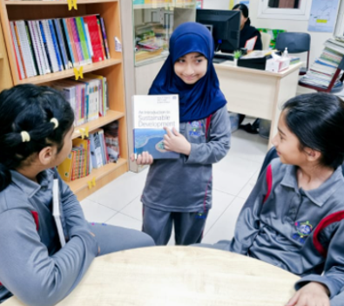
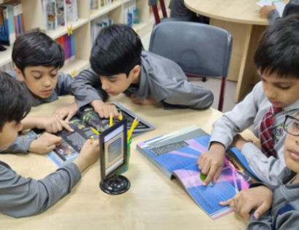
Feel Team Imagine Team

The Doers Imagine Team
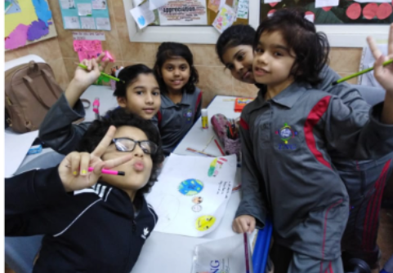
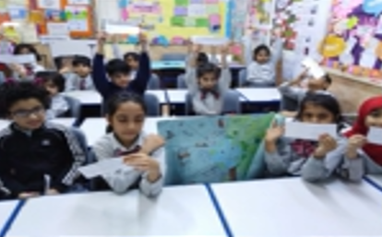

Youth Leadership Journey for Class 2C

- Planning Phase

Self-Training
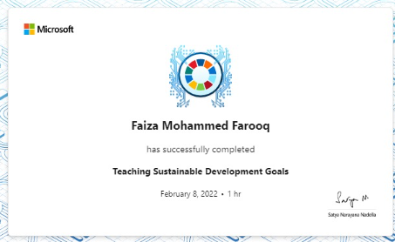
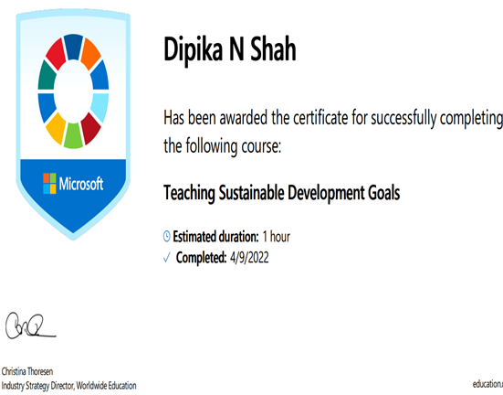
We enrolled in Microsoft Education Centre and a course in “Teaching Sustainable Development Goals” and obtained our certificates.

Earthna Summit – Joined the delegates of the school to learn more about building new sustainability pathways for hot and arid environments like Qatar. This is the note from TNG AK Deputy Headmistress, Miss Lally.
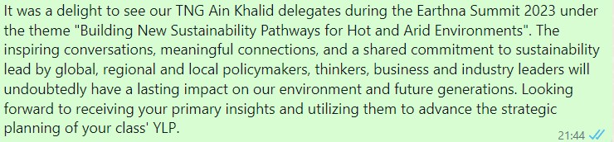
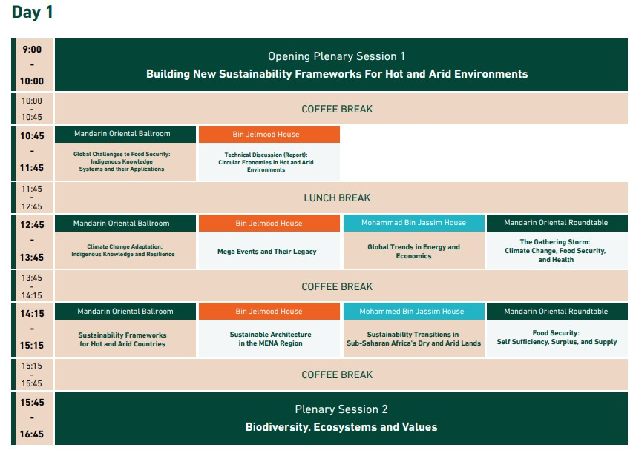

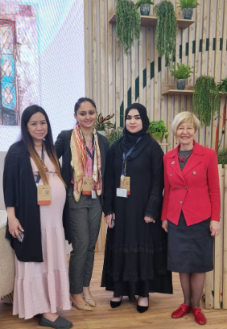
4

  - Meeting with Deputy Headmistress:

There have been series of meetings with Miss Lally regarding the topic chosen to tailor the research project of Year 2C to ensure it makes a lasting and deeper impression on the learners: from the conceptualization of the topic from Science Fair to making it more specific and engaging to the young minds. The survey questions were also suggested to make the research measurable, relevant and achievable. The YLP presentation was made powerful with the large displays on foam boards of the children’s YLP Journey following the advice from the deputy headmistress.

Brainstorming session with the class

Planting:

We celebrated Green Day at TNG Ain Khalid. Children of class 2C learned toll activities recorded through planting from scratch: Planting activities provide hands-on learning opportunities for children. They can learn about plant life cycles, photosynthesis, the importance of sunlight and water, and the role of plants in our ecosystem. It helps develop their scientific knowledge and understanding of the natural world. By participating in planting activities, children develop an appreciation for nature and the environment. They learn about the significance of plants in mitigating climate change, improving air quality, and providing habitat for wildlife. This can inspire them to become environmentally conscious individuals who care about protecting the planet.

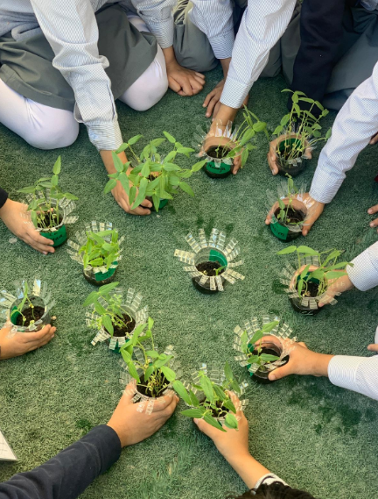
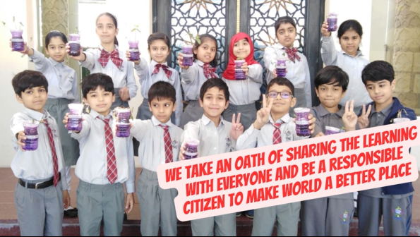

Execution Phase :

a) Development of Big Questions:
Big questions challenge students to think critically and engage in deeper analysis. They encourage us to consider different viewpoints, evaluate evidence, and develop logical reasoning skills. By grappling with these questions, we develop our ability to think independently and make an informed judgment
Students were curious to find the answers to their big questions like: Why there is global warming?
Why there is so much acid rain?
Why do people waste so much water?
Why there is smoke everywhere? How climate change is affecting our health?
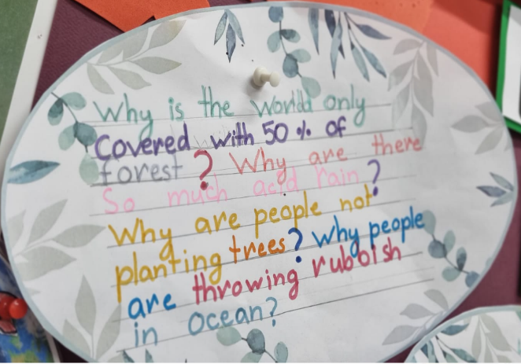
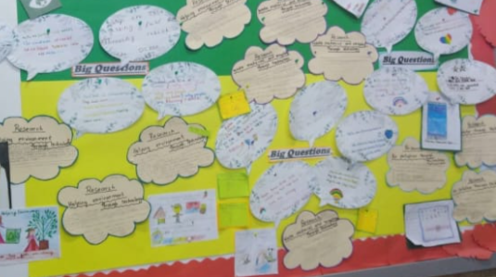

b) Student Appreciation:

Student appreciation is the recognition and acknowledgment of students’ efforts, achievements, and contributions within an educational setting. It is an important aspect of fostering a positive and supportive learning environment. Recognizing and appreciating students’ hard work and dedication can have numerous benefits, including increased motivation, improved self-esteem, and a sense of belonging.

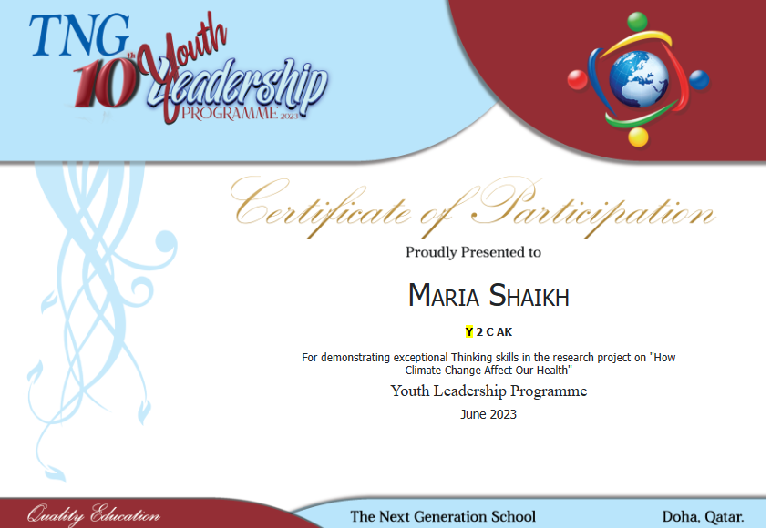

c) Inclusion Qatar Identity:
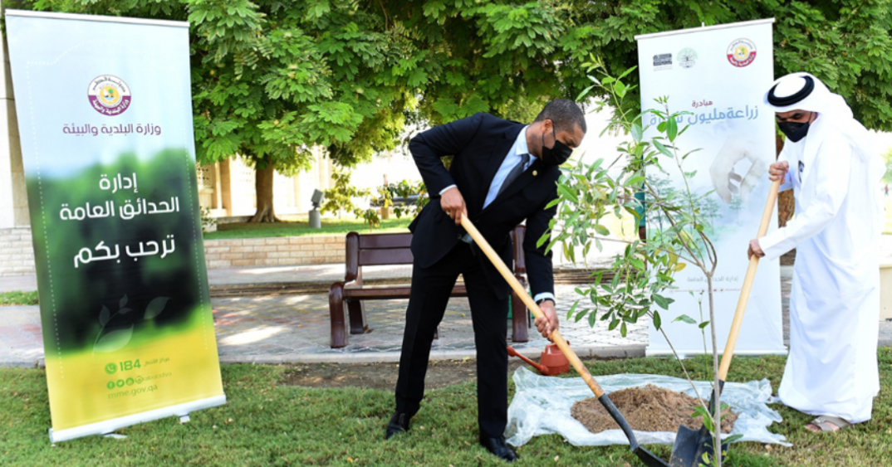
Students got involved in plantation activities where they understood the importance of plantation through research and knowing about the activities happening around Qatar. Qatar enhanced its efforts in addressing climate change by creating Ministry of Municipality and Climate Change and launching Qatar National Environment and Climate Change Strategy in 2021.
Qatar has achieved remarkable achievement in protecting environment and addressing climate change at national, regional and international levels, in addition to setting future plans for further accomplishments in line with Qatar National Vision 2030

d) Community Engagement:

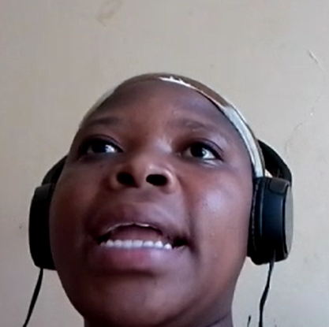
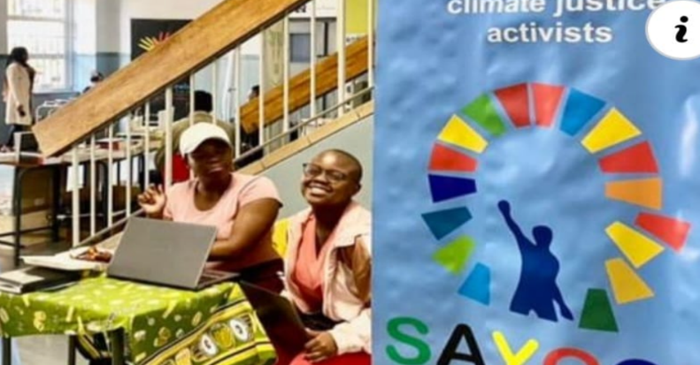
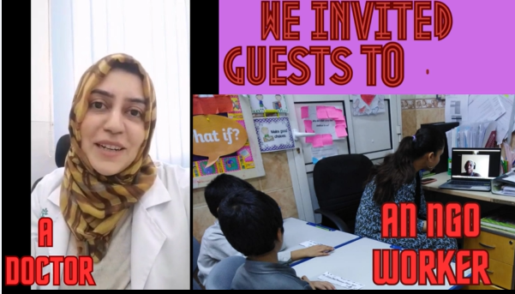
Dr.Azra Zehra participated in community engagement and shared her knowledge on climate change. She explained the importance of planting and a green city. She urged students to appreciate nature and a clean environment. Through the video, they also learned the significance of plants in mitigating climate change, improving air quality, and providing habitat for wildlife. She spoke about the ozone layer in Australia. She encouraged the students to become environmentally conscious individuals.

South African youth climate changecoalition,
Witisieshoek, South Africa is an NGO that came online to give a presentation on how climate change is affecting the environment and our health. Students had an opportunity to ask their big questions to her. Ms.Amanda Mlaba answered all the big questions and explained the importance of helping the environment. She also gave different examples of how her NGO is spreading awareness throughout different parts of the world.

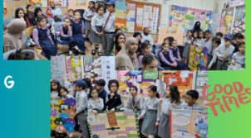

Classroom Displays:
7

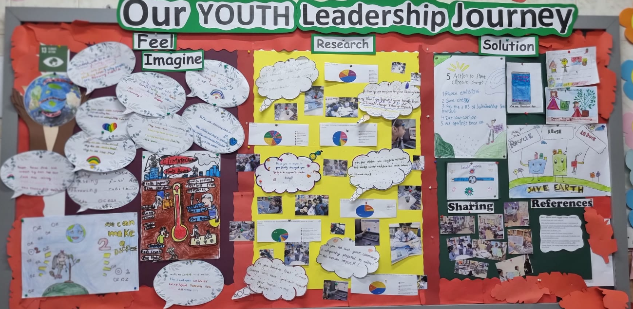

- Work of gifted and Talented students:
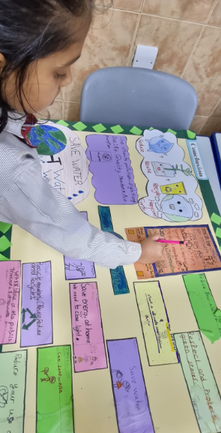
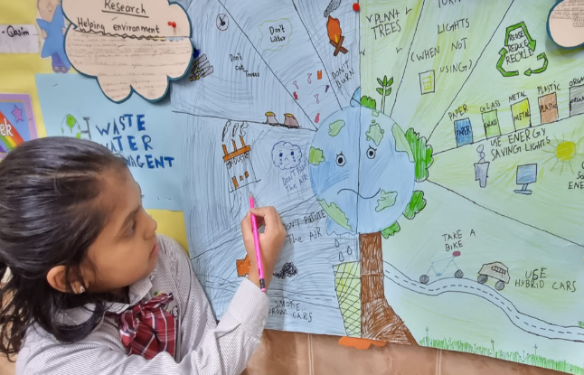

Maria Shaikh displayed a strong desire for knowledge and was engaged in independent research to pursue advance knowledge on climate change. She was always keen on exploring opportunities for further exploration.

Maria Shaikh displayed a strong desire for knowledge and was engaged in independent research to pursue advanced knowledge on climate change. She was always keen on exploring opportunities for further exploration.

- Analysis Phase:

  - Learning Result Analysis :
Year Group/Section | 2 C
Class Teacher | Ms. Dipika
Assigned Co-Teacher | Ms.Faiza
Date | 30/3/2023

Overall Class Analysis:

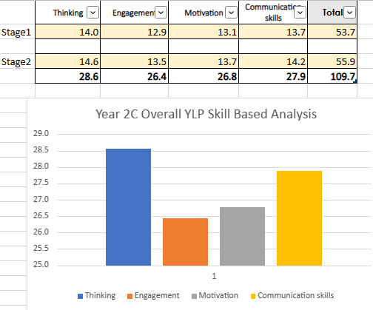

Analysis:

Year 2C shows evident growth and improvement in thinking skills. Ice breaking was done by showing them related videos and conducting research. The observation was made during research, quiz, surveys, group discussions, etc. Students were able to understand the given SDG topic. After continuous research, they began to understand the problem faced by our environment. They chose their own big questions and started to research their topic. They also participated in the plantation activity and learned everything from scratch, this was their first step towards creating green cities in Stage 1. Students had the opportunity to ask their research and survey questions to one of the international NGOs during an online zoom meeting.

In stage 2 there is significant growth in communication and skills. The major activities that helped improve learners were posture making, creating YLP posters, survey and research questions, group discussions, project making, and presentation on the given topic. Students made their own YLP mini books and wrote their findings on the basis of research conducted by them. They were able to communicate themselves through class presentations and posture-making. In addition, they also learned about how Qatar’s first sustainable city Msheireb downtown. They created survey questions related to climate change and its impact on human health. The survey was conducted in countries like Australia, Canada, India, Qatar, and South Africa.

Outcomes:
Area of Strength | Most Developed Learning Skill | Thinking
 | 2nd Developed Learning Skill | Communication
Area of Development | 3rd Developed Learning Skill | Motivation
 | Least Developed Learning Skill | Engagement

The youth Leadership program provided a strong framework for the learners to develop their learning results.
In Year 2C the leading skill which shows improvement is thinking and communication.
The learning skill which requires further development is motivation. The major reason for the dip in engagement skills is a lack of exposure to field trips.

Way Forward:
Development of engagement activities to enhance their skills.
- Field trips to conduct surveys physically and better understanding of the big question.
- Having more time for reflection to give immediate and appropriate corrective feedback.
- Parents being part of the theme exploration if possible e.g. activities involving parent and child as recommended by the department or school.

  - Sample of Student YLP Report:
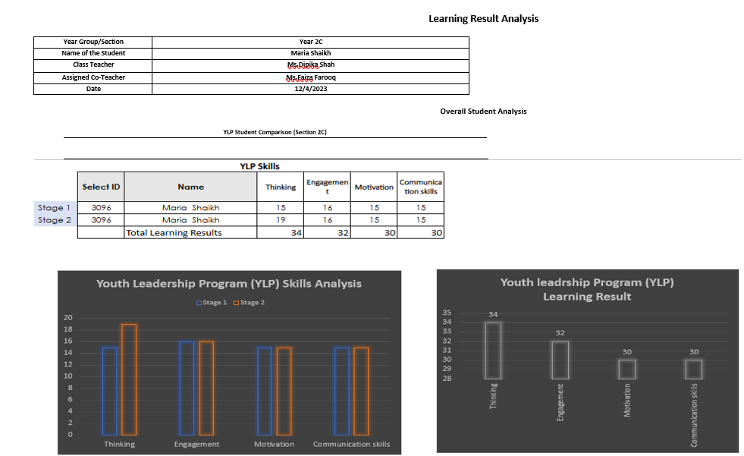

Analysis:
Maria Shaikh shows evident growth and improvement in engagement skills during Stage 1. The observation was made during research, plantation, quizzes, etc. Maria actively participated in all the activities. She was regular in all the lessons. She started researching SDG - goal 13( Climate change). She is able to understand the problems of pollution and other environmental problems. She also actively participated in research activities and shared all her research facts with her fellow classmates.

In stage 2 there is significant growth in the thinking skill.
The major activities that helped improve the learner were poster making, creating a YLP mini book, researching her big question, and presentations. Maria made a wonderful poster. She researched her big question and made a mini book where she wrote the key points. Also, she was able to express her findings about the topic which is “how climate change is affecting human health”. She was also able to come up with many solutions to combat the problems.

Outcomes:
Area of Strength | Most Developed Learning Skill | Engagement
 | 2nd Developed Learning Skill | Thinking
Area of Development | 3rd Developed Learning Skill | Communication
 | Least Developed Learning Skill | motivation

Teacher Comment and Way Forward:
Maria is a hardworking and self-motivated child. She has actively participated in all the research activities. She has shown evident growth in her thinking and engagement skills. She did her best in the presentation as well. However, she needs to work more on her motivation skills.

- Analysis and Reflection Phase:

    - Parent Feedback and Appreciation:

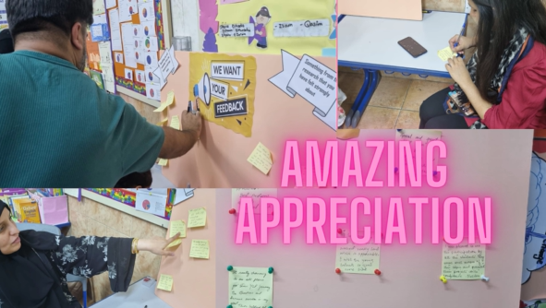
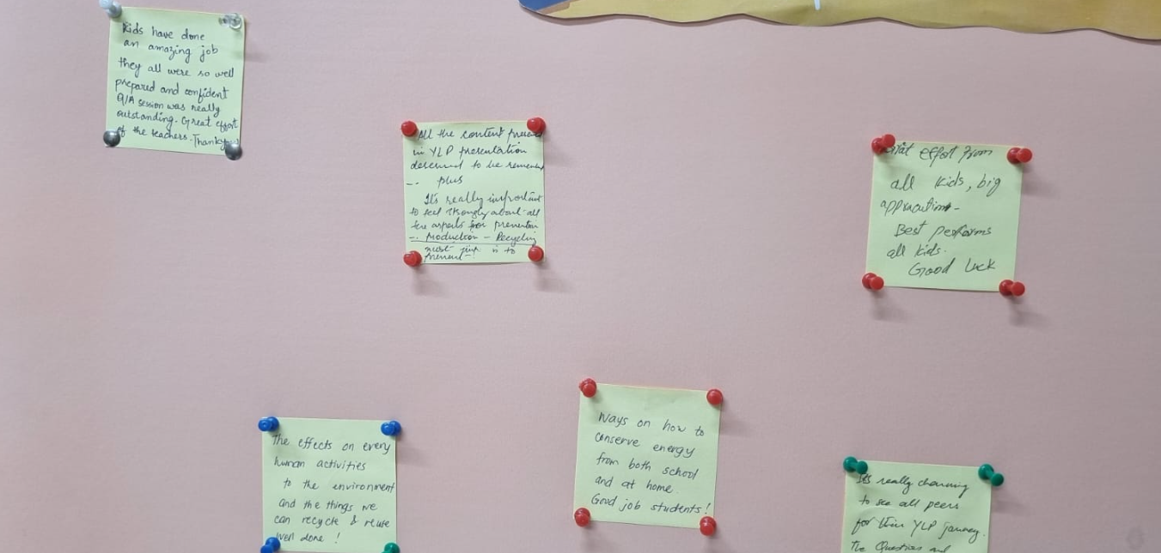

b.Student Reflection :
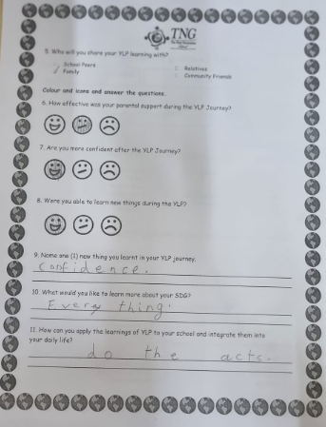

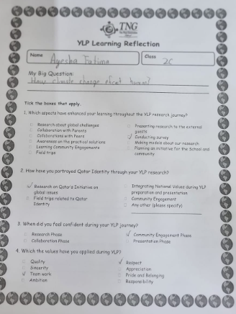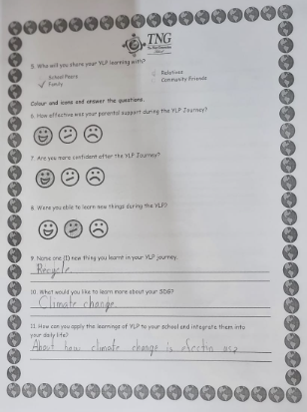

C.Teacher Reflection:

The Youth Leadership Programme offers students a valuable chance to examine
global issues from a comprehensive viewpoint. In addition to identifying important
problems and their root causes, students delve into these topics, deepening their
understanding and exploring potential solutions. This program nurtures critical
thinking skills, research abilities, and a broader awareness of the challenges faced
by our world. The active involvement of students in finding solutions demonstrates
their dedication to making a positive impact. Empowered by the Youth Leadership
Programme, students are equipped to become well-informed and proactive global
citizens capable of addressing complex issues with a holistic approach.

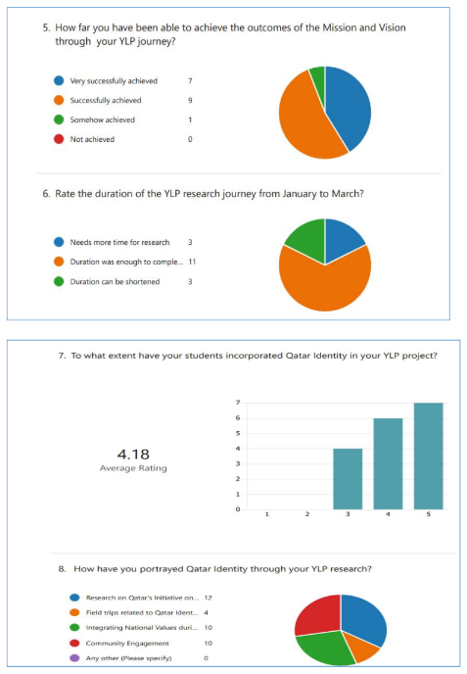

V. Way Forward

Year 2C shows evident growth and improvement in thinking skills. Ice breaking was done by showing them related videos and conducting research. The observation was made during research, quiz, surveys, group discussions, etc. Students were able to understand the given SDG topic. After continuous research, they began to understand the problem faced by our environment. They chose their own big questions and started to research their topic.

Development of engagement activities to enhance their skills.
- Field trips to conduct surveys physically and better understanding of the big question.
- Having more time for reflection to give immediate and appropriate corrective feedback.
- Parents being part of the theme exploration if possible e.g. activities involving parent and child as recommended by the department or school.
- Children could go back to these YLP experiences; get an update for example, after 5 years or so
- Better analysis of problems through group discussions.
- More engagement of LA students during the class presentation. Supporting the LA students or those with communication problems with activities that will boost their confidence

