**Youth Leadership Programme 2023-24**

**Journal**

|  |  |
| --- | --- |
| **Year** | 7A |
| **Teacher** | Ms. Sara Joy Tomias |
| **Co-teacher** |  |
| **Mentor** | Areeba Naeem(Grade 9A), Ammara Usman(Grade 8C) |

|  |  |
| --- | --- |
| **Project name:** | Cybersecurity |
| **Objective of the project:** | To spread awareness throughout our school about this topic. |

**Description of the project:**

|  |
| --- |
| The project on cybersecurity created by our class aims to educate and raise awareness about the importance of safeguarding digital information and systems. Through comprehensive research and practical demonstrations, we explored various threats such as phishing, malware, and data breaches, along with effective strategies for prevention and mitigation. Our project includes real-world examples, interactive elements, and practical tips to empower individuals and organizations to enhance their cybersecurity posture and protect against cyber threats in an increasingly digital world. |

**Implementation:**

|  |
| --- |
| 1. Awareness Campaign in classes 2. Cybersecurity Booklet – comprehensive guide to equip the students with essential knowledge and skills to navigate the digital world safely 3. Surveys with parents and students |

**What have we achieved from the project?**

|  |
| --- |
| 1. Awareness Campaign 2. Cybersecurity handbook 3. Surveys – got to know how aware students are on this topic which helped us frame the cyber security handbook 4. Discovered many aspects of Cybersecurity. |

**Way forward (How do we want to expand our project?):**

|  |
| --- |
| We want to make workshops specialised with parents working in this field and create a channel where students can send their cyber-related queries. |

**How did we involve the community in our project?**

|  |
| --- |
| Survey with parents and students was the primary research part of our project . |

**Skills developed during the project:**

|  |
| --- |
| 1. Teamwork skills 2. Research skills 3. Social skills 4. Leadership skills 5. Communication skills 6. Public speaking |

**Glimpses from our Youth Leadership Programme:**

***Planning phase (photos)***

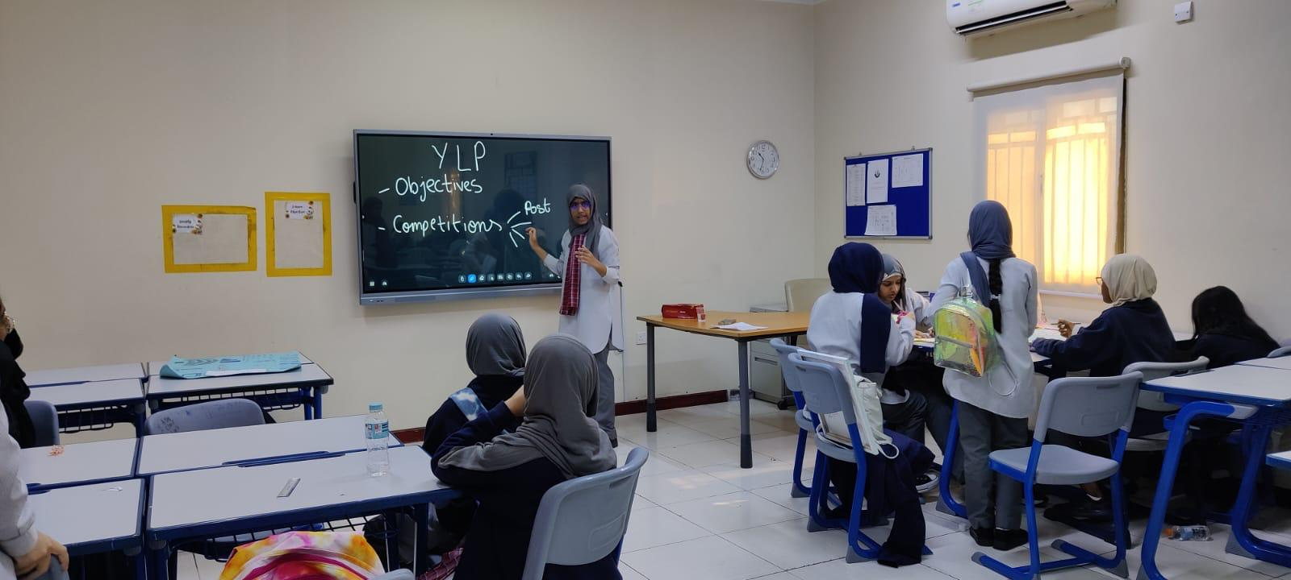

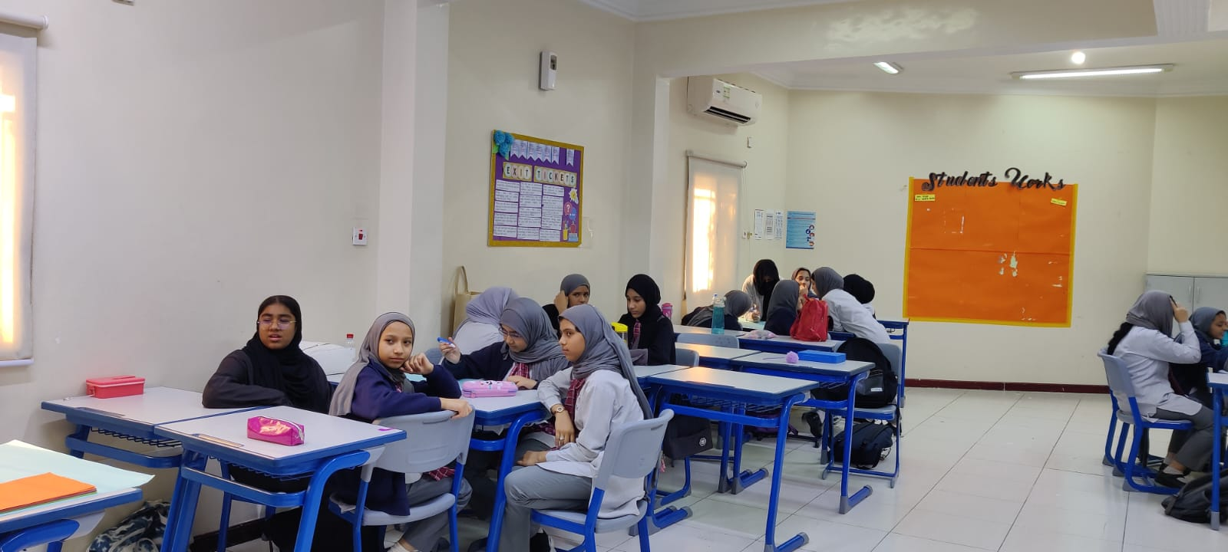

***Preparation phase (photos)***

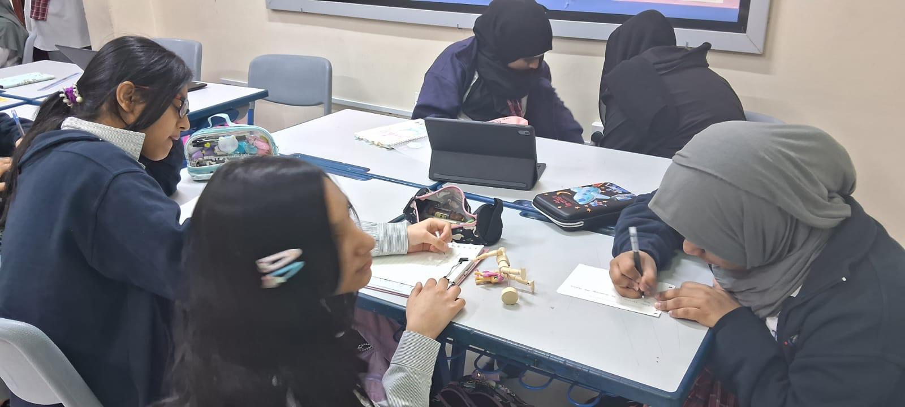

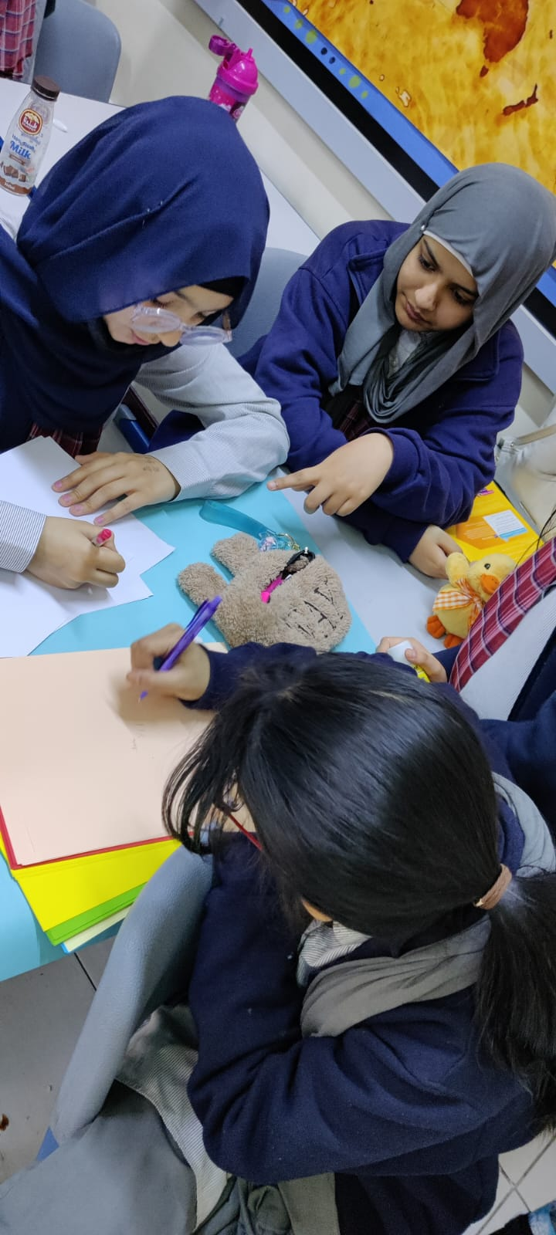

***Implementation phase (photos)***

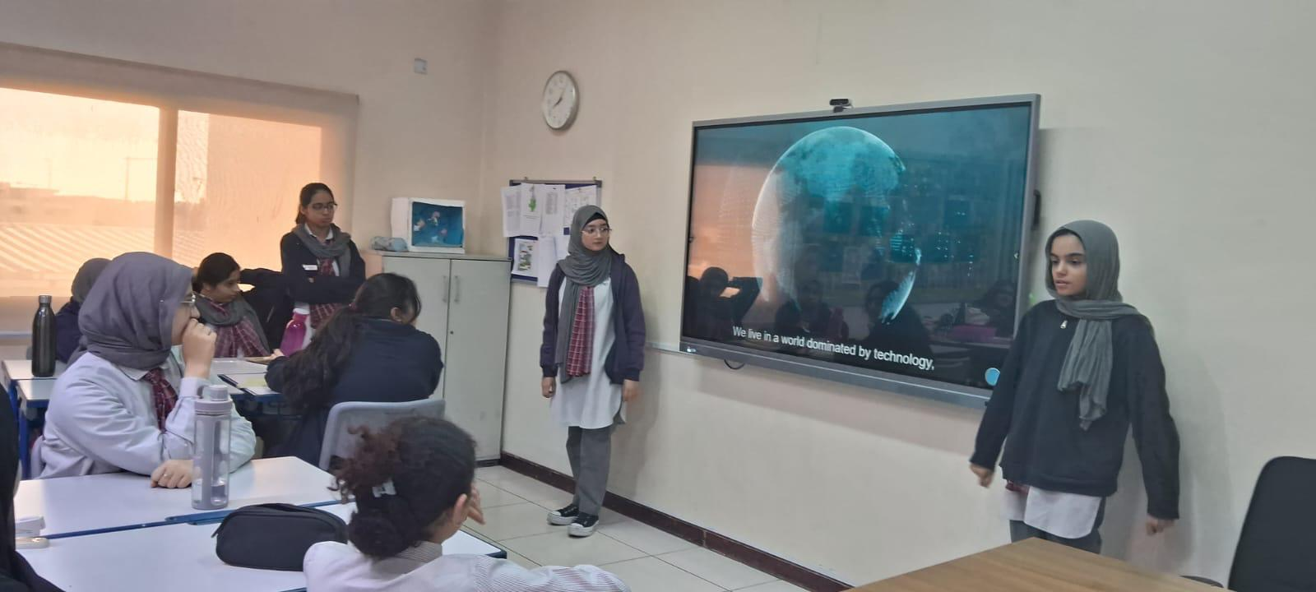

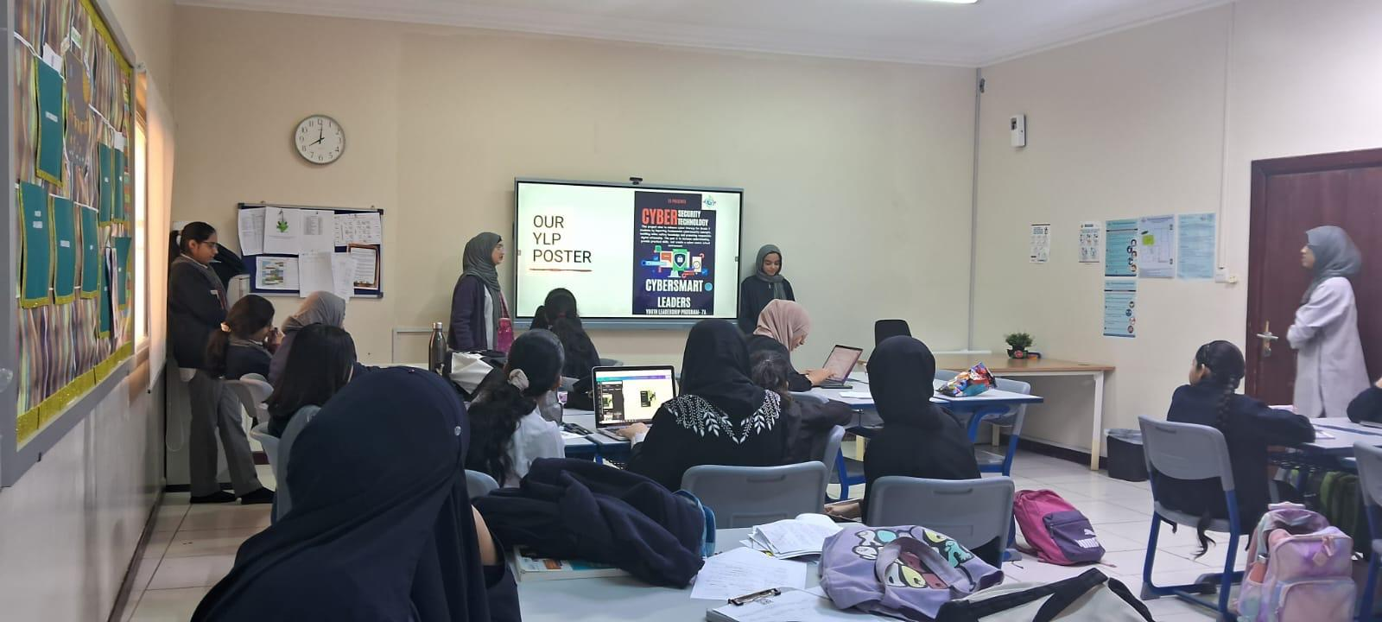

**Reflections**

**Mentor: (Areeba Naeem, 9A)**

|  |
| --- |
| This was my first time mentoring a class for YLP. Previously I was a part of a youth leadership program student and that was a very great experience but being a mentor was just brilliant. Even though it was challenging at first to mentor a class with a high strength of 30 students but then I overcame that and delegated tasks to all the students effectively and efficiently. During our Youth Leadership Program, we've had the opportunity to dive into the world of cybersecurity. It's been an eye-opening journey, filled with important lessons and discussions about how to stay safe in the digital age. We’ve learned about the significance of protecting our personal information online and the potential consequences of cyber threats. Understanding the importance of digital responsibility and ethical behavior has been a key focus, as we've explored ways to navigate the online world securely and responsibly. One of the most rewarding aspects of this program has been witnessing the growth and development of each participant as an emerging leader in cybersecurity. Together, we've shared knowledge, skills, and experiences, empowering each other to take proactive steps in promoting cybersecurity awareness within our school and wider community. |

**Student: (Zainab Sheikh, 7A)**

|  |
| --- |
| Participating in the cybersecurity YLP at school has been an enlightening journey. From understanding the basics of online safety to delving into the complexities of data encryption and network security, every session has been a stepping stone towards digital literacy and resilience. Through hands-on activities and discussions, I've learned to recognize cyber threats, protect personal information, and contribute to a safer online environment. This experience has not only equipped me with practical skills but also instilled a sense of responsibility in safeguarding digital assets. Overall, the cybersecurity YLP has been a transformative experience, empowering me to navigate the digital landscape with confidence and vigilance. |

**Student: (Zakiyya, 7A)**

|  |
| --- |
| The whole YLP has been very amazing, we got to learn a lot of new information that we wouldn't have known, our classmates have also contributed a lot of their time trying to spread awareness and making the cyber kit  I learnt about the digital world and the many different types of scams that hackers can use  (E.g.: Phishing scam, man in the middle etc.)  As well as the importance of being safe online  I also learnt about how to deal with these scams and that we need to spread awareness  This whole YLP has been amazing and overall, we learnt a lot of new things |

**Student: (Faha Hareem, 7A)**

|  |
| --- |
| Learning about cyber has shown me how everything in our digital world is connected and how important it is to keep it safe. It's not just about coding or hacking...it's about protecting our information and systems from bad things happening. We all need to work together to make sure our digital world stays safe, from everyday people to big companies and governments. It's about teamwork and taking action to keep our online world secure and make the most of its benefits while avoiding problems. |

**Teacher: (Ms. Sara Joy)**

|  |
| --- |
| Our youth leadership program focusing on cybersecurity has been a remarkable journey of growth, learning, and empowerment. As we reflect on the impact of this program, it becomes evident that nurturing the next generation of cybersecurity leaders is not just a necessity but a responsibility we owe to our society.  Through this program, I have witnessed young minds flourish as they delved into the complexities of cybersecurity, grasping concepts that were once foreign to them. With each meeting, these budding leaders have not only honed their technical skills but also developed a profound understanding of the ethical dimensions and societal implications of cybersecurity.  What stands out most is the passion and enthusiasm of my students and mentors. Their eagerness to learn, innovate, and collaborate serves as a source of inspiration to me. As they tackle challenges, engage in discussions, and propose solutions, they exemplify the creativity and resilience essential in the realm of cybersecurity.  Moreover, the bonds formed within this program extend beyond mere acquaintanceship; they are a network of support, encouragement, and shared aspirations. The relationship among participants shows the importance of collaboration in addressing cybersecurity threats and fostering a safer digital landscape for all.  In the end, our youth leadership program in cybersecurity is not just about imparting knowledge but about developing a sense of responsibility and leadership in the next generation. As I witness these young minds embrace the challenges of cybersecurity with passion and determination, I am reassured that the future of cybersecurity is indeed in capable hands. |