**Muhammad Usman,** a Medical expert from **Hammad Medical Hospital**, discussed the role of food nutrients in maintaining good health and how food choices influence mood and mental well-being, leaving a lasting impact on our students.

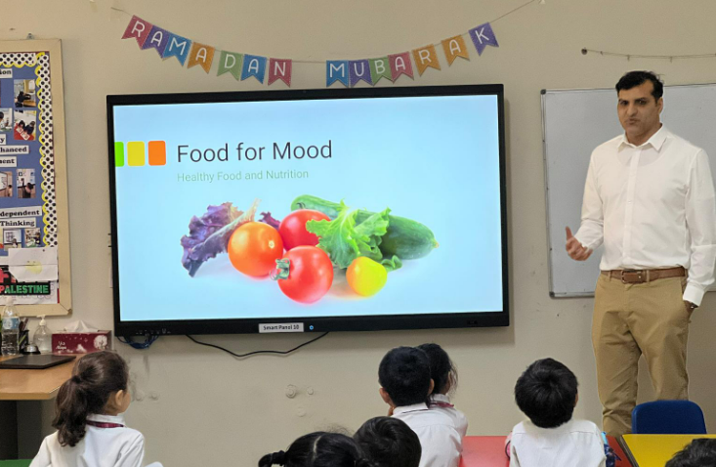

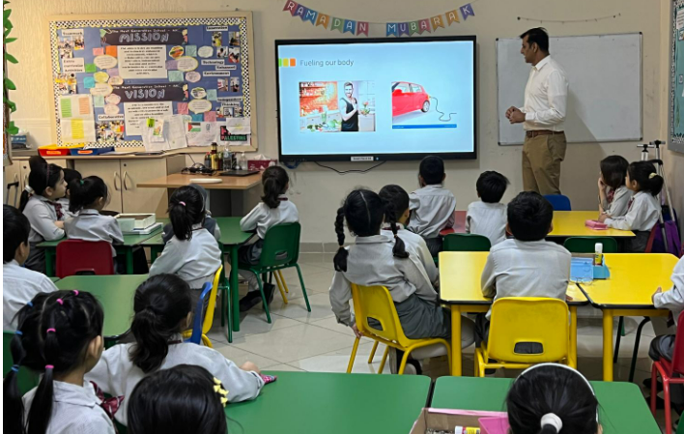

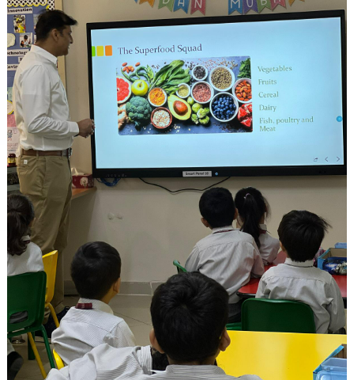



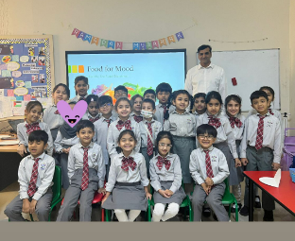

**Dr. Shafqat Ali Khan**, a specialized family physician from the **Public Health Center**, conducted an enlightening session on the impact of healthy food choices on mood, which deeply resonated with our students. His expertise and passion for nutrition illuminated the significance of mindful eating for mental well-being.



