Youth Leadership Programme 2023-24
Journal

Year | 10-C
Teacher | Ms. Rahila
Co-teacher | Ms. Luna
Mentor | Maheen Umair Qureshi

Project name: | Paws for a cause
Objective of the project: | Our projects objective is to showcase the importance of creating safe and comfortable shelters for stray animals.

Description of the project:

Our class embarked on a compassionate mission to support QAWS shelter in Qatar. Engaging with attendees, we also gathered insights on caring for stray animals. Additionally, we crafted two 3D model of an animal shelter to inspire empathy and awareness for stray animals. Join us in making a pawsitive impact!

Implementation:

For our implementation we've invented a unique and great solution to support animals in need: Portable Animal Shelters! We were inspired by the portable homeless shelters you see around many countries and thought of implementing it into our project. Our innovative approach blends sustainability with compassion. Our class crafted two models from recycled materials and durable cardboard. These shelters not only offer comfort to animals but also boast effortless mobility, allowing for easy relocation as needed. This was a great idea as there are only a few animal shelters around here in Qatar and making them portable so we can easily move the around is really efficient.

What have we achieved from the project?

Our project not only showcases our creativity but also stands as a force for good. We're raising awareness about the plight of stray animals, highlighting their basic needs for food and water. As we continued to raise awareness, we witnessed remarkable progress as people eagerly stepped forward to offer their support and express genuine interest in our cause. Our aim is to inspire others to join us in caring for these vulnerable creatures. With our approach, we hope to make a meaningful impact on animal welfare, one step at a time.
Top of Form

Way forward (How do we want to expand our project?):

We’re planning to team up with local animal shelters in Qatar to raise funds for our portable shelters, amplifying our impact on stray animal welfare. Additionally, we would love to conduct workshops on street animal care and advocating against animal violence to extend awareness beyond our community. These efforts aim to equip people with practical knowledge and skills to make a positive difference in the lives of animals. By collaborating with shelters and hosting educational sessions, we're fostering a culture of compassion and respect for all creatures.

How did we involve the community in our project?
We engaged the community by distributing online surveys and posters . These interactive tools enabled us to gather valuable insights and raise awareness about our project's mission. By involving the community in this way, we fostered a sense of ownership and collaboration, encouraging active participation in our efforts to support stray animals. Moreover, we discovered that people are genuinely eager to participate and support our project. It's clear that they value animal welfare and are willing to take action when given the opportunity.

Skills developed during the project:
- Creativity
- Teamwork
- Critical thinking
- Leadership
- Communication
- Problem-Solving
- Empathy and Compassion

Glimpses from our Youth Leadership Programme:

Planning phase (photos)

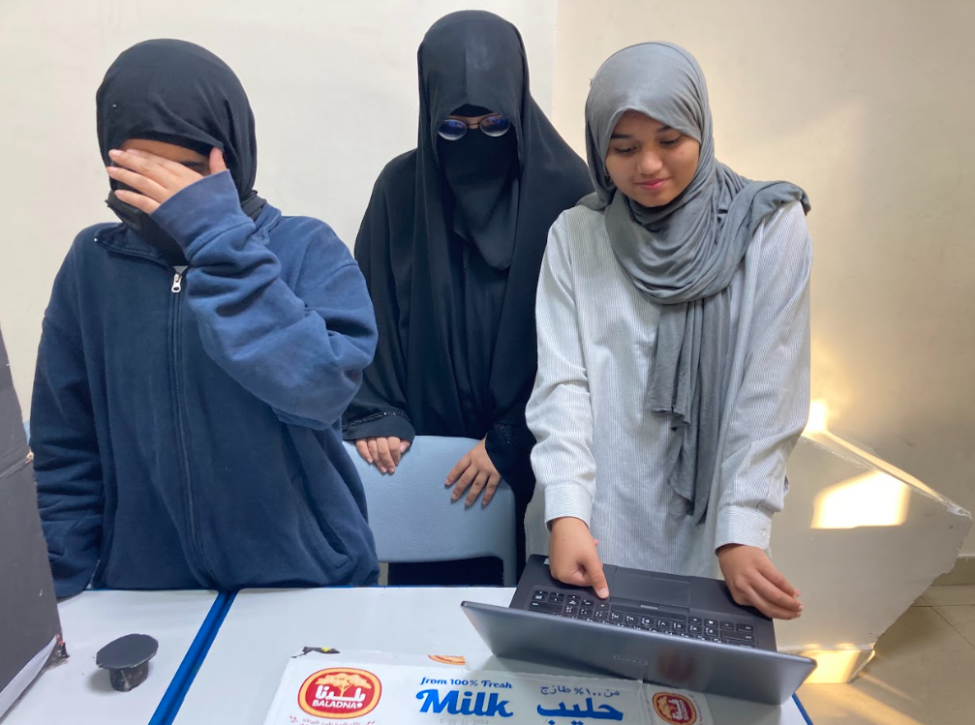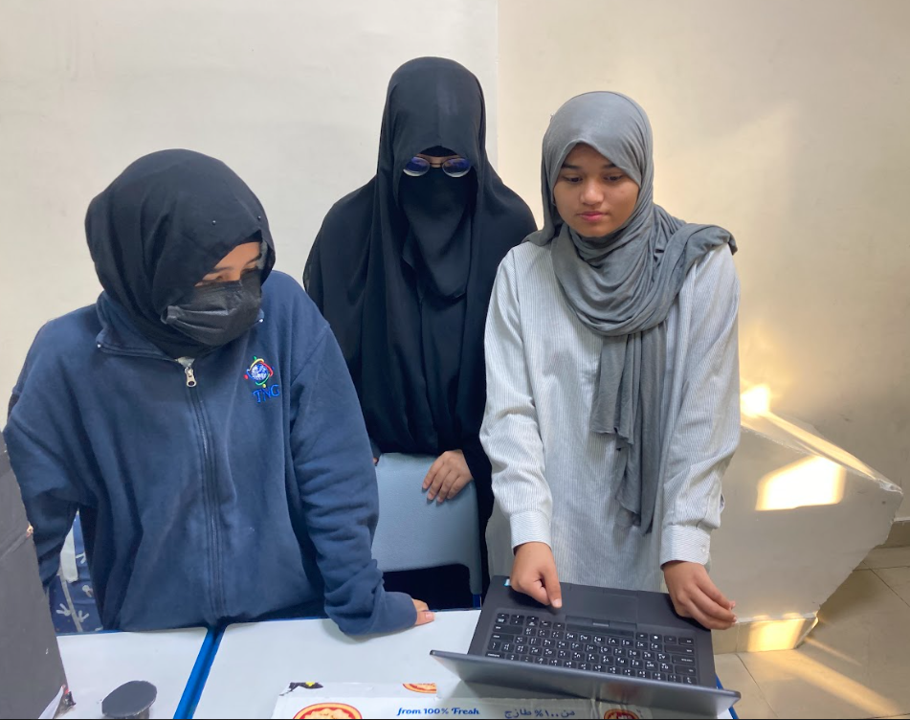
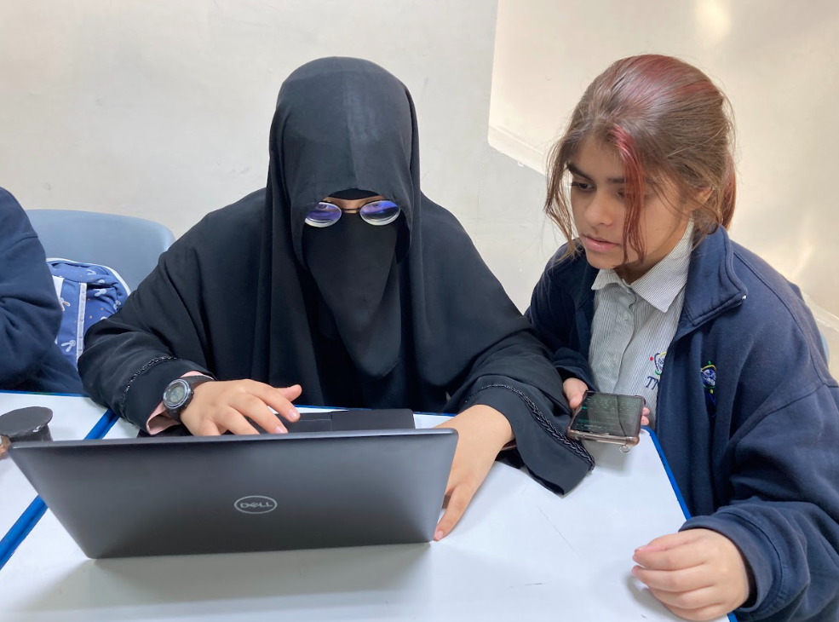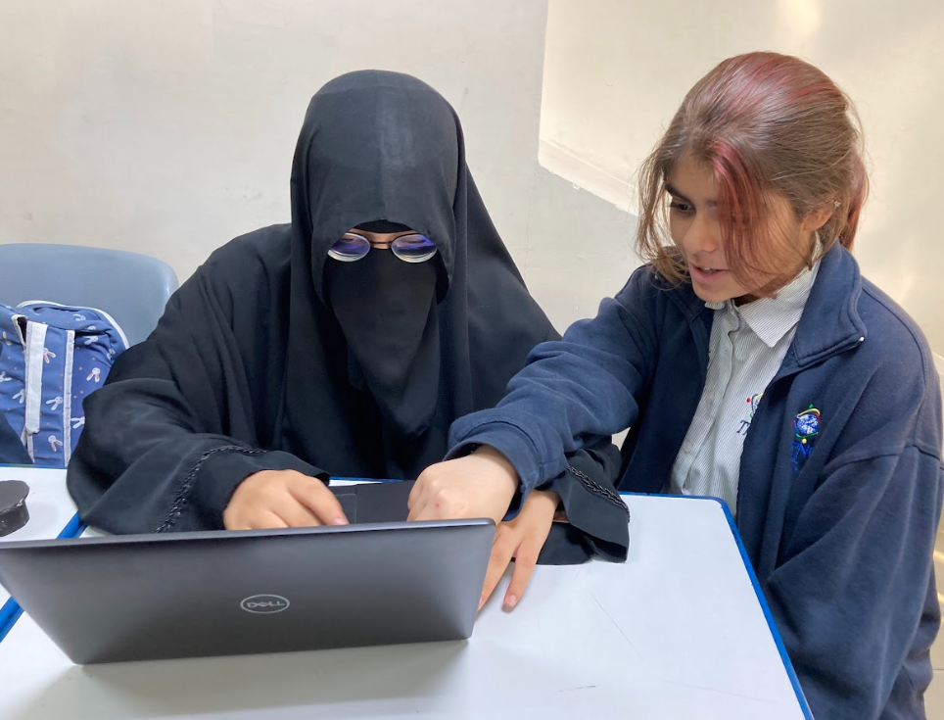

Preparation phase (photos)
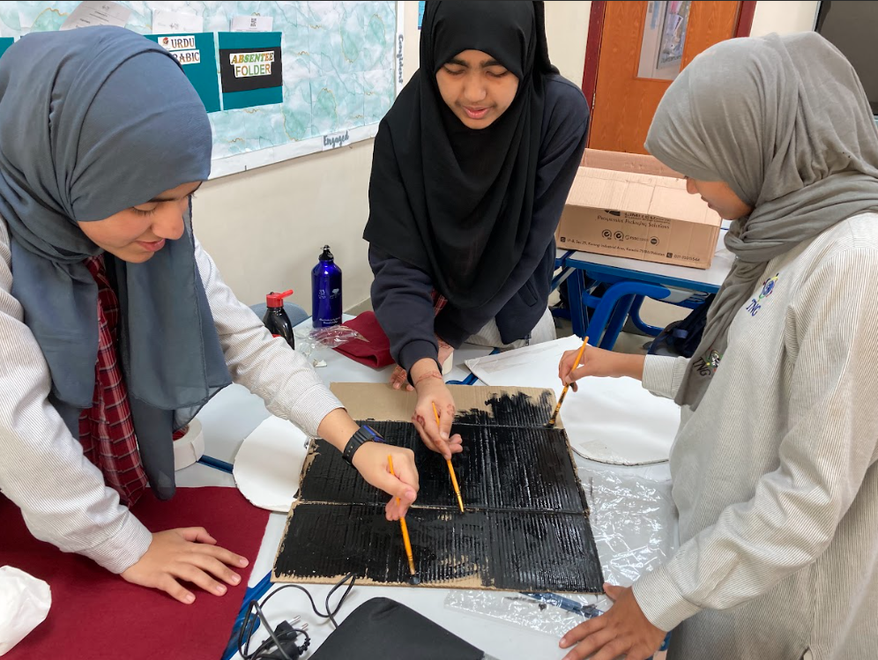
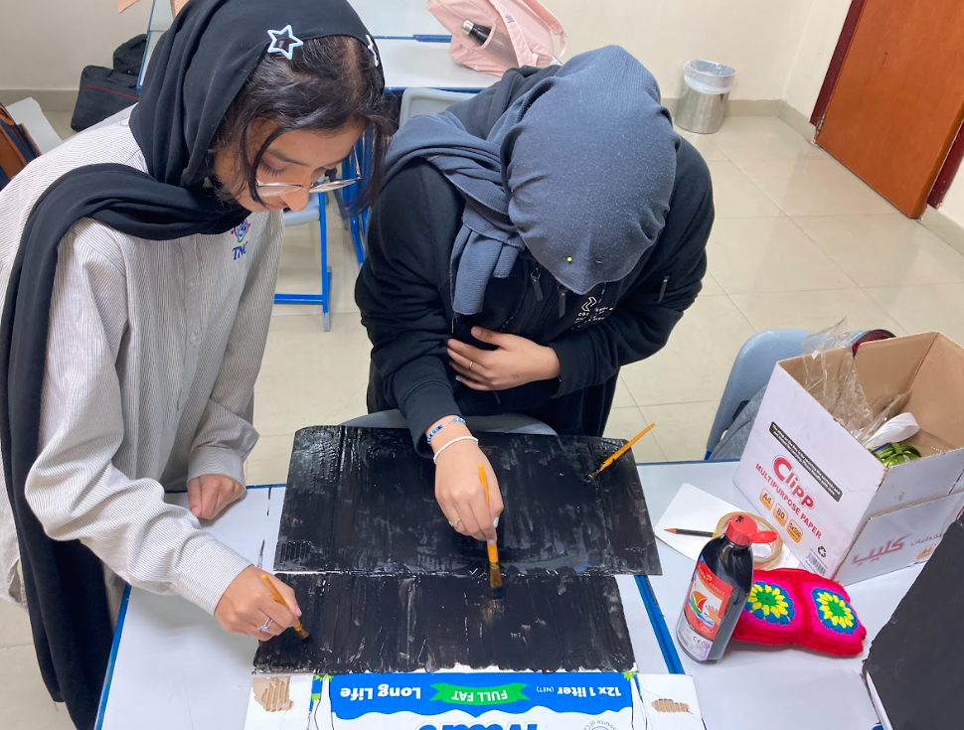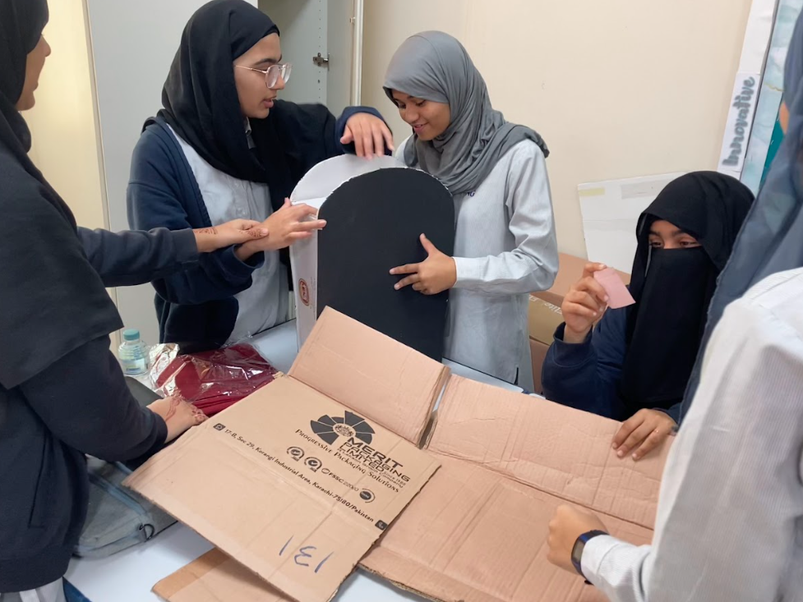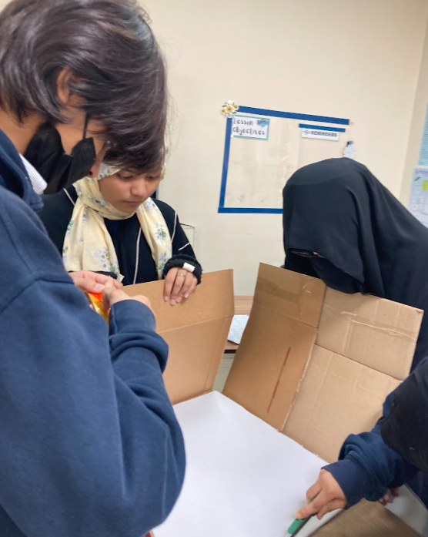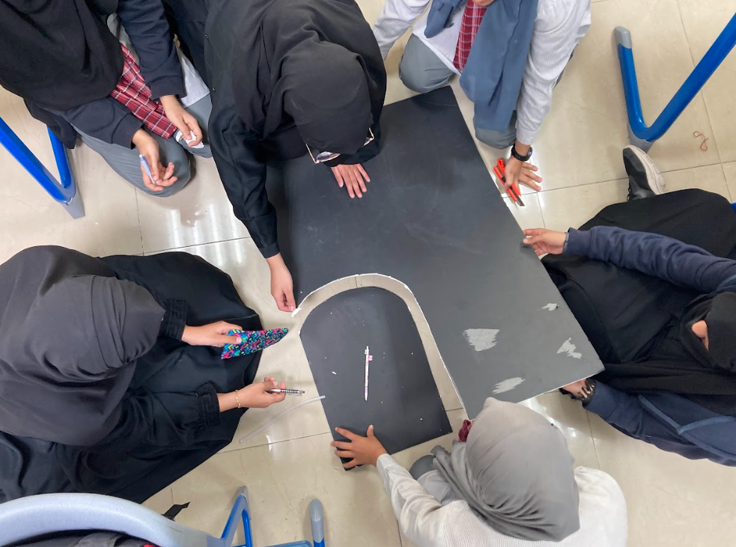

Implementation phase (photos)

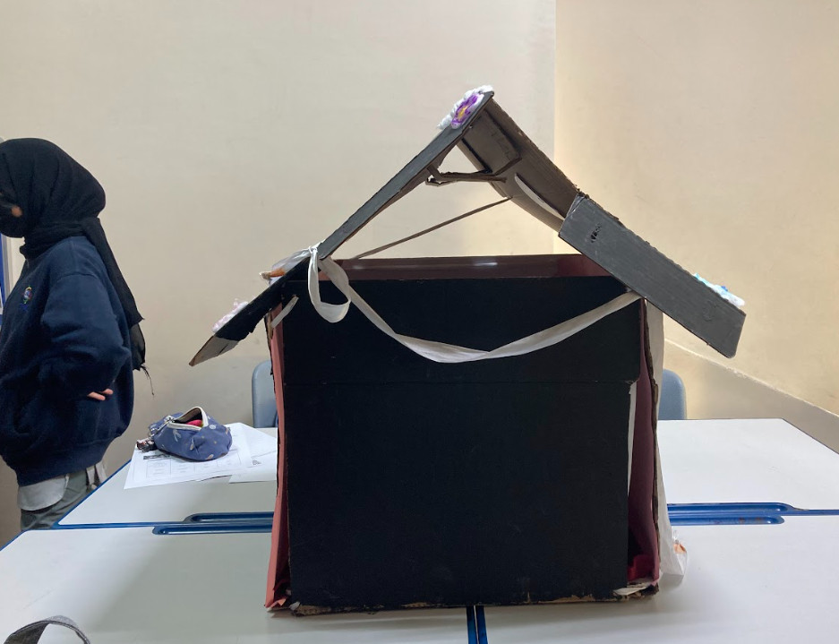

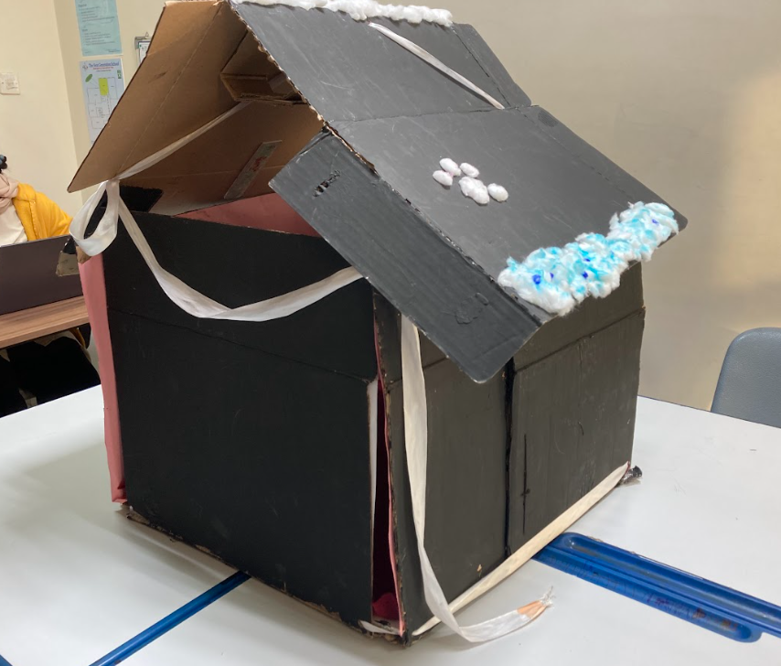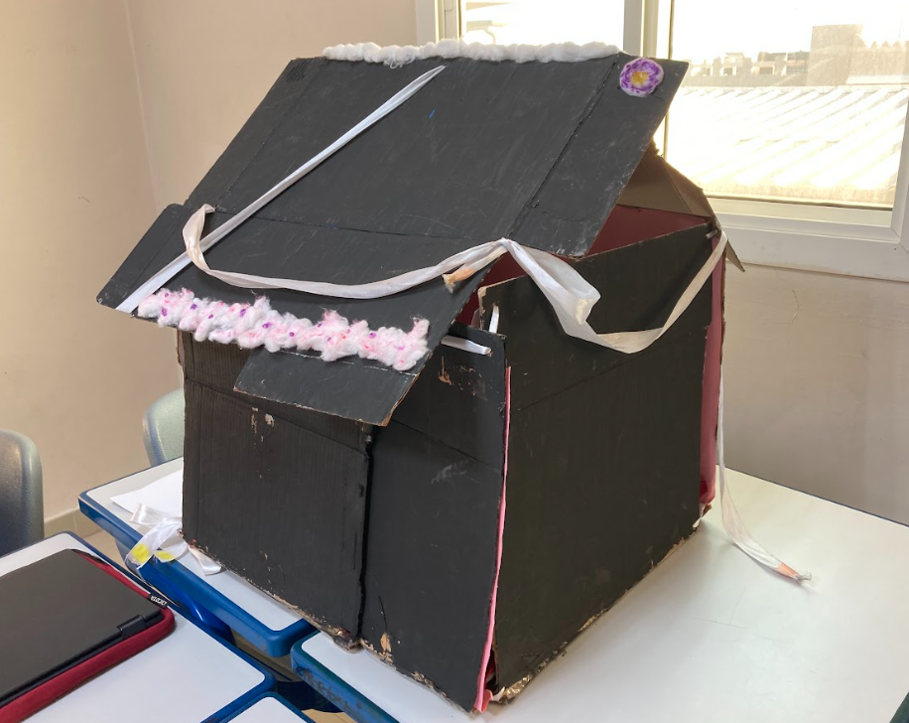

Reflections

Mentor: (Maheen Umair Qureshi, 11-A)
It's truly remarkable to witness the talent and creativity showcased by 10-C. My experience with them during the YLP was nothing short of exceptional. What set them apart was their choice of a unique and novel topic, especially considering the lack of shelters in Qatar. Their innovative approach was evident in the creation of portable animal shelters, demonstrating both their creativity and artistic skill. I also got to Learn about the challenges faced by stray animals and how easy it is to help them. Small acts of kindness can make a big difference in their lives. Sharing this knowledge inspired others to join in supporting these vulnerable creatures.

Student: (Hafsa Imran, 10-c)

I really enjoyed working on this year's YLP because it was very intriguing and fascinating to me. What I loved the most was the model we created and the fact that we constructed the model ourselves out of cardboard. This required strong planning, designing, and architectural abilities. Creativity and innovative skills also played an important part in this. Making the model portable was the only challenging part, but overall, I believe our efforts paid off because the model turned out extremely well and far better than we had expected. All in all, I had a great time and learned a lot from our YLP experience.

Student: (Anam Durwesh, 10-C)

I believe this year's topic for our YLP was probably the most interesting topic i have had for a YLP. This made it more special for me as I am an animal lover. It is great to know that me and my class can work together to help the animals that deserve their basic rights. As a furry lover my favorite part of the YLP was making the cat shelter model. Me and my team had great coordination while doing so and with that we were able to make one of the best shelters. This shelter is portable and comfortable.

Teacher: (Ms. Rahila)

Upon reflection of the youth leadership programme that our year 10C students completed, I am greatly impressed by their development and dedication throughout the process. Through discussions, they have gathered insights on caring for stray animals. It has been quite satisfying to watch them crafting a 3D model of portable animal shelters which has inspired empathy and awareness among them. They have improved their leadership skills via hands-on experimentation, research, and collaborative conversations, in addition to deepening their understanding of the necessity of providing safety, medical care, and a loving home for stray animals. It's been encouraging to see students take the initiative, communicate well, and work together to solve problems. I feel that these experiences will provide a firm foundation for their future endeavours, both personally and academically. I am proud of their accomplishments and eager to see how they will make a great effect in the future.

