**Youth Leadership Programme 2023-24**

**Journal**

|  |  |
| --- | --- |
| **Year** | 11c |
| **Teacher** | Ms Ailyn Sungcaya |
| **Mentor** | Naveera Shiraz |
| **Co-mentor** | Haleemah Owais |

|  |  |
| --- | --- |
| **Project name:** | Basic Self-Defence for Women |
| **Objective of the project:** | Through a self-defence training that provides awareness and effective tactics for responding to possible dangers and threats, we can provide women with the knowledge and skills they need to ensure their personal safety. |

**Description of the project:**

|  |
| --- |
| Our aim was to explore the provisions within Qatari law that empower women with the right and freedom to defend themselves. This involved engaging in a basic self-defence class, led by a representative of ‘Strong Man’ karate class, promoting practical skills and awareness of personal safety. Grade 9 girls attended the session, showing active participation and fulfilling our project aim. |

**Implementation:**

|  |
| --- |
| A professional trainer was contacted, who agreed for a self-defence session for grade 9 girls. |

**What have we achieved from the project?**

|  |
| --- |
| We concluded that women should have basic knowledge of self-defence to safeguard themselves. Additionally, we discovered that Qatar supports women's rights to a certain extent, allowing them to work alongside men and participate in various government and social activities, all while feeling safe. |

**Way forward (How do we want to expand our project?):**

|  |
| --- |
| Ensuring a safer environment for women by spreading awareness of the sensitivity of this issue. |

**How did we involve the community in our project?**

|  |
| --- |
| We engaged with Dojo Activity Heads for learning and the female student body for implementing. |

**Skills developed during the project:**

|  |
| --- |
| * Self-defense skills, using 4 different methods taught by the trainer * Leadership skills * Teamwork * Time management and punctuality * Communication skills |

**Glimpses from our Youth Leadership Programme:**

***Planning phase (photos)***

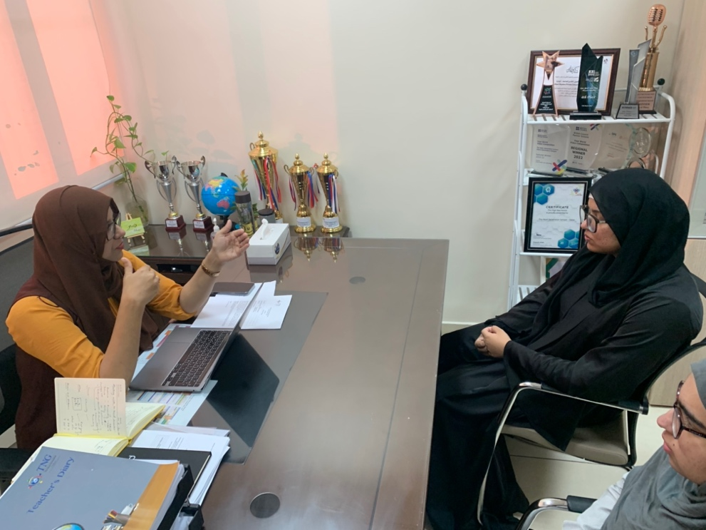

***Implementation phase (photos)***

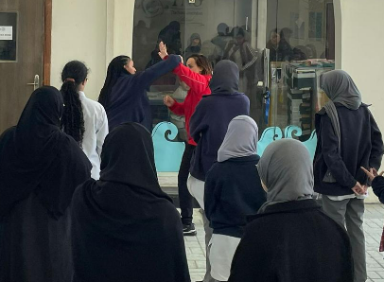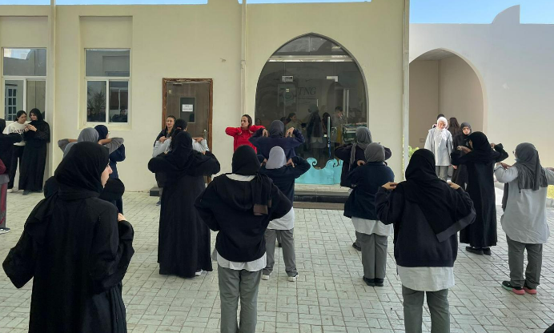

**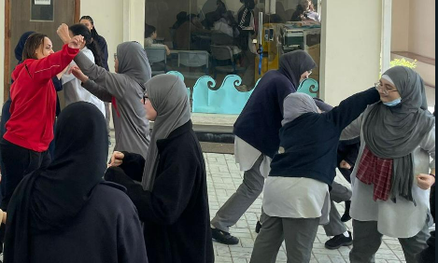*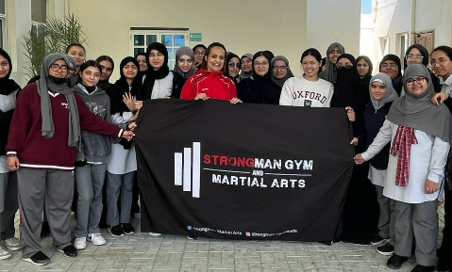***

**Reflections**

**Mentor: (Naveera Shiraz, 11C)**

|  |
| --- |
| I consider this project a success. It provided us with essential life-saving techniques for basic self-defence. We also recognized the necessity of self-defence for women and were able to spread the awareness to our fellow school mates. Furthermore, my communication, leadership, and planning skills were improved with the help of this project. |

**Student: (Aafia Rafiq, 9C)**

|  |
| --- |
| It was enjoyable and educational to take part in the 11 C YLP initiative on women's self-defense. A highlight was having a taekwondo instructor teach students in grade 9C. The lesson was really interesting and focused on empowerment and safety while imparting useful skills. It served as a potent reminder of how important these kinds of programmes are in advancing the rights and welfare of women. |

**Student: (Maahum Abbassi, 11C)**

|  |
| --- |
| Participating in the 11 C YLP project on women's self-defence was both fun and educational. Hosting a taekwondo expert for grade 9 girls was a highlight. The session was quite engaging, teaching valuable skills while emphasizing the importance of empowerment and safety. It was a powerful reminder of the impact of such initiatives in promoting women's rights and well-being. |

**Student: (Rimla Adnan, 9C)**

|  |
| --- |
| Attending the self-defence class arranged by 11th grade at school for girls was incredibly empowering. Learning practical techniques for protecting oneself in various situations felt both empowering and essential. I gained confidence in my ability to defend myself if ever faced with danger. Moreover, it underscored the importance of being prepared and aware of one's surroundings, implanting a sense of empowerment and security. Overall, it was a valuable experience that equipped me with skills for life. |

**Teacher: Ailyn Sungcaya**

|  |
| --- |
| I find our project very significant this year. I strongly support that women have the right to defend themselves as circumstances arise. Seeing the 11C girls owning their project was such a sight. They come up with the idea of women empowerment in our campus, planning activities that will engage young girls from Year 9. It’s a fun learning experience for both the students and the teachers who attended the self-defence session. The support we received from the school administration during the implementation stage thoroughly helped us in achieving our goals. Overall, it was a collaborative experience for the whole class where they showcased their creativity, communication, management and kinesthetic skills. |