 **The Next Generation School**

**Wakra Primary and Secondary Campus**

**AY 2023 -2024**

**Youth Leadership Programme**

**Year / Class ___5B____**

**A. Project Title: Sustainable cities and communities**

**B. Name of the Students:**

|  |
| --- |
| Muhammad Hasan Mehtab |
| Affan Humayun |
| Abdul Rahman |
| Muhammad Umer Kashif |
| Huzaifah Sherjeel Baig |
| Muhammad Malik Ashtar |
| Muhammad Ahmed Ilyas |
| Muhammad Bilal Mehmood |
| Izaan Imran Basith |
| Rayyan Waqar |
| Muhammad Bilal Shahid |
| Maruf Mujahid Patel |
| Yousha Hameed |
| Muhammad Arham Imran |
| Muhammad Hamza Aslam |
| Muhammad Bin Khurram |
| Muhammad Mahad |
| Nacer Dilmi |
| Sardar Mohammad Aoun Akbar |
| Azaan Muhammad Yousuf |
| Eyad Ibrahim Ahmed Alnadhari |
| Youcef Lamraoui |
| Abdur Waseem |
| Muhammad Huzaifa |
| Muhammad Hassan |
| Yassin Mohamed Abdelrahim |
| Ziyad Ahmed |
| Omar Ahmed Kadri Elsaid Hataba |

**C. Name of the Teachers: Ms Eesha Ali and Ms Nisha**

**D. Poster / Pictures:**

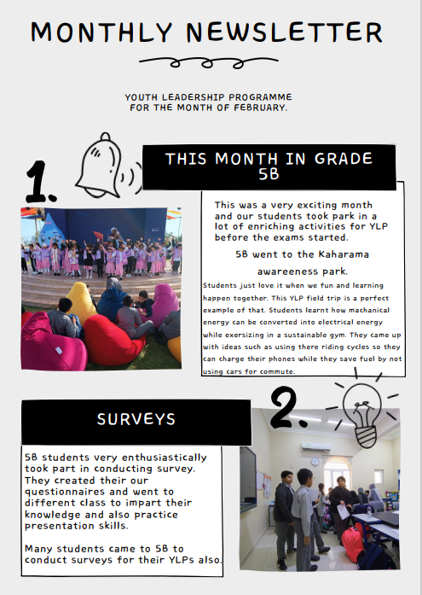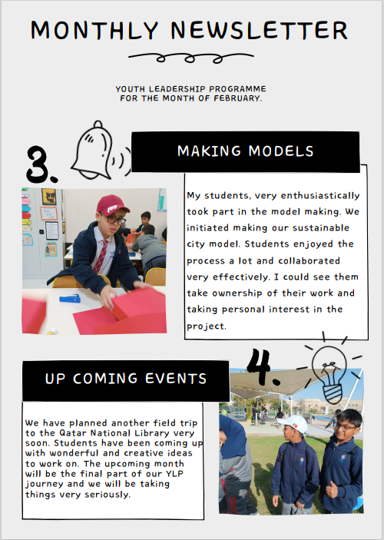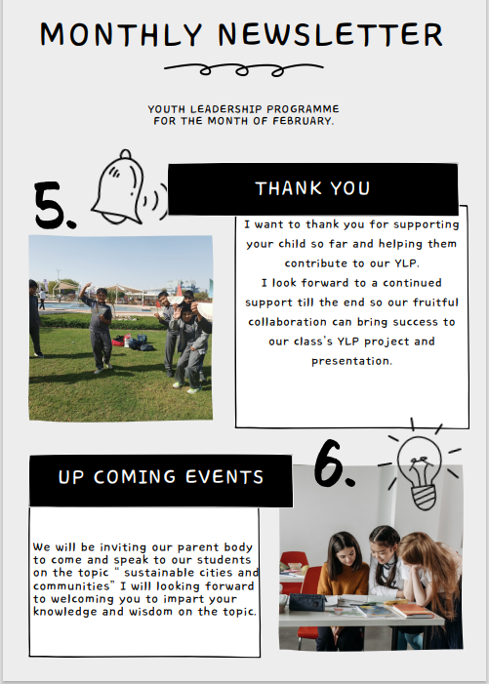

**E. Synopsis of the Project: Our project is about how we can make our communities more sustainable. It covers various aspects such as climate, environment, transportation, infrastructure, water conservation, education, equality, and equal distribution of resources. Alternative and renewable fuel. We are trying to link this with our school mission and vision by incorporating the Islamic teachings on the topic as well as cross curricular link it to Global Perspective.**