**Youth Leadership Programme 2022-23**

**Journal**

|  |  |
| --- | --- |
| **Year** | 10A |
| **Teacher** | Miss Hannah Alciso |
| **Co-teacher** | Miss Elshima |
| **Mentor** | Khadija Zarrar and Aroob Ali |

|  |  |
| --- | --- |
| **Project name:** | The better source, the better energy |
| **Objective of the project:** | Our project idea is to understand and develop our knowledge on energy and how it can be applied to make appropriate use of energy. |

**Description of the project:**

|  |
| --- |
| Our project's main goal is to comprehend energy. It is a subject on which each student can come up with new ideas and create something new. Everything, from the microwaves in our home to the dams that store water, uses energy. It is concluded that all of the items we use require energy. We must look for alternate strategies on how to use this energy profitably and sustainably. We may accept everyone's suggestions and combine them into one by doing this. We will also come up with a design idea to reduce the amount of land space taken up by solar power plants. |

**Implementation:**

|  |
| --- |
| We created a poster about our project which includes the objectives and very informative texts which we shared in our ClassDojo so our parents can learn from it and be involved in our goals. Then, we started working on the robots, discuss and studied more about our topic so we can improve our dissemination of information and make the robot work. We are planning to visit each classroom to share our work, but due to our need to prepare for our upcoming IGCSE, we were not able to do it. |

**What have we achieved from the project?**

|  |
| --- |
| We made in-depth research on how we can conserve energy and align it to the resources Qatar has and the feasibility to do it in Qatar. We have learned a lot of how the different ways of generating clean energy could benefit humans and the environment how to achieve them. It widens our perspective and became more aware of the things around us and want to improve and contribute in improving and saving the environment. |

**Way forward (How do we want to expand our project?):**

|  |
| --- |
| We are planning to make a campaign about this project and/or visit some organization/company that will help us know more about saving energy in a cleaner and more sustainable way. |

**How did we involve the community in our project?**

|  |
| --- |
| Due to our preparation for the IGCSE exams, we were not able to visit any company that will help us with our objective. However, we made sure to involve our parents and other students by sharing our work through  ClassDojo and sharing our work during free time as much as we can. |

**Skills developed during the project:**

|  |
| --- |
| * Research skills * Communication skills * Team management skills * Critical Thinking Skills * Self-Evaluation skills |

**Glimpses from our Youth Leadership Programme:**

***Planning phase***

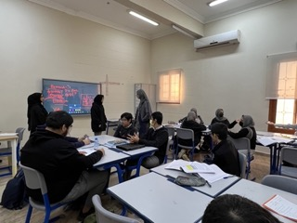

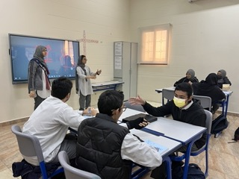

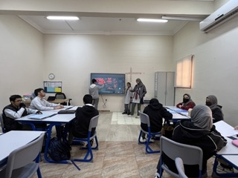

***Preparation phase***

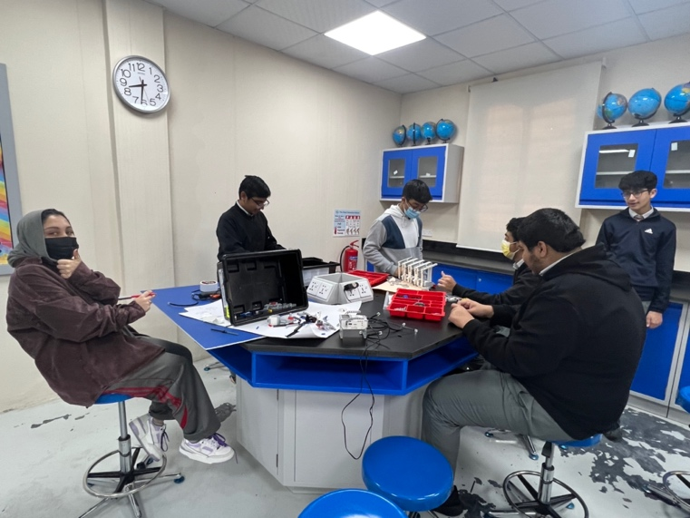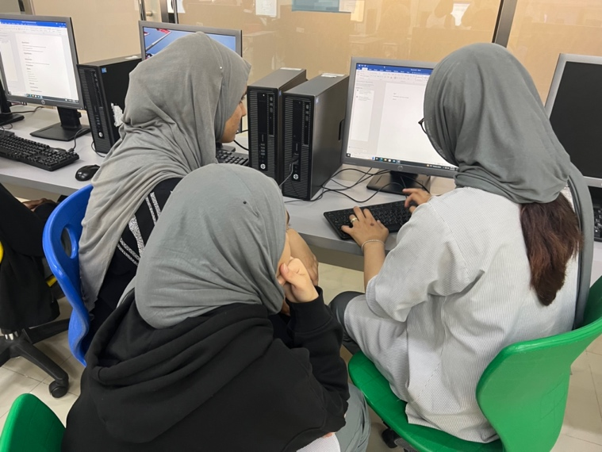

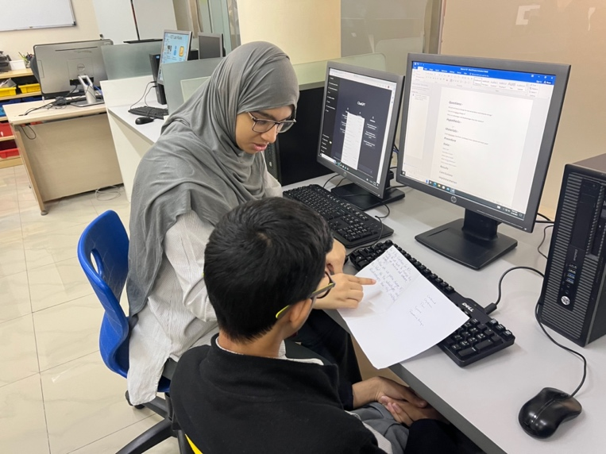

***Implementation phase***

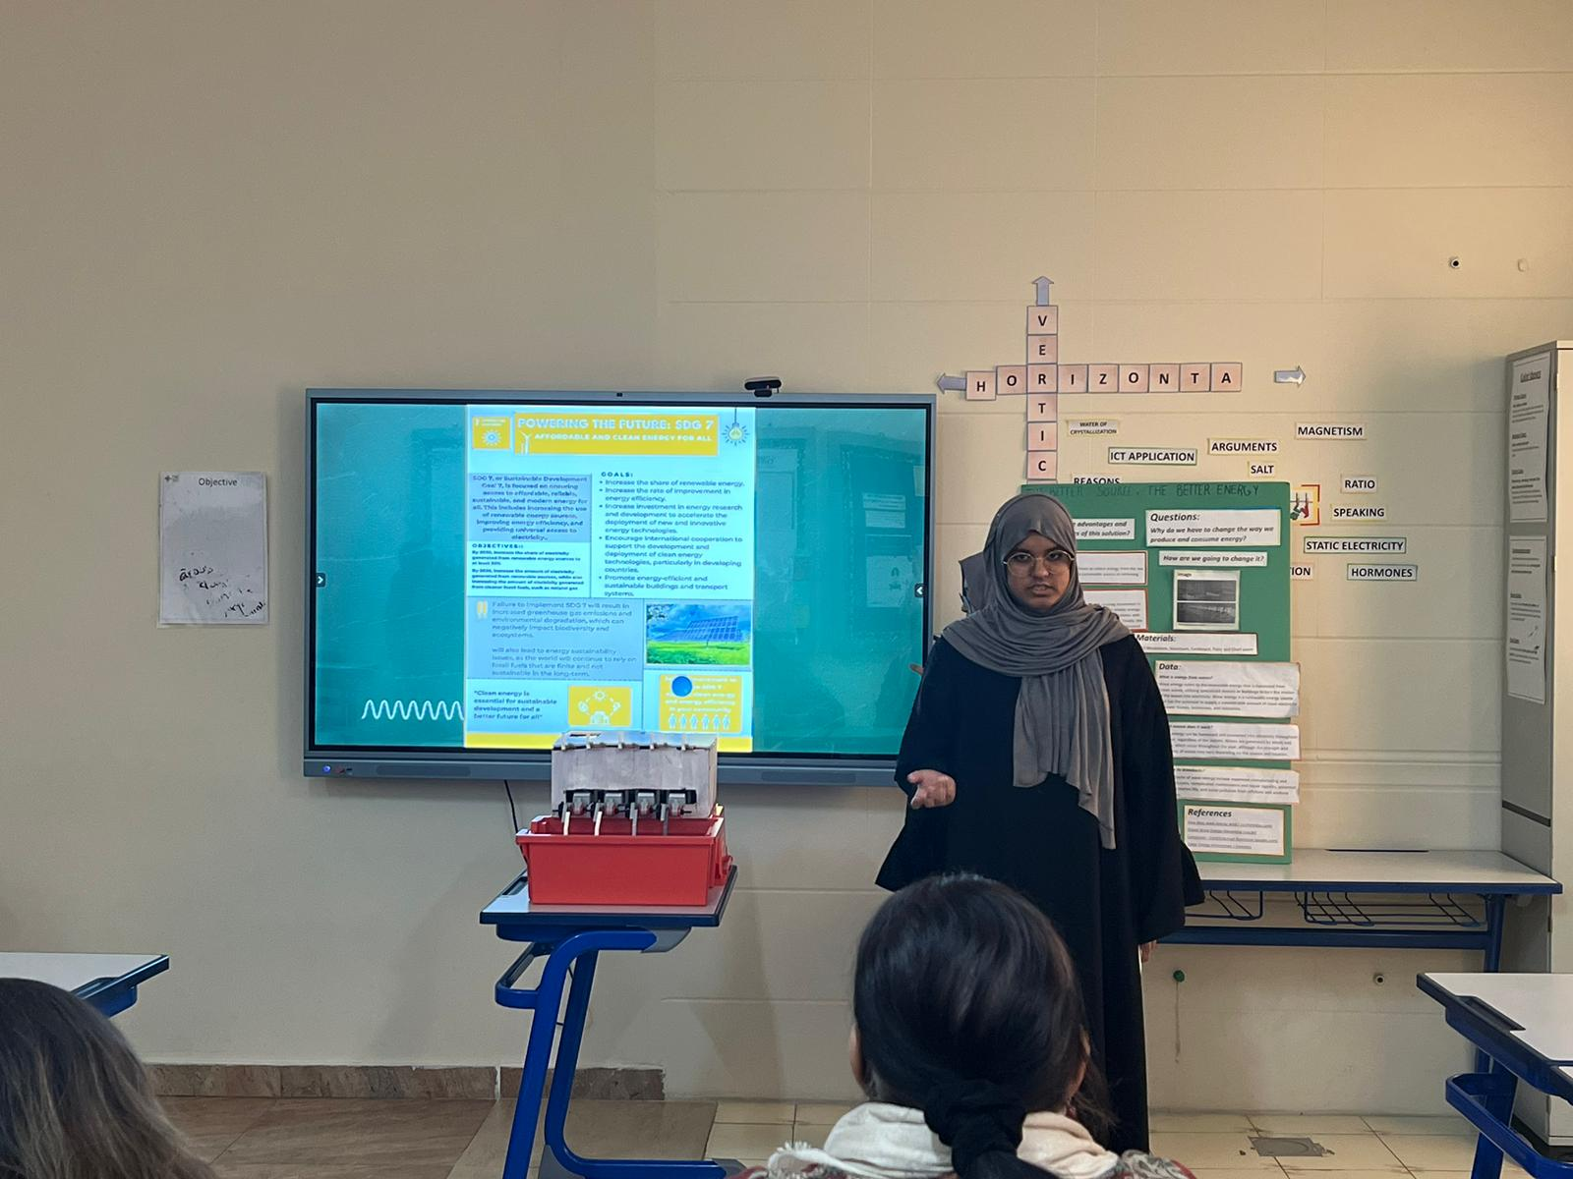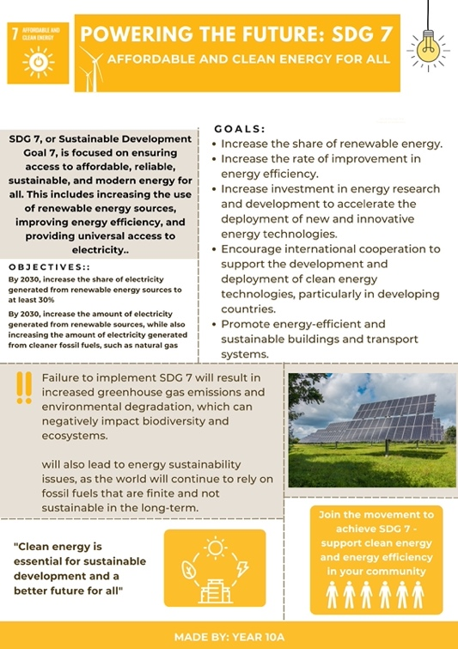

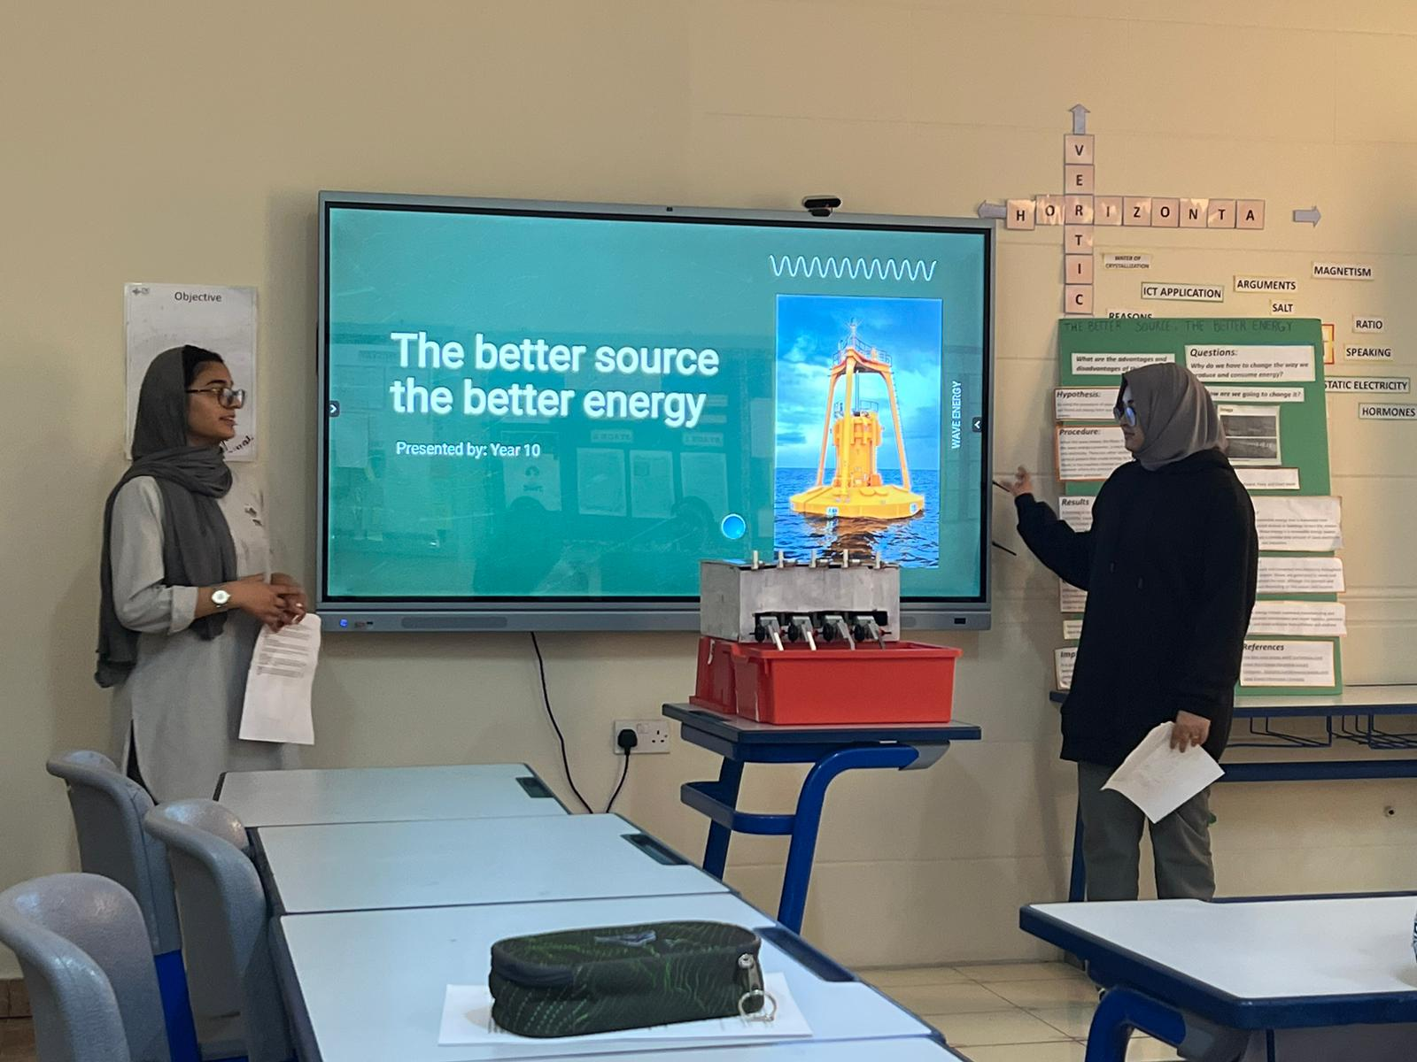

**Reflections**

Sharifah **– Class student:**

|  |
| --- |
| I feel like we had a strong and fun ylp project. Our project focused on providing access to clean, affordable, and sustainable energy to communities that lack it. The project aims to improve energy efficiency, reduce energy poverty, and increase access to renewable energy sources, such as solar or wind power, but We had less time to work on our project, and We’ve learned Innovation skills (we worked on technologies) and collaboration skills with classmates. |

Abdur Rehman **– Class student:**

|  |
| --- |
| I feel like we had a strong and fun ylp project. Our project focused on providing access to clean, affordable, and sustainable energy to communities that lack it. The project aims to improve energy efficiency, reduce energy poverty, and increase access to renewable energy sources, such as solar or wind power, but we had less time to work on our project, and we’ve learned Innovation skills (we worked on technologies) and collaboration skills with classmates.  I felt like this year’s YLP was unique in its own way. Although we were having difficulty brainstorming and deciding on the topic, after long and disastrous discussion and arguments, we finally decided on the topic. Honestly, at the start of the program, we did not make any progress. But after some time, we finally started to make Progress. We worked together and learnt the importance of cooperation and teamwork.  In addition we also learnt many new skills, while working on the project, such as engineering, programming and building robots etc.  In conclusion this YLP project was helpful in many ways, and was a nice way of diverting our focus away from studies and refreshing our mind. |

Ahmad Mustafa **– Class student:**

|  |
| --- |
| ylp robot was epic. We did brain storm and mad rob. |

Ms. Hannah **– Teacher**

|  |
| --- |
| It was a good experience working with the students, and learning along with them. Their behavior towards reaching one goal is inspiring and motivating. They worked amidst the pressure of preparing for their IGCSE exam and school work, yet they still did their best for this YLP project to be a successful one. |