1. Calculate x Include suitable units and give each answer to 1 decimal place

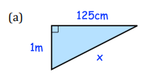

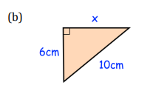

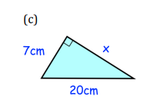

1. Find the diagonals of each rectangle given below
2. Length 12 cm , breadth 5 cm
3. Length 4cm , breadth 3 cm
4. Length 8 cm , breadth 6 cm
5. Find the diagonal of square whose each side is 20 cm
6. How far from the base of the house do you need to place a 15-foot ladder so that it exactly reaches the top of a 12- foot tall wall?
7. Find
8. **17 % of 2835**
9. **35 % of 1050**
10. **Find the percentage change from**
11. **140 to 125**
12. **1247 to 1586**
13. The price of a TV is £260 In a sale the price is decreased by 20% Work out the price of the TV in the sale
14. A puppy weighed 2kg. Eight weeks later the puppy weighed 3.5kg What was the percentage increase in the puppyʼs weight?
15. An empty bucket weighs 800g. The weight of the bucket increases to 2.1kg when filled with water. Calculate the percentage increase in the weight of the bucket. Give your answer to two significant figures
16. Rebecca and Jennifer take part in a training camp to improve their performance at the javelin. The table below shows Rebeccaʼs and Jenniferʼs best javelin throw before and after the training camp.

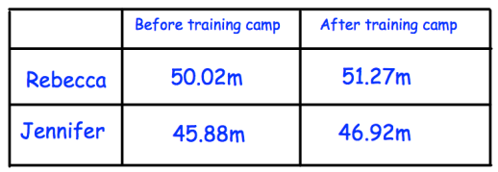

Which athlete had the biggest percentage improvement? You must show your method.