**Ans key Revision Worksheet 2**

1. Fill in ‘**better than’** or **‘worse than’** to complete these sentences.

a A mirror reflects light _________ **better than**________________ any other surface.

b A sheet of brown paper reflects light __________ **worse than**_______________ a sheet of aluminium foil.

2. Arun is reading a book before bedtime.

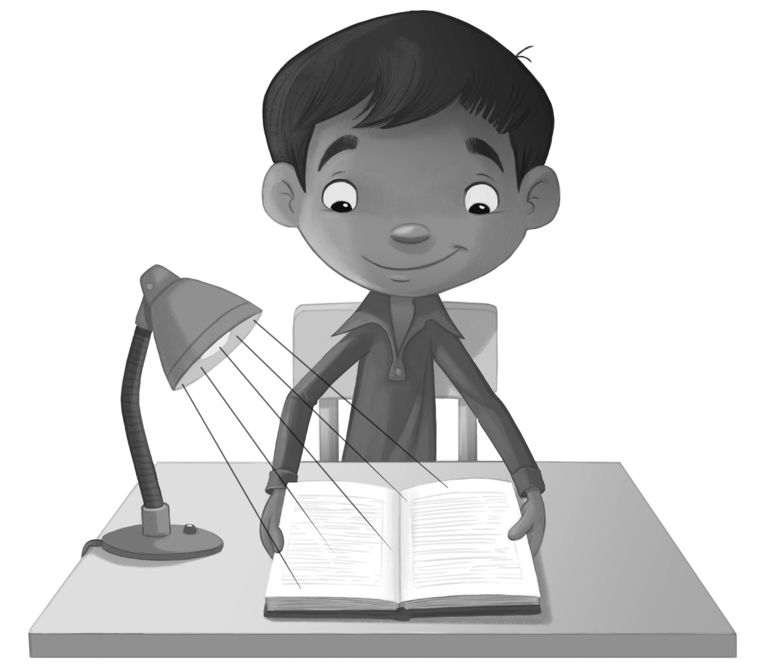

Complete these sentences.

a Light travels in straight lines called __Ray________.

b Light travels from the lamp to the __ Book ________.

c Arun sees the book because light travels into his ___Eyes_______.

d On the picture, draw lines with arrows to show how Arun sees the book.

1. Each day Oliver feeds his horse. His horse sees him when he arrives.

Here is a diagram of Oliver and his horse.

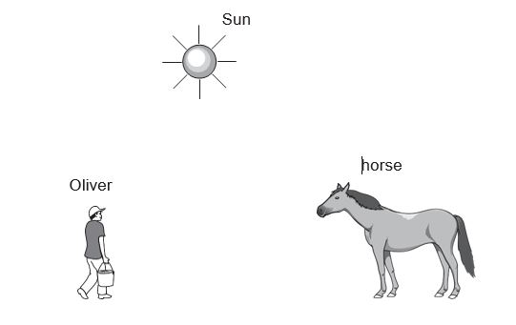

Draw rays of light on the diagram to show how the **horse** can see Oliver.

1. Imran is looking at his reflection in the mirror.

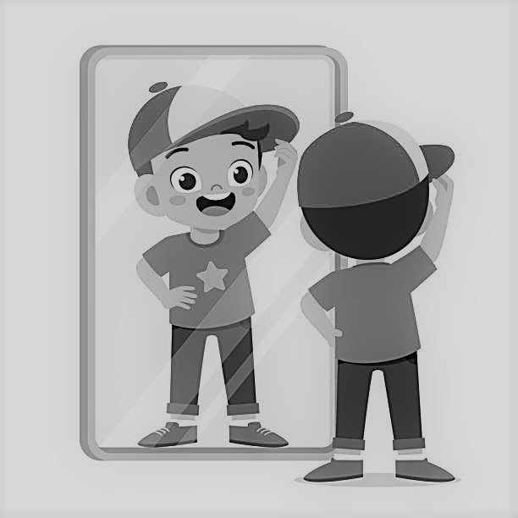

1. What is the reflection of an object in the mirror called?

____________Image_________________________________

1. Write **true or false** next to each sentence.
2. The moon is a natural source of light. False
3. Light travels in a straight line and cannot travel round corners. True
4. We see an object because light bounces off fromthe surface of the object into our eyes. True
5. Aluminium foil can reflect light better than a paper. True
6. The diagram which shows how we see an object is a called light diagram. False
7. Proof is an evidence that shows that something is true. True
8. Wood is a good reflector of light. False
9. Write down the five types of scientific enquiries.
10. ________Research___________________________
11. _________Pattern seeking__________________________
12. ________Fair testing___________________________
13. _________Observing over time__________________________
14. ___________Identifying and classifying________________________