**THE MALE REPRODUCTIVE ORGANS**

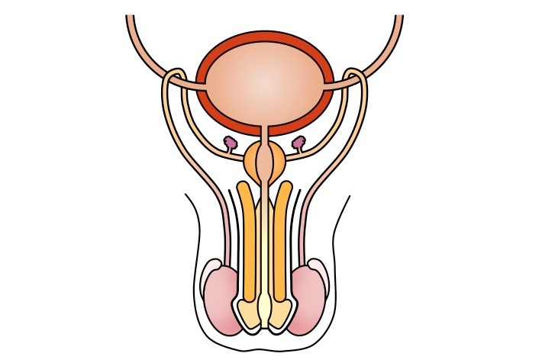

**Construct a Venn Diagram. Compare and contrast the human gametes.**

|  |  |  |
| --- | --- | --- |
| **Small** | **stationary** | **jelly coat** |
| **can be seen by naked eye** | **mobile** | **23 chromosomes in its nucleus** |
| **tail lashes from side to side** | **has a head** | **millions produced** |
| **produced (usually) one per month** | **acrosome** | **mitochndria needed for swimming** |