1. What is the result of a diet lacking iron?

**A** bleeding gums

**B** poor wound healing

**C** reduced number of red blood cells

**D** weak bones and teeth

1. The diagram shows part of the alimentary canal.

Which structure produces lipase?

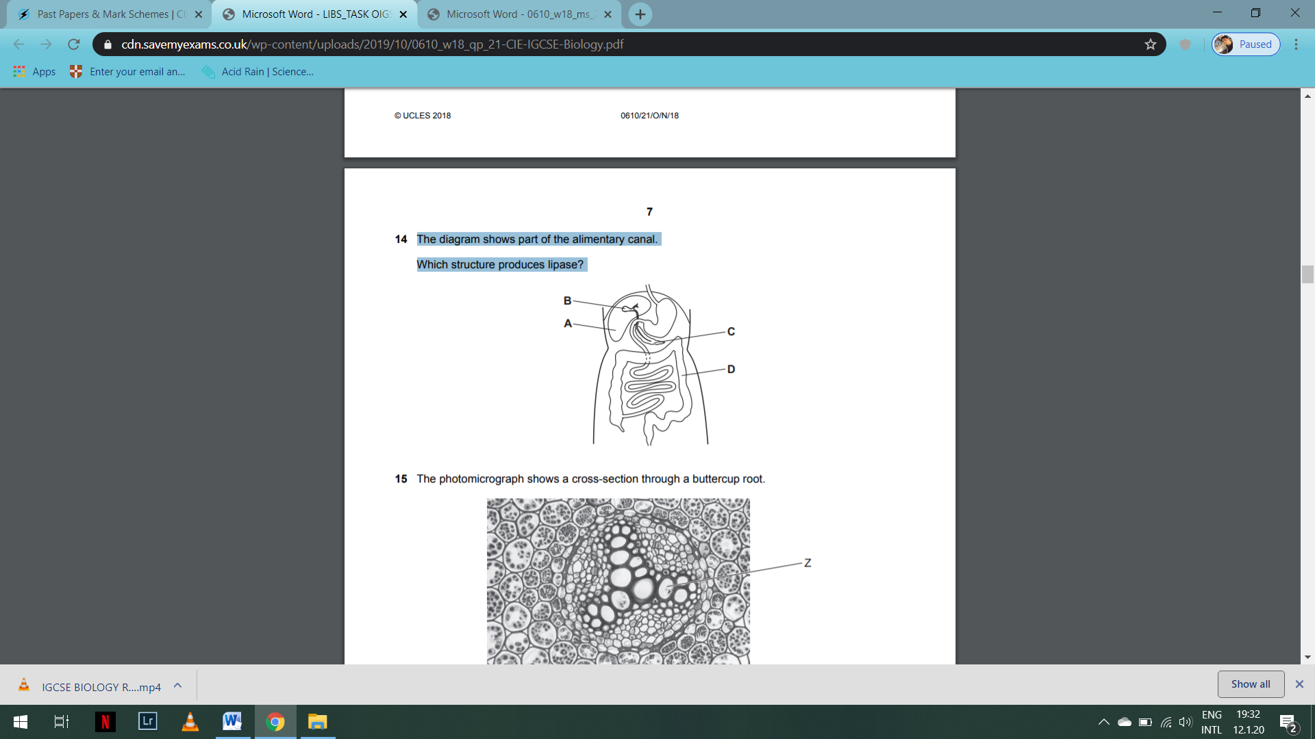

1. What must be increased in the diet of a person suffering from constipation?

**A** fats **B** fibre **C** iron **D** protein

1. Which disease can be caused by a deficiency of iron in the diet?

**A** anaemia

**B** kwashiorkor

**C** marasmus

**D** rickets

1. In which part of the body of a mammal does mechanical digestion occur?

**A** gall bladder

**B** liver

**C** mouth

**D** pancreas

1. Two functions of the alimentary canal are mechanical digestion and chemical digestion.

(a) Outline where and how mechanical digestion occurs in the alimentary canal. ................................................................................................................................................... ................................................................................................................................................... ................................................................................................................................................... ................................................................................................................................................... ................................................................................................................................................... ................................................................................................................................................... ................................................................................................................................................... ................................................................................................................................................... ...............................................................................................................................................[4]

(b) Enzymes catalyse the reactions of chemical digestion. Table 6.1 gives information about chemical digestion in three parts of the alimentary canal.

Complete Table 6.1.

**Table 6.1**

|  |  |  |  |
| --- | --- | --- | --- |
| **part of the alimentary canal** | **enzyme** | **substrate** | **product(s)** |
| **mouth** | **amylase** |  |  |
| **stomach** |  |  | **peptides** |
|  |  | **fats** | **fatty acids and glycerol** |

[6]

Mark: ___/15