**QUIZ 1 – GRADED**

**COMMON NETWORK DEVICES AND TERMS**

1. Two or more computers that are linked together so that they are able to share resources

* Data
* Packets
* Networks [1]

1. To build a network, ______________is needed [1]

* Electronic devices
* Network devices
* Mechanical devices

1. Each computer linked to the internet is given a number called [1]

* MAC address
* IP address
* Web address

1. The ___________ contain details of the destination address of the network [1]

* Data
* Packets
* IP address

1. Hardware device that read the address information to determine the final destination of the packet [1]

* NIC
* Routers
* Hub

1. Used to join wired or wireless networks together [1]

* Switches
* Bridges
* Routers

1. Combination of hardware which act as gateways so that computer networks can be connected to the internet using a single connection [1]

* Modems
* Routers
* Bridges

1. Cards connected directly to the motherboard of the computer and have external sockets so that computer can be connected to a network via cables. [1]

* Routers
* NIC
* Hubs

1. Name the device [1]

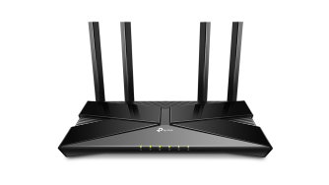 Answer _______________________

1. Name the device [1]

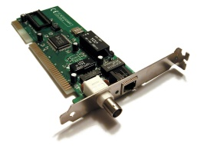 Answer _______________________