1. Tick four devices which are used to connect networks together. [4]

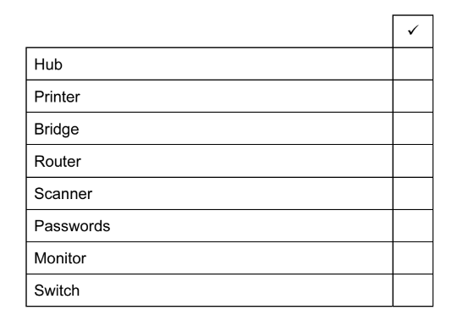

1. Complete each sentence below using the most appropriate item from the list.

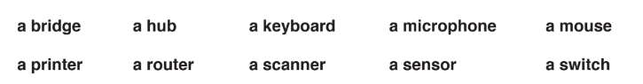

1. A network device which broadcasts data passing through it is called

…………………………………………………………………………………………………………………………………………[1]

1. A network device that connects a LAN with the internet is called

…………………………………………………………………………………………………………………………………………[1]

1. A network device that connects a LAN to another LAN using the same protocol is called

…………………………………………………………………………………………………………………………………………[1]

1. A network device that learns which devices are connected to which ports is called

…………………………………………………………………………………………………………………………………………[1]

1. A router is used to connect a LAN to the internet. A message is sent from the router to another

router. Give the name of the part of the router where the IP addresses are stored. [1]

…………………………………………………………………………………………………………………………………………………….

1. Six features of network devices are given below.

For each feature, tick (**√**) the appropriate box to indicate whether it refers to a router, hub or switch. [6]

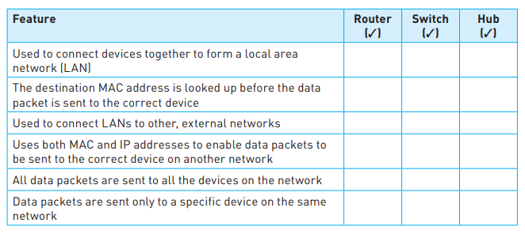

1. A bridge is a device used in network connectivity. Describe the functions of a bridge [4]

…………………………………………………………………………………………………………………………………………………………………………………………………………………………………………………………………………………………………………………………………………………………………………………………………………………………………………………………………………………………………………………………………………………………………………………………………………………….

………………………………………………………………………………………………………………………………………………………………………………………………………………………………………………………………………………………………………….

1. Compare and contrast bridges and routers [6]

…………………………………………………………………………………………………………………………………………………………………………………………………………………………………………………………………………………………………………………………………………………………………………………………………………………………………………………………………………………………………………………………………………………………………………………………………………………….

…………………………………………………………………………………………………………………………………………………………………………………………………………………………………………………………………………………………………………………………………………………………………………………………………………………………………………………………………………………………………………………………………………………………………………………………………………………….

…………………………………………………………………………………………………………………………………………………………………………………………………………………………………………………………………………………………………………

………………………………………………………………………………………………………………………………………………………………………………………………………………………………………………………………………………………………………….