**Quiz**

**Topic: Data Transmission**

1

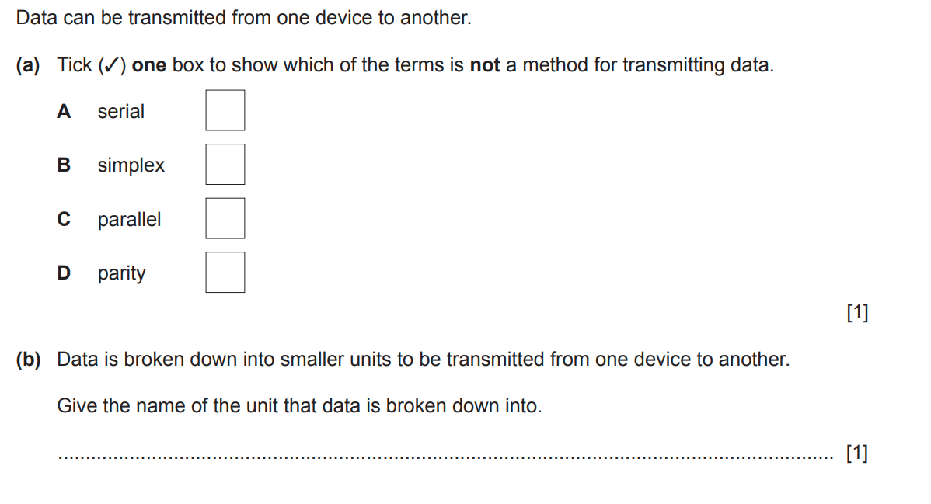

2.Data packets are transmitted across a network from one computer to another computer.

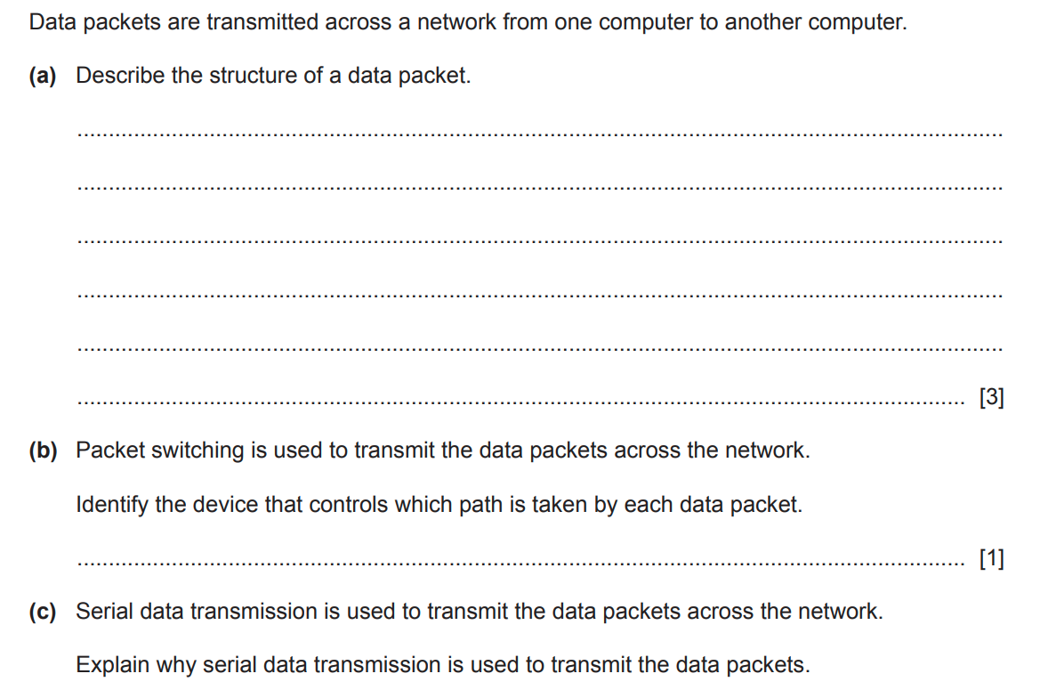

(c) What is payload?

…………………………………………………………………………………………………………………………….. [1]