1. **Fill the unit Storage hierarchy with capacity and Units as well. Like Bit can store 1, 0.**

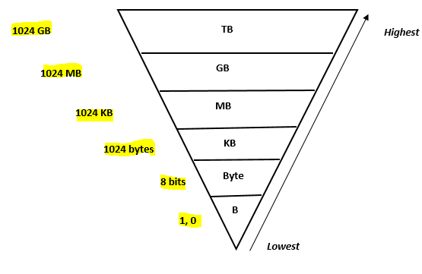

1. **Choose the right answer.**

|  |  |  |  |  |  |  |
| --- | --- | --- | --- | --- | --- | --- |
| **Fast** | **Gigahertz’s** | **Reports** | **Continuous data** | **Primary storage** | **Calculations** | **Spreadsheet** |

1. The modern processor is very ___ **Fast** ___.The speed at which the modern processor can operate is measured in ____ **Gigahertz’s** __________.
2. When the spreadsheet software was opened it was loaded into _______ **Primary storage** ______ storage.
3. ____ **Spreadsheet** _____ are capable of holding a lot of data. _____ **Calculations** ___ can be performed and charts can be created from the data stored.
4. The data that can take any value between two points (40.5) is called _____ **Continuous data** __________.
5. Databases are used to search data and create _ **Reports** _____ for analysis.

**II. State whether the statements are true or false.**

**6.** The speed of the processor is measured in megahertz. False

7. Computer memory is called as secondary storage. False

8. Secondary storage holds data in temporary basis. False

9 .A SSD is a secondary type of storage. True

10 . A data loggers are used to record and store temperature reading at specific interval of time.

True

11. Statistical investigation does not involve analysing or collecting of data.

False

**III. Match the following.**

|  |  |
| --- | --- |
| 12. Data logger | a. 0 and 1 |
| 13. Spreadsheet | b. 1024 MB |
| 14. Google Forms | c. Measures the pressure in the air |
| 15.It can store a single HD movie | d. Create a pie chart |
| 16.The smallest unit of storage | e.Processor |
| 17.It takes input and follows the instructions and produces the output. | f. Create a questionnaire for a survey |

|  |  |  |  |  |  |
| --- | --- | --- | --- | --- | --- |
| 12. | 13. | 14. | 15. | 16. | 17. |
| c | d | f | b | a | e |

**IV. Answer the following.**

18. ﻿The Ministry of Tourism wants to know the number of tourists that visit sites in the city. They must conduct a survey and present the results.

State ONE computing tool that is best suited for the following:

a. To create a questionnaire for the survey.

__________________________Forms_____________________________________

b. To sort the data and calculate the total number of tourists that visit the city.

____________________Spreadsheet_____________________________________

c. To create a chart to show the number of tourists that visit each site.

_______________________Spreadsheet_____________________________________

19. Sami is a computer lab technician. He needs to setup his lab with some new desktop systems. He requires certain types of storage devices which help him to store the data internally and externally.

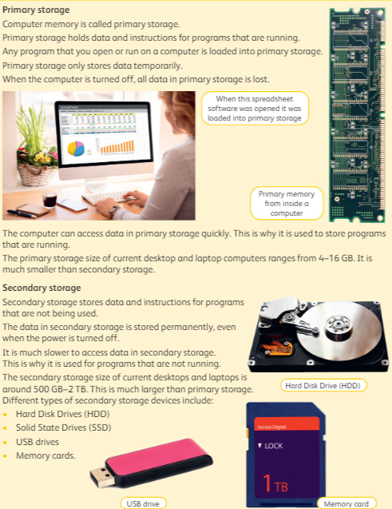 a. List the two storage devices types from each category.

b. Differentiate between the two main categories of storage devices.



20. Haseena is a data analyst, she is creating a spreadsheet for collecting and analysing the data to calculate the amount of money she have collected during her whole week of sales. She needs to analyse different types of data to understand the highest and lowest selling of the product.

a. Explain the different types of data with at least two points each that needs to be collected for anlaysing.

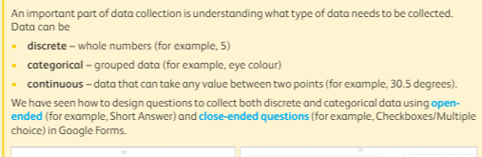

b. What are the **three** main things that needs to be considered while creating the spreadsheet for data collecting and management. 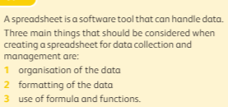

c. The spreadsheet below shows the cost of items sold in a grocery shop.

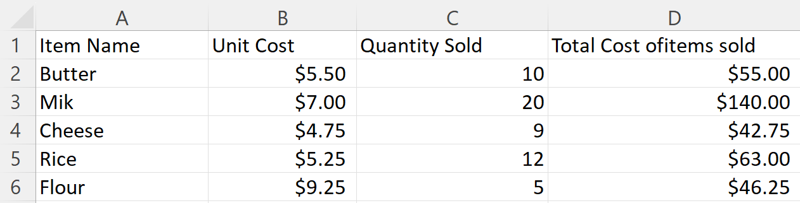

What data is needed? State the cells that will be selected for the following tasks:

i) Find the difference between the highest unit cost and least unit cost.

a. cells B2 and B5

b. cells B1 and B5

c. cells B6 and B4

ii) Create a column chart to show the unit cost and the quantity sold.

a. cells B2:B6 and C2:C5

b. cells A1:D5 and C2:C5

iii) Find the average quantity of all the items.

a. cells A2:A5

b. cells C2:C6