**Q. Match the following :**

**A B**

1. Personal Savings Small amount invested by each person

however results in a huge investment.

1. Investment from family and friends Failure to make payments can result in assets getting seized .
2. Bank Overdrafts Money can be spent for a specific project only.
3. Loans All the money invested might be lost .
4. Leasing Can only solve short term financial issue.
5. Mortgages Cheaper source of finance than buying equipment outright .
6. Grants Failure to make payments can result in getting seized .
7. Subsidies No interest has to be paid .
8. Crowdfunding Will expect a control in decision making to protect their

Investment.

1. Selling shares It can lead to a complete takeover by shareholders .
2. Retained Profits Can upset family relationships if not returned back .
3. Venture Capital Dividend payment will be involved .
4. Issue Shares Reduced tax bill or any other form of benefit.
5. Changes in tastes and fashion Inefficient Market Research
6. Changes in the size and structures of population Employer getting injured
7. Changes in Real income Enterprise capacity over estimated
8. Advances in technology DVD’s , Smartphones
9. Grants and Subsidies Insufficient or less skilled workers
10. Changes in taxation Low rate of taxation
11. Changes in law Favourable changes in law for promoting enterprises.
12. Globalisation An enterprise can sell in more than one country
13. Financial Risks Cash flow difficulties
14. Human Resources Risks Financial support from the government
15. Production Risks Increase in income above the rate of inflation
16. Health and Safety R isks Size , age distribution
17. Economic Risks Some products become less popular.

**CASH FLOW**

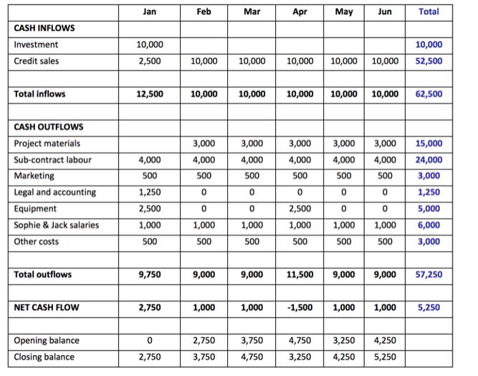

Define : (10)

Cash Inflow :

……………………………………………………………………………………………………………………………………………………………………..

…………………………………………………………………………………………………………………………………………………………………….

Cash outflow :

…………………………………………………………………………………………………………………………………………………………………….

……………………………………………………………………………………………………………………………………………………………………..

Net Cash Flow :

……………………………………………………………………………………………………………………………………………………………………..

…………………………………………………………………………………………………………………………………………………………………….

Surplus :

…………………………………………………………………………………………………………………………………………………………………….

……………………………………………………………………………………………………………………………………………………………………

Deficit : .

…………………………………………………………………………………………………………………………………………………………………………….

…………………………………………………………………………………………………………………………………………………………………………….

**COSTS**

**Total Cost = Fixed Cost + Variable cost**

**Fixed costs** are costs which do not vary with the number of items sold or produced in the short run. They have to be paid whether the business is making any sales or not .

Fixed costs are also known as **overhead costs .**

**Examples :** management salaries and rent paid for property. Even if output is zero , these costs would still have to be paid.

**Variable costs** are costs which vary directly with the number of items sold or produced.

**Examples :** raw materials and labour costs which will increase if the output increases and decreases if the output decreases.

Define :

Contribution (2)

……………………………………………………………………………………………………………………………………………………………………………….

……………………………………………………………………………………………………………………………………………………………………………….

**Compute the break even point :**

|  |  |  |  |  |
| --- | --- | --- | --- | --- |
| No. of units | Fixed costs ($) | Variable costs | Total costs | Total Revenue |
| **0**  **500**  **1000**  **1500**  **2000**  **2500**  **3000**  **3500** | 2500  2500  2500  2500  2500  2500  2500  2500 | **0**  **500**  750  1000  1250  1500  1750  2000 | **2500** | **0** |

**The price per unit is $5.**

**TC = FC + AC**

**Total Revenue = Price per unit X No. of units**

***INCOME STATEMENT***

Define : (10)

Profit:

……………………………………………………………………………………………………………………………………………………………………..

…………………………………………………………………………………………………………………………………………………………………….

Loss :

…………………………………………………………………………………………………………………………………………………………………….

……………………………………………………………………………………………………………………………………………………………………..

Income :

……………………………………………………………………………………………………………………………………………………………………..

…………………………………………………………………………………………………………………………………………………………………….

Revenue :

…………………………………………………………………………………………………………………………………………………………………….

……………………………………………………………………………………………………………………………………………………………………

Expenditure :

……………………………………………………………………………………………………………………………………………………………………… ……………………………………………………………………………………………………………………………………………………………………..

Debt :

………………………………………………………………………………………………………………………………………………………………………………………………………………………………………………………………………………………………………………………………………………………………………..

**BUDGET**

Define : (2)

Budget :

……………………………………………………………………………………………………………………………………………………………………..

…………………………………………………………………………………………………………………………………………………………………….

Budget Variance :

…………………………………………………………………………………………………………………………………………………………………….

……………………………………………………………………………………………………………………………………………………………………..

**Q. Explain the 30- day , 60-day and 90-day Provision of credit with its advantages and disadvantages.**

