

Term I

REVISION EXAMINATION

DECEMBER 2023 - 24

Key Stage 3 (Year VIII __)

**Date : November 2023**

**Name of the Candidate : _______________________________________________**

**Subject : ICT PRACTICAL**

**Total Maximum Marks : 70**

**INSTRUCTIONS**

**Answer all questions.**Use a black or dark blue pen.  
Write your name, centre number and candidate number in the boxes at the top of the page. Write your answer to each question in the space provided.  
Do **not** use an erasable pen or correction fluid.  
Do **not** write on any bar codes.  
You may use an HB pencil for any diagrams, graphs or rough work.

**The total mark for this paper is 70.**The number of marks for each question or part question is shown in brackets [ ].  
No marks will be awarded for using brand names of software packages or hardware.

|  |  |  |
| --- | --- | --- |
| **Section** | **Maximum Marks** | **Marks Obtained** |
| **TASK 1** | **0** |  |
| **TASK 2** | **51** |  |
| **TASK 3** | **19** |  |
| **Total** | **70** |  |

**Checked by : ____________________________**

**Re-checked by : ____________________________**

**Task 1 – Spreadsheet**

*You work for Hothouse Design and will produce materials for the Tawara Wildlife Conservation Trust. ✓*

1. Create a new folder called **N15Tawara**
2. The following source files are provided :

Store them in your **N15Tawara** folder:

n15_3_1.jpg

n15_3_2.jpg

n15_3_3.jpg

n15_3_4.jpg

n15_3_5.jpg

n15_3_6.jpg

n15_3_7.jpg

n15_3_8.jpg

n15_3_title.jpg

n15_3_evidence.rtf

n15_3_payroll.csv

1. Open the file **n15_3_evidence.rtf**

Make sure your name, Centre number and candidate number will appear on every page of

this document.

Save this Evidence Document in your work area as **n5evidence** followed by your candidate

number. For example, n5evidence9999. You will need this file later.

*The Tawara Wildlife Conservation Trust requires you to create a spreadsheet to calculate the*

*wage bill for one week.*

*All currency values must be shown in dollars ($) with 2 decimal places. Make sure that you use*

*the most efficient methods to do each task. Make sure that each printout fits on a single page and*

*that the contents of all cells are fully visible.*

1. Using a suitable software package, load the file **n15_3_payroll.csv**

Examine the contents of this file and save it as a spreadsheet.

1. Use cells **A19 to D27** to create a named range Rates

Show evidence of how you created this in your Evidence Document. [2]

1. Merge cells **A1 to H1** so they become a single cell. [1]
2. Enter the text **TWCT – Week 14 Payroll** in this cell. [1]
3. Format this text so that it is a bold, 18 point, centre aligned, sans-serif font. [3]
4. Format this cell so that it contains white text on a black background. [1]
5. In cell **D4** enter a function to look up the pay rate from the Rates table using the pay code as

the look up value and the named range Rates as the array.

*Formulae will be entered in steps 11 and 12. These will not produce results until test data is*

*entered into cell F4.* [7]

1. In cell **G4** enter a formula to calculate the pay for this employee using their pay rate and

hours worked.

Select appropriate data that you can enter into cell **F4** to test this formula. Enter this data in

the *Data chosen column* of the test table in your Evidence Document.

Record in the *Expected column* of your test table the value you expect to see in cell **G4**.

Enter your test data into cell **F4** and record the result in the Actual column of your test table. [3]

1. In cell **H4** enter a formula to display the word **Yes** if the hours worked are greater than the

contract hours, display the word **No** if the hours worked are the same as the contract hours

or display the word **Incomplete** if the hours worked are less than the contract hours.

Select **three** items of *appropriate data* that you can enter into cell **F4** to test this formula.

Enter this data in the *Data chosen* column of the test table in your Evidence Document.

Record in the *Expected column* of your test table the output you expect to see in cell H4. [7]

Enter each item of test data into cell **F4** and record each result in the *Actual* *column* of your

test table for each item of test data. [9]

1. Replicate the formulae entered in steps 10, 11 and 12 for all employees. [1]
2. Apply appropriate formatting to all cells.
3. In cell **G16** enter a function to calculate the total wage bill for this week. [1]
4. In the centre of the header, add your name, Centre number and candidate number. [1]
5. Save and print the spreadsheet showing the values. [2]
6. Enter the following data in the Hours worked column:

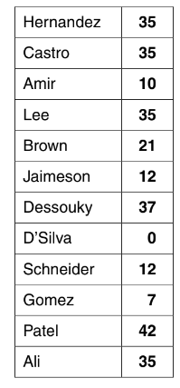 [2]

1. Save and print the spreadsheet showing formulae. Make sure the row and column headings

are displayed.

1. Print the spreadsheet showing the values.
2. In row 1 change the text ...Week 14... so that it becomes ...Week 15...
3. Replace the existing data in the Hours worked column with this data:

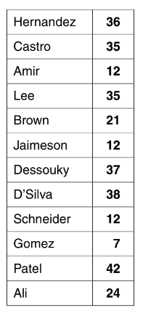 [3]

1. Print the spreadsheet showing the values.
2. Sort the Employees data into ascending order of the employee name. [1]
3. Print the spreadsheet showing the values.
4. Hide rows 17 to 27. [1]
5. Search the data to extract only the employees who have worked overtime and have a Pay

code starting with F [2]

Show evidence of your method(s) in your Evidence Document. [1]

1. Print the spreadsheet showing the values and Evidence document. [2]

**Task 2 – DOCUMENT**

*You work for an organisation promoting coarse fishing in the UK. You are going to perform some tasks for this organisation.*

1. Open the Evidence Document called **J215EVIDENCE.RTF**

Make sure that your name, Centre number and candidate number will appear on every page of this document.

Save this Evidence Document in your work area as **J215EVIDENCE** followed by your candidate number. For example, J215EVIDENCE9999

You will need this file later

*You are now going to edit an information sheet about coarse fishing.*

1. Using a suitable software package, load the file **J215ANGLING.RTF**
2. Save this document with a new file name in your work area. Make sure it is saved in the format of the software you are using.
3. Set the:

• page size to A4

• orientation to portrait.

Place screenshot evidence of the page size in your Evidence Document.

1. Set the:

• top margin to 3.5 centimetres and bottom margin to 2 centimetres

• left and right margins to **1.5** centimetres.

Place screenshot evidence of this in your Evidence Document

1. Place the image **J215LOGO.JPG** on the right in the header:

• Resize the image to 2.5 centimetres high and maintain the aspect ratio.

• Make sure the header is displayed on all pages and the image does not overlap any text. [1]

Place in the footer:

• automated file name and file path left aligned

• your name and candidate number right aligned. [1]

Make sure the footer is displayed on all pages and alignments match the page margins.

1. At the start of the document enter the title **COARSE FISHING IN THE UK** [1]
2. Make the title:

• right aligned

• font size 30 point

• bold. [1]

1. Below the title, add a subtitle:

**Beginners guide by:** and add your name. [1]

1. Make the subtitle:

• centre aligned

• font size **16** point

• italic and underlined with no other emphasis [1]

1. Set the title and subtitle to the same sans-serif font.
2. Format all the text from the subheading *Types of Angling* so that this subheading and all

following text is displayed in two equally spaced columns with **2** centimetre spacing

between the columns. [1]

1. Set all of the body text to:

• be fully justified [1]

• a serif **11** point font [1]

• **single** line spacing [1]

1. Identify all the subheadings(7) in the document and make them all:

• centre aligned

• serif font

• underlined

• font size **14** point. [1]

1. Insert a table with **3** columns and **8** rows after the text ...must have a rod licence. [3]
2. Enter the following data into the table:

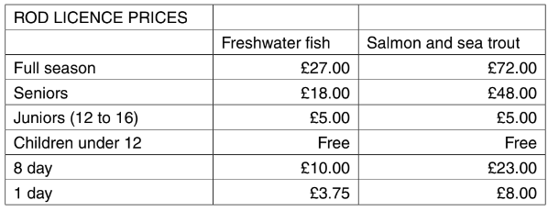

1. Format the text in the table as body text. [1]
2. Format the top row of the table to be:

* bold and inderlined. [1]
* Merged and centre aligned [1]

1. Format the second row of the table to be

* Italic
* Right aligned
* Haedings wrapped – do not allow the words to split [1]

1. Format rows 3 to 8 so that:

• the data is displayed on one line

• the numbers are right aligned. [1]

1. Save the document with the same file name and format used in Step 31.

Print the document and Evidence document in portrait orientation