QUIZ-9
Data Manipulation (Marking Scheme)

Sl.No | Answers | Marks
1. | 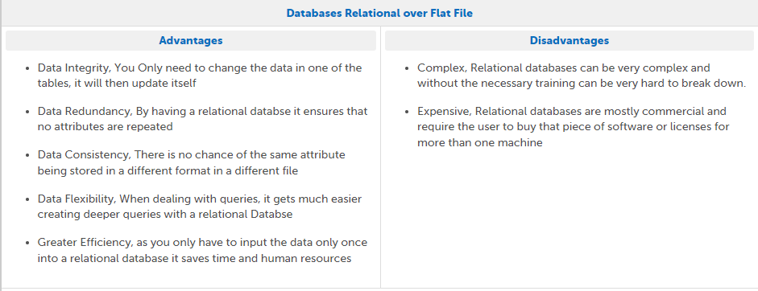 | 5
2.a | A primary key is the column or columns that contain values that uniquely identify each row in a table. A database table must have a primary key for Optim to insert, update, restore, or delete data from a database table. | 2
2.b | A foreign key is a column or group of columns in a relational database table that provides a link between data in two tables. It acts as a cross-reference between tables because it references the primary key of another table, thereby establishing a link between them. | 2
3 | ORDER_ID

