**Grade 3 Unit 11– Formatting cells (Data Formats)**

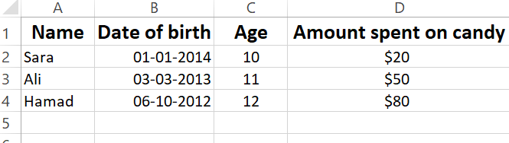

The students will open MS – Excel and enter the above given data in the spreadsheet.