**TASK A: [9]**

**Follow the steps to display ‘i’ on the microbit:**

1. Open Google , Type MakeCode. [0.5]
2. Click on the first link and create New project by your name. [0.5]
3. Remove the existing blocks from the interface. [0.5]
4. Click on input and select on button **A** is pressed. [1]
5. Select **LED** click on this block 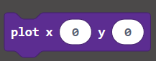 [0.5]
6. Put the value of x = 1 and y = 4. [1]
7. Select **LED** and click on this block again  [0.5]
8. Put the value of x = 1 and y = 3. [1]
9. Select **LED** and click on this block again  [0.5]
10. Put the value of x = 1 and y = 2. [1]
11. Select **LED** and click on this block again  [0.5]
12. Put the value of x = 1 and y = 0. [1]
13. Run your program. [0.5]

**TASK B: [16]**

**In this task you are required to make dice game in MakeCode using Microbit by**

**Applying the following steps in your program:**

1. Open Google , Type MakeCode and click on the first link. [1]
2. Create a new project by your name. [0.5]
3. Remove the existing blocks from the interface. [0.5]
4. Click on Input and select on button **A** is pressed. [1]
5. Click on variable and create a variable by **dice** name. [1]
6. Click on **set dice to** and join it with **pick random** from maths block. [2]
7. Put random number **first value 1 and second value 6**. [1]
8. Click on logic block and select If. [1]
9. If dice equal to 1 then: [1]

* 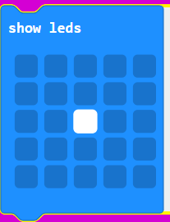Show LEDs in following pattern: [1]

1. If dice equal to 2 then: [1]

* Show LEDs in following pattern: [1]
* 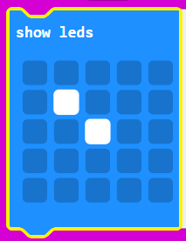

1. Similarly do till dice value equal to 6. [2]
2. Run and test your code. [1]