**CELLULAR NETWORKS:**

1. State whether the following statements are true **(✓)** or false**(X).**
2. Mobile phones can be used to make phone calls while on a train.
3. Mobile devices can access the internet by using wireless signals.
4. A cell tower has an antenna that can only receive signals from mobile phones.
5. A cell is a place where mobile phones are stored.
6. A cell tower uses Wi-Fi to connect to mobile devices.
7. 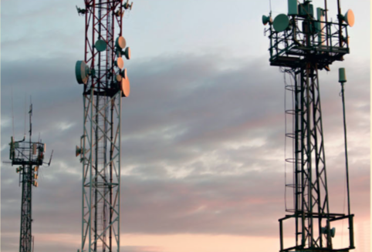How would you explain the role of Cell in cellular network?

_________________________________________

_________________________________________

_________________________________________

_________________________________________

_________________________________________

_________________________________________

_________________________________________

1. What are the equipment is found at a cell site?

_____________________________________________________________________

_____________________________________________________________________

_____________________________________________________________________

_____________________________________________________________________

1. How can a mobile device continue to access the internet while travelling in a car over a long distance?

_____________________________________________________________________

_____________________________________________________________________

_____________________________________________________________________

_____________________________________________________________________