WORKSHEET - MS
1 | Any five from  LAN WAN  Local area network Wide area network  Confined to a small area Covers a wide geographical area  Usually located in same building In lots of different buildings and cities, countries etc..  Use cables, wireless, infra-red and microwave links which are usually owned by the organization. Uses more expensive telecommunication links that are supplied by telecommunication companies.  Less expensive to build as equipment is owned by the organization which is cheaper than renting lines and equipment. More expensive to build as sophisticated communication systems are used involving rental of communication lines. | 5
2 | 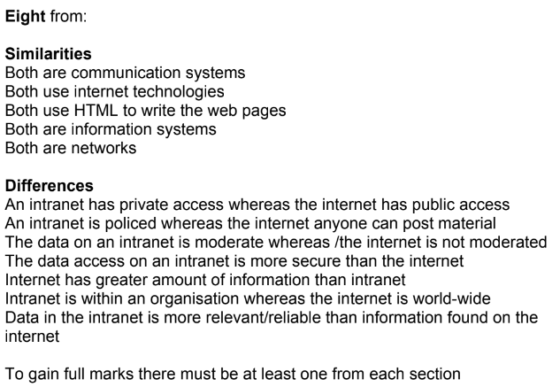 | 8

