- Table 1.1 shows some names of the parts of the fermenter and their functions.
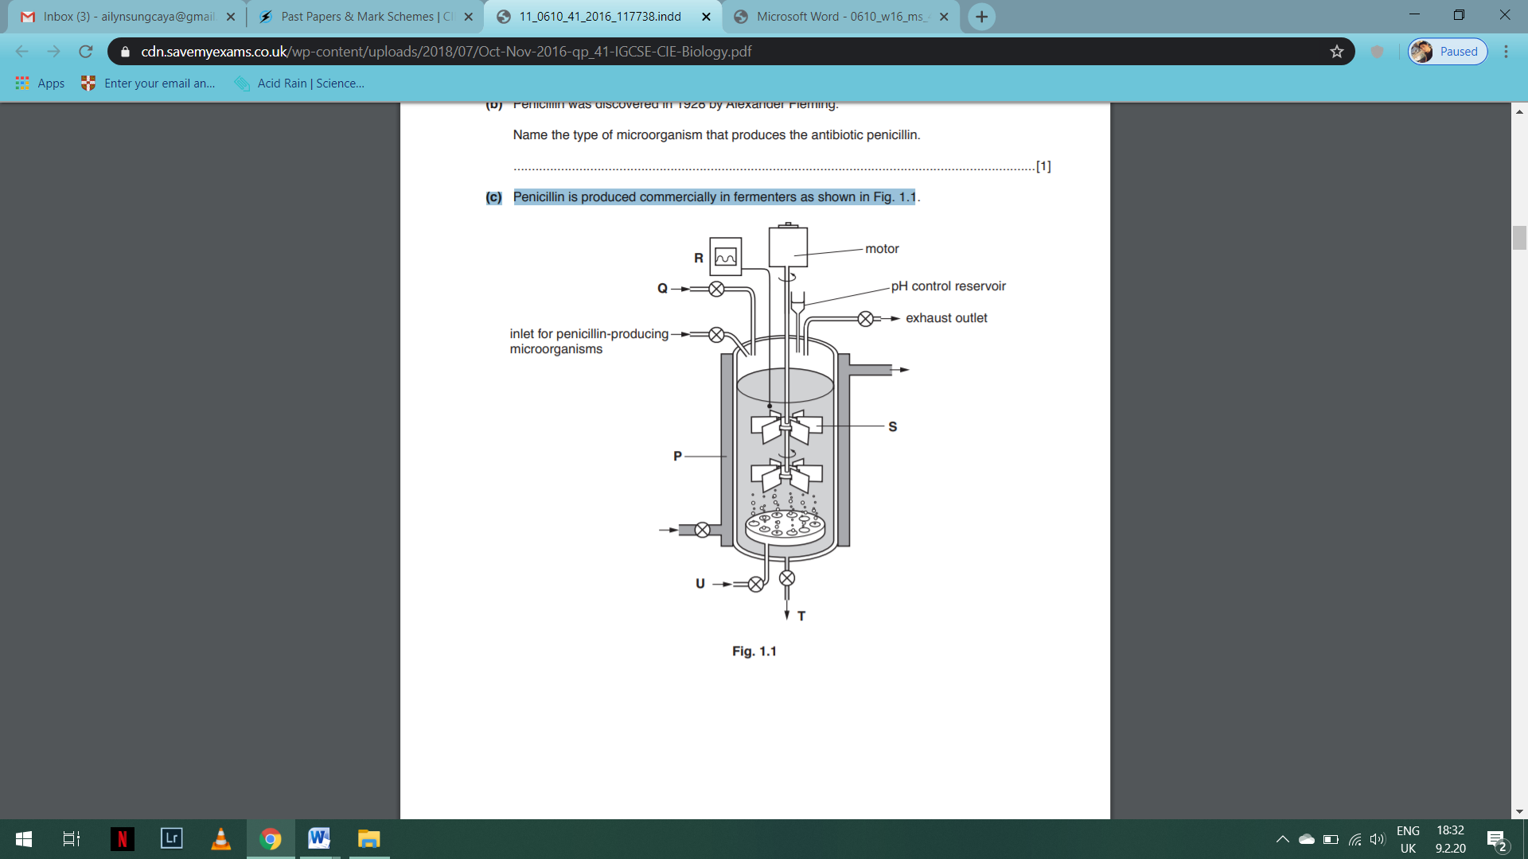
Complete Table 1.1.
One row has been done for you.
Table 1.1
letter from Fig. 1.1 | name | Function
 | water jacket
S
 | nutrient inlet
R
 | air supply
T | outlet | allows collection of the liquid containing  penicillin after fermentation

- One product that is made in fermenters is the antibiotic penicillin. This is made by a fungus called Penicillium. The fungus is made up of long threads called hyphae.

- Explain what an antibiotic is used for.
______________________________________________________________________________________
____________________________________________________________________________________________________________________________________________________________________________

- Carbohydrates and amino acids are added to the fermenter. Explain why both of these substances are added.
__________________________________________________________________________________________________________________________________________________________________________________________________________________________________________________________________
- The fermenters in which Penicillium is cultivated do not usually have paddles. Suggest why.
__________________________________________________________________________________________________________________________________________________________________________________________________________________________________________________________________

