Quiz 7 - MS
Computers in medicine
1 | Three from:  3D digital copy is made and put in the software.  Software slices the model into hundreds of layers.  Printer creates the model layer by layer.  Binds them together | 3
2 | 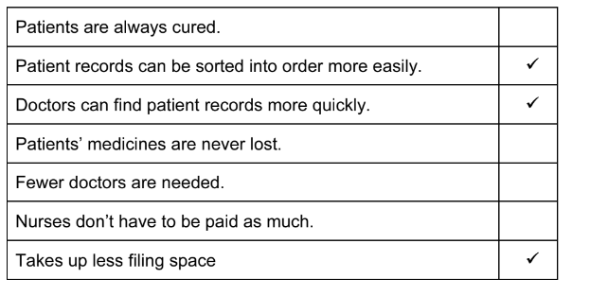 | 3
3 | Four from:  Reduced cost of wage bill  Computer readings are more accurate/human errors are reduced.  Readings can be taken more frequently / continously  Nurses can get tired and forget to take readings  Nurses are so busy they might not be able to take readings regularly  Graphs can be produced automatically | 4

