**QUIZ-**7 **(GRADED)**

**COMPUTERS IN MEDICINE**

1. Car production lines use robots to manufacture the vehicles. The robots have devices attached to

their arms to help in the manufacturing process. Cars have to be designed before they can be manufactured. 3D printers can be used to produce models of a car.

Describe the process involved in producing the models.

…………………………………………………………………………………………………………………………………………………………..……………………..……………………………………………………………………………………………………………………………………..…..………………………………………………………………………………………………………………………………………………………...……………………………………………………………………………..………………………………………………………………………………………………………………………………………………………[3]

1. Tick three benefits of using computers to store patient records in hospitals.

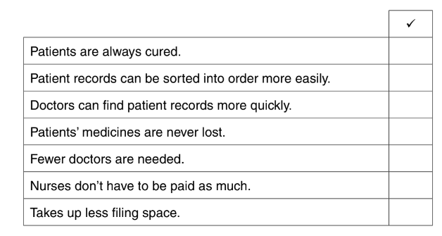 [3]

1. Give four advantages using computerised monitoring of patients rather than using nursing staff for monitoring .

i………………………………………………………………………………………………………………………………………………………….………………………………………………………………………………ii…………………………………………………………………………………………………………………...……………………………………….……………………………………………………………………………iii…………………………………………………………………………………………………………………..…………………………………….………………………………………………………………………………iv…………………………………………………………………………………………………………………...……………………………………..……………………………………………………………….…………[4]