- Choose the words from bank. /5
mistake humans fictional
computers preform

- Computers can _______ tasks for a long time.
- Computers follow instructions they do not make ______ .
- _________ robots does not really exist.
- ___________ store a lot of information in small space.
- Computers can do some things better than ______.

- State whether the statement is true or false. /5
Robot are faster than humans.
All Robots are fictional.
Humans do not need a break.
Tablet is a portable device.
A robot vacuum can do a better job than a broom.
Graphic designer don’t need a large screen they can use smartphone.

- Match the following. /4
- location | - Somone sit at a desk for many hours each day .
- Purpose | - A delivery uses a tablet.
- Attaching other device  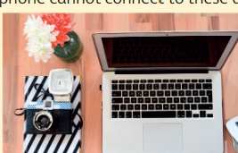 | - . Needs a device that last more than a day before recharging
- Battery  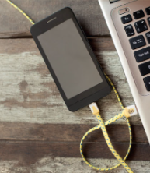 | - needs to attach printer to the device

