1. Write correct mathematical symbol to make the number sentences correct. /3

+ - =

1. 81 _____ 40 + 41
2. 55 _____ 5 = 60
3. 30 _____ 2 = 28
4. Check whether the answers are correct or wrong. Write if the answer is correct and if the answer is wrong. /3
5. 24 + 63 = 87 _____________
6. 40 + 55 = 90 _____________
7. 25 – 11= 13 ______________
8. Find the mystery number. /2
9. 24 + = 36
10. 48 – 6 =
11. 37 – = 32
12. + 16 = 38
13. Solve these calculations using the T10 strategy. Write your answer in steps in the format given below. /2
14. 25 + 7 = ________ b) 53 + 9 = _______

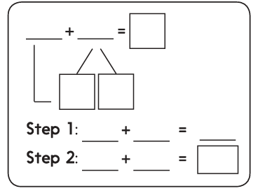

1. Continue the pattern, starting with the number below and writing a number in each box. /2

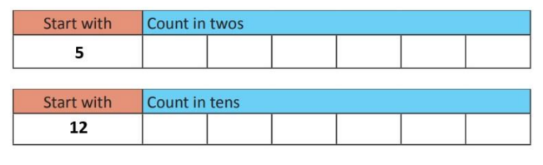

1. Use the bead bar to help solve these calculations. /2
2. 75 + 23 = __________



1. 87 – 11 = ___________



1. Use only 10 p coins to make the amount. /1

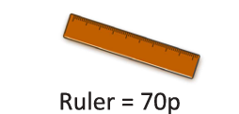

1. Use only 2p coins to make the amount. /1

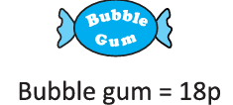

1. An ice cream truck is selling all these ice creams for half the price. Write the correct amount next to them. /2

16 p

12 p

16 p

32 p

24 p

28 p

Half price:

10) Complete each sentence. Using picture prompts for your help. /2



1. Half of 18 =

Double = 18



1. Half of 14 =

Double = 14

Teacher’s Signature:_____________________ Parent’s Signature:_____________