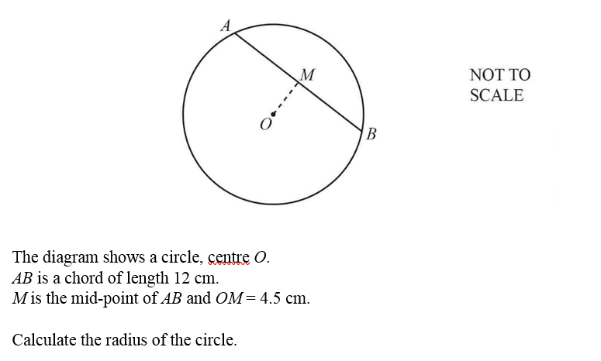

...................................................cm [3]



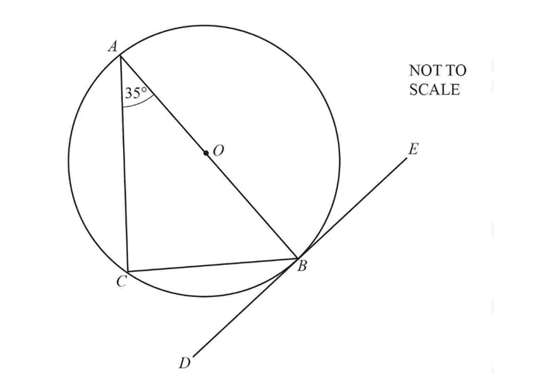

*A*, *B* and *C* are points on the circumference of the circle, centre *O*.The straight line *DE* touches the circle at *B*.

**(a)** Write down the mathematical name for the line *DE*.

................................................... [1]

**(b)** On the circle, draw a radius. [1]

**(c)** Complete the following statements.

**(i)** Angle *ABD* = ............ because ............................................................................................

..........................................................................................................................................[2]

**(ii)** Angle *ACB* = ............ because ............................................................................................

..........................................................................................................................................[2]



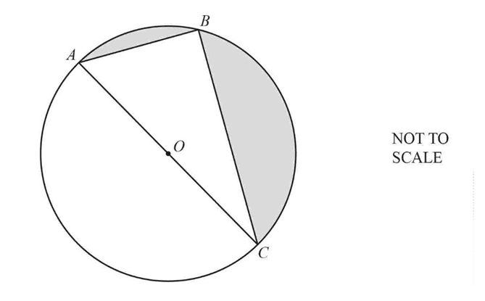

A, B and C are points on the circumference of a circle, centre O.

1. Give a geometrical reason why angle ABC = 90°.

...........................................................................................................................................................................................................................................................................................[1]