I) Answer the following questions.

a) Name an online tool for creating electronic forms.

_________________________________________________________________________

b) What software can manage lots of data in a structured way?

_________________________________________________________________________

c) What computing device collects data at regular intervals?

_________________________________________________________________________

d) What software performs calculations?

________________________________________________________________________

e) The school principal needs to determine the number of students who use the school bus. Which computing tool is best for collecting responses from students?

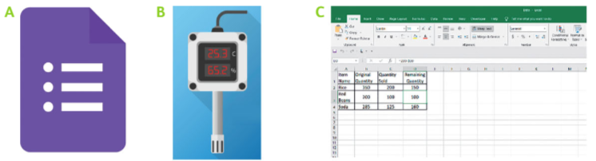

f) The librarian needs to determine the number of 'Science Fiction' books that are in the library. Which computing tool is best for carrying out a search for data?

