**I) Circle the correct answer. [6]**

1) I can share information on the internet.

a) True

b) False

2) Two computers connected together is called the internet.



a) True

b) False

# 

3) A portable computer is called a __________________.

a) Laptop 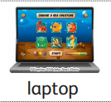

b) Desktop 

4) I cannot chat with friends on the internet.



             a) True

             b) False

5) A _______________ can connect to a network.

1. Smartwatch b) Bicycle

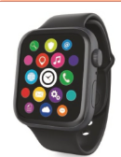 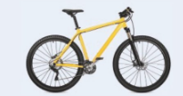

6) Devices can connect to a network using__________.



a) String b) Wires

**II) a) From the below given pictures, Circle the devices that can connect to a network.**  [2]

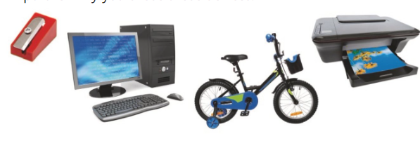

1. **Circle the devices below that commonly connect to a network with a wire.[2]**



**III. Match the correct devices. [5]**

|  |  |
| --- | --- |
| A)Tablet |  |
| B)Desktop |  |
| C) Games console |  |
| D) Smartwatch |  |
| E)Laptop |  |