Light and Shadow

1. **Underline the correct answer.**
2. A _________ object blocks some of the light.
3. Opaque
4. Translucent
5. Transparent
6. Light always travels in a _______________________.
7. Curved line
8. Straight line
9. 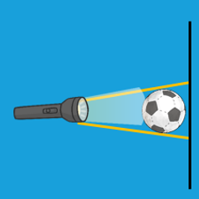When an object moves further away from a light source, it's shadow _______________________.
10. Gets smaller
11. Gets bigger
12. Changes shape
13. Stays the same
14. Which will make the darkest shadow? Light shining on a _______________________.
15. Sheet of thin tissue paper
16. Glass window
17. Plastic bottle
18. Wooden chopping board
19. **Look at the picture.**

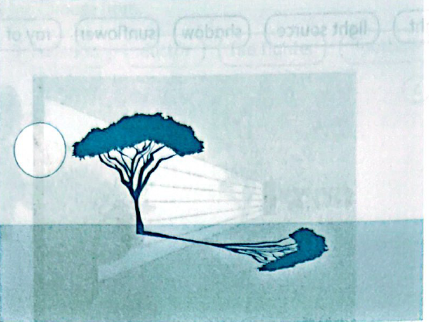

1. Why is there a shadow?

_________________________________________________________________________________________________________________________________________________________________________________________________________________________________

1. In the picture, the shape of the shadow is similar to the shape of the tree. Explain why.

_________________________________________________________________________________________________________________________________________________________________________________________________________________________________

1. **Hadir is putting on a shadow puppet performance.**

Complete the sentences below. Use these words:

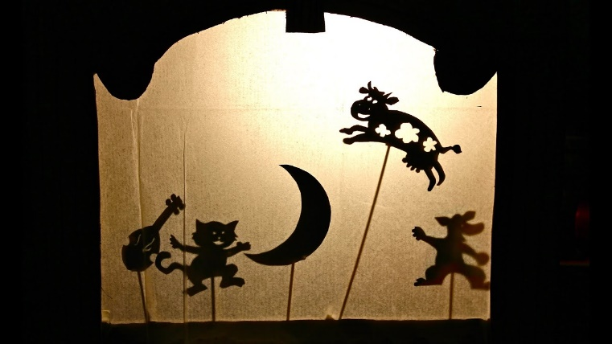

|  |  |  |  |
| --- | --- | --- | --- |
| bigger and fuzzier | darker | | lighter |
| disappear | | smaller and sharper | |

1. If Hadir uses a brighter light source, the puppet's shadow will get ______________________.
2. If Hadir moves the puppet closer to the screen, the puppet's shadow will get ____________________.
3. If Hadir switches off the light source, the puppet's shadow will ________________________.
4. If Hadir moves the puppet further away from the screen, the puppet's shadow will get ___________________________.
5. If Hadir uses a dimmer light source, the puppet's shadow will get ______________________.
6. **Draw and write the name of these objects into the correct group in the table below.**

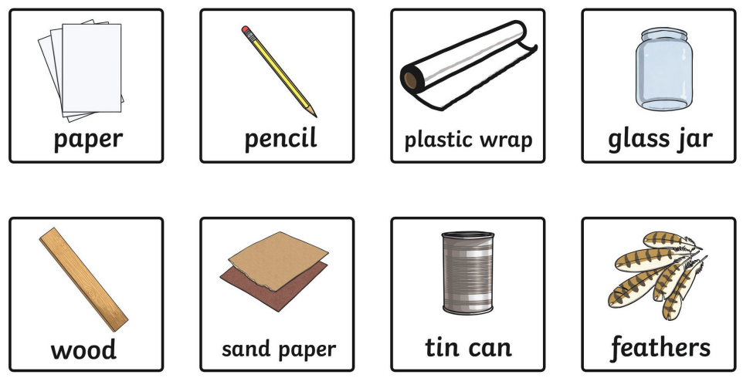

|  |  |
| --- | --- |
| 12. Transparent | 13. Opaque |
|  |  |

1. **Pierre and Mike investigate shadows.**

Pierre makes a shadow. Mike draws around the shadow.

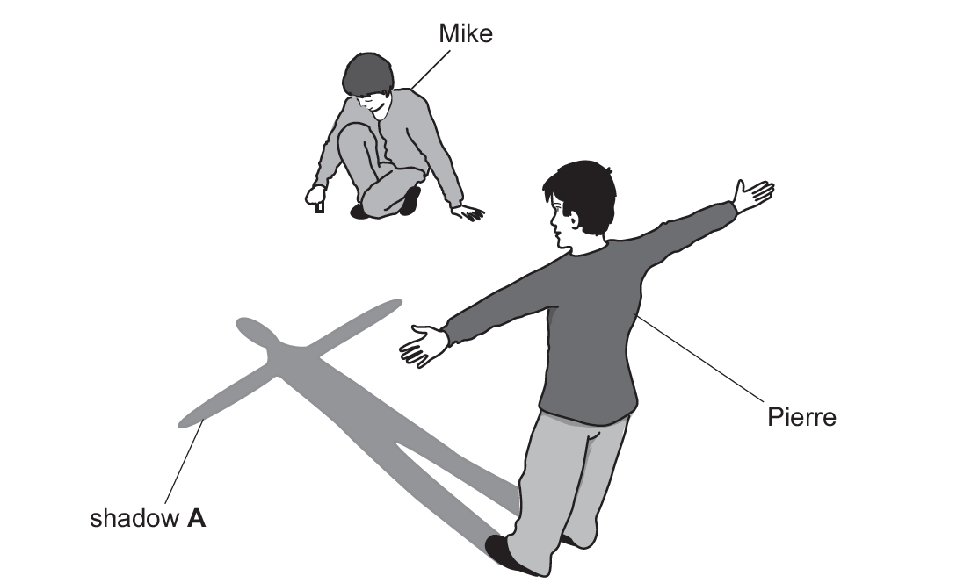

1. Explain why there is a shadow.

_________________________________________________________________________________________________________________________________________________________________________________________________________________________________

1. How might a shadow get longer or shorter?

____________________________________________________________________________________________________________________________________________________________________________________________________________________________________________________________________________________________________________

1. **Answer the following questions.**
2. What happens if you shine a torch on a shiny surface?

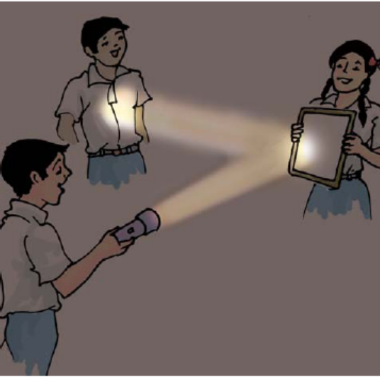

_________________________________________________________________________________________________________________________________________________________________________________________________________________________________

1. Why do you think road signs are made out of reflective material?

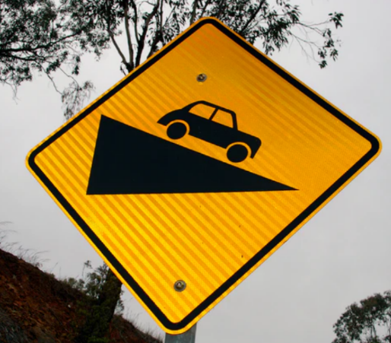

_________________________________________________________________________________________________________________________________________________________________________________________________________________________________

1. Why should you never look directly at the Sun or other bright lights?

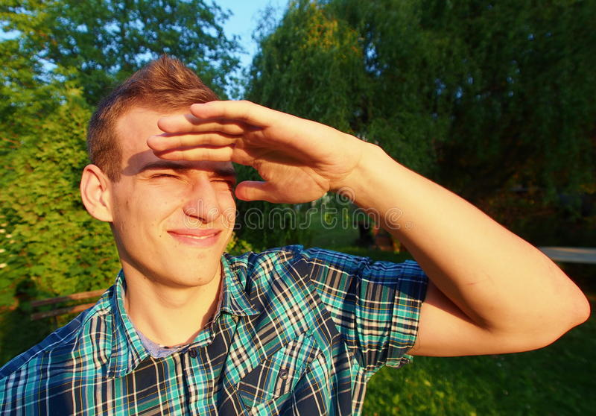

______________________________________________________________________________________________________________________________________________________

1. How do you make a shadow bigger?



