**I. The doctor wants to listen to Danny’s heart using a stethoscope.** 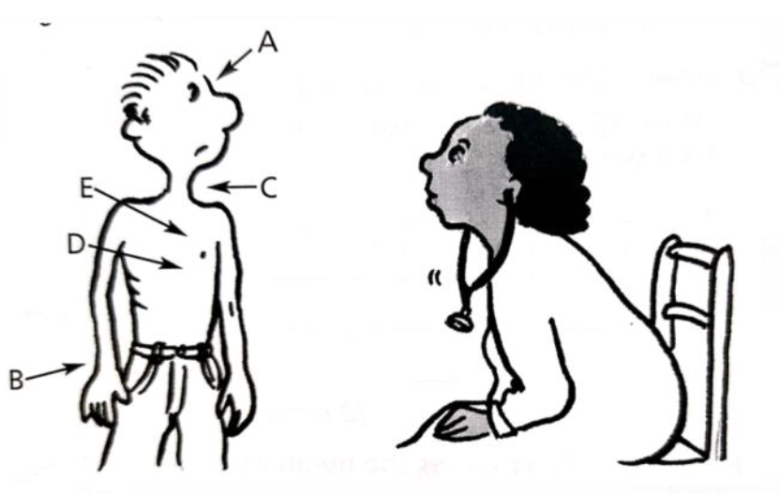

1. Where should the end of a stethoscope be placed to listen to Danny’s heart? Circle the correct

letter**. /1**

______________________________________________________________________________

2. What is the job of the heart? **/1**

______________________________________________________________________________

3. The doctor asked Danny to run on the spot for a minute. She listened to his heart again. What would be different when the doctor listened to Danny’s heart after exercise? Give reason for your answer. **/2**

______________________________________________________________________________

______________________________________________________________________________

**II. The thorax or chest contains major organs of two organ systems. Name the organs and the organ systems to which they belong. /4**

4. Organ _________________________________

Organ system _________________________________

5. Organ _________________________________

Organ system _________________________________

**III.** **The graph shows how Will’s heartbeat rate changed as he started to run.**

6. What does the graph tell us about Will’s heartbeat rate as he ran? /1 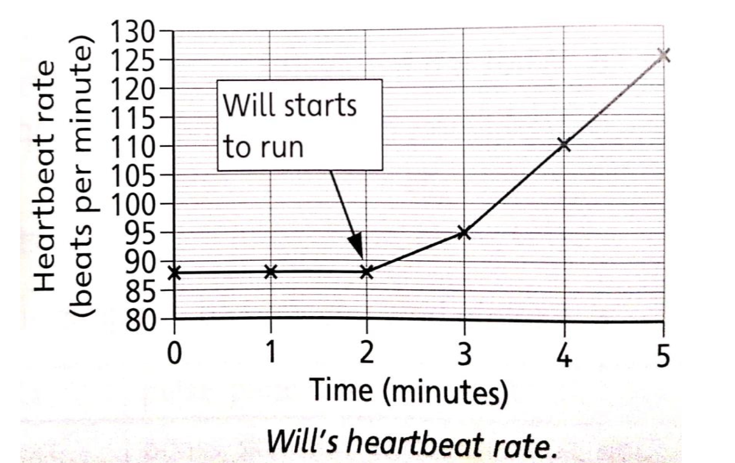

______________________________________________________________________________

______________________________________________________________________________

7. Explain why this happens, using your scientific knowledge. /1

______________________________________________________________________________

______________________________________________________________________________

8. When did Will have a heartbeat rate of 102 beats per minute? /1

______________________________________________________________________________

______________________________________________________________________________

**IV. The labels describe different ways our body protects us from diseases. /4 Draw a line from each label to match the way of preventing disease with the right body part.** 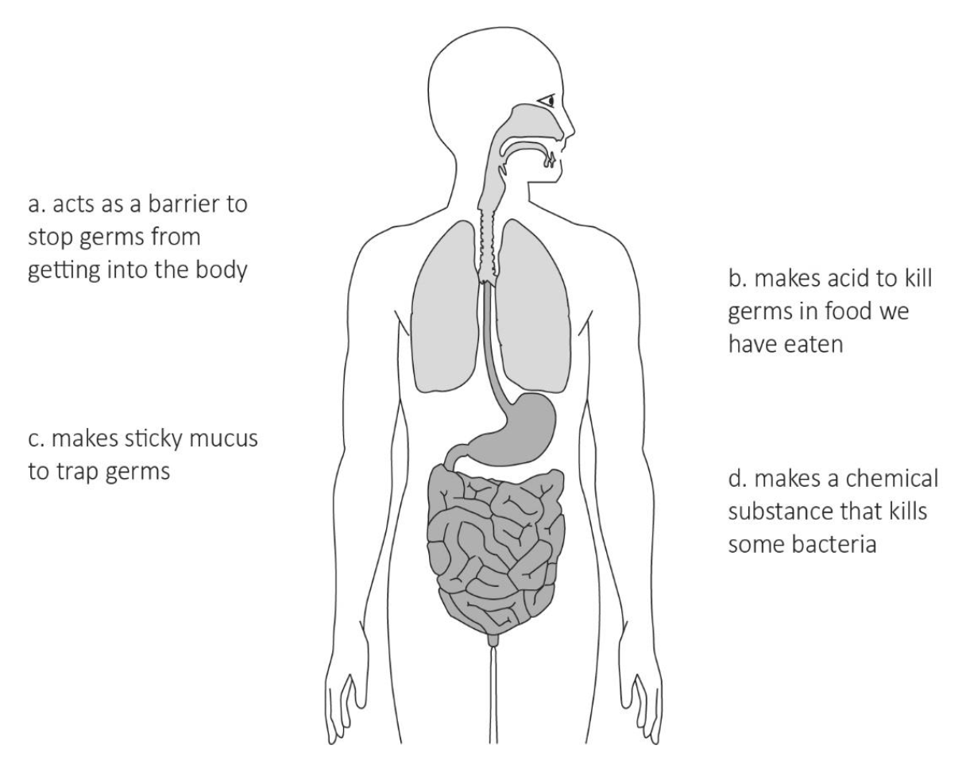

**V. Label the following parts of the respiratory system. /5**

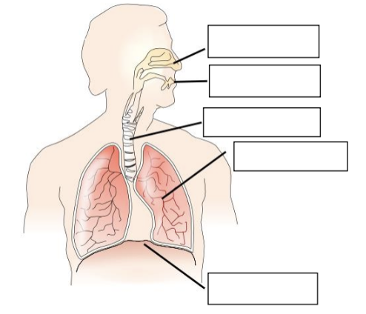

**VI. Elephants have a similar circulatory system to humans.**

9. Write down the names of the three types of blood vessels in an elephant. /3

______________________________________________________________________________

______________________________________________________________________________

10. One of the functions of the blood in an elephant is to transport the gas carbon dioxide.

Write down two other substances the blood transports. /2

______________________________________________________________________________

______________________________________________________________________________

**VII. Nasra wants to find out if the water temperature affects the time it takes for sugar to dissolve. Nasra dissolves one teaspoon of sugar in 100 cm? of water. She repeats her test using water at different temperatures.**

11. Name two variables Nasra should keep the same to make her test fair. /2

______________________________________________________________________________

______________________________________________________________________________

12. Nasra records her results in a table. /3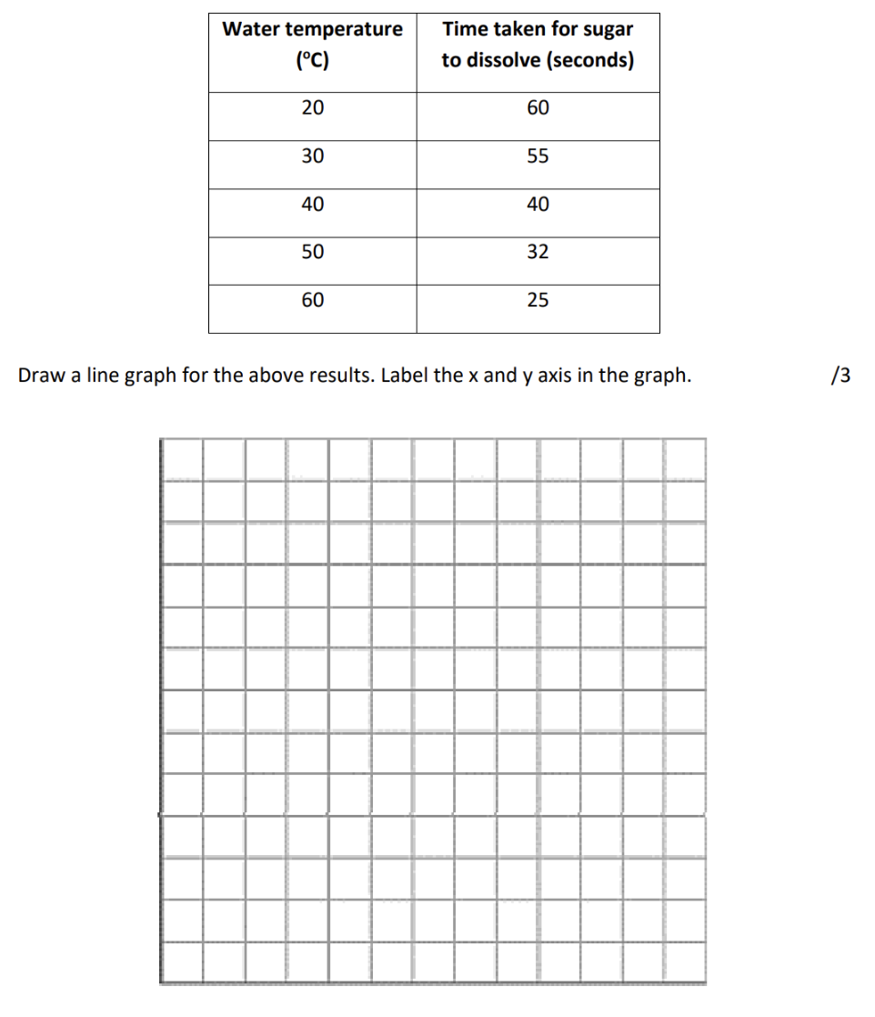



13. Explain how the temperature of the water affects the time taken for the sugar to dissolve. /1

______________________________________________________________________________

______________________________________________________________________________

**VIII. The breathing rate of a human is measured in the number of breaths per minute.**

**Sarah investigates the breathing rates of five of her friends. She measures the breathing rates after they have been sitting still for five minutes. Her friends then run 200m as fast as they can. Sarah measures the breathing rates just after they have run this 200m.**

14. Predict what difference she expects in the breathing rates of her friends before and after running. /2

**prediction _____________________________________________________________________**

**______________________________________________________________________________**

**explanation ___________________________________________________________________**

**_____________________________________________________________________________**

15. Draw the results table in the space below for Sarah's measurements. /2

**IX. Look at the table of properties of some substances.**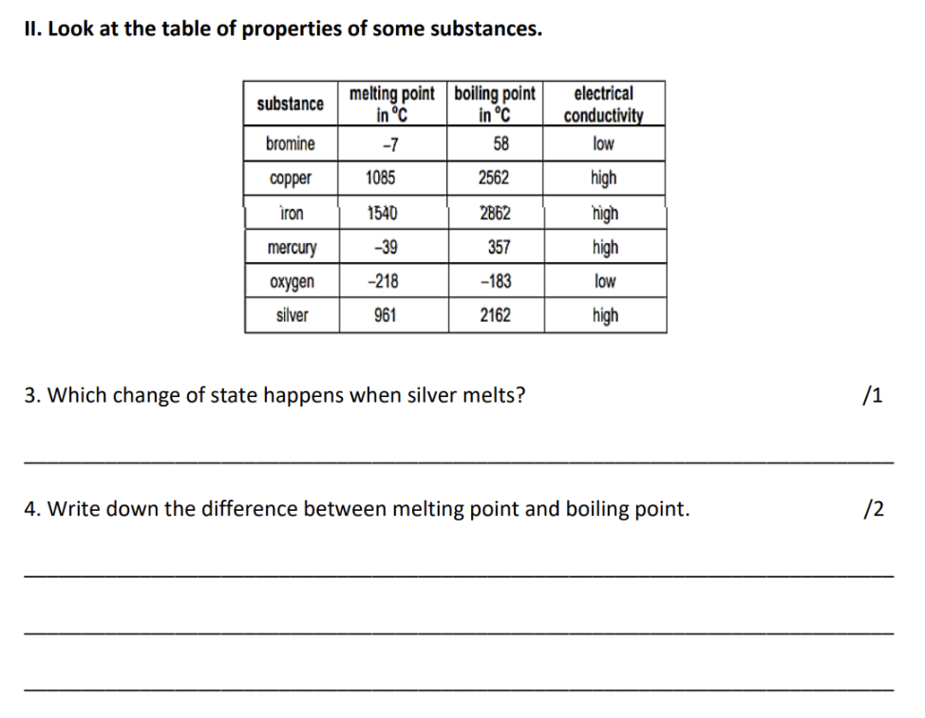

16. Which change of state happens when silver melts? /1

______________________________________________________________________________

17. Write down the difference between melting point and boiling point. /2

______________________________________________________________________________

______________________________________________________________________________

______________________________________________________________________________

______________________________________________________________________________

18. Room temperature is 25°C. Mercury is liquid at room temperature. Complete the sentence to explain why. /2

Mercury has a boiling point _________________________ than room temperature and a

melting point _______________________ than room temperature.

**X. Write yes or no in each row of the table to show if the activity causes a reversible change./3**

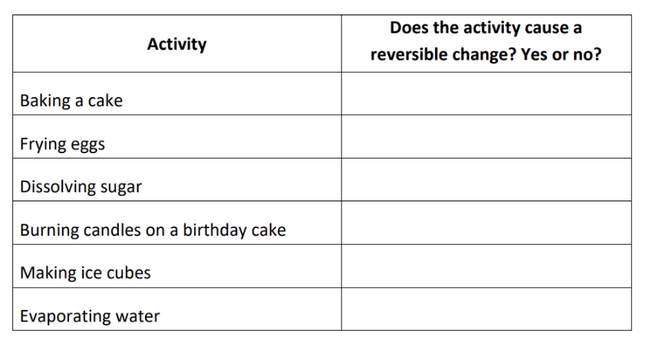

**XI. Class 6 are investigating how long it takes heat to travel along rods made from different materials.**

19. What scientific name is given to materials that allow heat to pass through them? /1

______________________________________________________________________________

20. Class 6 push a paperclip into some wax. Then they attach the wax to a rod.

The candle heats up the rod. The heat travels along the rod to the wax.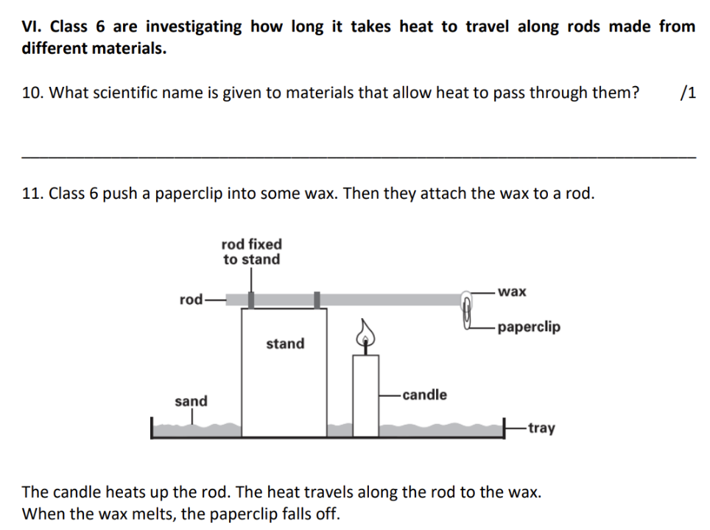

When the wax melts, the paperclip falls off.

21. Class 6 measure the time it takes for the paperclip to fall off.

What force causes the paperclip to fall into the tray? /1

______________________________________________________________________________

22. Class 6 record their results in a table. Fill in the missing heading on the table. /1

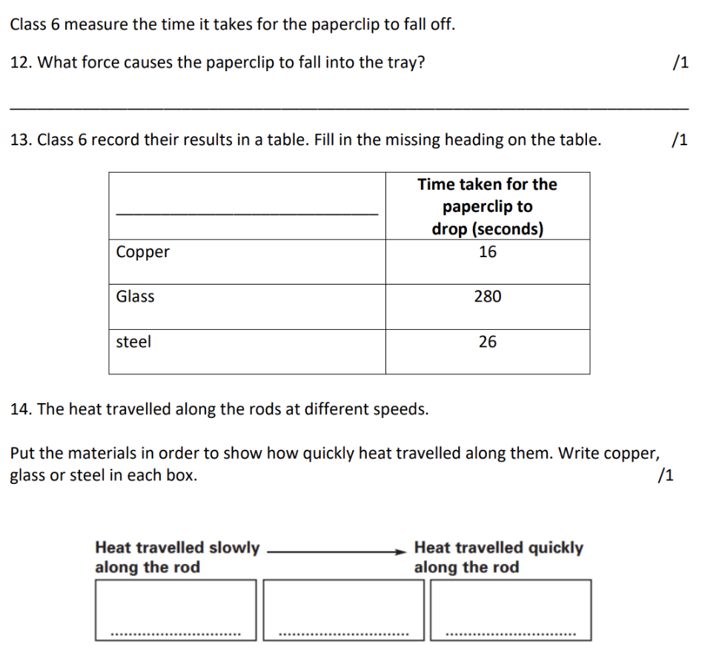

23. The heat travelled along the rods at different speeds.

Put the materials in order to show how quickly heat travelled along them. Write copper, glass or steel in each box. /1

**XII. 24. Describe one similarity between boiling and evaporation. /1**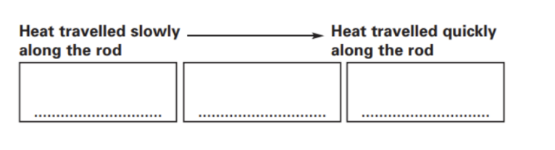

______________________________________________________________________________

______________________________________________________________________________

______________________________________________________________________________

**25. Describe two differences between boiling and evaporation. /2**

______________________________________________________________________________

______________________________________________________________________________

_____________________________________________________________________________