Word Search Activity
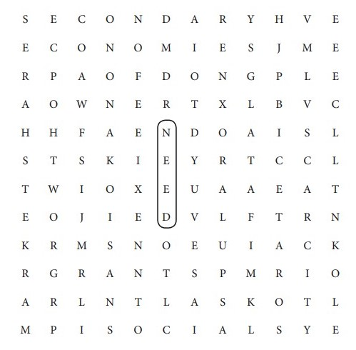
Recall the key terminologies from chapters 1, 2, and 3 and search them in the table below.

