**Pop Quiz 3**

1. Find the mystery number. /2
2. 16 + = 20
3. + 7 = 20
4. 12 + = 20
5. 5 + = 20
6. Complete these calculations. /2
7. 3 + 4 = 7 so, 13 + 4 = ________, 23 + 4 = __________.
8. 2 + 6 = 8 so, 22 + 6 = _________, 32 + 6 = __________.
9. 5 + 4 = 9 so, 25 + 4 = __________, 45 + 4 = ___________.
10. 8 +2 = 10 so, 38 + 2 = __________, 58 + 2 = ___________.
11. Solve the following using the beaded line. /2



1. 44 + 9 = ________ c) 50 – 4 = _________
2. 36 + 5 = ________ d) 62 – 6 = _________
3. Complete the sequence. /2
4. 2, 4, 6, 8, ____,_____, 14.
5. 25, 30, 35, ______,______, 50.
6. 16, 18, ______, _______, 24.
7. 65, 70, 75, ______, ______.
8. 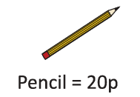Draw the number of 10p coins for each of the items. /1

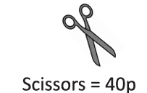

1. 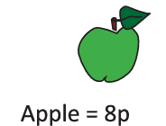Draw the number of 2p coins for each of these items. /1

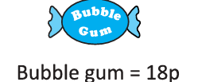

Teacher’s Signature:_________________ Parent’s Signature:_____________